Objectives

Describe the fundamentals of the Linux operating system

Describe the vulnerabilities of the Linux operating system

Describe Linux remote attacks

Explain countermeasures for protecting the Linux operating system
Review of Linux Fundamentals

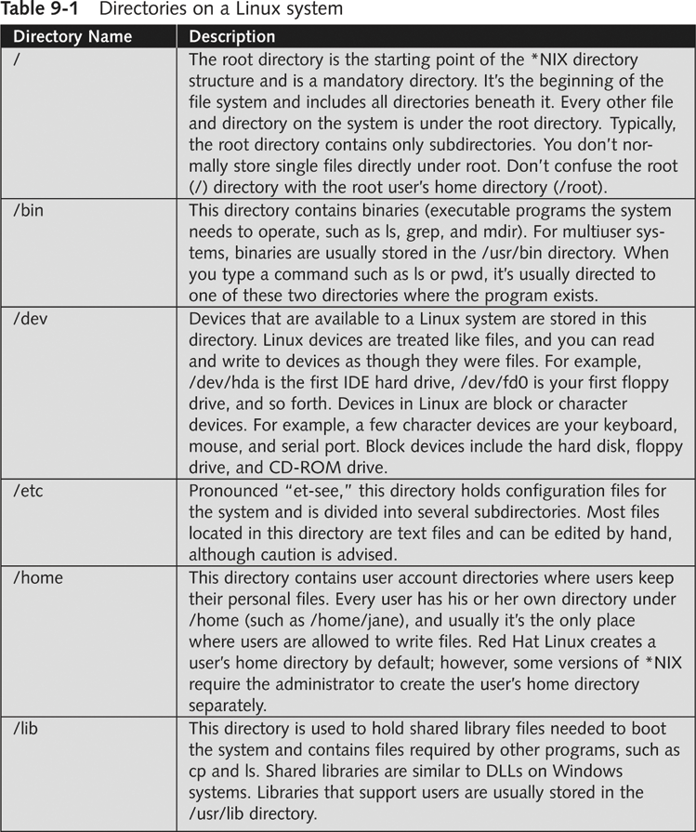
Linux is a version of UNIX

Usually available free

Red Hat

Includes documentation and support for a fee

Linux creates default directories

Linux Exploration Demo

cd /
ls -F

Note: ls -F adds:
/ to directories
* to executables
@ to linked files

cd /bin
ls -F

Note: familiar commands ls, nc, mkdir

cd /dev
ls

Note: hda - hard disk. eth0 is not here--Ethernet devices are treated differently (link Ch 9a)

cd /etc
ls -F

Note: hosts file with name-to-IP mapping ("cat hosts" to see it)
passwd with user names and groups ("cat passwd" to see it)
shadow file with hashed passwords ("sudo cat shadow" to see it)
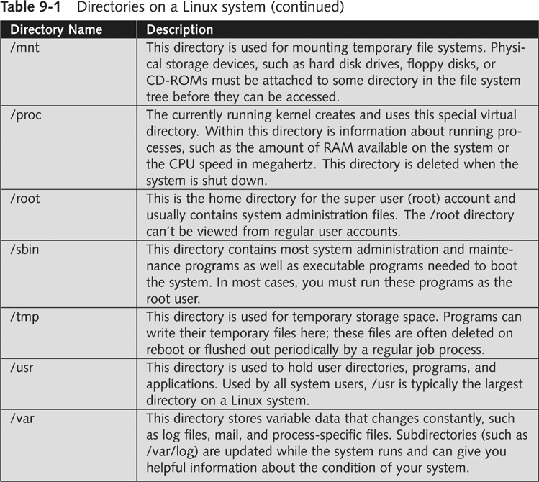
cd /home
ls -l

Note: Home directory for each user, owned by the user

cd /lib
ls -F

Note: Libraries here, nothing particularly interesting

cd /mnt
ls -al

Note: Nothing here unless a removable device is connected

cd /proc
ls -F

Note: These files show information about running processes.
"cat interrupts" "cat iomem" "cat ioports" shows the device resources, like Device Manager
"cat meminfo" shows memory statistics
"cat partitions" shows the hard disk partitions
"cat version" shows the Linux version

cd /var/log
ls
cat boot

Note: This file is the boot log
Linux File System

Provides directory structure

Establishes a file-naming convention

Includes utilities to compress or encrypt files

Provides for both file and data integrity

Enables error recovery

Stores information about files and folders

*NIX systems store information about files in information nodes (inodes)

inodes

Information stored in an inode

An inode number

Owner of the file

Group the file belongs to

Size of the file

Date the file was created

Date the file was last modified or read

There is a fixed number of inodes

By default, one inode per 4 KB of disk space

Mounting

In Windows, each device has a letter

A: for floppy, C: for hard disk, and so on

*NIX mounts a file system (usually a drive) as a subfile system of the root file system /

mount and df in Ubuntu

mount command is used to mount file systems

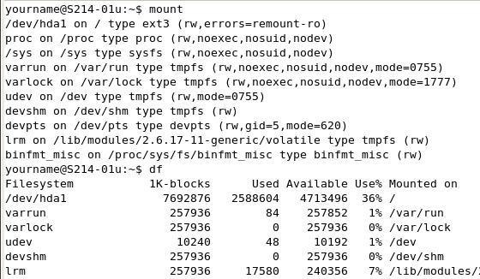
or to display currently mounted file systems

df command displays disk usage of mounted file systems

*NIX File System History

Minix file system

Max. size 64 MB, Max. file name 14 chars

Extended File System (Ext)

Max. size 2 GB, Max. file name 256 chars

Second Extended File System (Ext2fs)

Max. size 4 TB, better performance and stability

Third Extended File System (Ext3fs)

Journaling—recovers from crashes better

Linux Commands
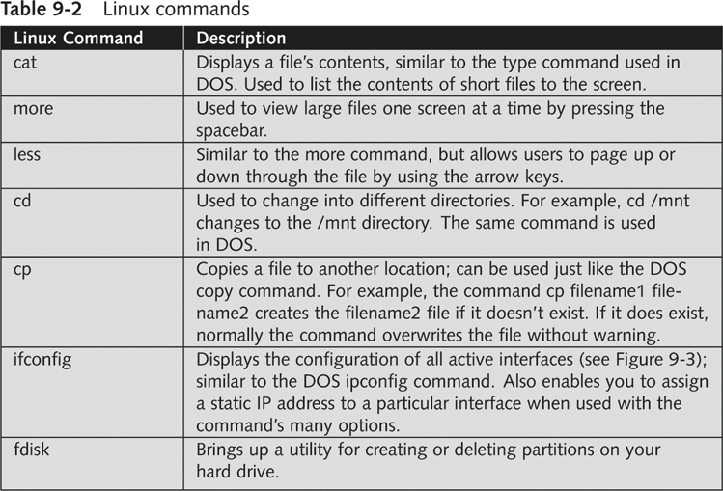
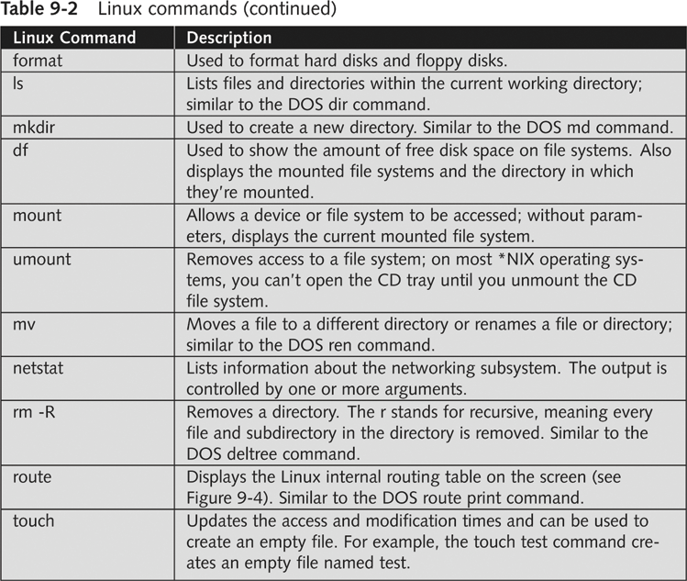

Getting Help

Many of these commands have multiple parameters and additional functionality

Use these commands to get help. (Replace command with the command you want help with, such as ifconfig)

command --help

man command

Linux OS Vulnerabilities

UNIX has been around for quite some time

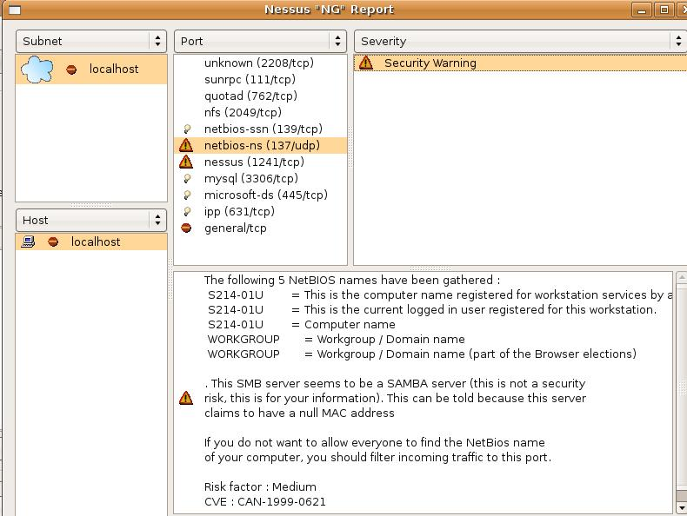
Attackers have had plenty of time to discover
vulnerabilities in *NIX systems

Nessus Scanning a Linux Server (with Samba)

Enumeration tools can also be used
against Linux systems

Nessus can be used to enumerate Linux systems

Nessus can be used to

Discover vulnerabilities related to SMB and NetBIOS

Discover other vulnerabilities

Enumerate shared resources

Test Linux computer against common known vulnerabilities

Review the CVE and CAN information

See links Ch 9m, n, o

Remote Access Attacks on Linux Systems

Differentiate between local attacks and remote attacks

Remote attacks are harder to perform

Attacking a network remotely requires

Knowing what system a remote user is operating

The attacked system’s password and login accounts

Footprinting an Attacked System

Footprinting techniques

Used to find out information about a target system

Determining the OS version the attacked computer is running

Check newsgroups for details on posted messages

Knowing a company’s e-mail address makes the search easier

Other Footprinting Tools

Whois databases

DNS zone transfers

Nessus

Port scanning tools

Using Social Engineering to Attack Remote Linux Systems

Goal

To get OS information from company employees

Common techniques

Urgency

Quid pro quo

Status quo

Kindness

Position

Train your employees about social engineering techniques
Trojans

Trojan programs spread as

E-mail attachments

Fake patches or security fixes that can be downloaded from the Internet

Trojan program functions

Allow for remote administration

Create a FTP server on attacked machine

Steal passwords

Log all keys a user enters, and e-mail results to the attacker

Trojan programs can use legitimate outbound ports

Firewalls and IDSs cannot identify this traffic as malicious

Example: Sheepshank uses HTTP GETs

It is easier to protect systems from already identified Trojan programs

See links Ch 9e, f, g
Rootkits

Contain Trojan binary programs ready to be installed by an intruder with root access to the system

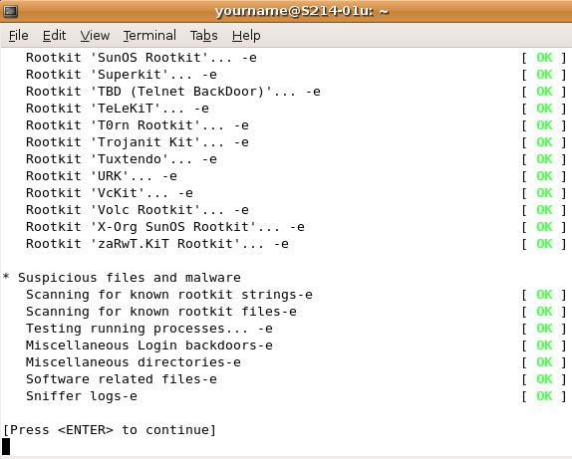
Replace legitimate commands with Trojan programs

Hides the tools used for later attacks

Example: LRK5

LRK5

A famous Linux Rootkit

See Links Ch 9h, i, j

Rootkit Detectors

Security testers should check their Linux systems for rootkits

Rootkit Hunter (Link Ch 9l)

Chkrootkit (Link Ch 9l)

Rootkit Profiler (Link Ch 9k)

Demonstration of rkhunter

sudo apt-get install rkhunter

sudo rkhunter –c

Creating Buffer Overflow Programs

Buffer overflows write code to the OS’s memory

Then run some type of program

Can elevate the attacker’s permissions to the level of the owner

Security testers should know what a buffer overflow program looks like

A C program that causes a buffer overflow
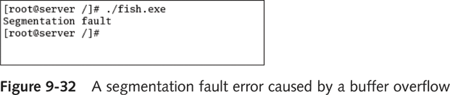

The program compiles, but returns the error shown to the right

A C code snippet that fills the stack with shell code

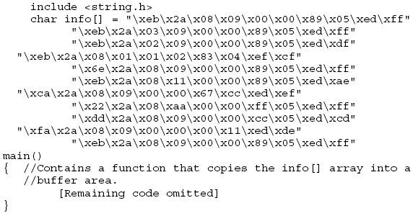

Avoiding Buffer Overflows

Write code that avoids functions known to have buffer overflow vulnerabilities

strcpy()

strcat()

sprintf()

gets()

Configure OS to not allow code in the stack to run any other executable code in the stack

Some compilers like gcc warn programmers when dangerous functions are used
Using Sniffers to Gain Access to Remote Linux Systems

Sniffers work by setting a network card adapter in promiscuous mode

NIC accepts all packets that traverse the network cable

Attacker can analyze packets and learn user names and passwords

Avoid using protocols such as Telnet, HTTP, and FTP that send data in clear text

Sniffers

Tcpdump, Ethereal (now Wireshark)
Countermeasures Against Linux Remote Attacks

Measures include

User awareness training

Keeping current on new kernel releases and security updates

User Awareness Training

Social Engineering

Users must be told not to reveal information to outsiders

Make customers aware that many exploits can be downloaded from Web sites

Teach users to be suspicious of people asking questions about the system they are using

Verify caller’s identity

Call back technique

Keeping Current

Never-ending battle

New vulnerabilities are discovered daily

New patches are issued to fix new vulnerabilities

Installing these fixes is essential to protecting your system

Many OSs are shipped with automated tools for updating your systems
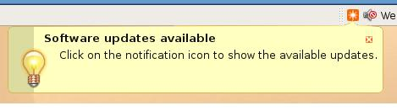

Last modified 3-22-07 9 am

