Objectives

Describe the history of cryptography

Describe symmetric and asymmetric cryptography algorithms

Explain public key infrastructure (PKI)

Describe possible attacks on cryptosystems
Understanding Cryptography Basics

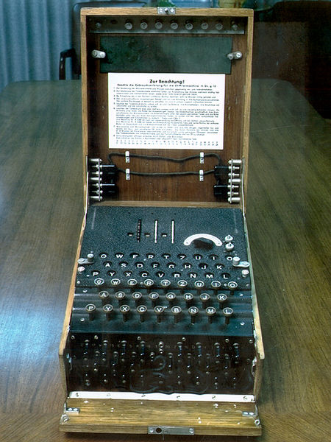
Cryptography is the process of converting plaintext into ciphertext

Plaintext: readable text (also called cleartext)

Ciphertext: unreadable or encrypted text

Cryptography is used to hide information from unauthorized users

Decryption is the process of converting ciphertext back to plaintext

History of Cryptography

Substitution cipher

Replaces one letter with another letter based on a key

Example: Julius Caesar’s Cipher

Used a key value of 3

ABCDEFGHIJKLMNOPQRSTUVWXYZ

DEFGHIJKLMNOPQRSTUVWXYZABC

Cryptanalysis studies the process of breaking encryption algorithms

When a new encryption algorithm is developed, cryptanalysts study it and try to break it

Or prove that it is impractical to break it (taking much time and many resources)

Enigma

Used by the Germans during World War II

Replaced letters as they were typed

Substitutions were computed using a key and a set of switches or rotors

Image from Wikipedia (link Ch 12a)

Steganography

The process of hiding data in plain view in pictures, graphics, or text

Example: changing colors slightly to encode individual bits in an image

The image on the left contains the image on the right hidden in it (link Ch 12c)

Algorithms

An algorithm is a mathematical function or program that works with a key

Security comes from

A strong algorithm—one that cannot be reversed without the key

A key that cannot be found or guessed

Keys (not in textbook)

A sequence of random bits

The range of allowable values is called a keyspace

The larger the keyspace, the more secure the key

8-bit key has 2⁸ = 256 values in keyspace

24-bit key has 2²⁴ = 16 million values

56-bit key has 2⁵⁶ = 7 x 10¹⁶ values

128-bit key has 2¹²⁸ = 3 x 10³⁸ values

Brute Force (not in textbook)

In 1997 a 56-bit key was broken by brute force

Testing all possible 56-bit keys

Used 14,000 machines organized via the Internet

It took 3 months

See link Ch 12d

How Many Bits Do You Need? (not in textbook)

How many keys could all the computers on Earth test in a year?

Pentium 4 processor: 10⁹ cycles per second

One year = 3 x 10⁷ seconds

There are less than 10¹⁰ computers on Earth

One per person

10⁹ x 3 x 10⁷ x 10¹⁰ ⁼ 3 x 10²⁶ calculations

128 bits should be enough (3 x 10³⁸ values)

Unless computers get much faster, or someone breaks the algorithm
Symmetric Cryptography
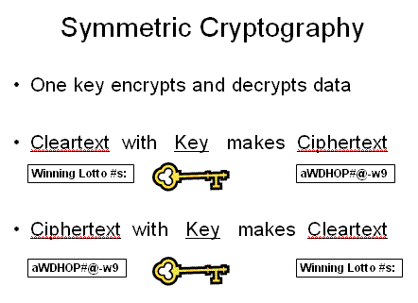

Symmetric Cryptography Algorithms

Symmetric algorithms have one key that encrypts and decrypts data

Advantages

Symmetric algorithms are fast

They are difficult to break if a large key size is used

Only one key needed

Disadvantages

Symmetric keys must remain secret

Difficult to deliver keys (key distribution)

Symmetric algorithms don’t support authenticity or nonrepudiation

You can’t know for sure who sent the message, since two people have the same key

Types of symmetric algorithms

Stream ciphers

Operate on plaintext one bit at a time

Block ciphers

Operate on blocks of plaintext

DeCSS

Commercial DVDs are encoded with a 40-bit key

It’s simple to crack it by brute force

Three hackers did that in 1999

See links Ch 12e, 12f

Legislation such as the DMCA made it illegal to publish the algorithm

See Illegal Prime Number (Link Ch 12g)

Data Encryption Standard (DES)

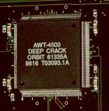
National Institute of Standards and Technology (NIST)

Wanted a means of protecting sensitive but unclassified data

Invited vendors in early 1970 to submit data encryption algorithms

IBM proposed Lucifer

A 128-bit encryption algorithm

The National Security Agency (NSA) reduced the key size from 128 bits to 64 bits and created DES

Only 56 bits of the key are actually used

In 1988, NSA thought the standard was at risk to be broken

In 1997, a DES key was broken in 3 months

In 1998, the EFF built a a computer system that cracked a DES key in 3 days

Link Ch 12h

Triple DES (3DES)

Triple Data Encryption System (3DES)

3DES served as a quick fix to the vulnerabilities of DES

3DES performed three DES encryptions

2⁵⁶ times stronger than DES

More secure but slower to compute

See link Ch 12i

Advanced Encryption Standard (AES)

Became effective in 2002 as a standard

The process took 5 years

Block cipher that operates on 128-bit blocks of plaintext

Keys can be 128, 192, or 256 bits

Uses Rindjael algorithm

Link Ch 12j

International Data Encryption Algorithm (IDEA)

Block cipher that operates on 64-bit blocks of plaintext

It uses a 128-bit key

Developed by Xuejia Lai and James Massey

Designed to work more efficiently in computers used at home and in businesses

IDEA is free for noncommercial use

It is included in PGP encryption software

Blowfish

Block cipher that operates on 64-bit blocks of plaintext

The key length can be as large as 448 bits

Developed by Bruce Schneier

RC5

Block cipher that can operate on different block sizes: 32, 64, and 128

The key size can reach 2048 bits

Created by Ronald L. Rivest in 1994 for RSA Data Security

Cracking RC5

56-bit and 64-bit key RC5s have already been cracked

The RC5-72 project is underway, trying to crack a 72-bit key

At the current rate, it will take 1000 years

Links Ch 12l, 12m
Asymmetric Cryptography Algorithms

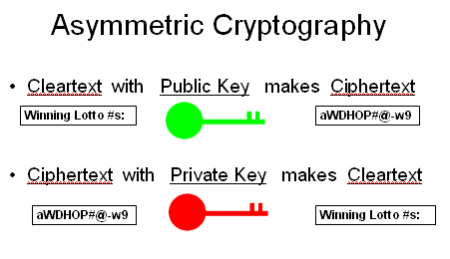
Use two keys that are mathematically related

Data encrypted with one key can be decrypted only with the other key

Another name for asymmetric key cryptography is public key cryptography

Public key: known by the public

Private key: known only by owner

Asymmetric Cryptography

Provides message authenticity and nonrepudiation

Authenticity validates the sender of a message

Nonrepudiation means a user cannot deny sending a message

Asymmetric algorithms are more scalable but slower than symmetric algorithms

Scalable: can adapt to larger networks

Each person needs only one key pair

Everyone can use the same public key to send you data

Each person signs messages with their own private key

RSA

Developed in 1977 by Ronald L. Rivest, Adi Shamir, and Leonard M. Adleman

The algorithm is based on the difficulty of factoring large numbers

The Secure Socket Layer (SSL) protocol uses the RSA algorithm

Diffie-Hellman

Developed by Whitfield Diffie and Martin Hellman

Does not provide encryption but is used for key exchange

Two parties agree on a key without ever sending it directly over the network

The numbers transmitted can be used to compute the key, but only by the parties holding secret private numbers

Prevents sniffing attacks (link Ch 12

Elliptic Curve Cryptosystems (ECC)

It is an efficient algorithm requiring few resources

Memory

Disk space

Bandwidth

ECC is used for encryption as well as digital signatures and key distribution

Elgamal

Public key algorithm used to

Encrypt data

Create digital signature

Exchange secret keys

Written by Taher Elgamal in 1985

The algorithm uses discrete logarithm problems

Solving a discrete logarithm problem can take many years and require CPU-intensive operations

Digital Signatures

A hash value ensures that the message was not altered in transit (integrity)

Provides message integrity, authenticity and nonrepudiation

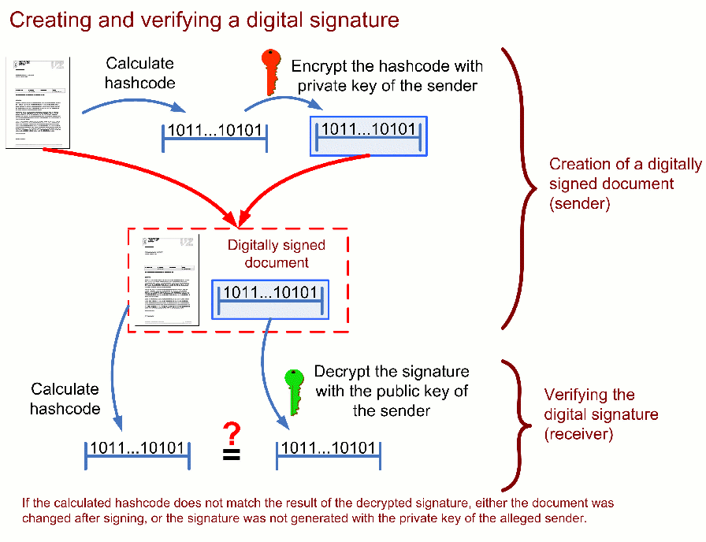

Digital Signature Standard (DSS)

Established by the NIST in 1991

Ensures that digital signatures rather than written signatures can be verified

Federal government requirements

RSA and Digital Signature Algorithm (DSA) must be used for all digital signatures

Hashing algorithm must be used to ensure the integrity of the message

NIST required that the Secure Hash Algorithm (SHA) be used

Pretty Good Privacy (PGP)

Developed by Phil Zimmerman as a free e-mail encryption program

Zimmerman was almost arrested for his innovation

Back in the mid-1990s, any kind of “unbreakable” encryption was seen as a weapon and compared to selling arms to the enemy

PGP is a free public key encryption program

PGP uses certificates similar to those in public key infrastructure (PKI)

PGP does not use a centralized CA

Verification of a CA is not as efficient as PKI

Algorithms supported by PGP

IDEA

RSA

DSA

Message Digest 5 (MD5)

SHA-1

Secure Multipurpose Internet Mail Extension (S/MIME)

Is another public key encryption standard used to encrypt and digitally sign e-mail

Can encrypt e-mail messages containing attachments

Can use PKI certificates for authentication

S/MIME version 2 defined in RFC 2311

S/MIME version 3 defined in RFC 2633

Privacy-Enhanced Mail (PEM)

Internet standard that is compatible with both symmetric and asymmetric methods of encryption

Can use the X.509 certificate standards and encrypt messages with DES

Not used as much today

MIME Object Security Services (MOSS) is a newer implementation of PEM
Hashing Algorithms

Take a variable-length message and produce a fixed-length value called a message digest

A hash value is equivalent to a fingerprint of the message

If the message is changed later, the hash value changes

Collisions

If two different messages produce the same hash value, it results in a collision

A good hashing algorithm must be collision-free

Hashing Algorithms

SHA-1 is one of the most popular hashing algorithms

SHA-1 has been broken

Collisions were found in 2004 and 2005 (link Ch 12p

As of March 15, 2005, the NIST recommends not using SHA applications

But there are collisions in MD5 too

SHA-256 hasn’t been broken yet

See link Ch 12q

Summary of Cryptographic Algorithms
Symmetric Algorithms (Private-key)
Name Key size Notes
DES 56 bits Insecure because key is too short

3DES 168 bits As secure as 112-bit key, not yet broken
Being replaced by AES

AES 128,192, or 256 bits Uses 128-bit blocks and the Rindjael algorithm
Approved for US Govt classified information

IDEA 128 bits Uses 64-bit blocks, used in PGP, very secure

Blowfish 32 bits to 448 bits Uses 64-bit blocks, developed by Bruce Schneier
Public domain

RC5 0 bits to 2040 bits Block size can be 32, 64, or 138 bits
56-bit and 64-bit key versions have been cracked
72-bit version has not been cracked

Asymmetric Algorithms (Public-key)

Name Notes

Diffie-Hellman Key exchange only, not encryption

RSA Secure, used by SSL

ECC Efficient newer technique

Elgamal Used in GPG and PGP

Hashing Algorithms

Name Notes

MD2 Written for 8-bit machines, no longer secure

MD4 No longer secure

MD5 Security is questionable now

SHA-1 The successor to MD5, used in TLS, SSL, PGP, SSH, S/MIME, and IPsec.
It has been broken so it's not longer completely secure

SHA-2 Not yet broken, but no longer recommended.

The NIST is now developing a new algorithm to replace SHA.

Public Key Infrastructure (PKI)

Not an algorithm

A structure that consists of programs, protocols, and security protocols

Uses public key cryptography

Enables secure data transmission over the Internet

PKI Components

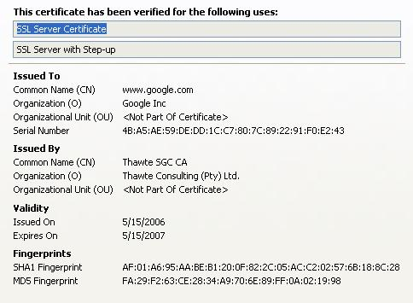
Certificate: a digital document that verifies the identity of an entity

Contains a unique serial number and must follow the X.509 standard

Public keys are issued by a certification authority (CA)

A certificate that the CA issues to a company binds a public key to the recipient’s private key

Certificate Expiration and Renewal

A period of validity is assigned to each certificate

After that date, the certificate expires

A certificate can be renewed with a new expiration date assigned

If the keys are still valid and remain uncompromised

Certificate Revocation and Suspension

Reasons to suspend or revoke a certificate

A user leaves the company

A hardware crash causes a key to be lost

A private key is compromised

Revocation is permanent

Suspension can be lifted

Certificate Revocation List (CRL)

Contains all revoked and suspended certificates

Issued by CAs

Backing Up Keys

Backing up keys is critical

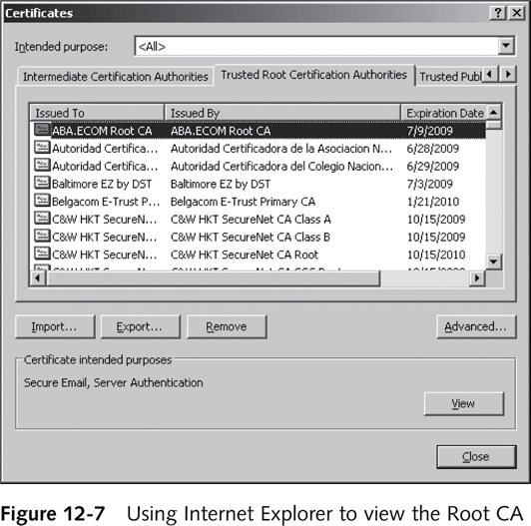
If keys are destroyed and not backed up properly, encrypted business-critical information might be irretrievable
Trusted Root CAs

The CA is usually responsible for backing up keys

A key recovery policy is also part of the CA’s responsibility

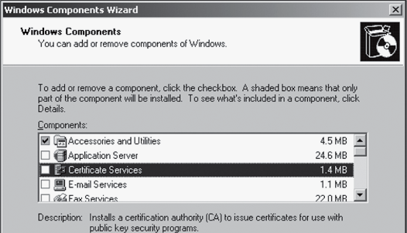
Microsoft Root CA

You can set up your own Certificate Authority Server

Windows Server 2003 or Windows 2000 Server

Install the Certificate Services

Note that after installing this service the name of the domain or computer cannot change

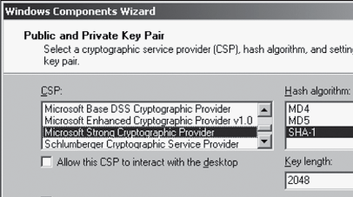

Specify options to generate certificates, including

Cryptographic Service Provider

Hash algorithm

Key length

Understanding Cryptographic Attacks

Sniffing and port scanning are passive attacks – just watching

Active attacks attempt to determine the secret key being used to encrypt plaintext

Cryptographic algorithms are usually public

Follows the open-source culture

Except the NSA and CIA and etc.

Birthday Attack

If 23 people are in the room, what is the chance that they all have different birthdays?
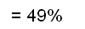
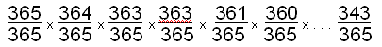

So there’s a 51% chance that two of them have the same birthday

See link Ch 12r

If there are N possible hash values,

You’ll find collisions when you have calculated 1.2 x sqrt(N) values

SHA-1 uses a 160-bit key

Theoretically, it would require 2⁸⁰ computations to break

SHA-1 has already been broken, because of other weaknesses

Mathematical Attacks

Properties of the algorithm are attacked by using mathematical computations

Categories

Ciphertext-only attack

The attacker has the ciphertext of several messages but not the plaintext

Attacker tries to find out the key and algorithm used to encrypt the messages

Attacker can capture ciphertext using a sniffer program such as Ethereal or Tcpdump

Categories

Known plaintext attack

The attacker has messages in both encrypted form and decrypted forms

This attack is easier to perform than the ciphertext-only attack

Looks for patterns in both plaintext and ciphertext

Chosen-plaintext attack

The attacker has access to plaintext and ciphertext

Attacker has the ability to choose which message to encrypt

Categories (continued)

Chosen-ciphertext attack

The attacker has access to the ciphertext to be decrypted and to the resulting plaintext

Attacker needs access to the cryptosystem to perform this type of attack

Brute Force Attack

An attacker tries to guess passwords by attempting every possible combination of letters

Requires lots of time and patience

Password-cracking programs that can use brute force

John the Ripper

Cain and Abel

Ophcrack

Also uses memory to save time – “Rainbow tables”

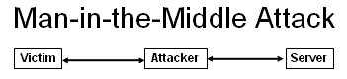
Man-in-the-Middle Attack

Victim sends public key to Server

Attacker generates two “false” key pairs

Attacker intercepts the genuine keys and send false keys out

Both parties send encrypted traffic, but not with the same keys

These false keys won’t be verified by a CA

Dictionary Attack

Attacker uses a dictionary of known words to try to guess passwords

There are programs that can help attackers run a dictionary attack

Programs that can do dictionary attacks

John the Ripper

Cain and Abel

Replay Attack

The attacker captures data and attempts to resubmit the captured data

The device thinks a legitimate connection is in effect

If the captured data was logon information, the attacker could gain access to a system and be authenticated

Most authentication systems are resistant to replay attacks

Password Cracking

Password cracking is illegal in the United States

It is legal to crack your own password if you forgot it

You need the hashed password file

/etc/passwd or /etc/shadow for *NIX

The SAM database in Windows

Then perform dictionary or brute-force attacks on the file

Password cracking programs

John the Ripper

Hydra (THC)

EXPECT

L0phtcrack

Pwdump3v2

Ophcrack does it all for you – gathering the SAM database and cracking it

Last modified 11-6-08

