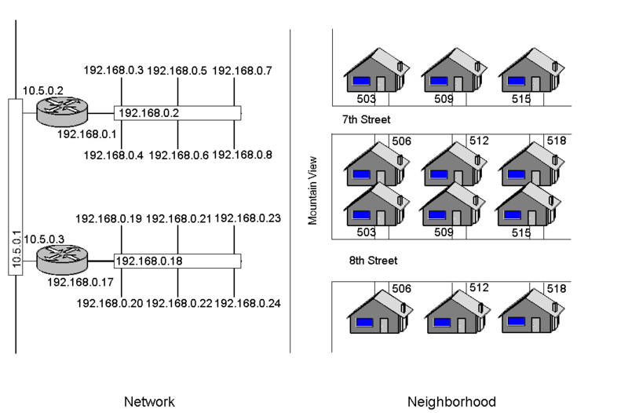
Objectives
Router

Describe network security devices

Describe firewall technology

Describe intrusion detection systems

Describe honeypots
Routers

Routers are like intersections; switches are like streets

Image from Wikipedia (link Ch 13a)

Understanding Routers

Routers are hardware devices used on a network to send packets to different network segments

Operate at the network layer of the OSI model

Routing Protocols

Routers tell one another what paths are available with Routing Protocols

Link-state routing protocol

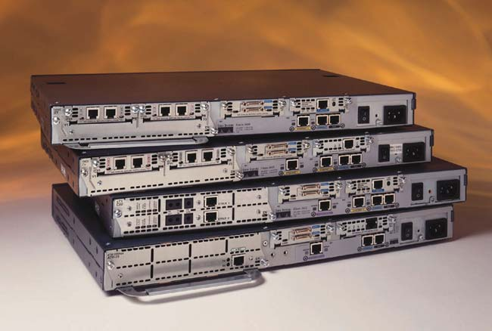
Each router has complete information about every network link

Example: Open Shortest Path First (OSPF)

Distance-vector routing protocol

Routers only know which direction to send packets, and how far

Example: Routing Information Protocol (RIP)

Cisco Routers

Image from cisco.com (link Ch 13b)

Understanding Basic Hardware Routers

Cisco routers are widely used in the networking community

More than one million Cisco 2500 series routers are currently being used by companies around the world

Vulnerabilities exist in Cisco as they do in any operating system

See link Ch 13c

Cisco Router Components

Internetwork Operating System (IOS)

Random access memory (RAM)

Holds the router’s running configuration, routing tables, and buffers

If you turn off the router, the contents stored in RAM are wiped out

Nonvolatile RAM (NVRAM)

Holds the router’s configuration file, but the information is not lost if the router is turned off

Flash memory

Holds the IOS the router is using

Is rewritable memory, so you can upgrade the IOS

Read-only memory (ROM)

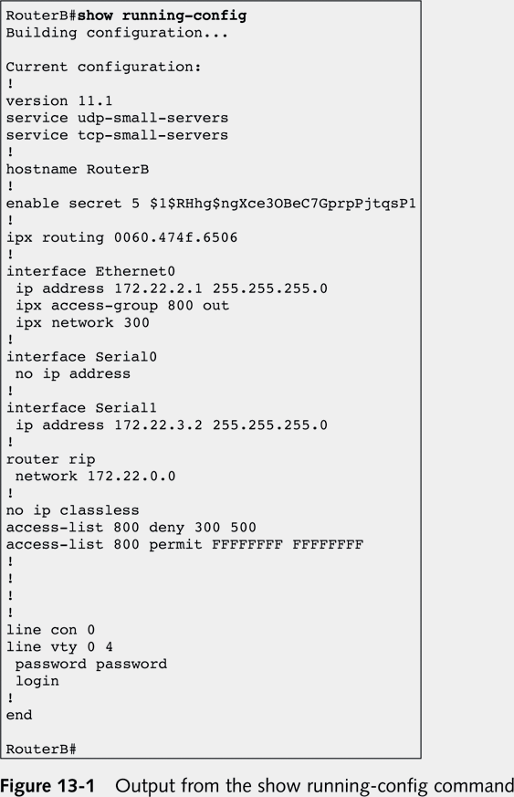
Contains a minimal version of the IOS used to boot the router if flash memory gets corrupted

Interfaces

Hardware connectivity points

Example: an Ethernet port is an interface that connects to a LAN

Michael Lynn

He presented a major Cisco security vulnerability at the Black Hat security conference in 2005

He lost his job, was sued, conference materials were confiscated, etc.

See links Ch 13 d, e, f, g

Cisco IOS is controlled from the command line

The details are not included in this class

Skip pages 324-329

Understanding Firewalls

Firewalls are hardware devices or software installed on a system and have two purposes

Controlling access to all traffic that enters an internal network

Controlling all traffic that leaves an internal network

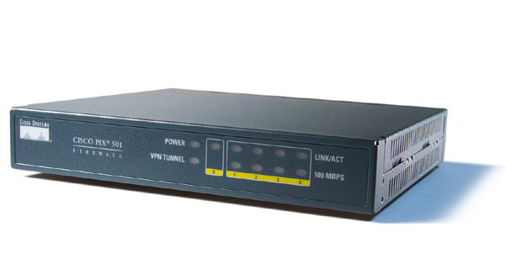
Hardware Firewalls

Advantage of hardware firewalls

Faster than software firewalls (more throughput)

Disadvantages of hardware firewalls

You are limited by the firewall’s hardware

Number of interfaces, etc.

Usually filter incoming traffic only (link Ch 13i)

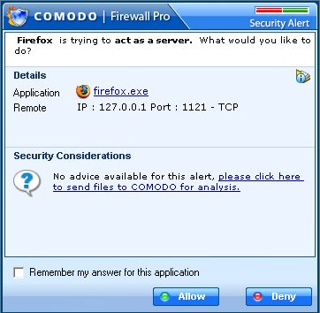
Software Firewalls

Advantages of software firewalls

Customizable: can interact with the user to provide more protection

You can easily add NICs to the server running the firewall software

Software Firewalls

Disadvantages of software firewalls

You might have to worry about configuration problems

They rely on the OS on which they are running

Firewall Technologies

Network address translation (NAT)

Access control lists (Packet filtering)

Stateful packet inspection (SPI)

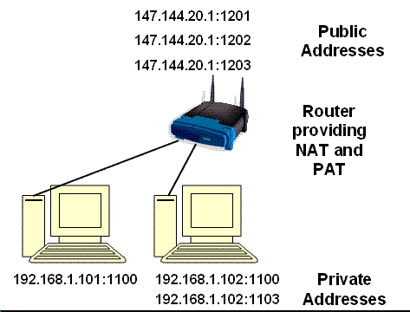

Network Address Translation (NAT)

Internal private IP addresses are mapped to public external IP addresses

Hides the internal infrastructure

Port Address Translation (PAT)

This allows thousands of internal IP addresses to be mapped to one external IP address

Each connection from the private network is mapped to a different public port

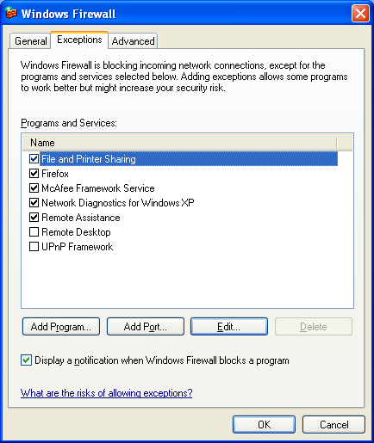

Access Control Lists

A series of rules to control traffic

Criteria

Source IP address

Destination IP address

Ports or services

More possibilities

Same as “Packet Filtering”

Stateful Packet Inspection (SPI)

Stateful packet filters examine the current state of the network

If you have sent a request to a server, packets from that server may be allowed in

Packets from the same server might be blocked if no request was sent first

State Table

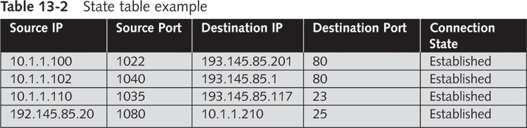
Stateful firewalls maintain a state table showing the current connections

ACK Port scan

Used to get information about a firewall

Stateful firewalls track connection and block unsolicited ACK packets

Stateless firewalls only block incoming SYN packets, so you get a RST response

We covered this in chapter 5

Stateful Packet Inspection (SPI)

Stateful packet filters recognize types of anomalies that most routers ignore

Stateless packet filters handle each packet on an individual basis

This makes them less effective against some attacks

Implementing a Firewall

Using only one firewall between a company’s internal network and the Internet is dangerous

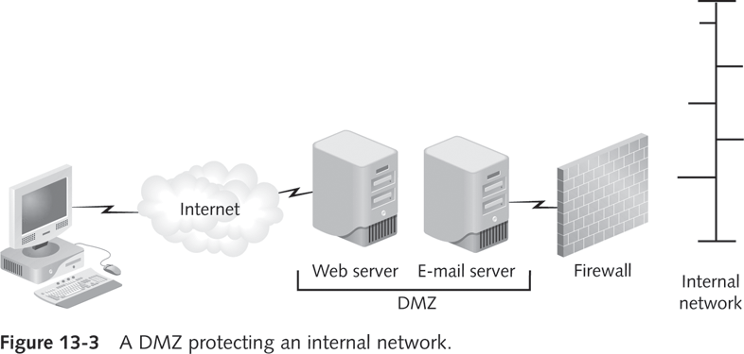
It leaves the company open to attack if a hacker compromises the firewall

Use a demilitarized zone instead

Demilitarized Zone (DMZ)

DMZ is a small network containing resources available to Internet users

Helps maintain security on the company’s internal network

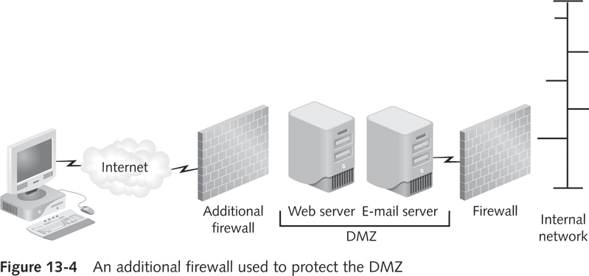
Sits between the Internet and the internal network

It is sometimes referred to as a “perimeter network”

Understanding the Private Internet Exchange (PIX) Firewall

Cisco PIX firewall

One of the most popular firewalls on the market

Configuration of the PIX Firewall

Working with a PIX firewall is similar to working with any other Cisco router

Login prompt

If you are not authorized to be in this XYZ Hawaii network device,

log out immediately!

User Access Verification

Password:

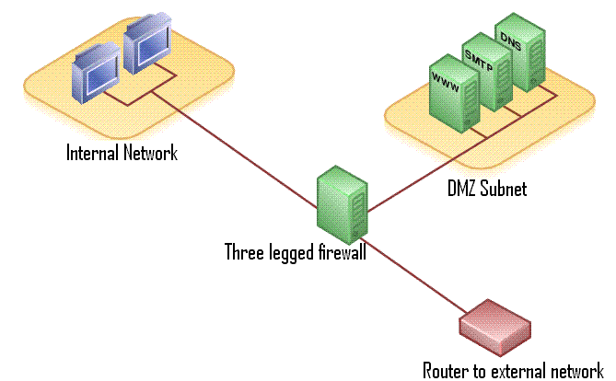
This banner serves a legal purpose

A banner that says “welcome” may prevent prosecution of hackers who enter

PIX Firewall Features

One PIX can be used to create a DMZ

See link Ch 13k

PIX Firewall Features

Unicast Reverse Path Forwarding

Also known as "reverse route lookup"

Checks to see that packets have correct source IP addresses

Flood Defender

Prevents SYN Floods

Only a limited number of "embryonic connections" are allowed

PIX Firewall Features

FragGuard and Virtual Re-Assembly

Re-assembles IP fragments to prevent some DoS attacks, like the Ping of Death and Teardrop

Limits

DNS Responses

ActiveX controls

Java applets

I skipped pages 333-336

Microsoft ISA

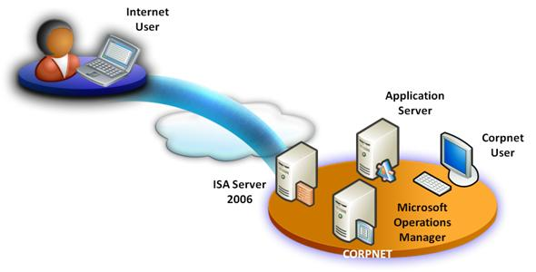
Internet Security and Acceleration (ISA)

Microsoft’s software approach to firewalls

Microsoft Internet Security and Acceleration (ISA) Server

Software that runs on a Windows Server

Functions as a software router, firewall, and IDS (Intrusion Detection System)

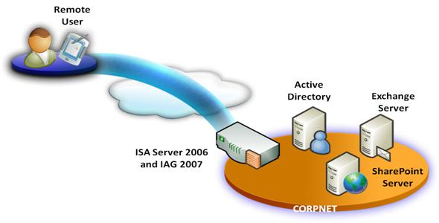
ISA protects your network from Internet threats

ISA lets remote users connect securely, handling authentication and encryption

Image from microsoft.com link Ch 13m

ISA has the same functionality as any hardware router

Packet filtering to control incoming traffic

Application filtering through the examination of protocols

Intrusion detection filters

Access policies to control outgoing traffic

IP Packet Filters

ISA enables administrators to filter IP traffic based on the following:

Source and destination IP address

Network protocol, such as HTTP

Source port or destination port

ISA provides a GUI for these configurations

A network segment can be denied or allowed HTTP access in the Remote Computer tab

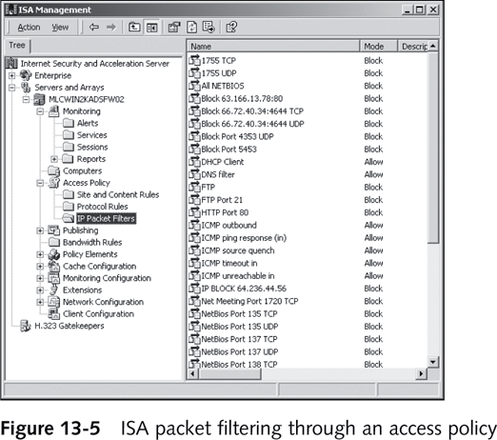

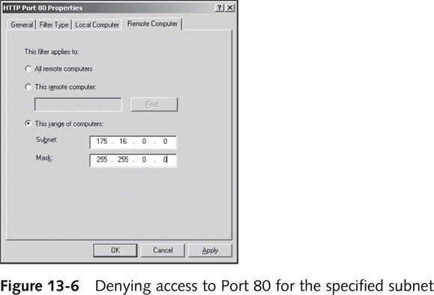

Denying access to port 80 for the specified subnet

Application Filters

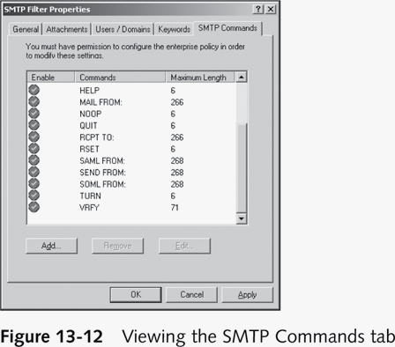
Can accept or deny data from specific applications or data containing specific content

SMTP filter can restrict

E-mail with specific attachments

E-mail from a specific user or domain

E-mail containing specific keywords

SMTP commands

Email can also be filtered based o

Sender's name

Sender's domain

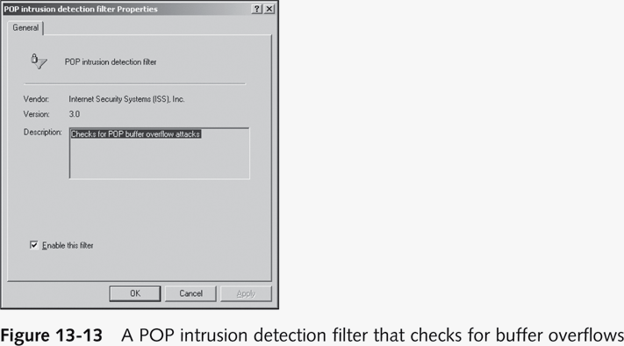
Keywords like VIAGRA or Mortgage

These techniques are not very effective—spammers know how to defeat them

SMTP Commands tab

Administrator can prevent a user from running SMTP commands

FTP Access filter

H.323 filter

real-time multimedia conferences

See link Ch 13n

Intrusion Detection Filters

Analyze all traffic for possible known intrusions

DNS intrusion detection filter

POP filter

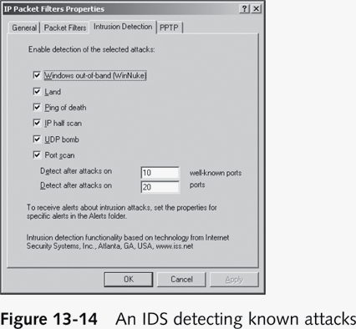
RPC filter

SMTP filter

SOCKS filter

Streaming Media filter

Web Proxy filter

Intrusion Detection Systems (IDSs)

Monitor network devices so that security administrators can identify attacks in progress and stop them

An IDS looks at the traffic and compares it with known exploits

Similar to virus software using a signature file to identify viruses

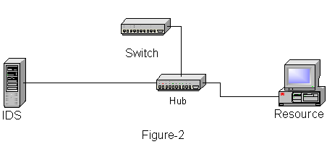
Types

Network-based IDSs

Host-based IDSs

Network-based IDSs

Monitor activity on network segments

They sniff traffic and alert a security administrator when something suspicious occurs

See link Ch 13o

Host-based IDSs

The software is installed on the server you’re attempting to protect, like antivirus software

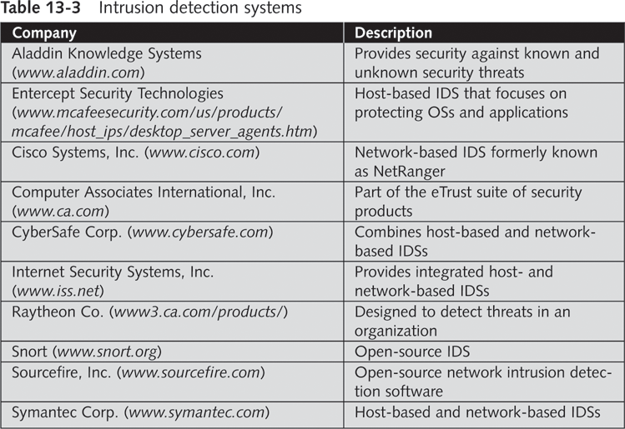
Used to protect a critical network server or database server

Passive and Active IDSs

IDSs are categorized by how they react when they detect suspicious behavior

Passive systems

Send out an alert and log the activity

Don't try to stop it

Active systems

Log events and send out alerts

Can also interoperate with routers and firewalls to block the activity automatically

Understanding Honeypots

Honeypot

Computer placed on the perimeter of a network

Contains information intended to lure and then trap hackers

Computer is configured to have vulnerabilities

Goal

Keep hackers connected long enough so they can be traced back

How They Work

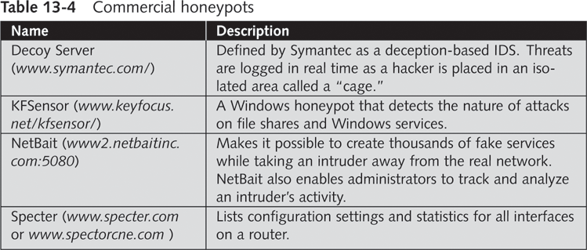
A honeypot appears to have important data or sensitive information stored on it

Could store fake financial data that tempts hackers to attempt browsing through the data

Hackers will spend time attacking the honeypot

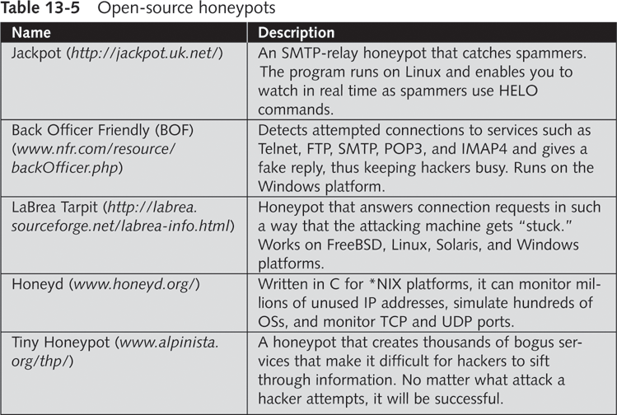
And stop looking for real vulnerabilities in the company’s network

Honeypots also enable security professionals to collect data on attackers

Virtual honeypots

Honeypots created using software solutions instead of hardware devices

Example: Honeyd

Project Honey Pot

Web masters install software on their websites

When spammers harvest email addresses from sites, HoneyNet's servers record the IP of the harvester

Can help prosecute the spammers and block the spam

Link Ch 13p

Uses a Capture Server and one or more Capture Clients

The clients run in virtual machines

Clients connect to suspect Web servers

If the client detects an infection, it alerts the Capture Server and restores itself to a clean state

The server gathers data about malicious websites

See link Ch 13q

Last modified 6-4-09

