Legal Concerns

Defeating security to enter a network without permission is clearly illegal

Even if the security is weak

Sniffing unencrypted wireless traffic may also be illegal

It could be regarded as an illegal wiretap

The situation is unclear, and varies from state to state

In California, privacy concerns tend to outweigh other considerations

See links l14v, l14w
Equipment

Wireless Network Interface Cards (NICs) and Drivers

The Goal

All wireless NICs can connect to an Access Point

But hacking requires more than that, because we need to do

Sniffing – collecting traffic addressed to other devices

Injection – transmitting forged packets which will appear to be from other devices

Windows v. Linux

The best wireless hacking software is written in Linux

The Windows tools are inferior, and don't support packet injection

But all the wireless NICs are designed for Windows

And the drivers are written for Windows

Linux drivers are hard to find and confusing to install

Wireless NIC Modes

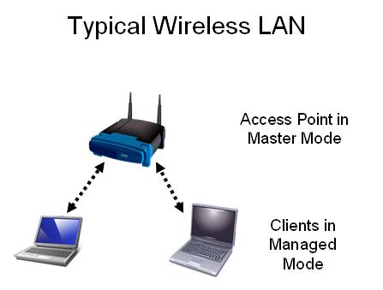
There are four modes a NIC can use

Master mode

Managed mode

Ad-hoc mode

Monitor mode

See link l_14j

Master Mode

Also called AP or Infrastructure mode

Looks like an access point

Creates a network with

A name (SSID)

A channel

Managed Mode

Also called Client mode

The usual mode for a Wi-Fi laptop

Joins a network created by a master

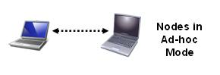
Automatically changes channel to match the master

Presents credentials, and if accepted, becomes associated with the master

Ad-hoc Mode

Peer-to-peer network

No master or Access Point

Nodes must agree on a channel and SSID

Monitor Mode

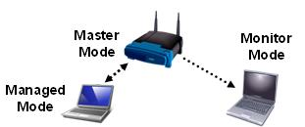
Does not associate with Access Point

Listens to traffic

Like a wired NIC in Promiscuous Mode

Wi-Fi NICs

To connect to a Wi-Fi network, you need a Network Interface Card (NIC)
PCMCIA

PCMCIA

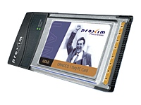
The most common type is the PCMCIA card

Designed for laptop computers

USB

Can be used on a laptop or desktop PC

PCI

Installs inside a desktop PC

Choosing a NIC

For penetration testing (hacking), consider these factors:

Chipset
USB

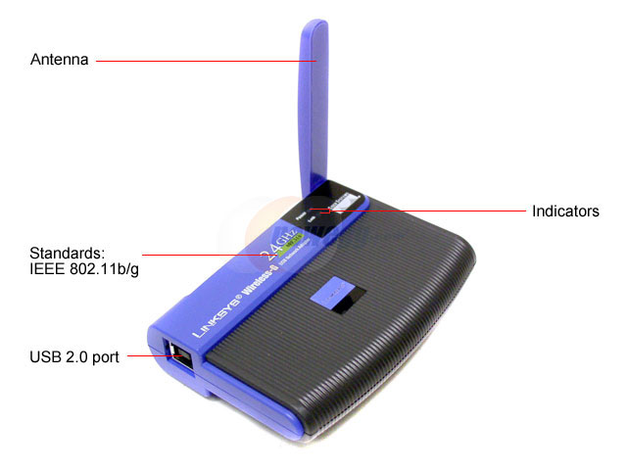
Output power

Receiving sensitivity

External antenna connectors

Support for 802.11i and improved WEP versions

Wi-Fi NIC Manufacturers

Each wireless card has two manufacturers

The card itself is made by a company like

Netgear

Ubiquiti

Linksys

D-Link

many, many others

But the chipset (control circuitry) is made by a different company

Chipsets

To find out what chipset your card uses, you must search on the Web

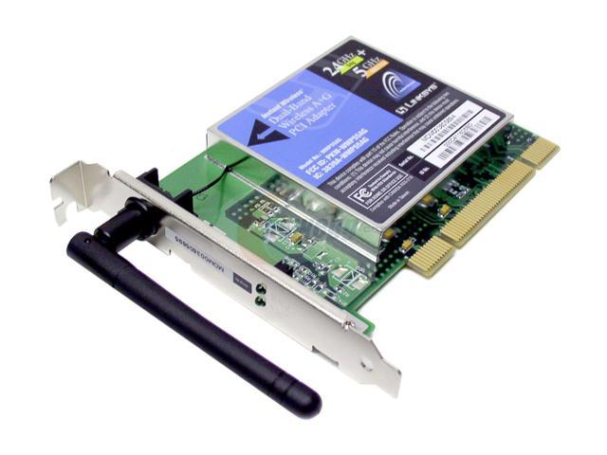
Card manufacturer's don't want you to know
PCI

Major chipsets:

Prism

Cisco Aironet

Hermes/Orinoco

Atheros

There are others

Prism Chipset

Prism chipset is a favorite among hackers

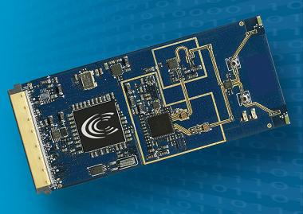
Completely open -- specifications available

Has more Linux drivers than any other chipset

See link l_14d

Prism chipset is the best choice for penetration testing

HostAP Linux Drivers are highly recommended, supporting:

NIC acting as an Access Point

Use of the iwconfig command to configure the NIC

See link l_14h

Cisco Aironet Chipset

Cisco proprietary – not open

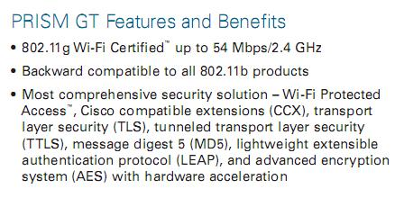
Based on Prism, with more features

Regulated power output

Hardware-based channel-hopping

Very sensitive – good for wardriving

Cannot use HostAP drivers

Not useful for man-in-the-middle or other complex attacks

Hermes Chipset

Lucent proprietary – not open

Lucent published some source code for WaveLAN/ORiNOCO cards

Useful for all penetration testing, but require

Shmoo driver patches (link l_14l) to use monitor mode

Atheros Chipset

The most common chipset in 802.11a devices

Best Atheros drivers are MadWIFI (link l_14m)

Some cards work better than others

Monitor mode is available, at least for some cards

Other Cards

If all else fails, you could use Windows drivers with a wrapper to make them work in Linux

DriverLoader (link l_14n)

NdisWrapper (link l_14o)

But all you'll get is basic functions, not monitor mode or packet injection

Not much use for hacking
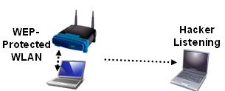
Cracking WEP: Tools and Principles

A Simple WEP Crack

The Access Point and Client are using WEP encryption

The hacker device just listens

Listening is Slow

You need to capture 50,000 to 200,000 "interesting" packets to crack a 64-bit WEP key

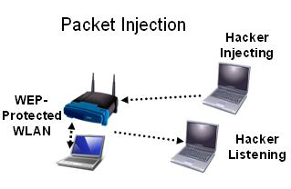
The "interesting" packets are the ones containing Initialization Vectors (IVs)

Only about ¼ of the packets contain IVs

So you need 200,000 to 800,000 packets

It can take hours or days to capture that many packets

Packet Injection

A second hacker machine injects packets to create more "interesting packet"

Injection is MUCH Faster

With packet injection, the listener can collect 200 IVs per second

5 – 10 minutes is usually enough to crack a 64-bit key

Cracking a 128-bit key takes an hour or so

Link l_14r

AP & Client Requirements

Access Point

Any AP that supports WEP should be fine (they all do)

Client

Any computer with any wireless card will do

Could use Windows or Linux

Listener Requirements

NIC must support Monitor Mode

Could use Windows or Linux

But you can't use NDISwrapper

Software

Airodump (part of the Aircrack Suite) for Windows or Linux (see Link l_14q)

BackTrack is a live Linux CD with Aircrack on it (and many other hacking tools)

Link l_14n

Injector Requirements

NIC must support injection

Must use Linux

Software

void11 and aireplay

Link l_14q

Sources

http://www.aircrack-ng.org/doku.php?id=compatible_cards (link l_14a)

http://www.wi-foo.com/ (link l_14c)

http://www.vias.org/wirelessnetw/wndw_05_04.html (link l_14j)

http://smallnetbuilder.com/content/view/24244/98/ (link l_14p)

Last modified 5-11-09

