How HTTPS Works

HTTP v. HTTPS

HTTP doesn't encrypt data at all

You can sniff traffic with Wireshark, ettercap, etc.

Completely insecure

HTTPS uses public-key encryption to secure data

Much safer, but it can still be cracked to some extent by a man-in-the-middle attack

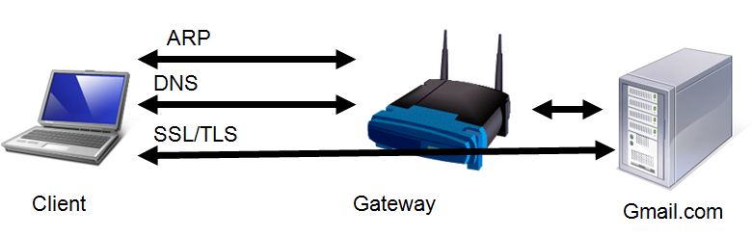
Components of HTTPS

When you use a secure session (HTTPS), these protocols work together:

Address Resolution Protocol (ARP)

Domain Name System (DNS)

Secure Sockets Layers (SSL)

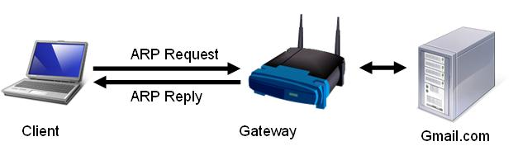
ARP Request and Reply

Client wants to find Gateway

ARP Request: Who has 192.168.2.1?

ARP Reply:

MAC: 00-30-bd-02-ed-7b has 192.168.2.1

Demonstration: Sniffing ARP with Wireshark

Start Wireshark capturing packets

Clear the ARP cache

arp –d *

Ping the default gateway

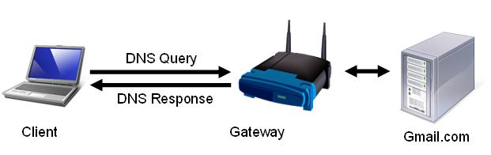
DNS Query and Response

Client wants to find Gmail.com

DNS Query: Where is Gmail.com?

DNS Response:

Gmail.com is at 64.233.171.83

Demonstration: Sniffing DNS with Wireshark

Start Wireshark capturing packets

Clear the DNS cache

ipconfig /flushdns

Ping Gmail.com

SSL Handshake

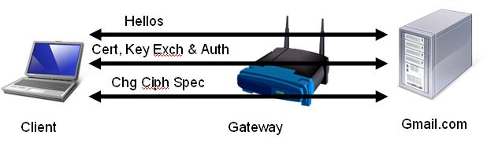
SSL handshake has three stages:

Hellos

Certificate, Key Exchange, and Authentication

"Change cipher spec" – handshake finished

The Gateway just forwards all this traffic to the Web server

Demonstration: Sniffing SSL Handshake with Wireshark

Start Wireshark capturing packets

Open a browser and go to yahoo.com

Click the My Mail button

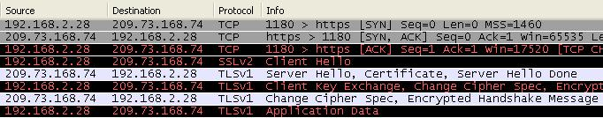
Hand

Hello

Key

Hand – these three packets are the TCP Handshake, which happens before the SSL handshake
Hello – these two packets are the Hellos, which start the SSL handshake
Key – these packets perform the last two stages of the SSL handshake:

Certificate, Key Exchange, and Authentication

"Change cipher spec" – handshake finished

Open a Socket to Port 443

This is the usual SYN, SYN/ACK, SYN TCP handshake

Port 443 is used for HTTPS

Hellos

Client Hello

Server sends Hello

This exchange is used to agree on a protocol version and encryption method

Certificate, Key Exchange, and Authentication

Server sends Certificate

Client sends Public Key

Client Authenticates Certificate with Certificate Authority (not visible)

Change Cipher Spec

Server sends "Change Cipher Spec"

Client sends "Change Cipher Spec"

SSL Handshake is done, now client can send encrypted Application Data

Summary of HTTPS Process

SSL handshake has three stages:

Hellos

Certificate, Key Exchange, and Authentication

"Change cipher spec" – handshake finished
Man-in-the-Middle Attack

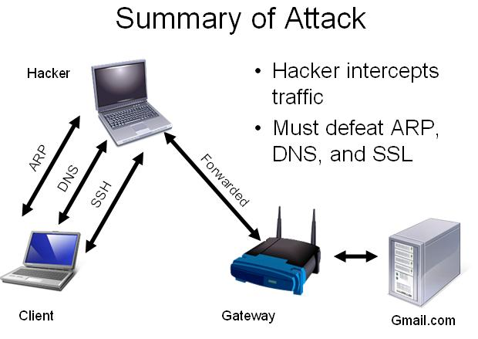
ARP Cache Poisoning

The Linux utility 'arpspoof' sends a constant series of ARP REPLIES

This diverts Ethernet traffic to the hacker

Part of the 'dsniff' package

DNS Spoofing

The Linux utility 'dnspoof' listens for DNS queries

Sends DNS responses sending Web server data to the hacker

Part of the 'dsniff' package

IP Routing

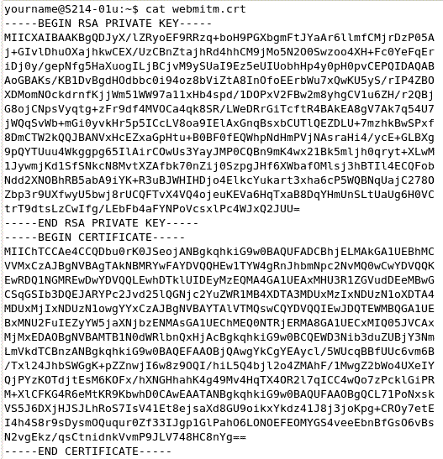
'fragrouter' can forward packets to their correct destination

That allows normal Web surfing (HTTP)

Part of the 'dsniff' package

This could also be done with 'iptables'

SSL Spoofing

'webmitm' creates a Certificate and intercepts SSL handshakes

Part of the 'dsniff' package

Limitations of the Attack

The SSL spoofing is not perfect

You can't actually log in and read email

Internet Explorer sends your password to the hacker before giving up on the connection

Firefox doesn't send your password to the hacker

Sources

Hacking videos from link l_15b

How to decrypt SSL encrypted traffic using a man in the middle attack (Auditor).swf

MITM Hijacking.wmv

SSL Handshake information from l_15a (cs.bham.ac.uk)

Last modified 5-11-09

