Objectives

Describe the role of an ethical hacker

Describe what you can do legally as an ethical hacker

Describe what you cannot do as an ethical hacker
Introduction to Ethical Hacking

Ethical hackers

Employed by companies to perform penetration tests

Penetration test

Legal attempt to break into a company’s network to find its weakest link

Tester only reports findings, does not solve problems

Security test

More than an attempt to break in; also includes analyzing company’s security policy and procedures

Tester offers solutions to secure or protect the network

The Role of Security and Penetration Testers

Hackers

Access computer system or network without authorization

Breaks the law; can go to prison

Crackers

Break into systems to steal or destroy data

U.S. Department of Justice calls both hackers

Ethical hacker

Performs most of the same activities but with owner’s permission

The Role of Security and Penetration Testers

Script kiddies or packet monkeys

Young inexperienced hackers

Copy codes and techniques from knowledgeable hackers

Experienced penetration testers write programs or scripts using these languages

Practical Extraction and Report Language (Perl), C, C++, Python, JavaScript, Visual Basic, SQL, and many others

Script

Set of instructions that runs in sequence

It Takes Time to Become a Hacker

This class alone won’t make you a hacker, or an expert

It might make you a script kiddie

It usually takes years of study and experience to earn respect in the hacker community

It’s a hobby, a lifestyle, and an attitude

A drive to figure out how things work

The Role of Security and Penetration Testers

Tiger box

Collection of OSs and hacking tools

Usually on a laptop

Helps penetration testers and security testers conduct vulnerabilities assessments and attacks

Penetration-Testing Methodologies

White box model

Tester is told everything about the network topology and technology

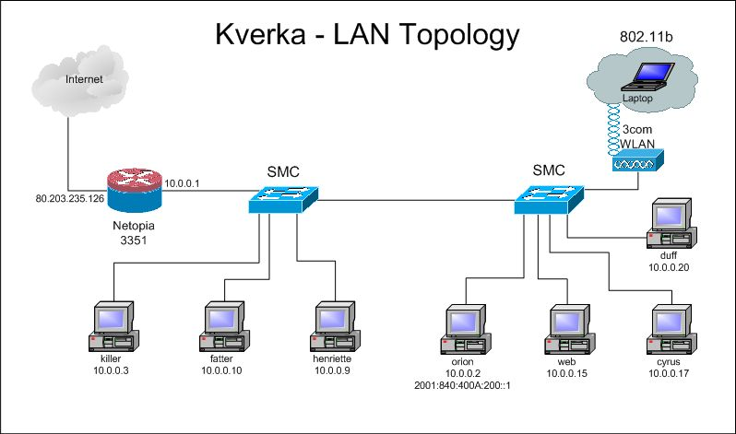
Network diagram

Tester is authorized to interview IT personnel and company employees

Makes tester’s job a little easier

Network Diagram

From ratemynetworkdiagram.com (Link Ch 1g)

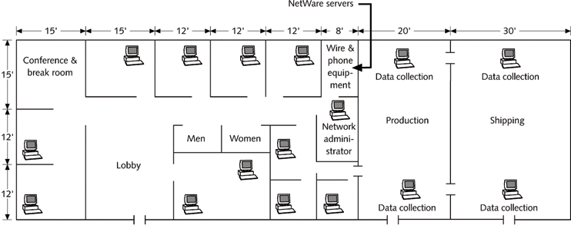

This is a Floor Plan

Penetration-Testing Methodologies

Black box model

Company staff does not know about the test

Tester is not given details about the network

Burden is on the tester to find these details

Tests if security personnel are able to detect an attack

Penetration-Testing Methodologies

Gray box model

Hybrid of the white and black box models

Company gives tester partial information

Certification Programs for Network Security Personnel

Basics:

CompTIA Security+ (CNIT 120)

Network+ (CNIT 106 or 201)

Certified Ethical Hacker (CEH)

CNIT 123: Ethical Hacking and Network Defense

CNIT 124: Advanced Ethical Hacking
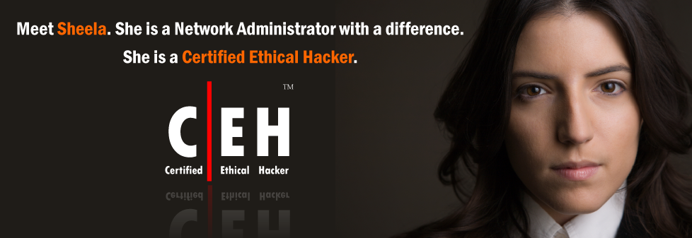

OSSTMM Professional Security Tester (OPST)

Designated by the Institute for Security and Open Methodologies (ISECOM)

Uses the Open Source Security Testing Methodology Manual (OSSTMM)

Test is only offered in Connecticut and outside the USA, as far as I can tell

See links Ch 1f and Ch 1h on my Web page

Certified Information Systems Security Professional (CISSP)

Issued by the International Information Systems Security Certifications Consortium (ISC2)

Usually more concerned with policies and procedures than technical details

CNIT 125: Information Security Professional Practices

Web site: www.isc2.org

SANS Institute

SysAdmin, Audit, Network, Security (SANS)

Offers certifications through Global Information Assurance Certification (GIAC)

Top 20 list

One of the most popular SANS Institute documents

Details the most common network exploits

Suggests ways of correcting vulnerabilities

Web site: www.sans.org (links Ch 1i & Ch 1j)

What You Can Do Legally

Laws involving technology change as rapidly as technology itself

Find what is legal for you locally

Laws change from place to place

Be aware of what is allowed and what is not allowed

Laws of the Land

Tools on your computer might be illegal to possess

Contact local law enforcement agencies before installing hacking tools

Written words are open to interpretation

Governments are getting more serious about punishment for cybercrimes

Recent Hacking Cases

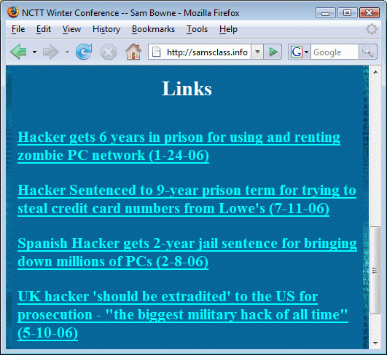
Is Port Scanning Legal?

Some states deem it legal

Not always the case

Federal Government does not see it as a violation

Allows each state to address it separately

Read your ISP’s “Acceptable Use Policy”

IRC “bots” may be forbidden

Program that sends automatic responses to users

Gives the appearance of a person being present

CCSF Computer Use Policy

Federal Laws

Federal computer crime laws are getting more specific

Cover cybercrimes and intellectual property issues

Computer Hacking and Intellectual Property (CHIP)

New government branch to address cybercrimes and intellectual property issues

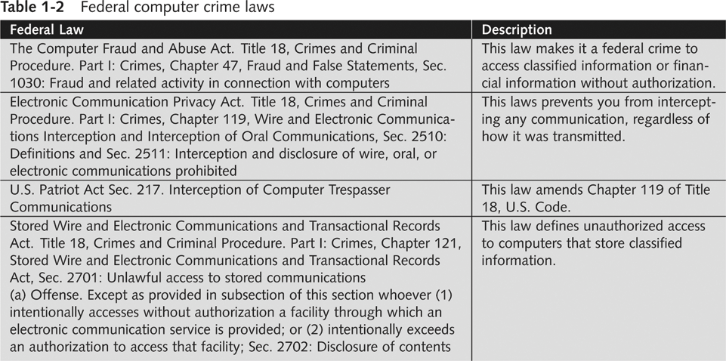

What You Cannot Do Legally

Accessing a computer without permission is illegal

Other illegal actions

Installing worms or viruses

Denial of Service attacks

Denying users access to network resources

Be careful your actions do not prevent customers from doing their jobs

Anti-Spam Vigilantes: Lycos

Ch 1l1: Lycos starts anti-spam screensaver plan: Dec 2, 2004

Ch 1l2: Lycos Pulls Anti-Spam 'Vigilante' Campaign -- Dec 3, 2004

Ch 1l3: Lycos's Spam Attack Network Dismantled -- Spammers sent the DOS packets back to Lycos -- Dec 6, 2004

Anti-Spam Vigilantes: Blue Frog

Ch 1m: Blue Frog begins its "vigilante approach" to fight spam -- July, 2005

Ch 1n: Russian spammer fights back, claims to have stolen Blue Frog's database, sends threating email -- DOS attack in progress -- May 2, 2006

Ch 1o: Blue Frog compromised and destroyed by attacks, urgent instructions to uninstall it, the owners have lost control -- May 17, 2006

Anti-Spam Vigilantes: The Future

Ch 1p: Call for help creating distributed, open-source Blue Frog replacement -- May 17, 2006

Not in textbook, see links on my page (samsclass.info)

Get It in Writing

Using a contract is just good business

Contracts may be useful in court

Books on working as an independent contractor

The Computer Consultant’s Guide by Janet Ruhl

Getting Started in Computer Consulting by Peter Meyer

Internet can also be a useful resource

Have an attorney read over your contract before sending or signing it

Ethical Hacking in a Nutshell

What it takes to be a security tester

Knowledge of network and computer technology

Ability to communicate with management and IT personnel

Understanding of the laws

Ability to use necessary tools

Last modified 8-18-10

