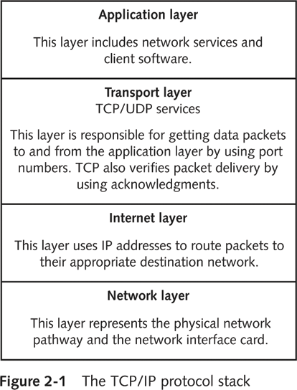
Objectives

Describe the TCP/IP protocol stack

Explain the basic concepts of IP addressing

Explain the binary, octal, and hexadecimal numbering system
Overview of TCP/IP

Protocol

Common language used by computers for speaking

Transmission Control Protocol/Internet Protocol (TCP/IP)

Most widely used protocol

TCP/IP stack

Contains four different layers

Network

Internet

Transport

Application

The Application Layer

Front end to the lower-layer protocols

What you can see and touch – closest to the user at the keyboard

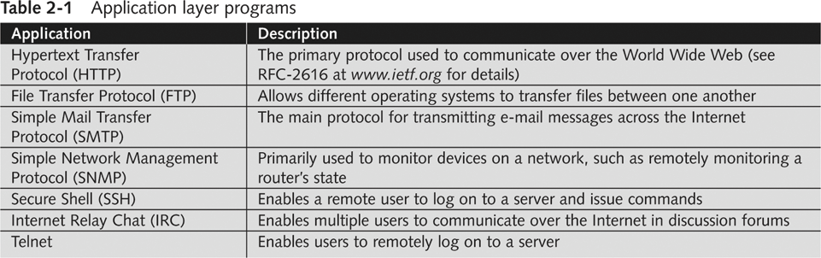
HTTP, FTP, SMTP, SNMP, SSH, IRC and TELNET all operate in the Application Layer

The Transport Layer

Encapsulates data into segments

Segments can use TCP or UDP to reach a destination host

TCP is a connection-oriented protocol

TCP three-way handshake

Computer A sends a SYN packet

Computer B replies with a SYN-ACK packet

Computer A replies with an ACK packet

TCP Header Format
0 1 2 3
0 1 2 3 4 5 6 7 8 9 0 1 2 3 4 5 6 7 8 9 0 1 2 3 4 5 6 7 8 9 0 1
+-+-+-+-+-+-+-+-+-+-+-+-+-+-+-+-+-+-+-+-+-+-+-+-+-+-+-+-+-+-+-+-+
| Source Port | Destination Port |
+-+-+-+-+-+-+-+-+-+-+-+-+-+-+-+-+-+-+-+-+-+-+-+-+-+-+-+-+-+-+-+-+
| Sequence Number |
+-+-+-+-+-+-+-+-+-+-+-+-+-+-+-+-+-+-+-+-+-+-+-+-+-+-+-+-+-+-+-+-+
| Acknowledgment Number |
+-+-+-+-+-+-+-+-+-+-+-+-+-+-+-+-+-+-+-+-+-+-+-+-+-+-+-+-+-+-+-+-+
| Data | |U|A|P|R|S|F| |
| Offset| Reserved |R|C|S|S|Y|I| Window |
| | |G|K|H|T|N|N| |
+-+-+-+-+-+-+-+-+-+-+-+-+-+-+-+-+-+-+-+-+-+-+-+-+-+-+-+-+-+-+-+-+
| Checksum | Urgent Pointer |
+-+-+-+-+-+-+-+-+-+-+-+-+-+-+-+-+-+-+-+-+-+-+-+-+-+-+-+-+-+-+-+-+
| Options | Padding |
+-+-+-+-+-+-+-+-+-+-+-+-+-+-+-+-+-+-+-+-+-+-+-+-+-+-+-+-+-+-+-+-+
| data |
+-+-+-+-+-+-+-+-+-+-+-+-+-+-+-+-+-+-+-+-+-+-+-+-+-+-+-+-+-+-+-+-+

TCP Segment Headers

Critical components:

TCP flags

Initial Sequence Number (ISN)

Source and destination port

Abused by hackers finding vulnerabilities

TCP Flags

Each flag occupies one bit

Can be set to 0 (off) or 1 (on)

Six flags

SYN: synchronize flag

ACK: acknowledge flag

PSH: push flag

URG: urgent flag

RST: reset flag

FIN: finish flag

Initial Sequence Number (ISN)

32-bit number

Tracks packets received

Enables reassembly of large packets

Sent on steps 1 and 2 of the TCP three-way handshake

By guessing ISN values, a hacker can hijack a TCP session, gaining access to a server without logging in

TCP Ports

Port

Logical, not physical, component of a TCP connection

Identifies the service that is running

Example: HTTP uses port 80

A 16-bit number – 65,536 ports

Each TCP packet has a source and destination port

Blocking Ports

Helps you stop or disable services that are not needed

Open ports are an invitation for an attack

You can’t block all the ports

That would stop all networking

At a minimum, ports 25 and 80 are usually open on a server, so it can send out Email and Web pages

Only the first 1023 ports are considered well-known

List of well-known ports

Available at the Internet Assigned Numbers Authority (IANA) Web site (www.iana.org)

Ports 20 and 21

File Transfer Protocol (FTP)

Use for sharing files over the Internet

Requires a logon name and password

More secure than Trivial File Transfer Protocol (TFTP)

Port 25

Simple Mail Transfer Protocol (SMTP)

E-mail servers listen on this port

Port 53

Domain Name Service (DNS)

Helps users connect to Web sites using URLs instead of IP addresses

Port 69

Trivial File Transfer Protocol

Used for transferring router configurations

Port 80

Hypertext Transfer Protocol (HTTP)

Used when connecting to a Web server

Port 110

Post Office Protocol 3 (POP3)

Used for retrieving e-mail

Port 119

Network News Transfer Protocol

For use with newsgroups

Port 135

Remote Procedure Call (RPC)

Critical for the operation of Microsoft Exchange Server and Active Directory

Port 139

NetBIOS

Used by Microsoft’s NetBIOS Session Service

File and printer sharing

Port 143

Internet Message Access Protocol 4 (IMAP4)

Used for retrieving e-mail, More features than POP3

Demonstration

Telnet to hills.ccsf.edu and netstat to see the connections

Port 23 (usual Telnet)

Port 25 blocked off campus, but 110 connects

Port 21 works, but needs a username and password

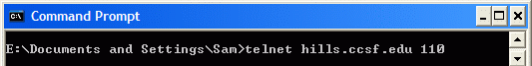

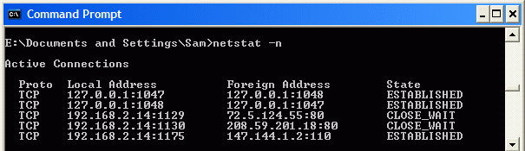

Demonstration

Wireshark Packet Sniffer

TCP Handshake: SYN, SYN/ACK, ACK

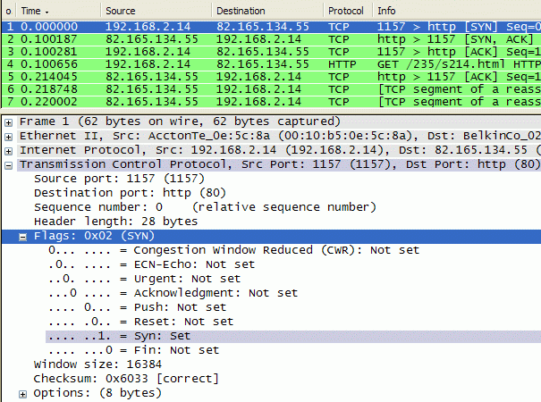
TCP Ports

TCP Status Flags

User Datagram Protocol (UDP)

Fast but unreliable protocol

Operates on transport layer

Does not need to verify whether the receiver is listening

Higher layers of the TCP/IP stack handle reliability problems

Connectionless protocol

The Internet Layer

Responsible for routing packets to their destination address

Uses a logical address, called an IP address

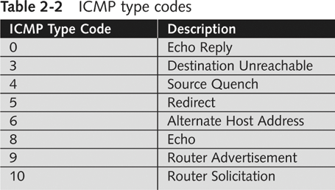
IP addressing packet delivery is connectionless

Internet Control Message Protocol (ICMP)

Operates in the Internet layer of the TCP/IP stack

Used to send messages related to network operations

Helps in troubleshooting a network

Some commands include

Ping

Traceroute

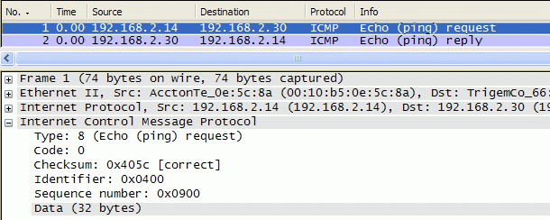

Wireshark Capture of a PING

Warriors of the Net

Network+ Movie

Warriorsofthe.net (link Ch 2d)

IP Addressing

Consists of four bytes, like 147.144.20.1

Two components

Network address

Host address

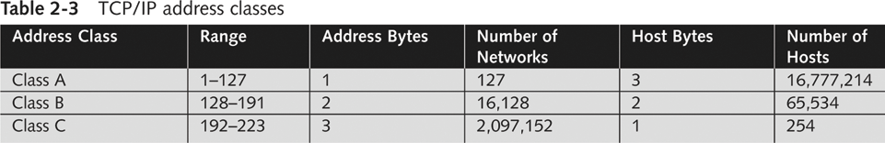
Neither portion may be all 1s or all 0s

Classes

Class A

Class B

Class C

Class A

First byte is reserved for network address

Last three bytes are for host address

Supports more than 16 million host computers

Limited number of Class A networks

Reserved for large corporations and governments (see link Ch 2b)

Format: network.node.node.node

Class B

First two bytes are reserved for network address

Last two bytes are for host address

Supports more than 65,000 host computers

Assigned to large corporations and Internet Service Providers (ISPs)

Format: network.network.node.node

CCSF has 147.144.0.0 – 147.144.255.255

Class C

First three bytes are reserved for network address

Last byte is for host address

Supports up to 254 host computers

Usually available for small business and home networks

Format: network.network.network.node

Subnetting

Each network can be assigned a subnet mask

Helps identify the network address bits from the host address bits

Class A uses a subnet mask of 255.0.0.0

Also called /8

Class B uses a subnet mask of 255.255.0.0

Also called /16

Class C uses a subnet mask of 255.255.255.0

Also called /24

Planning IP Address Assignments

Each network segment must have a unique network address

Address cannot contain all 0s or all 1s

To access computers on other networks

Each computer needs IP address of gateway

TCP/IP uses subnet mask to determine if the destination computer is on the same network or a different network

If destination is on a different network, it relays packet to gateway

Gateway forwards packet to its next destination (routing)

Packet eventually reaches destination

IPv6
Modern operating systems like Windows 7 use IPv6 in addition to IPv4
IPv6 addresses are much longer: 128 bits instead of the 32 bits used by IPv4
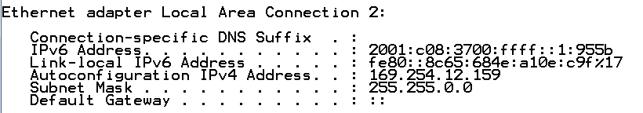

Last modified 8-25-10 12 pm

