Objectives

Describe port scanning

Describe different types of port scans

Describe various port-scanning tools

Explain what ping sweeps are used for

Explain how shell scripting is used to automate security tasks
Introduction to Port Scanning

Port Scanning

Finds out which services are offered by a host

Identifies vulnerabilities

Open services can be used on attacks

Identify a vulnerable port

Launch an exploit

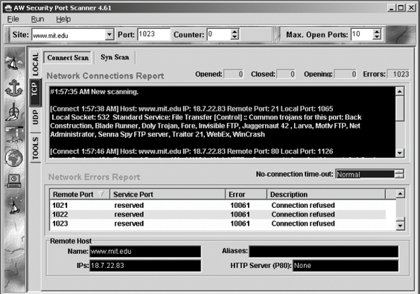
Scan all ports when testing

Not just well-known ports

AW Security Port Scanner

A commercial tool to identify vulnerabilities

Port scanning programs report

Open ports

Closed ports

Filtered ports

Best-guess assessment of which OS is running

Is Port Scanning Legal?

The legal status of port scanning is unclear

If you have permission, it's legal

If you cause damage of $5,000 or more, it may be illegal

For more, see links Ch 5a and Ch 5b
Types of Port Scans

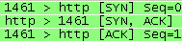
Normal TCP Handshake

Client SYN → Server

Client ← SYN/ACK Server

Client ACK → Server

After this, you are ready to send data

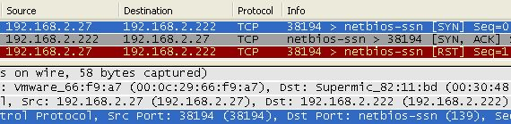
SYN Port Scan

Client SYN → Server

Client ← SYN/ACK Server

Client RST → Server

The server is ready, but the client decided not to complete the handshake

SYN scan

Stealthy scan, because session handshakes are never completed

That keeps it out of some log files

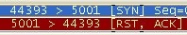
Three states

Closed

RST response from server

Open

SYN,ACK response from server

Client then sends RST
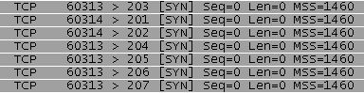

Filtered

No response from server

Connect scan

Completes the three-way handshake

Not stealthy--appears in log files

Three states

Closed

RST response from server

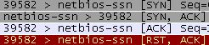
Open

SYN,ACK response from server

Client sends ACK

Client sends RST
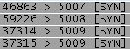

Filtered

No response from server

NULL scan

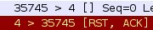
All the packet flags are turned off

Two results:

Closed ports reply with RST

Open or filtered ports give no response

XMAS scan

FIN, PSH and URG flags are set

Works like a NULL scan – a closed port responds with an RST packet

FIN scan

Only FIN flag is set

Closed port responds with an RST packet

Windows Machines

NULL, XMAS and FIN scans don't work on Windows machines

Win 2000 Pro and Win Server 2003 shows all ports closed

Win XP Pro all ports open/filtered

See the NMAP tutorial (link Ch 5c)

Ping scan

Simplest method sends ICMP ECHO REQUEST to the destination(s)

TCP Ping sends SYN or ACK to any port (default is port 80 for Nmap)

Any response shows the target is up

ACK scan

Used to get information about a firewall

Stateful firewalls track connection and block unsolicited ACK packets

Stateless firewalls just block incoming SYN packets, so you get a RST response

UDP scan

Closed port responds with ICMP “Port Unreachable” message

Rarely used
Using Port-Scanning Tools

Nmap

Unicornscan

NetScanTools Pro 2004

Nessus

Nmap

Originally written for Phrack magazine

One of the most popular tools

GUI versions

Xnmap and Ubuntu's NmapFE

Open source tool

Standard tool for security professionals

The Matrix Reloaded

Trinity uses Nmap (Video at link Ch 4e)

Unicornscan

Developed in 2004 for Linux & UNIX only

Ideal for large networks

Scans 65,535 ports in three to seven seconds

Optimizes UDP scanning

Alco can use TCP, ICMP, or IP

Free from http://unicornscan.org/ (link Ch 5f)

NetScanTools Pro

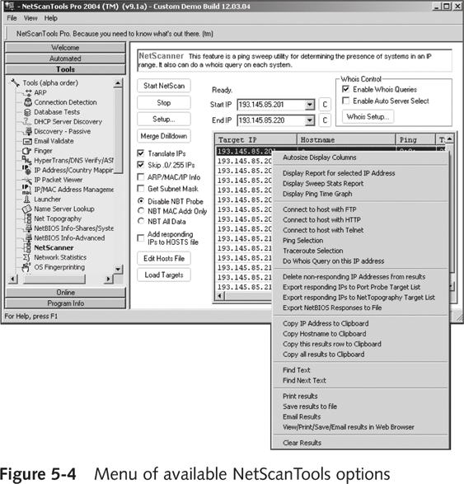
Robust easy-to-use commercial tool

Runs on Windows

Types of tests

Database vulnerabilities

DHCP server discovery

IP packets viewer

Name server lookup

OS fingerprinting

Many more (see link Ch 5g)

Nessus

First released in 1998

Free, open source tool

Uses a client/server technology

Can conduct tests from different locations

Can use different OSs for client and network

Server

Any *NIX platform

Client

Can be *NIX or Windows

Functions much like a database server

Ability to update security checks plug-ins

Some plug-ins are considered dangerous
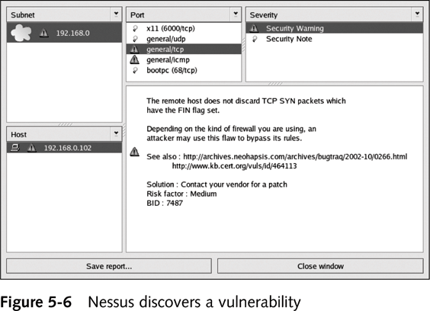

Finds services running on ports

Finds vulnerabilities associated with identified services
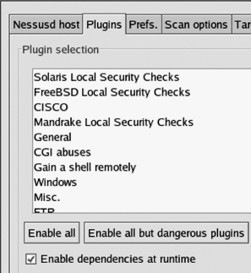
Nessus Plug-ins

Conducting Ping Sweeps

Ping sweeps

Identify which IP addresses belong to active hosts

Ping a range of IP addresses

Problems

Computers that are shut down cannot respond

Networks may be configured to block ICMP Echo Requests

Firewalls may filter out ICMP traffic

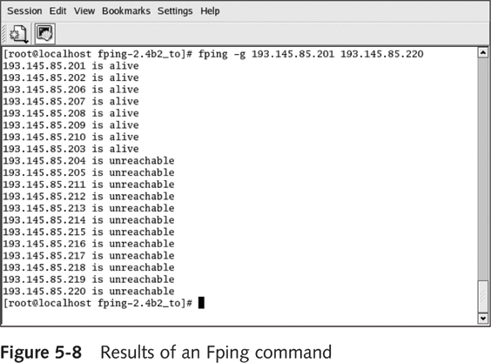
FPing

Ping multiple IP addresses simultaneously

www.fping.com/download

Command-line tool

Input: multiple IP addresses

To enter a range of addresses

-g option

Input file with addresses

-f option

See links Ch 5k, 5l

Hping

Used to bypass filtering devices

Allows users to fragment and manipulate IP packets

www.hping.org/download

Powerful tool

All security testers must be familiar with tool

Supports many parameters (command options)

See links Ch 5m, Ch 5n

Broadcast Addresses

If you PING a broadcast address, that can create a lot of traffic

Normally the broadcast address ends in 255

But if your LAN is subnetted with a subnet mask like 255.255.255.192

There are other broadcast addresses ending in 63, 127, and 191

Smurf Attack

Pinging a broadcast address on an old network resulted in a lot of ping responses

So just put the victim's IP address in the "From" field

The victim is attacked by a flood of pings, none of them directly from you

Modern routers don't forward broadcast packets, which prevents them from amplifying smurf attacks

Windows XP and Ubuntu don't respond to broadcast PINGs

See links Ch 5o, 5p

Crafting IP Packets

Packet components

Source IP address

Destination IP address

Flags

Crafting packets helps you obtain more information about a service

Tools

Fping

Hping
Understanding Shell Scripting

Modify tools to better suit your needs

Script

Computer program that automates tasks

Time-saving solution

Scripting Basics

Similar to DOS batch programming

Script or batch file

Text file

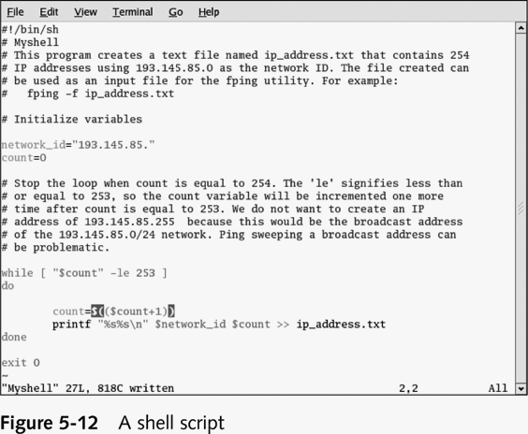
Contains multiple commands

Repetitive commands are good candidate for scripting

Practice is the key

Last modified 2-23-07 8 pm

