Objectives

Describe the enumeration step of security testing

Enumerate Microsoft OS targets

Enumerate NetWare OS targets

Enumerate *NIX OS targets
Introduction to Enumeration

Enumeration extracts information about:

Resources or shares on the network

User names or groups assigned on the network

Last time user logged on

User’s password

Before enumeration, you use Port scanning and footprinting

To Determine OS being used

Intrusive process

NBTscan

NBT (NetBIOS over TCP/IP)

is the Windows networking protocol

used for shared folders and printers

NBTscan

Tool for enumerating Microsoft OSs
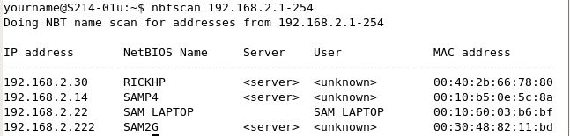

Enumerating Microsoft Operating Systems

Study OS history

Knowing your target makes your job easier

Many attacks that work for older Windows OSs still work with newer versions

Windows 95

The first Windows version that did not start with DOS

Still used the DOS kernel to some extent

Introduced the Registry database to replace Win.ini, Autoexec.bat, and other text files

Introduced Plug and Play and ActiveX

Used FAT16 file system

Windows 98 and ME

More Stable than Win 95

Used FAT32 file system

Win ME introduced System Restore

Win 95, 98, and ME are collectively called "Win 9x"

Windows NT 3.51 Server/Workstation

No dependence on DOS kernel

Domains and Domain Controllers

NTFS File System to replace FAT16 and FAT32

Much more secure and stable than Win9x

Many companies still use Win NT Server Domain Controllers

Win NT 4.0 was an upgrade

Windows 2000 Server/Professional

Upgrade of Win NT

Active Directory

Powerful database storing information about all objects in a network

Users, printers, servers, etc.

Based on Novell's Novell Directory Services

Enumerating this system would include enumerating Active Directory

Windows XP Professional

Much more secure, especially after Service Pack 2

Windows File Protection

Data Execution Prevention

Windows Firewall

Windows Server 2003

Much more secure, especially after Service Pack 1

Network services are closed by default

Internet Explorer security set higher

Windows Vista

User Account Control

Users log in with low privileges for most tasks

BitLocker Drive Encryption

Address Space Layout Randomization (ASLR)

Windows Server 2008

User Account Control

BitLocker Drive Encryption

ASLR

Network Access Protection

Granular levels of network access based on a clients level of compliance with policy

Server Core

Small, stripped-down server, like Linux

Hyper-V

Virtual Machines

Windows 7

XP Mode

A virtual machine running Win XP

User Account Control was refined and made easier to use

NetBIOS Basics

Network Basic Input Output System (NetBIOS)

Programming interface

Allows computer communication over a LAN

Used to share files and printers

NetBIOS names

Computer names on Windows systems

Limit of 16 characters

Last character identifies type of service running

Must be unique on a network

NetBIOS Suffixes

For complete list, see link Ch 6h

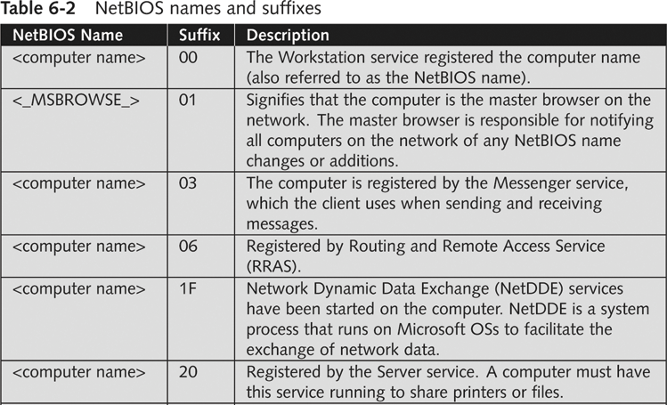

NetBIOS Null Sessions

Null session

Unauthenticated connection to a Windows computer

Does not use logon and passwords values

Around for over a decade

Still present on Windows XP

Disabled on Server 2003

Absent entirely in Vista and later versions

A large vulnerability

See links Ch 6a-f

Null Session Information

Using these NULL connections allows you to gather the following information from the host:

List of users and groups

List of machines

List of shares

Users and host SIDs (Security Identifiers)

From brown.edu (link Ch 6b)

Demonstration of Null Sessions

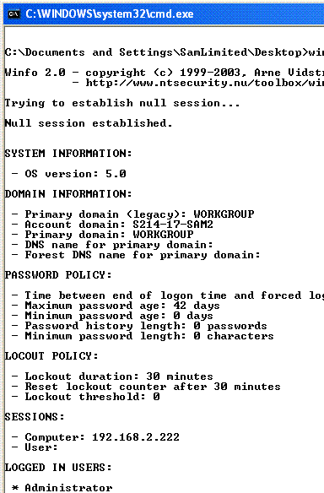
Start Win 2000 Pro

Share a folder

From a Win XP command prompt

NET VIEW \\ip-address Fails

NET USE \\ip-address\IPC$ "" /u:""

Creates the null session

Username="" Password=""

NET VIEW \\ip-address Works now

Demonstration of Enumeration

Download Winfo from link Ch 6g

Run it – see all the information!

NULL Session Information

NULL sessions exist in windows networking to allow:

Trusted domains to enumerate resources

Computers outside the domain to authenticate and enumerate users

The SYSTEM account to authenticate and enumerate resources

NetBIOS NULL sessions are enabled by default in Windows NT and 2000

From brown.edu (link Ch 6b)

NULL Sessions in Win XP and 2003 Server

Windows XP and 2003 don't allow Null Sessions, according to link Ch 6c.

I tried the NET USE command on Win XP SP2 and it did not work

Link Ch 6f says you can still do it in Win XP SP2, but you need to use a different procedure
NetBIOS Enumeration Tools

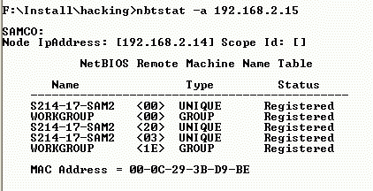
Nbtstat command

Powerful enumeration tool included with the Microsoft OS

Displays NetBIOS table

Net view command

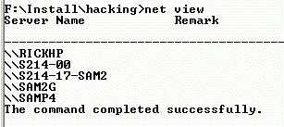
Shows whether there are any shared resources on a network host

Net use command

Used to connect to a computer with shared folders or files

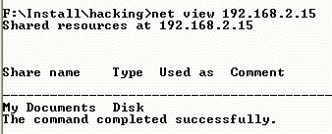

Additional Enumeration Tools

Windows tools included with BackTrack

Smb4K tool

DumpSec

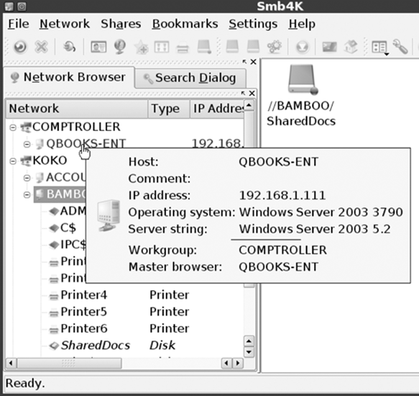
Hyena

Nessus and OpenVAS

Using Windows Enumeration Tools

Backtrack Smb4K tool

Used to enumerate Windows computers in a network

DumpSec

Enumeration tool for Windows systems

Produced by Foundstone, Inc.

Allows user to connect to a server and “dump”:

Permissions for shares

Permissions for printers

Permissions for the Registry

Users in column or table format

Policies

Rights

Services

Hyena

Excellent GUI product for managing and securing Windows OSs

Shows shares and user logon names for Windows servers and domain controllers

Displays graphical representation of:

Microsoft Terminal Services

Microsoft Windows Network

Web Client Network

Find User/Group

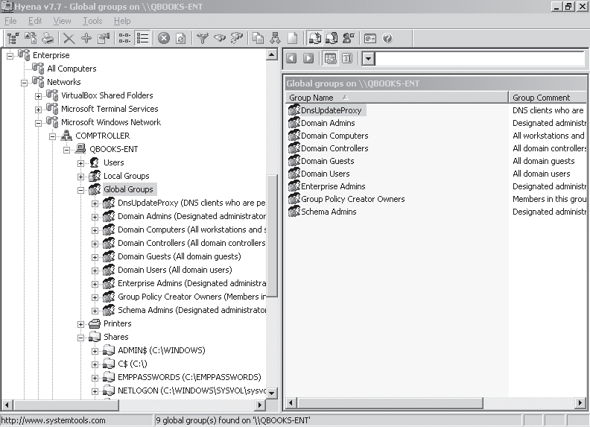

Nessus and OpenVAS

OpenVAS

Operates in client/server mode

Open-source descendent of Nessus

Popular tool for identifying vulnerabilities

Nessus Server and Client

Latest version can run on Windows, Mac OS X, FreeBSD, and most Linux distributions

Handy when enumerating different OSs on a large network

Many servers in different locations

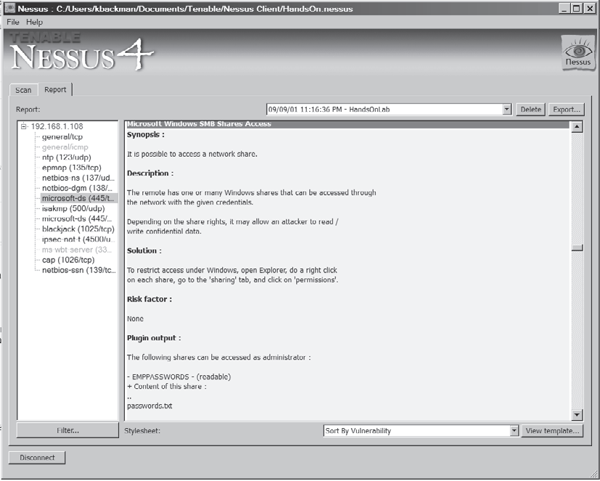

Enumerating the NetWare Operating System

Novell NetWare

Some security professionals see as a “dead” OS

Ignoring an OS can limit your career as a security professional

NetWare

Novell does not offer any technical support for versions before 6.5

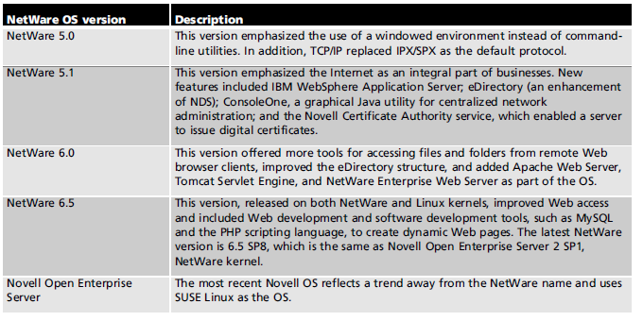

NetWare Enumeration Tools

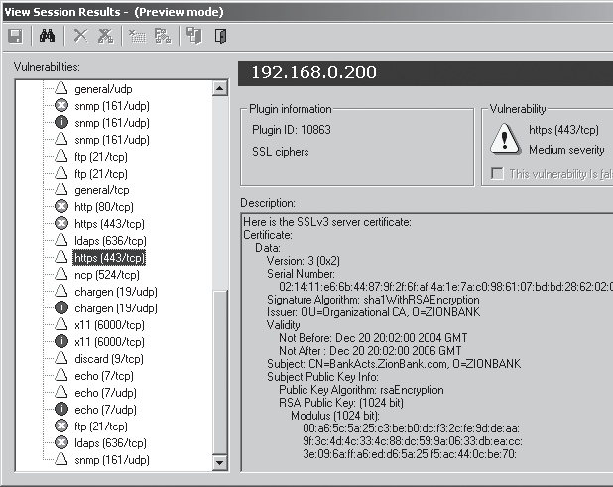
NetWare 5.1

Still used on many networks

New vulnerabilities are discovered daily

Vigilantly check vendor and security sites

Example

Older version of Nessus to scan a NetWare 5.1 server

Novell Client for Windows

Gathers information on shares and resources

Vulnerability in NetWare OS

You can click Trees, Contexts, and Servers buttons without a login name or password

Open dialog boxes showing network information

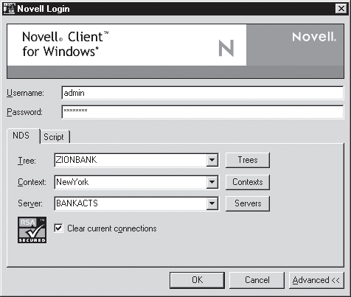

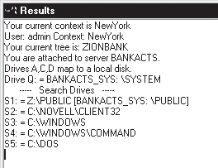

Enumerating the *nix Operating System

Several variations

Solaris and OpenSolaris

HP-UX

Mac OS X and OpenDarwin

AIX

BSD UNIX

FreeBSD

OpenBSD

NetBSD

Linux, including several distributions

UNIX Enumeration

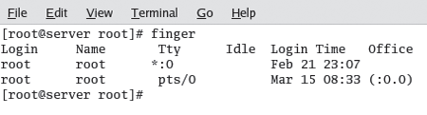
Finger utility

Most popular enumeration tool for security testers

Finds out who is logged in to a *nix system

Determines who was running a process

Nessus

Another important *nix enumeration tool

Last modified 9-22-10

