Objectives

Explain basic programming concepts

Write a simple C program

Explain how Web pages are created with HTML

Describe and create basic Perl programs

Explain basic object-oriented programming concepts
Introduction to Computer Programming

Computer programmers must understand the rules of programming languages

Programmers deal with syntax errors

One minor mistake and the program will not run

Or worse, it will produce unpredictable results

Being a good programmer takes time and patience

Computer Programming Fundamentals

Fundamental concepts

Branching, Looping, and Testing (BLT)

Documentation

Function

Mini program within a main program that carries out a task

Branching, Looping, and Testing (BLT)

Branching

Takes you from one area of the program to another area

Looping

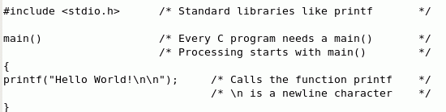
Act of performing a task over and over

Testing

Verifies some condition and returns true or false

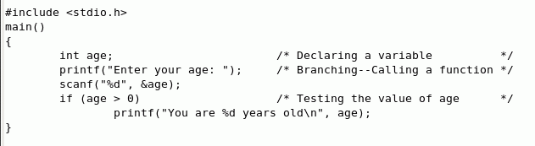
A C Program

Filename ends in .c

It's hard to read at first

A single missing semicolon can ruin a program

Comments

Comments make code easier to read

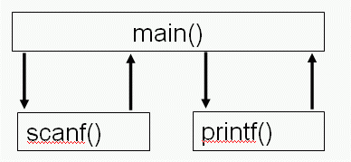
Branching and Testing

Diagram of branches

See links Ch 7b, 7c

Looping

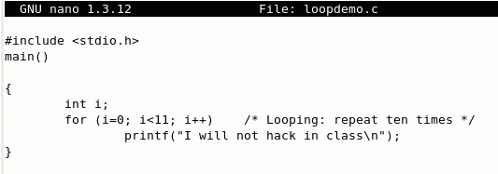
Algorithm

Defines steps for performing a task

Keep it as simple as possible

Bug

An error that causes unpredictable results

Pseudocode

English-like language used to create the structure of a program

Pseudocode For Shopping

PurchaseIngredients Function

Call GetCar Function

Call DriveToStore Function

Purchase Bacon, Bread, Tomatoes, Lettuce, and Mayonnaise

End PurchaseIngredients Function

Documentation

Documenting your work is essential

Add comments to your programs

Comments should explain what you are doing

Many programmers find it time consuming and tedious

Helps others understand your work

Bugs

Industry standard

20 to 30 bugs for every 1000 lines of code
(link Ch 7f)

Textbook claims a much smaller number without a source

Windows 2000 contains almost 50 million lines

And fewer than 60,000 bugs (about 1 per 1000 lines)

See link Ch 7e for comments in the leaked Win 2000 source code

Linux has 0.17 bugs per 1000 lines of code

(Link Ch 7f)
Learning the C Language

Developed by Dennis Ritchie at Bell Laboratories in 1972

Powerful and concise language

UNIX was first written in assembly language and later rewritten in C

C++ is an enhancement of the C language

C is powerful but dangerous

Bugs can crash computers, and it's easy to leave security holes in the code

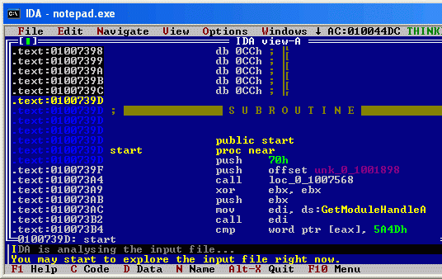
Assembly Language

The binary language hard-wired into the processor is machine language

Assembly Language uses a combination of hexadecimal numbers and expressions

Very powerful but hard to use (Link Ch 7g)

Compiling C in Ubuntu Linux

Compiler

Converts a text-based program (source code) into executable or binary code

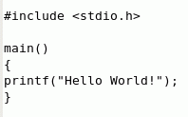
To prepare Ubuntu Linux for C programming, use this command:

sudo apt-get install build-essential

Then you compile a file named "program.c" with this command:

gcc program.c –o program.exe

Anatomy of a C Program

The first computer program a C student learns "Hello, World!"

Comments

Use /* and */ to comment large portions of text

Use // for one-line comments

Include

#include statement

Loads libraries that hold the commands and functions used in your program

Functions

A Function Name is always followed by parentheses ( )

Curly Braces { } shows where a function begins and ends

main() function

Every C program requires a main() function

main() is where processing starts

Functions can call other functions

Parameters or arguments are optional

\n represents a line feed

Declaring Variables

A variable represents a numeric or string value

You must declare a variable before using it
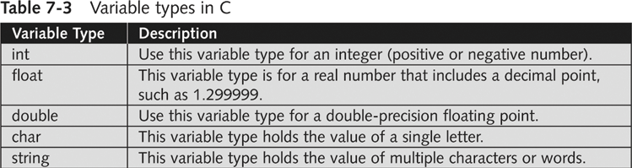

Mathematical Operators

The i++ in the example below adds one to the variable i

Logical Operators

The i<11 in the example below compares the variable i to 11

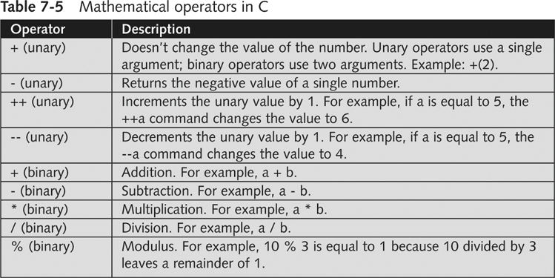

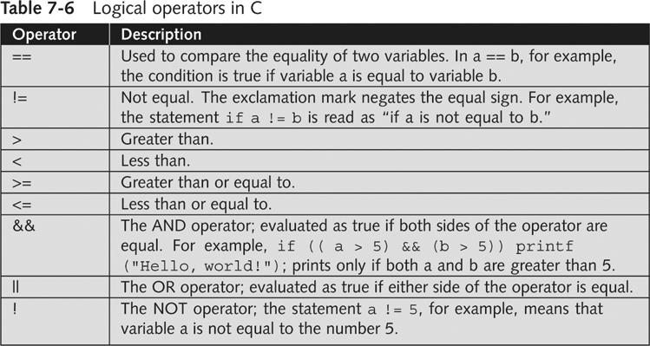

Understanding HTML Basics

HTML is a language used to create Web pages

HTML files are text files

Security professionals often need to examine Web pages

Be able to recognize when something looks suspicious

Creating a Web Page Using HTML

Create HTML Web page in Notepad, View HTML Web page in a Web browser

HTML does not use branching, looping, or testing

HTML is a static formatting language, rather than a programming language

< and > symbols denote HTML tags

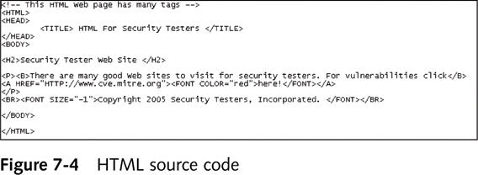
Each tag has a matching closing tag, like <HTML> and </HTML>

Understanding Practical Extraction and Report Language (Perl)

PERL

Powerful scripting language

Used to write scripts and programs for security professionals

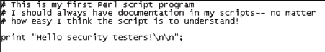
Background on Perl

Developed by Larry Wall in 1987

Can run on almost any platform

*NIX-base OSs already have Perl installed

Perl syntax is similar to C

Hackers use Perl to write malware

Security professionals use Perl to perform repetitive tasks and conduct security monitoring

Understanding the Basics of Perl

perl –h command

Gives you a list of parameters used with perl
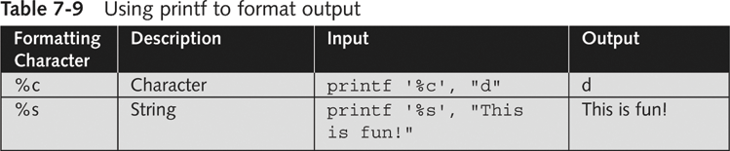
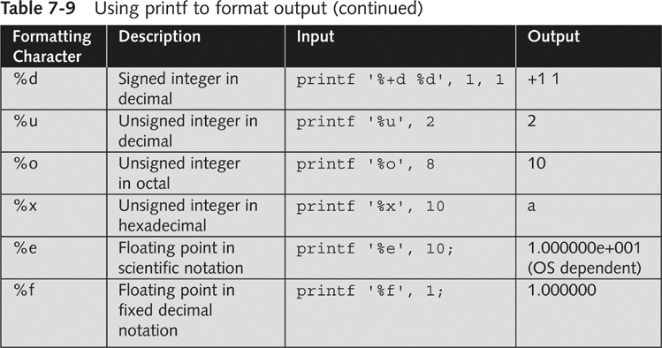

Understanding the BLT of Perl

Some syntax rules

Keyword “sub” is used in front of function names

Variables begin with the $ character

Comment lines begin with the # character

The & character is used when calling a function

Branching in Perl

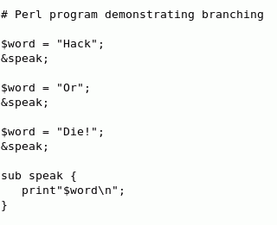
&speak;

Calls the subroutine

sub speak

Defines the subroutine

For Loop in Perl

For loop

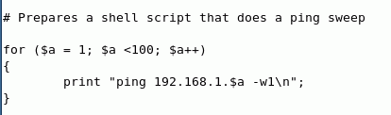

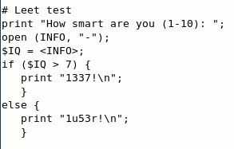

Testing Conditions in Perl

Understanding Object-Oriented Programming Concepts

New programming paradigm

There are several languages that support object-oriented programming

C++

C#

Java

Perl 6.0

Object Cobol

Components of Object-Oriented Programming

Classes

Structures that hold pieces of data and functions

The :: symbol

Used to separate the name of a class from a member function

Example:

Employee::GetEmp()

Example of a Class in C++

class Employee

{

public:

char firstname[25];

char lastname[25];

char PlaceOfBirth[30];

[code continues]

};

void GetEmp()

{

// Perform tasks to get employee info

[program code goes here]

}

Error in textbook

C example on page 138 should be this instead
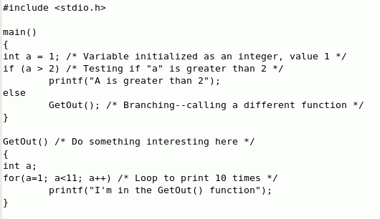

Last modified 3-9-07

