Objectives

After reading this chapter and completing the exercises, you will be able to:

Describe vulnerabilities of Windows and Linux operating systems

Identify specific vulnerabilities and explain ways to fix them

Explain techniques to harden systems against Windows and Linux vulnerabilities
Windows OS Vulnerabilities

Windows OS Vulnerabilities

Many Windows OSs have serious vulnerabilities

Windows 2000 and earlier

Administrators must disable, reconfigure, or uninstall services and features

Windows XP, Vista, Server 2003, Server 2008, and Windows 7

Most services and features are disabled by default

Good information source:

CVE Web site

Link Ch 8c, click on "CVE Search on NVD"

Windows File Systems

File system

Stores and manages information

User created

OS files needed to boot

Most vital part of any OS

Can be a vulnerability

File Allocation Table

Original Microsoft file system

Supported by nearly all desktop and server Oss

Standard file system for most removable media

Other than CDs and DVDs

Later versions provide for larger file and disk sizes

Most serious shortcoming

Doesn’t support file-level access control lists (ACLs)

Necessary for setting permissions on files

Multiuser environment use results in vulnerability

NTFS

New Technology File System (NTFS)

First released as high-end file system

Added support for larger files, disk volumes, and ACL file security

Subsequent Windows versions

Included upgrades for compression, journaling, file-level encryption, and self-healing

Alternate data streams (ADSs)

Can “stream” (hide) information behind existing files

Without affecting function, size, or other information

Several detection methods

ADS Demo

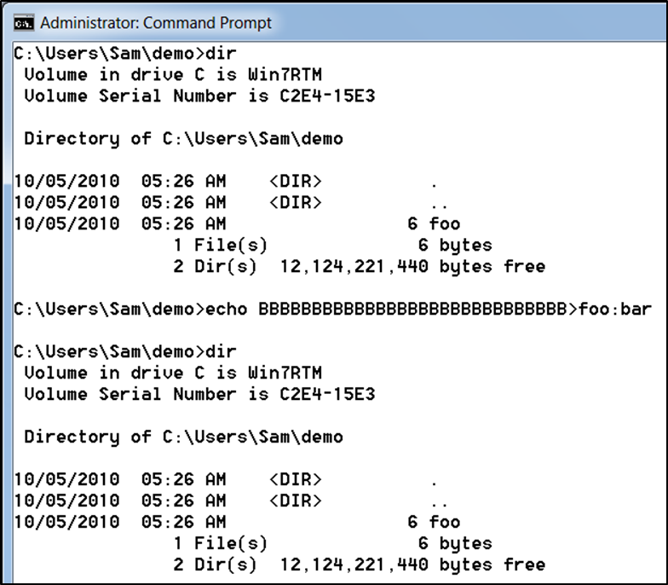
Remote Procedure Call

Interprocess communication mechanism

Allows a program running on one host to run code on a remote host

Worm that exploited RPC

Conficker worm

Microsoft Baseline Security Analyzer

Determines if system is vulnerable due to an RPC-related issue

NetBIOS

Software loaded into memory

Enables computer program to interact with network resource or device

NetBIOS isn’t a protocol

Interface to a network protocol

NetBios Extended User Interface (NetBEUI)

Fast, efficient network protocol

Allows NetBIOS packets to be transmitted over TCP/IP

NBT is NetBIOS over TCP

Systems running newer Windows OSs

Vista, Server 2008, Windows 7, and later versions

Share files and resources without using NetBIOS

NetBIOS is still used for backward compatibility

Companies use old machines

Server Message Block

Used to share files

Usually runs on top of:

NetBIOS

NetBEUI, or

TCP/IP

Several hacking tools target SMB

L0phtcrack’s SMB Packet Capture utility and SMBRelay

It took Microsoft seven years to patch these

SMB2

Introduced in Windows Vista

Several new features

Faster and more efficient

Windows 7

Microsoft avoided reusing code

Still allowed backward capability

Windows XP Mode

Spectacular DoS vulnerabilities

Links Ch 8za-8zc

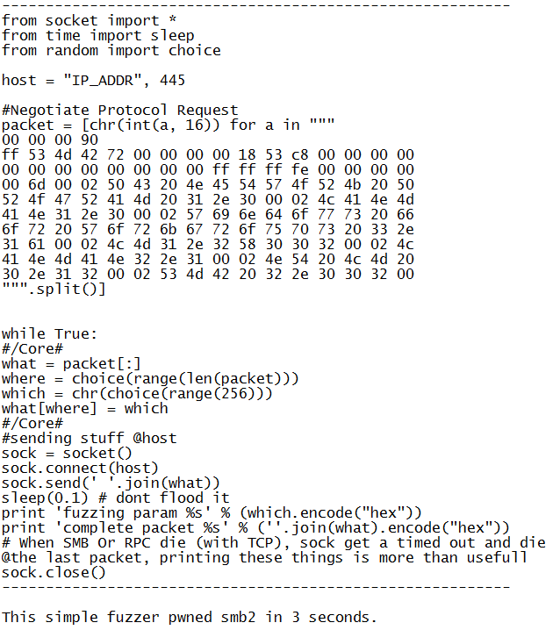
Laurent Gaffié's Fuzzer

Look how easy it is!

From Link Ch 8zb

Common Internet File System

Standard protocol

Replaced SMB for Windows 2000 Server and later

SMB is still used for backward compatibility

Remote file system protocol

Enables sharing of network resources over the Internet

Relies on other protocols to handle service announcements

Notifies users of available resources

Enhancements

Locking features

Caching and read-ahead/write-behind

Support for fault tolerance

Capability to run more efficiently over dial-up

Support for anonymous and authenticated access

Server security methods

Share-level security (folder password)

User-level security (username and password)

Attackers look for servers designated as domain controllers

Severs handle authentication

Windows Server 2003 and 2008

Domain controller uses a global catalog (GC) server

Locates resources among many objects

Domain Controller Ports

By default, Windows Server 2003 and 2008 domain controllers using CIFS listen on the following ports

DNS (port 53)

HTTP (port 80)

Kerberos (port 88)

RPC (port 135)

NetBIOS Name Service (port 137)

NetBIOS Datagram Service (port 139)

LDAP (port 389)

HTTPS (port 443)

SMB/ CIFS (port 445)

LDAP over SSL (port 636)

Active Directory global catalog (port 3268)

Null Sessions

Anonymous connection established without credentials

Used to display information about users, groups, shares, and password policies

Necessary only if networks need to support older Windows versions

To enumerate NetBIOS vulnerabilities use:

Nbtstat, Net view, Netstat, Ping, Pathping, and Telnet commands

Web Services

IIS installs with critical security vulnerabilities

IIS Lockdown Wizard

Locks down IIS versions 4.0 and 5.0

IIS 6.0 and later versions

Installs with a “secure by default” mode

Previous versions left crucial security holes

Keeping a system patched is important

Configure only needed services

SQL Server

Many potential vulnerabilities

Null System Administrator (SA) password

SA access through SA account

SA with blank password by default on versions prior to SQL Server 2005

Gives attackers administrative access

Database and database server

Buffer Overflows

Data is written to a buffer and corrupts data in memory next to allocated buffer

Normally, occurs when copying strings of characters from one buffer to another

Functions don’t verify text fits

Attackers run shell code

C and C++

Lack built-in protection against overwriting data in memory

Passwords and Authentication

Weakest security link in any network

Authorized users

Most difficult to secure

Relies on people

Companies should take steps to address it

Comprehensive password policy is critical

Should include:

Change passwords regularly

Require at least six characters

Require complex passwords

Passwords can’t be common words, dictionary words, slang, jargon, or dialect

Passwords must not be identified with a user

Never write it down or store it online or in a file

Do not reveal it to anyone

Use caution when logging on and limit reuse

Configure domain controllers

Enforce password age, length, and complexity

Password policy aspects that can be enforced:

Account lockout threshold

Set number of failed attempts before account is disabled temporarily

Account lockout duration

Set period of time account is locked out after failed logon attempts

Disable LM Hashes
Tools for Identifying Vulnerabilities in Windows

Tools for Identifying Vulnerabilities in Windows

Many tools are available

Using more than one is advisable

Using several tools

Helps pinpoint problems more accurately

Built-in Windows Tools

Microsoft Baseline Security Analyzer (MBSA)

Capable of checking for:

Patches

Security updates

Configuration errors

Blank or weak passwords

Using MBSA

System must meet minimum requirements

Before installing

After installing, MBSA can:

Scan itself

Scan other computers remotely

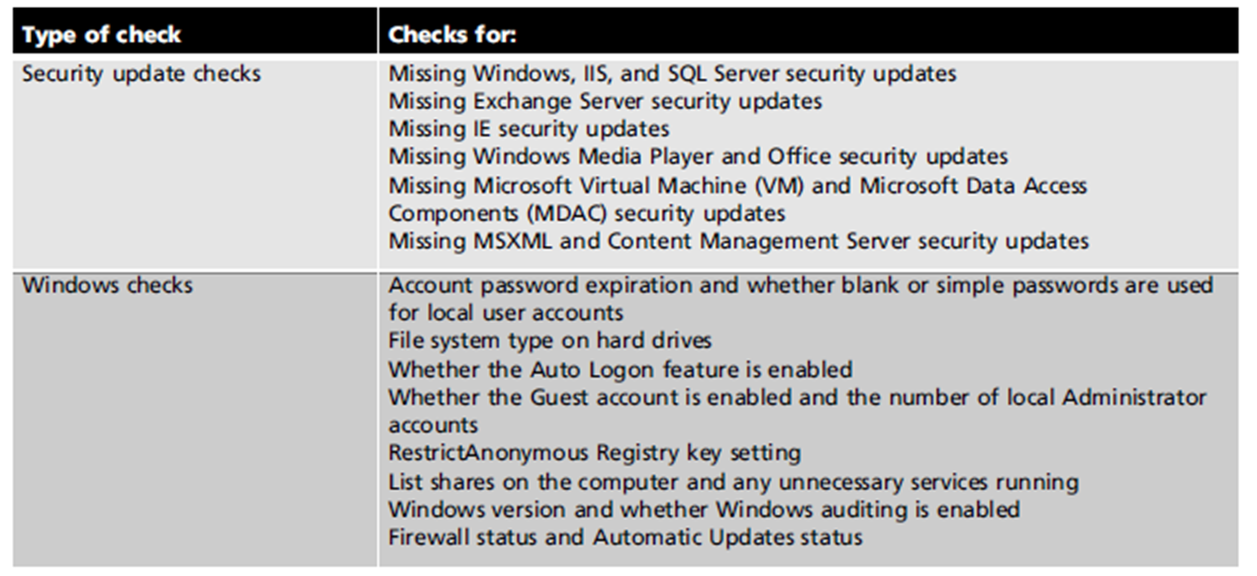
Be scanned remotely

Table 8-2 Checks performed by MBSA in full-scan mode

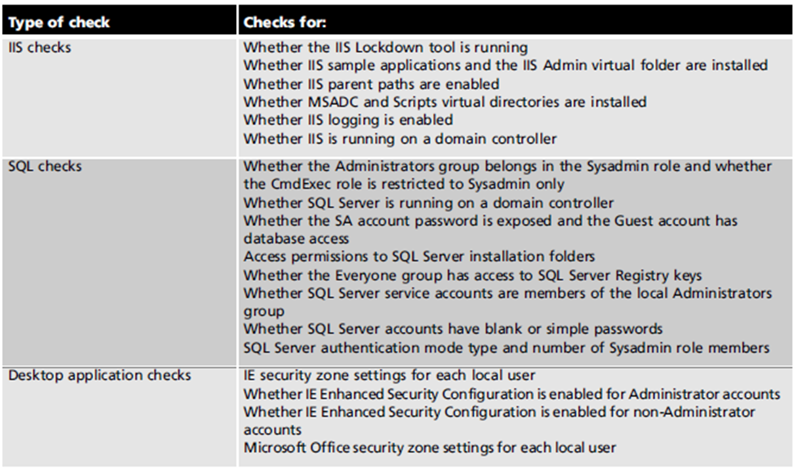
Best Practices for Hardening Windows Systems

Best Practices for Hardening Windows Systems

Penetration tester

Finds and reports vulnerabilities

Security tester

Finds vulnerabilities

Gives recommendations for correcting them

Patching Systems

Best way to keep systems secure

Keep up to date

Attackers take advantage of known vulnerabilities

Options for small networks

Accessing Windows Update manually

Configure Automatic Updates

Options for large networks

Systems Management Server (SMS)

Windows Software Update Service (WSUS)

Third-party patch management solutions

Antivirus Solutions

Antivirus solution is essential

Small networks

Desktop antivirus tool with automatic updates

Large networks

Require corporate-level solution

Antivirus tools

Almost useless if not updated regularly

Enable Logging and Review Logs Regularly

Important step for monitoring critical areas

Performance

Traffic patterns

Possible security breaches

Can have negative impact on performance

Review regularly

Signs of intrusion or problems

Use log-monitoring tool

Disable Unused Services and Filtering Ports

Disable unneeded services

Delete unnecessary applications or scripts

Unused applications are invitations for attacks

Reducing the attack surface

Open only what needs to be open, and close everything else

Filter out unnecessary ports

Make sure perimeter routers filter out ports 137 to 139 and 445

Other Security Best Practices

Other practices include:

Delete unused scripts and sample applications

Delete default hidden shares

Use different naming scheme and passwords for public interfaces

Be careful of default permissions

Use appropriate packet-filtering techniques

Use available tools to assess system security

Disable Guest account

Rename (or disable) default Administrator account

Make sure there are no accounts with blank passwords

Use Windows group policies

Develop a comprehensive security awareness program

Keep up with emerging threats

The New Challenge (not in textbook)

Patching not only the OS, but the applications too!

Following figures from Microsoft Security Intelligence Report Volume 8

Link Ch 8zd

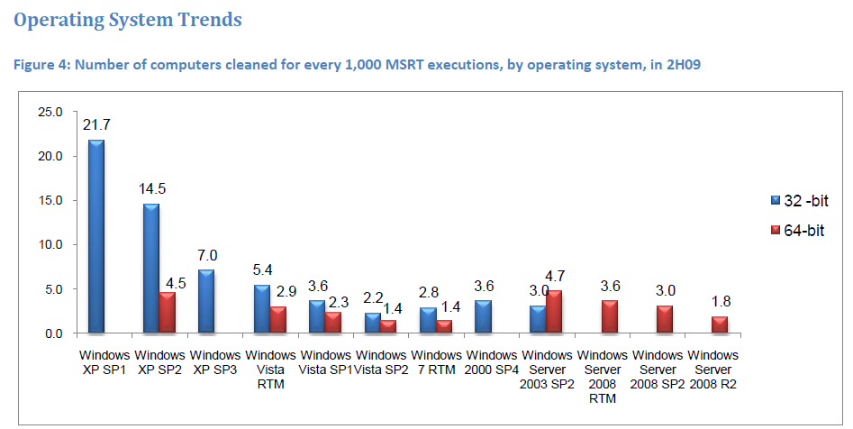

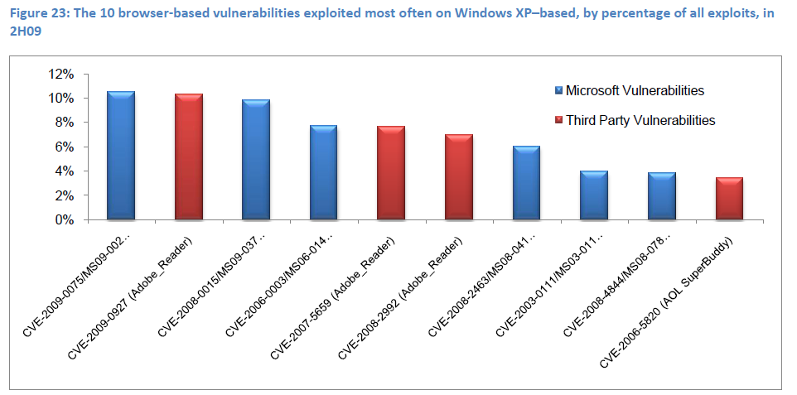

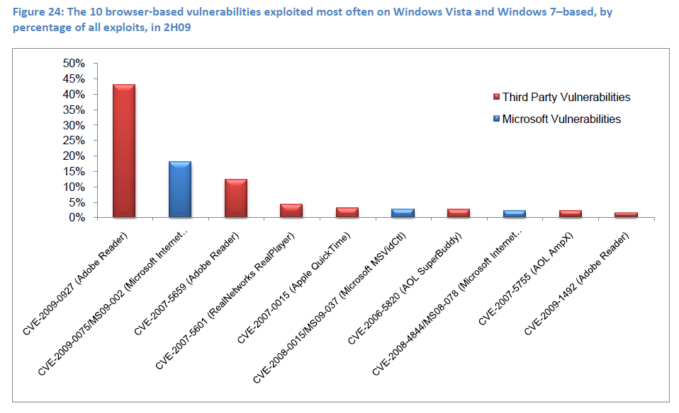

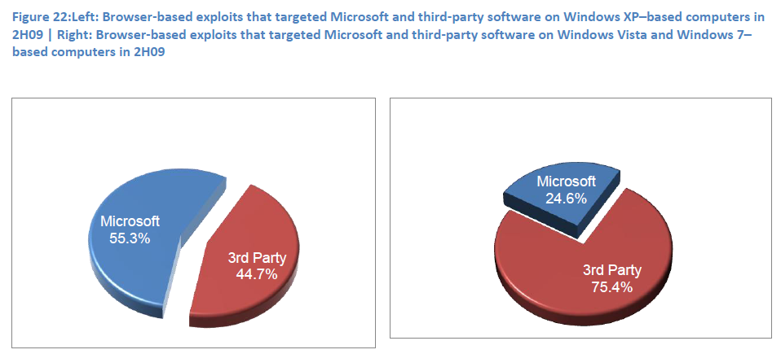

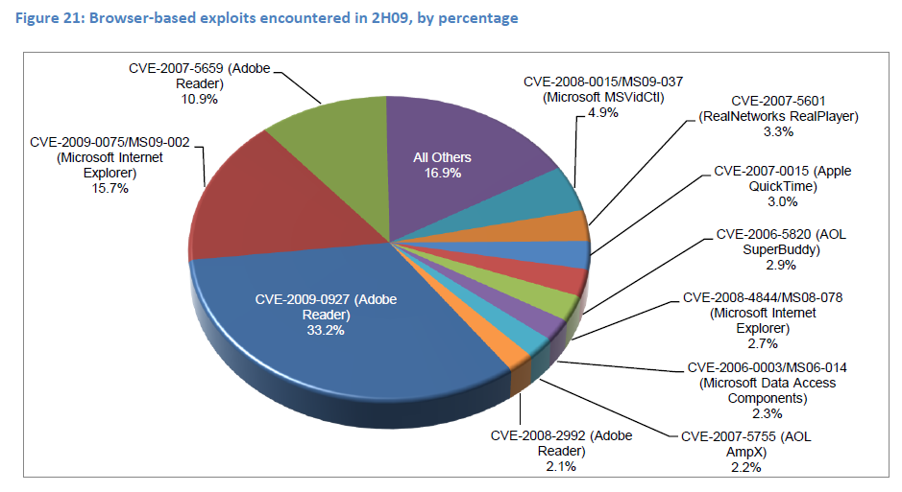

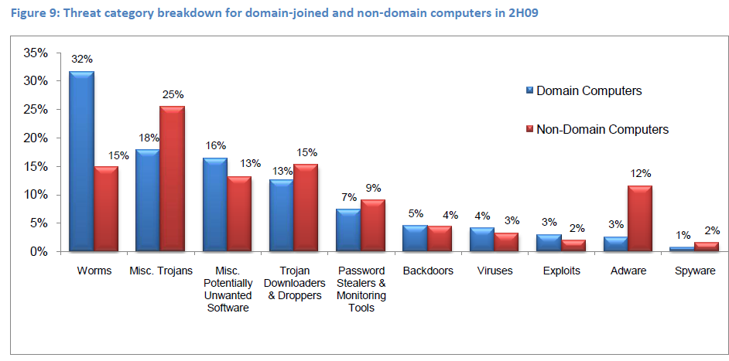
Linux OS Vulnerabilities

Linux OS Vulnerabilities

Linux can be made more secure

Awareness of vulnerabilities

Keep current on new releases and fixes

Many versions are available

Differences ranging from slight to major

It’s important to understand basics

Run control and service configuration

Directory structure and file system

Basic shell commands and scripting

Package management

Samba

Open-source implementation of CIFS

Created in 1992

Allows sharing resources over a network

Security professionals should have basic knowledge of SMB and Samba

Many companies have a mixed environment of Windows and *nix systems

Used to “trick” Windows services into believing *nix resources are Windows resources

Tools for Identifying Linux Vulnerabilities

CVE Web site

Source for discovering possible attacker avenues

OpenVAS can enumerate multiple OSs

Security tester using enumeration tools can:

Identify a computer on the network by using port scanning and zone transfers

Identify the OS by conducting port scanning

Identify via enumeration any logon accounts

Learn names of shared folders by using enumeration

Identify services running

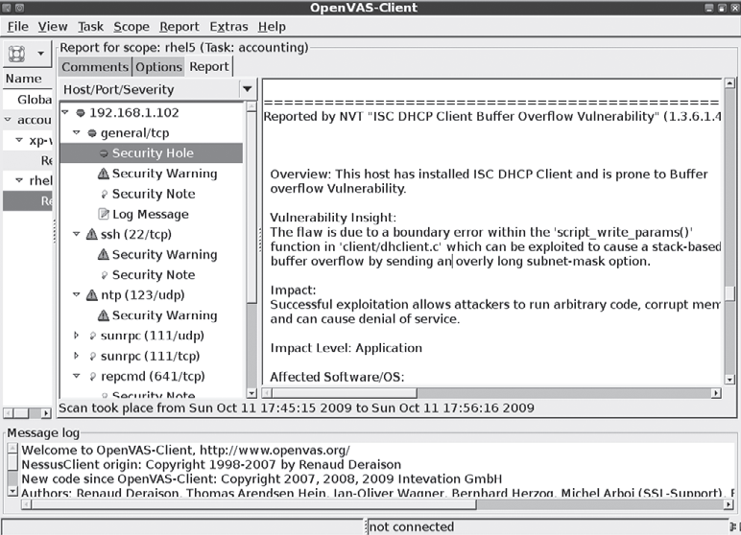

Checking for Trojan Programs

Most Trojan programs perform one or more of the following:

Allow remote administration of attacked system

Create a file server on attacked computer

Files can be loaded and downloaded

Steal passwords from attacked system

E-mail them to attacker

Log keystrokes

E-mail results or store them in a hidden file the attacker can access remotely

Linux Trojan programs

Sometimes disguised as legitimate programs

Contain program code that can wipe out file systems

More difficult to detect today

Protecting against identified Trojan programs is easier

Rootkits containing Trojan binary programs

More dangerous

Attackers hide tools

Perform further attacks

Have access to backdoor programs

More Countermeasures Against Linux Attacks

Most critical tasks:

User awareness training

Keeping current

Configuring systems to improve security

User Awareness Training

Inform users

No information should be given to outsiders

Knowing OS makes attacks easier

Be suspicious of people asking questions

Verify who they are talking to

Call them back

Keeping Current

As soon as a vulnerability is discovered and posted

OS vendors notify customers

Upgrades

Patches

Installing fixes promptly is essential

Linux distributions

Most have warning methods

Secure Configuration

Many methods to help prevent intrusion

Vulnerability scanners

Built-in Linux tools

Free benchmark tools

Center for Internet Security

Security Blanket

Trusted Computer Solutions

Last modified 10-5-10

