Objectives

After reading this chapter and completing the exercises, you will be able to:

Explain what embedded operating systems are and where they’re used

Describe Windows and other embedded operating systems

Identify vulnerabilities of embedded operating systems and best practices for protecting them
Introduction to Embedded Operating Systems

Embedded system

Any computer system that isn’t a general-purpose PC or server

GPSs and ATMs

Electronic consumer and industrial items

Embedded operating system (OS)

Small program developed for embedded systems

Stripped-down version of OS commonly used on general-purpose computers

Designed to be small and efficient

Real-time operating system (RTOS)

Typically used in devices such as programmable thermostats, appliance controls, and spacecraft

Corporate buildings

May have many embedded systems

Firewalls, switches, routers, Web-filtering appliances, network attached storage devices, etc.

Embedded systems

Are in all networks

Perform essential functions

Route network traffic; block suspicious packets

Windows and Other Embedded Operating Systems

Recycling common code and reusing technologies

Sound software engineering practices

Also introduce common points of failure

Viruses, worms, Trojans, and other attack vectors

Windows and Linux vulnerabilities

Might also exist in embedded version

Windows CE

Some source code is available to the public

Code sharing is not common

Microsoft believed it would increase adoptions

Windows Embedded Standard

Provides full Windows API

Performs many of the same tasks as desktop version

Designed for more advanced devices

Complex hardware requirements

Modular OS

Unneeded features can be removed

Windows Embedded Standard, code-named Quebec

Based on Windows 7

Windows Embedded Enterprise

Embedded versions of Windows Enterprise OSs (e.g., XP Professional, Windows Vista Business and Ultimate, and Windows 7 Ultimate and Professional)

Functional versions of Windows desktop OSs

Higher hardware requirements

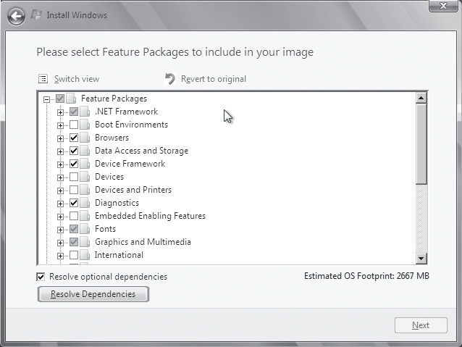

Other Proprietary Embedded OSs

VxWorks

Widely used embedded OS

Developed by Wind River Systems

Used in many different environments and applications

Designed to run efficiently on minimal hardware

Used by a variety of systems

Green Hill Software embedded OSs

F-35 Joint Strike Fighter

Multiple independent levels of security/safety (MILS)

OS certified to run multiple levels of classification

Embedded OS code

Used in printers, routers, switches, etc.

QNX Software Systems QNX

Commercial RTOS

Used in Cisco’s ultra-high-availability routers and Logitech universal remotes

Real-Time Executive for Multiprocessor Systems (RTEMS)

Open-source embedded OS

Used in space systems

Supports processors designed to operate in space

Using multiple embedded OSs

Increases attack surface

*Nix Embedded OSs

Embedded Linux

Monolithic OS

Used in industrial, medical, and consumer items

Can be tailored for devices with limited memory or hard drive capacity

Supports widest variety of hardware

Allows adding features

Dynamic kernel modules

Real Time Linux (RTLinux)

OS microkernel extension

Turns “regular” Linux into an RTOS

Suitable for embedded applications requiring a guaranteed response in a predictable manner

Linux dd-wrt

Embedded Linux OS

Used in Linksys WRT54G wireless router

Found in home offices and small businesses
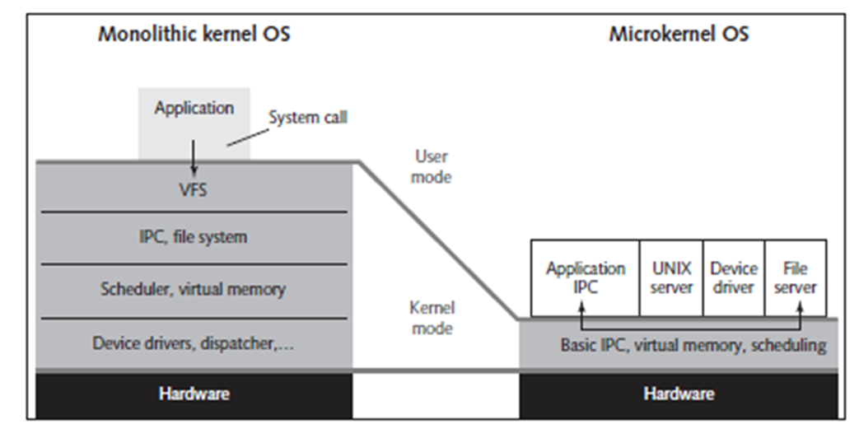

Vulnerabilities of Embedded OSs

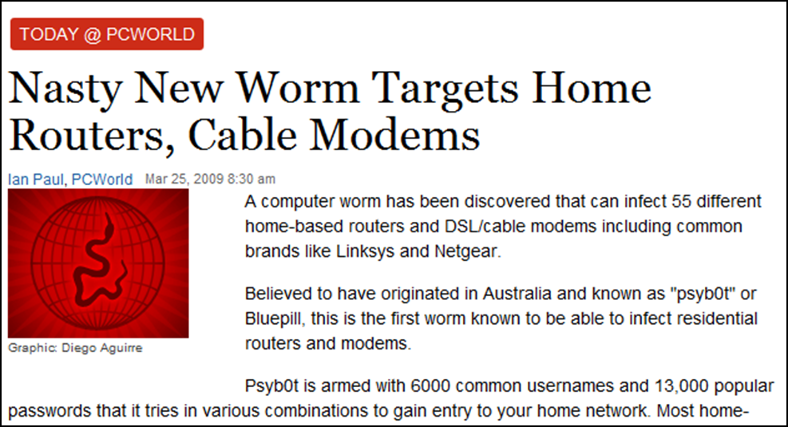
PsyBot

Links Ch 9e, 9f

Windows Mobile Vulnerabilities

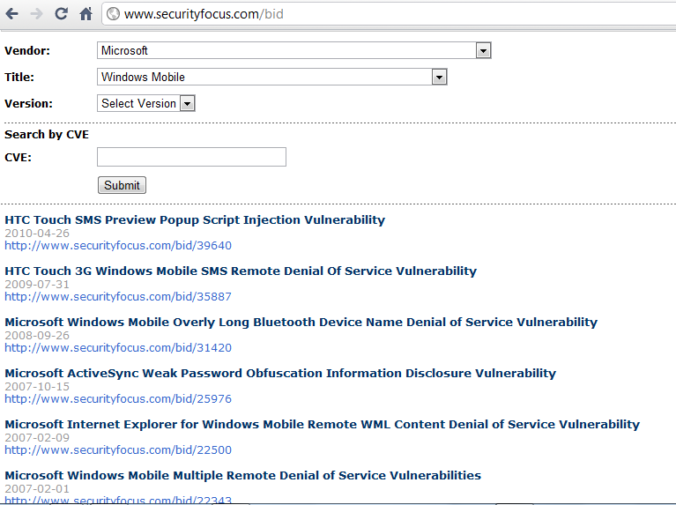

Vulnerabilities of Embedded OSs

Impact of attacks have become more serious

Embedded OSs are no exception

Easiest way to profit from hacking

Attack devices that store and dispense cash (e.g., ATMs)

Involves use of card skimmers or stealing the machines

Embedded OSs Are Everywhere

Embedded systems with Y2K software flaw

Billions located everywhere

Today

Many more embedded devices

Under attack from hackers and terrorists

Attackers want to further financial or political causes

Addressing security early in design phase is essential

Embedded OSs Are Networked

Advantages of connecting to a network

Efficiency and economy

Ability to manage and share services

Keeps human resources and expertise minimal

Reduces costs

Any device added to a network infrastructure

Increases potential for security problems

Embedded OSs Are Difficult to Patch

General-purpose desktop OSs

Simple to patch

Wait for vulnerability to be identified

Download and install patch

Embedded OSs

Must continue operating regardless of threat

Lack familiar interfaces

Buffer overflow attacks might be successful

Few updates released to correct vulnerabilities

Manufacturers typically prefer system upgrades

Open-source software

Cost of developing and patching shared by open-source community

Patching Linux kernel

Estimated at tens of billions of dollars

Offers flexibility and support

Large; has many code portions

Fixing a vulnerability

Weigh cost of fixing against importance of information the embedded system controls

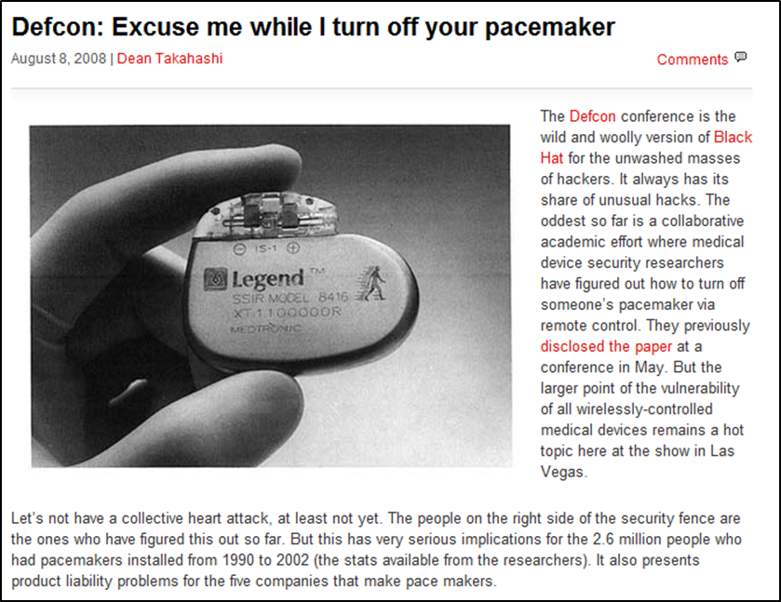
Hacking Pacemakers

Link Ch 9g

Embedded OSs Are in Networking Devices

Networking devices

Usually have software and hardware designed to transmit information across networks

General-purpose computers

Originally performed routing and switching

High-speed networks now use specialized hardware and embedded OSs

Attacks that compromise a router

Can give complete access to network resources

Attackers follow usual methods of footprinting, scanning, and enumerating the target

Authentication bypass vulnerability

Common vulnerability of routers

Specially crafted URL bypasses normal authentication mechanism

Router Hacking Contest

Link Ch 8h

After bypassing authentication

Attackers can launch other network attacks

Use access gained through compromised router

Embedded OSs Are in Network Peripherals

Common peripheral devices:

Printers, scanners, copiers, and fax devices

Multifunction devices (MFDs)

Perform more than one function

Rarely scanned for vulnerabilities or configured for security

Have embedded OSs with sensitive information

Information susceptible to theft and modification

Attackers may use malware or insert malicious links

Social-engineering techniques may be used to gain access

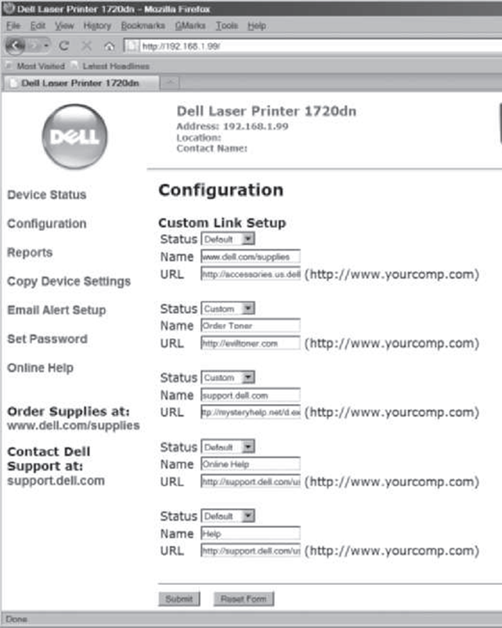
Hacking into a Printer

Taking control of a printer gives you

Access to stored print jobs

You can use the printer as a gateway into a secure LAN

See link Ch 9i

You could also alter the messages the printer produces to send malicious links to desktops

Supervisory Control and Data Acquisition Systems

Used for equipment monitoring in large industries (e.g., public works and utilities)

Anywhere automation is critical

May have many embedded systems as components

Vulnerable through data fed in and out or embedded OSs

Systems controlling critical infrastructure

Usually separated from Internet by “air gap”

Project AURORA

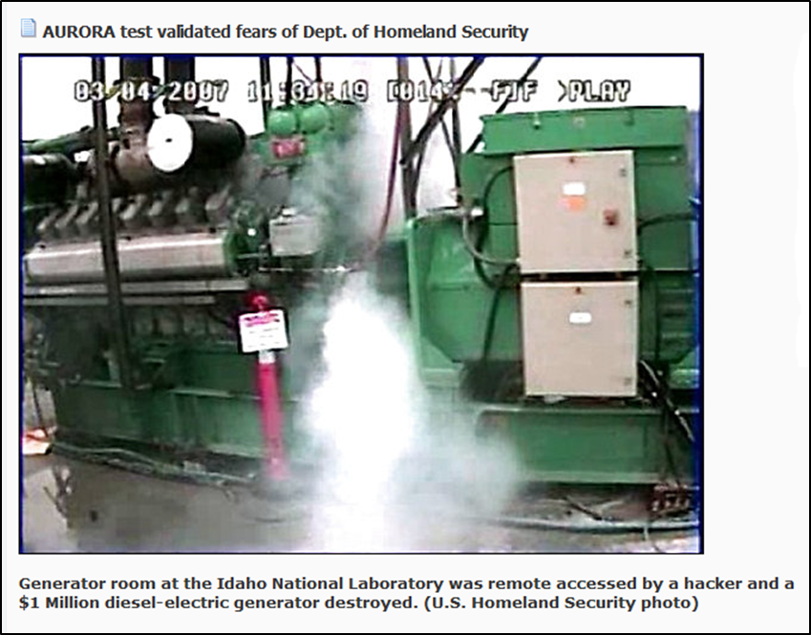
In a 2007 security test, a simulated cyber attack on a diesel generator destroyed it

Link Ch 9j

Stuxnet

Infected Siemens Programmable Logic Controller cards in nuclear power plants

Suspected to be a targeted military attack against one Iranian nuclear plant

Very sophisticated attack, using four 0-day exploits

Infected thousands of Iranian systems

Iran may have executed nuclear staff over this

Links Ch 9k – 9m

Cell Phones, Smartphones, and PDAs

Conversations over traditional phones

Considered protected

Tapping used to require a lot of time, expensive equipment, and a warrant

Many have the same security expectations of cell phones, smartphones, and PDAs

PDAs have additional vulnerabilities associated with PDA applications and services

Smartphones combine functions; have even more vulnerabilities

Cell phone vulnerabilities

Attackers listening to your phone calls

Using the phone as a microphone

“Cloning” the phone to make long-distance calls

Get useful information for computer or network access

Steal trade or national security secrets

Java-based phone viruses


Cell Phone Rootkit

Link Ch 9l

Rootkits

Modify OS parts or install themselves as kernel modules, drivers, libraries, and applications

Exist for Windows and *nix OSs

Rootkit-detection tools and antivirus software

Detect rootkits and prevent installation

More difficult if OS has already been compromised

Rootkits can monitor OS for anti-rootkit tools and neutralize them

Biggest threat

Infects firmware

Trusted Platform Module (TPM)

Defense against low-level rootkits

Ensures OS hasn’t been subverted or corrupted

ISO standard ISO/IEC 11889

Firmware rootkits

Hard to detect

Code for firmware often isn’t checked for corruption

Insider hacking

Harder to detect

Malicious code hidden in flash memory

Systems compromised before purchased

May function like normal

Must flash (rewrite) BIOS, wipe hard drive, and reload OS

Expensive and time consuming

LoJack for Laptops

Laptop theft-recovery service

Some design-level vulnerabilities rootkits can exploit

Infection residing in computer’s BIOS

Call-home mechanism
Best Practices for Protecting Embedded OSs

Include:

Identify all embedded systems in an organization

Prioritize systems or functions that depend on them

Follow least privileges principle for access

Use data transport encryption

Configure embedded systems securely

Use cryptographic measures

Install patches and updates

Restrict network access and reduce attack surface

Upgrade or replace systems that can’t be fixed or pose unacceptable risks

Last modified 10-13-10

