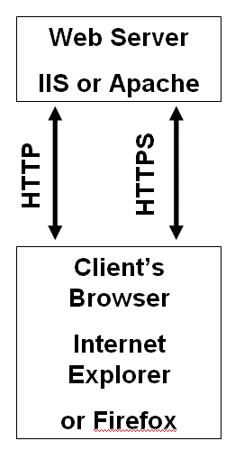
Objectives

Describe Web applications

Explain Web application vulnerabilities

Describe the tools used to attack Web servers

Web Servers

The two main Web servers are Apache (Open source) and IIS (Microsoft)
Understanding Web Applications

It is nearly impossible to write a program without bugs

Some bugs create security vulnerabilities

Web applications also have bugs

Web applications have a larger user base than standalone applications

Bugs are a bigger problem for Web applications

Web Application Components

Static Web pages

Created using HTML

Dynamic Web pages

Need special components

<form> tags

Common Gateway Interface (CGI) scripts

Active Server Pages (ASP)

PHP

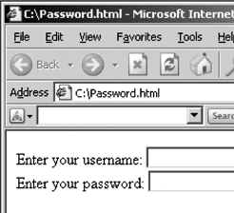
ColdFusion

Scripting languages like JavaScript

ODBC (Open Database connector)

Web Forms

Use the <form> element or tag in an HTML document

Allows customer to submit information to the Web server

Web servers process information from a Web form by using a Web application

Easy way for attackers to intercept data that users submit to a Web server

Web form example

<html><body>

<form>

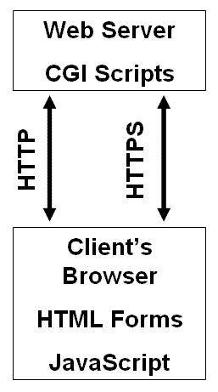
Enter your username:

<input type="text" name="username">

<br>

Enter your password:

<input type="text" name="password">

</form></body></html>

Common Gateway Interface (CGI)

Handles moving data from a Web server to a Web browser

The majority of dynamic Web pages are created with CGI and scripting languages

Describes how a Web server passes data to a Web browser

Relies on Perl or another scripting language to create dynamic Web pages

CGI Languages

CGI programs can be written in different programming and scripting languages

C or C++

Perl

Unix shell scripting

Visual Basic

FORTRAN

CGI example

Written in Perl

Hello.pl

Should be placed in the cgi-bin directory on the Web server

#!/usr/bin/perl

print "Content-type: text/html\n\n";

print "Hello Security Testers!";

Another CGI Example

Link Ch 10a: Sam’s Feedback Form

Link Ch 10b: CGI Script in Perl that processes the data from the form

Active Server Pages (ASP)

Microsoft’s server-side script engine

HTML pages are static—always the same

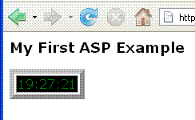
ASP creates HTML pages as needed. They are not static

ASP uses scripting languages such as JScript or VBScript

Not all Web servers support ASP

IIS supports ASP

Apache doesn’t support ASP as well

Active Server Pages (ASP)

You can’t see the source of an ASP page from a browser

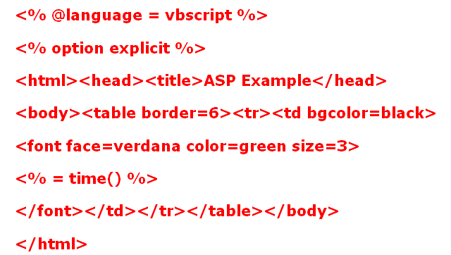
This makes it harder to hack into, although not impossible

ASP examples at links
Ch 10d, e, f

Apache Web Server

Apache is the most popular Web Server program

Advantages

Stable and reliable

Works on just about any *NIX and Windows platform

It is free and open source

See links Ch 10g, 10h

Using Scripting Languages

Dynamic Web pages can be developed using scripting languages

VBScript

JavaScript

PHP

PHP: Hypertext Processor (PHP)

Enables Web developers to create dynamic Web pages

Similar to ASP

Open-source server-side scripting language

Can be embedded in an HTML Web page using PHP tags <?php and ?>

Users cannot see PHP code in their Web browser

Used primarily on UNIX systems

Also supported on Macintosh and Microsoft platforms

PHP Example

<html><head><title>Example</title></head>

<body>

<?php

echo 'Hello, World!';

?>

</body></html>

See links Ch 10k, 10l

PHP has known vulnerabilities

See links Ch 10m, 10n

PHP is often used with MySQL Databases

ColdFusion

Server-side scripting language used to develop dynamic Web pages

Created by the Allaire Corporation

Purchased by Macromedia, now owned by Adobe -- Expensive

Uses its own proprietary tags written in ColdFusion Markup Language (CFML)

CFML Web applications can contain other technologies, such as HTML or JavaScript

ColdFusion Example

<html><head><title>Ex</title></head>

<body>

<CFLOCATION URL="www.isecom.org/cf/index.htm" ADDTOKEN="NO">

</body>

</html>

See links Ch 10o

ColdFusion Vulnerabilities

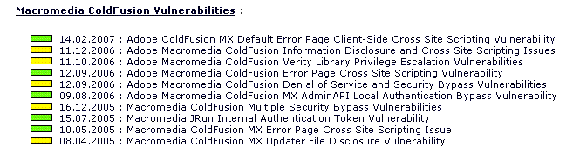
See links Ch 10p, 10q

VBScript

Visual Basic Script is a scripting language developed by Microsoft

You can insert VBScript commands into a static HTML page to make it dynamic

Provides the power of a full programming language

Executed by the client’s browser

VBScript Example

<html><body>

<script type="text/vbscript">

document.write("<h1>Hello!</h1>")

document.write("Date Activated: " & date())

</script>

</body></html>

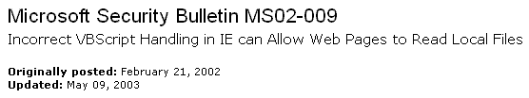
See link Ch 10r – works in IE, but not in Firefox

Firefox does not support VBScript (link Ch 10s)

VBScript vulnerabilities

See links Ch 10t, 10u

JavaScript

Popular scripting language

JavaScript also has the power of a programming language

Branching

Looping

Testing

JavaScript Example

<html><head>

<script type="text/javascript">

function chastise_user(){

alert("So, you like breaking rules?")

document.getElementByld("cmdButton").focus()}

</script></head>

<body><h3>Don't click the button!</h3>

<form>

<input type="button" value="Don't Click!" name="cmdButton" onClick="chastise_user()" />

</form></body></html>

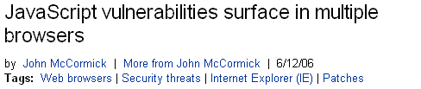
See link Ch 10v – works in IE and Firefox

JavaScript Vulnerabilities

See link Ch 10w

Connecting to Databases

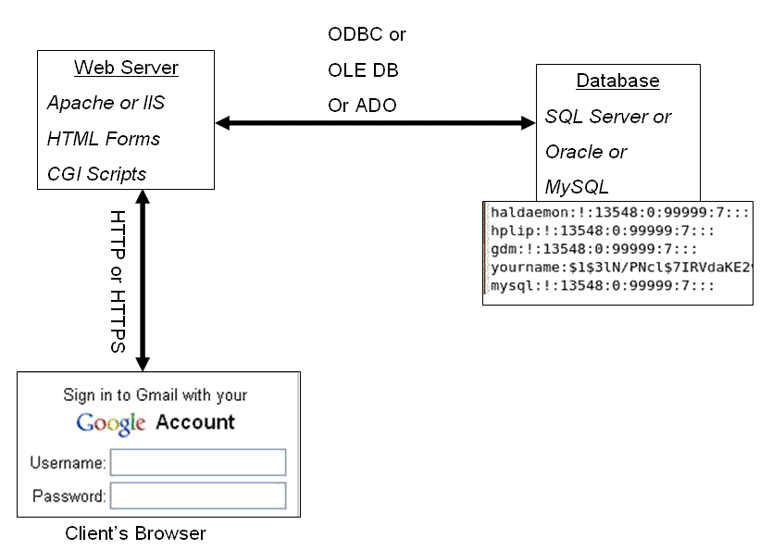
Web pages can display information stored on databases

There are several technologies used to connect databases with Web applications

Technology depends on the OS used

ODBC

OLE DB

ADO

Theory is the same

Open Database Connectivity (ODBC)

Standard database access method developed by the SQL Access Group

ODBC interface allows an application to access

Data stored in a database management system (DBMS)

Can use Oracle, SQL, or any DBMS that understands and can issue ODBC commands

Interoperability among back-end DBMS is a key feature of the ODBC interface

ODBC defines

Standardized representation of data types

A library of ODBC functions

Standard methods of connecting to and logging on to a DBMS

OLE DB and ADO

Object Linking and Embedding Database (OLE DB) and

ActiveX Data Objects (ADO)

These two more modern, complex technologies replace ODBC and make up"Microsoft’s Universal Data Access“

See link Ch 10x
Understanding Web Application Vulnerabilities

Many platforms and programming languages can be used to design a Web site

Application security is as important as network security

Attackers controlling a Web server can

Deface the Web site

Destroy or steal company’s data

Gain control of user accounts

Perform secondary attacks from the Web site

Gain root access to other applications or servers

Open Web Application Security Project (OWASP)

Open, not-for-profit organization dedicated to finding and fighting vulnerabilities in Web applications

Publishes the Ten Most Critical Web Application Security Vulnerabilities

Top-10 Web application vulnerabilities

Cross-site scripting (XSS) flaws

Attackers inject code into a web page, such as a forum or guestbook

When others user view the page, confidential information is stolen

See link Ch 10za

Command injection flaws

An attacker can embed malicious code and run a program on the database server

Example: SQL Injection

Malicious file execution

Users allowed to upload or run malicious files

Unsecured Direct Object Reference

Information in the URL allows a user to reference files, directories, or records

Cross-site Request Forgery (CSRF)

Stealing an authenticated session, by replaying a cookie or other token

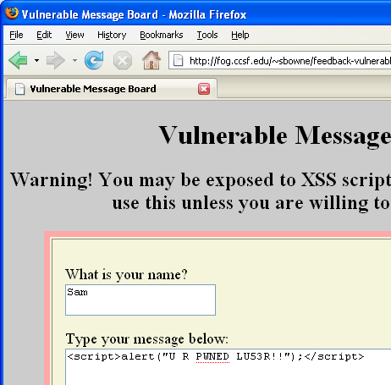
Information Leakage and Incorrect Error Handling

Error messages that give away too much information

Broken Authentication and Session Management

Allow attackers to steal cookies or passwords

Unsecured cryptographic Storage

Storing keys, certificates, and passwords on a Web server can be dangerous

Unsecured Communication

Using HTTP instead of HTTPS

Failure to Restrict URL Access

Security through obscurity

Hoping users don't find the "secret" URLs

Cross-Site Scripting (XSS)

One client posts active content, with <script> tags or other programming content

When another client reads the messages, the scripts are executed in his or her browser

One user attacks another user, using the vulnerable Web application as a weapon

XSS Attack Examples

<script>alert("XSS vulnerability!")</script>

<script>alert(document.cookie)</script>

<script>window.location="http://www.ccsf.edu"</script>

XSS Scripting Effects

Steal another user's authentication cookie

Hijack session

Harvest stored passwords from the target's browser

Take over machine through browser vulnerability

Redirect Webpage

Many, many other evil things…

WebGoat project

Helps security testers learn how to perform vulnerabilities testing on Web applications

Developed by OWASP

It’s excellent, and now has video tutorials

Assessing Web Applications

Issues to consider

Dynamic Web pages

Connection to a backend database server

User authentication

What platform was used?

Does the Web Application Use Dynamic Web Pages?

Static Web pages do not create a secure environment

IIS attack example: Directory Traversal

Adding ..\ to a URL refers to a directory above the Web page directory

Early versions of IIS filtered out \, but not %c1%9c, which is a Unicode version of the same character

See link Ch 10 zh

Connection to a Backend Database Server

Security testers should check for the possibility of SQL injection being used to attack the system

SQL injection involves the attacker supplying SQL commands on a Web application field

SQL Injection Example

HTML form collects name and pw

SQL then uses those fields:

SELECT * FROM customer WHERE username = ‘name' AND password = ‘pw'

If a hacker enters a name of

’ OR 1=1 --

The SQL becomes:

SELECT * FROM customer WHERE username = ‘’ OR 1=1 --' AND password = ‘pw‘

Which is always true, and returns all the records

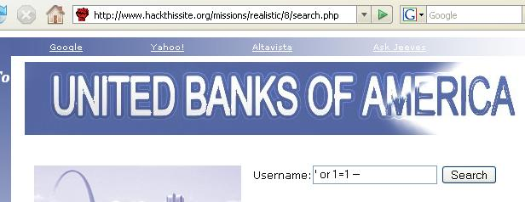
HackThisSite

Basic testing should look for

Whether you can enter text with punctuation marks

Whether you can enter a single quotation mark followed by any SQL keywords

Whether you can get any sort of database error when attempting to inject SQL

User Authentication

Many Web applications require another server to authenticate users

Examine how information is passed between the two servers

Encrypted channels

Verify that logon and password information is stored on secure places

Authentication servers introduce a second target

What Platform Was Used?

Popular platforms include:

IIS with ASP and SQL Server (Microsoft)

Linux, Apache, MySQL, and PHP (LAMP)

Footprinting is used to find out the platform

The more you know about a system the easier it is to gather information about its vulnerabilities
Tools of Web Attackers and Security Testers

Choose the right tools for the job

Attackers look for tools that enable them to attack the system

They choose their tools based on the vulnerabilities found on a target system or application

Web Tools

Cgiscan.c: CGI scanning tool

Written in C in 1999 by Bronc Buster

Tool for searching Web sites for CGI scripts that can be exploited

One of the best tools for scanning the Web for systems with CGI vulnerabilities

See link Ch 10zi

cgiscan and WebGoat
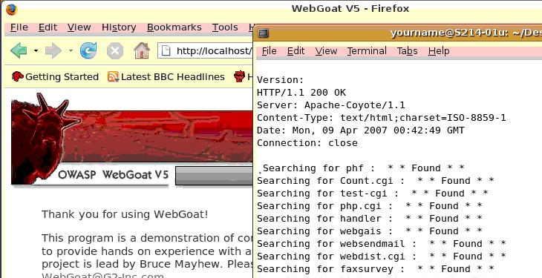
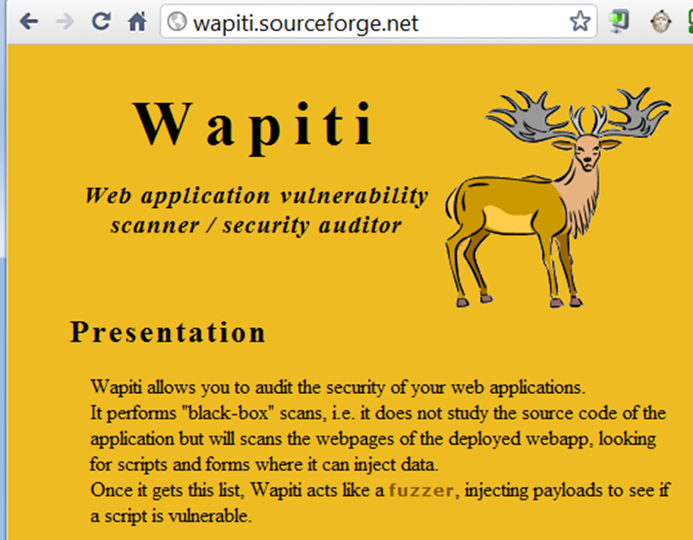

Wfetch: GUI tool from Microsoft

Displays information that is not normally shown in a browser, such as HTTP headers

It also attempts authentication using

Multiple HTTP methods

Configuration of host name and TCP port

HTTP 1.0 and HTTP 1.1 support

Anonymous, Basic, NTLM, Kerberos, Digest, and Negotiation authentication types

Multiple connection types

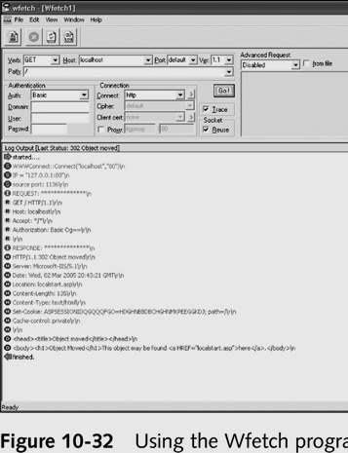
Proxy support

Client-certificate support

See link Ch 10zl

Last modified 10-20-10

