Objectives

Explain wireless technology

Describe wireless networking standards

Describe the process of authentication

Describe wardriving

Describe wireless hacking and tools used by hackers and security professionals
Understanding Wireless Technology

For a wireless network to function, you must have the right hardware and software

Wireless technology is part of our lives

Baby monitors

Cell and cordless phones

Pagers

GPS

Remote controls

Garage door openers

Two-way radios

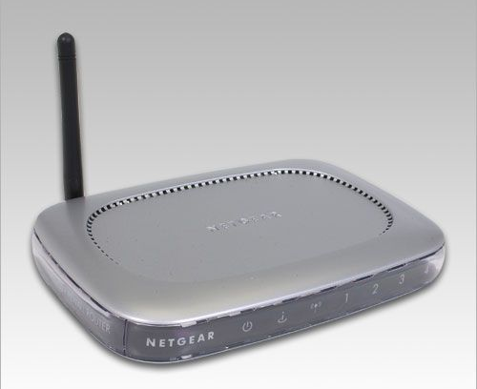
Wireless PDAs

Components of a Wireless Network

A wireless network has only three basic components

Access Point (AP)

Wireless network interface card (WNIC)

Ethernet cable

Access Points

An access point (AP) is a transceiver that connects to an Ethernet cable

It bridges the wireless network with the wired network

Not all wireless networks connect to a wired network

Most companies have Wireless LANs (WLANs) that connect to their wired network topology

The AP is where channels are configured

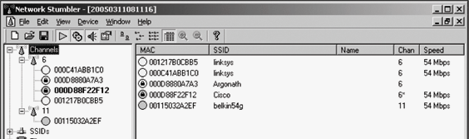
An AP enables users to connect to a LAN using wireless technology

An AP is available only within a defined area

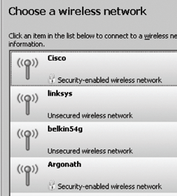
Service Set Identifiers (SSIDs)

Name used to identify the wireless local area network (WLAN)

The SSID is configured on the AP

Unique 1- to 32-character alphanumeric name

Name is case sensitive

Wireless computers need to configure the SSID before connecting to a wireless network

SSID is transmitted with each packet

Identifies which network the packet belongs

The AP usually broadcasts the SSID

Many vendors have SSIDs set to a default value that companies never change

An AP can be configured to not broadcast its SSID until after authentication

Wireless hackers can attempt to guess the SSID

Verify that your clients or customers are not using a default SSID

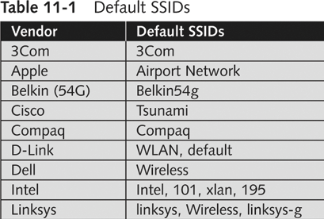
See links Ch 11a, b

Configuring an Access Point

Configuring an AP varies depending on the hardware

Most devices allow access through any Web browser

Enter IP address on your Web browser and provide your user logon name and password

Wireless Router

A wireless router includes an access point, a router, and a switch

Configuring an Access Point

Wireless Configuration Options

SSID

Wired Equivalent Privacy (WEP) encryption

WPA (WiFi Protected Access ) is better

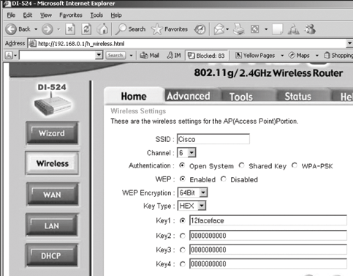
Turn off SSID broadcast

You should also change your SSID

Wireless NICs

For wireless technology to work, each node or computer must have a wireless NIC

NIC’s main function

Converting the radio waves it receives into digital signals the computer understands

There are many wireless NICs on the market

Choose yours depending on how you plan to use it

Some tools require certain specific brands of NICs

Cracking WEP requires NICs that can use monitor mode or perform packet injection

Understanding Wireless Network Standards

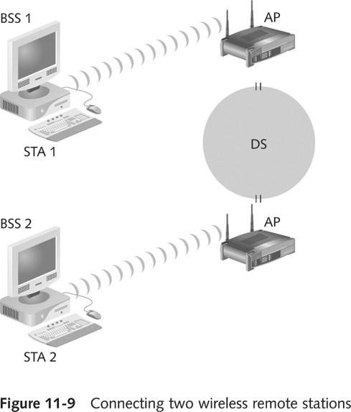
A standard is a set of rules formulated by an organization

Institute of Electrical and Electronics Engineers (IEEE)

Defines several standards for wireless networks

IEEE: CCSF Student Chapter

Next meeting:

May 3, 2007 in Cloud 218 4:30 pm

Email sbowne@ccsf.edu for more info

IEEE Standards

Standards pass through these groups:

Working group (WG)

Sponsor Executive Committee (SEC)

Standards Review Committee (RevCom)

IEEE Standards Board

IEEE Project 802

LAN and WAN standards

The 802.11 Standard

The first wireless technology standard

Defined wireless connectivity at 1 Mbps and 2 Mbps within a LAN

Applied to layers 1 and 2 of the OSI model

Wireless networks cannot detect collisions

Carrier sense multiple access/collision avoidance (CSMA/CA) is used instead of CSMA/CD

Addressing

Wireless LANs do not have an address associated with a physical location

An addressable unit is called a station (STA)

The Basic Architecture of 802.11

802.11 uses a basic service set (BSS) as its building block

Computers within a BSS can communicate with each other

To connect two BSSs, 802.11 requires a distribution system (DS)

Frequency Range

In the United States, Wi-Fi uses frequencies near 2.4 GHz

(Except 802.11a at 5 GHz)

There are 11 channels, but they overlap, so only three are commonly used

See link Ch 11c & Ch 11zh
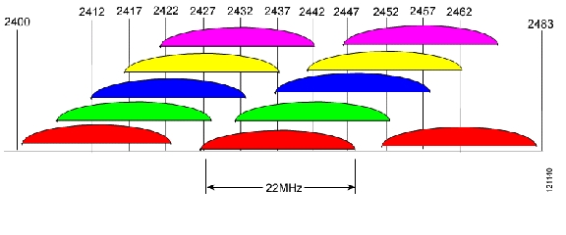

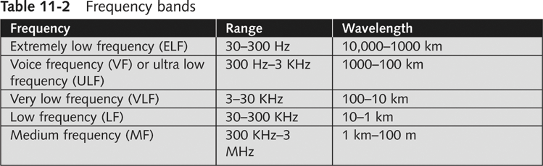
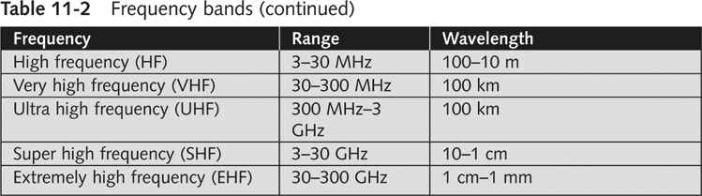
Other terms to define the channel:

Wavelength

Frequency

Cycle

Hertz or cycles per second

Bands

Infrared (IR)

Infrared light can’t be seen by the human eye

IR technology is restricted to a single room or line of sight

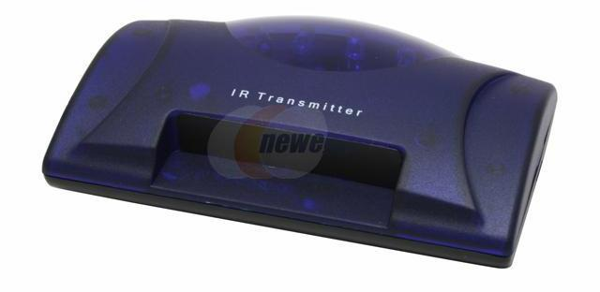
IR light cannot penetrate walls, ceilings, or floors

Image: IR transmitter for wireless headphones

Narrowband

Uses microwave radio band frequencies to transmit data

Popular uses

Cordless phones

Garage door openers

Spread Spectrum

Data is spread across a large-frequency bandwidth instead of traveling across just one frequency band

Methods

Frequency-hopping spread spectrum (FHSS)

Direct sequence spread spectrum (DSSS)

Orthogonal frequency division multiplexing (OFDM)

See links Ch 11d, Ch 11d1

IEEE Additional 802.11 Projects

802.11a

Created in 1999

Operating frequency 5 GHz

Throughput 54 Mbps

802.11b

Operates in the 2.4 GHz range

Throughput 11 Mbps

Also referred as Wi-Fi (wireless fidelity)

Allows for 11 channels to prevent overlapping signals

Effectively only three channels (1, 6, and 11) can be used in combination without overlapping

Introduced Wired Equivalent Privacy (WEP)

802.11e

It has improvements to address the problem of interference

When interference is detected, signals can jump to another frequency more quickly

802.11g

Operates in the 2.4 GHz range

Uses OFDM for modulation

Throughput increased from 11 Mbps to 54 Mbps

802.11i

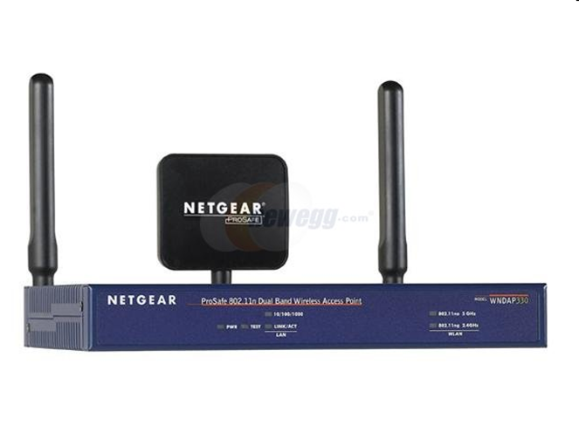
Introduced Wi-Fi Protected Access (WPA)

Corrected many of the security vulnerabilities of 802.11b

802.11n

Finalized in 2009

Can use up to four spatial streams with multiple antennas

Speeds up to 600 Mbps

Link 11zh

802.15


Addresses networking devices within one person’s workspace

Called wireless personal area network (WPAN)

Bluetooth is a common example

Bluetooth

Defines a method for interconnecting portable devices without wires

Maximum distance allowed is 10 meters

It uses the 2.45 GHz frequency band

Throughput of up to 2.1 Mbps for Bluetooth 2.0

Up to 24 Mbps for Bluetooth 3.0 (not 12 Mbps as stated in the textbook, p. 316)

Link Ch 11zg

HiperLAN2

European WLAN standard

It is not compatible with 802.11 standards

802.16

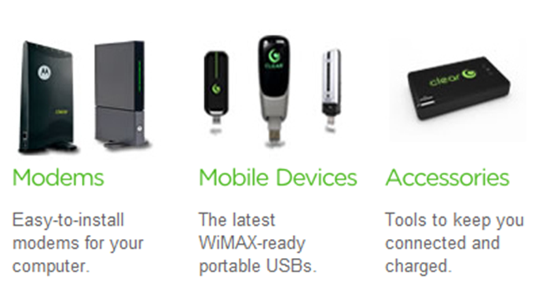
Addresses the issue of wireless metropolitan area networks (MANs)

Defines the WirelessMAN Air Interface

It will have a range of up to 30 miles

Throughput of up to 120 Mbps

Clear WIMAX

10 Mbps throughout whole cities

San Francisco is not yet covered

Link Ch 11zi

802.20

Addresses wireless MANs for mobile users who are sitting in trains, subways, or cars traveling at speeds up to 150 miles per hour

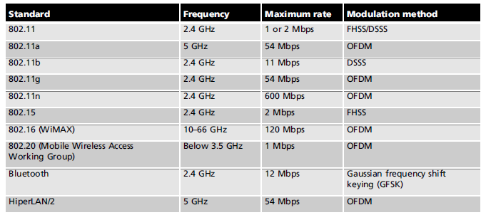
24 Mbps

Understanding Authentication

Wireless technology brings new security risks to a network

Authentication

Establishing that a user is authentic—authorized to use the network

If authentication fails, anyone in radio range can use your network

The 802.1X Standard

Defines the process of authenticating and authorizing users on a WLAN

Basic concepts

Point-to-Point Protocol (PPP)

Extensible Authentication Protocol (EAP)

Wired Equivalent Privacy (WEP)

Wi-Fi Protected Access (WPA)

Point-to-Point Protocol (PPP)

Many ISPs use PPP to connect dial-up or DSL users

PPP handles authentication with a user name and password, sent with PAP or CHAP

PAP (Password Authentication Protocol) sends passwords unencrypted

Vulnerable to trivial sniffing attacks

See link Ch 11f

CHAP Vulnerability

CHAP (Challenge-Handshake Authentication Protocol)

Server sends a Challenge with a random value

Client sends a Response, hashing the random value with the secret password

This is still vulnerable to a sort of session hijacking attack (see links Ch 11e)

Extensible Authentication Protocol (EAP)

EAP is an enhancement to PPP

Allows a company to select its authentication method

Certificates

Kerberos

Kerberos is used on LANs for authentication

Uses Tickets and Keys

Used by Windows 2000, XP, and 2003 Server by default

Not common on WLANS

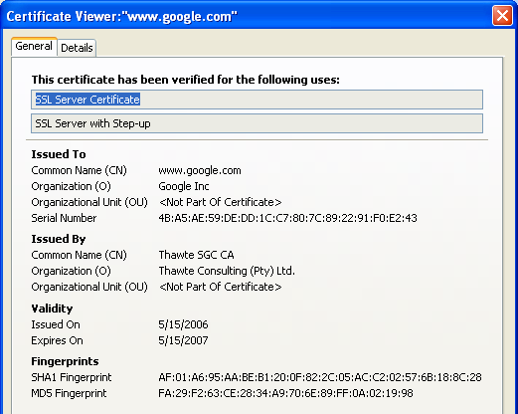
X.509 Certificate

Record that authenticates network entities

Identifies

The owner

The certificate authority (CA)

The owner’s public key

See link Ch 11j

Sample X.509 Certificate

Go to gmail.com

Double-click the padlock

Public Key

Your browser uses the Public Key to encrypt data so only Gmail can read it

LEAP

Lightweight Extensible Authentication Protocol (LEAP)

A Cisco product

Vulnerable, but Cisco didn’t care

Joshua Wright wrote the ASLEAP hacking tool to crack LEAP, and forced Cisco to develop a better protocol

See link Ch 11g

“Within months, some "helpful" person invested their time into generating a cracker tool. Publicizing the threat was a service to everyone, but I leave it as an exercise for readers to determine what satisfaction is obtained by the authors of tools that turn threat into reality and lay waste to millions of dollars of investments.”

--"Real 802.11 Security", William Arbaugh and Jon Edney, as quoted in link Ch 11g

More Secure EAP Methods

Extensible Authentication Protocol-Transport Layer Security (EAP-TLS)

Secure but rarely used, because both client and server need certificates signed by a CA

Protected EAP (PEAP) and Microsoft PEAP

Very secure, only requires server to have a certificate signed by a CA

See link Ch 11h

802.1X components

Supplicant

The user accessing a WLAN

Authenticator

The AP

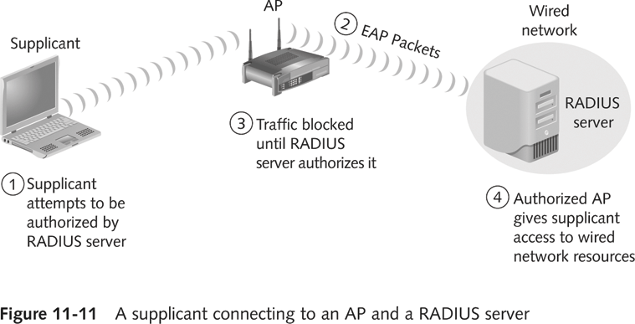
Authentication server

Checks an account database to see if user’s credentials are acceptable

May use RADIUS (Remote Access Dial-In User Service)

See link Ch 11k

Wired Equivalent Privacy (WEP)

Part of the 802.11b standard

Encrypts data on a wireless network

WEP has many vulnerabilities

To crack WEP, see links Ch 11l, 11m

Wi-Fi Protected Access (WPA)

Specified in the 802.11i standard

Replaces WEP

WPA improves encryption by using Temporal Key Integrity Protocol (TKIP)

TKIP Enhancements

Message Integrity Check (MIC)

Prevent attacker from injecting forged packets

Extended Initialization Vector (IV) with sequencing rules

Prevent replays (attacker re-sending copied packets)

Per-packet key mixing

MAC addresses are used to create a key

Each link uses a different key

Rekeying mechanism

Provides fresh keys

Prevents attackers from reusing old keys

WPA Adds 802.1x

WPA also adds an authentication mechanism implementing 802.1X and EAP

This was not available in WEP

WPA Versions

WPA and WPA-2

WPA only implements part of 802.11i, using TKIP

Can run on older hardware

WPA2 implements the full IEEE 802.11i security standard, using CCMP

More secure

Link Ch 11zj

Pre-Shared Key v. 802.1x

Both WPA and WPA-2 can run in either mode

Pre-Shared Key uses a passphrase the user types into each device

Less secure because the user might choose a guessable passphrase, and all devices on the WLAN use the same passphrase

802.1x uses a server to manage keys

Each user has a different key

More secure

Link Ch 11zj

Hacking WPA

In 2008 and 2009, some new WPA attacks were developed, for its weakest form (TKIP)

These attacks allow injection of spoofed packets for limited periods of time

Up to 18 minutes

They don't find the WPA key, but they are a warning that it's time to go to WPA-2
Understanding Wardriving

Hackers use wardriving

Finding insecure access points

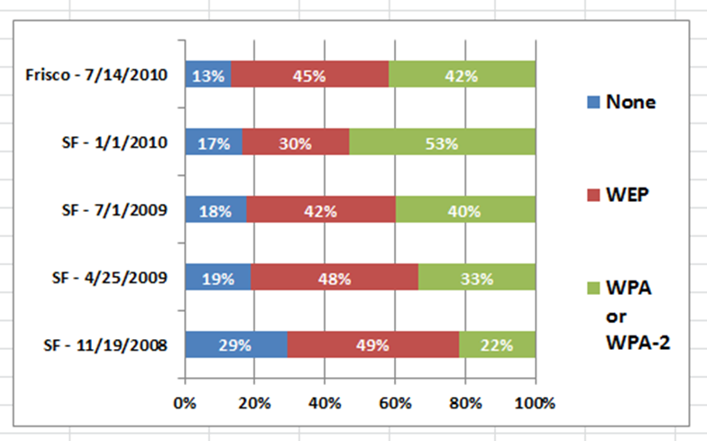
Using a laptop or palmtop computer

Wardriving is not illegal

But using the resources of these networks is illegal

Warflying

Variant where an airplane is used instead of a car

CCSF Wardriving

How It Works

An attacker or security tester simply drives around with the following equipment

Laptop computer

Wireless NIC

An antenna

Software that scans the area for SSIDs

Not all wireless NICs are compatible with scanning programs

Antenna prices vary depending on the quality and the range they can cover

Scanning software can identify

The company’s SSID

The type of security enabled

The signal strength

Indicating how close the AP is to the attacker
Wardriving Software

For our wardrive, I recommend this software

Windows XP: InSSIDer

Vista or Win 7: VisStumbler

Linux: Kismet

Mac OS X: KisMac-ng

NetStumbler is not useful for us, because it doesn't distinguish between WEP and WPA

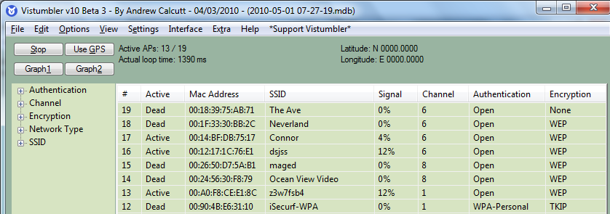

NetStumbler

Shareware tool written for Windows that enables you to detect WLANs

Supports 802.11a, 802.11b, and 802.11g standards

NetStumbler was primarily designed to

Verify your WLAN configuration

Detect other wireless networks

Detect unauthorized APs
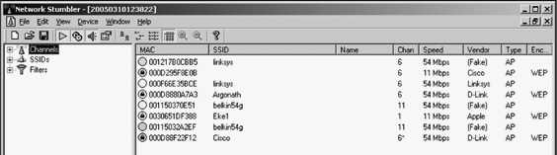

NetStumbler is capable of interface with a GPS

Enabling a security tester or hacker to map out locations of all the WLANs the software detects

NetStumbler logs the following information

SSID

MAC address and Manufacturer of the AP

Channel

Signal Strength

Encryption

Can detect APs within a 350-foot radius

With a good antenna, they can locate APs a couple of miles away

Kismet

Another product for conducting wardriving attacks

Runs on Linux, BSD, MAC OS X, and Linux PDAs

Kismet is advertised also as a sniffer and IDS

Kismet can sniff 802.11b, 802.11a, and 802.11g traffic

Kismet features

Ethereal- and Tcpdump-compatible data logging

AirSnort compatible

Network IP range detection

Hidden network SSID detection

Graphical mapping of networks

Client-server architecture

Manufacturer and model identification of APs and clients

Detection of known default access point configurations

XML output

Supports more than 25 card types
Understanding Wireless Hacking

Hacking a wireless network is not much different from hacking a wired LAN

Techniques for hacking wireless networks

Port scanning

Enumeration

Tools of the Trade

Equipment

Laptop computer

A wireless NIC

An antenna

Sniffer software

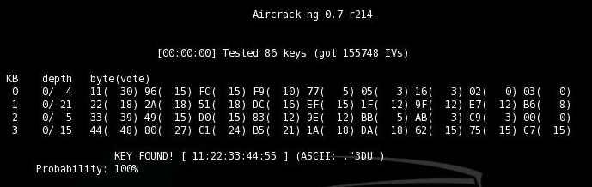
Aircrack-ng

Popular WEP-cracking tool

Included in BackTrack

Countermeasures for Wireless Attacks

Anti-wardriving software makes it more difficult for attackers to discover your wireless LAN

Honeypots

Servers with fake data to snare intruders

Fakeap and Black Alchemy Fake AP

Software that makes fake Access Points

Link Ch 11s

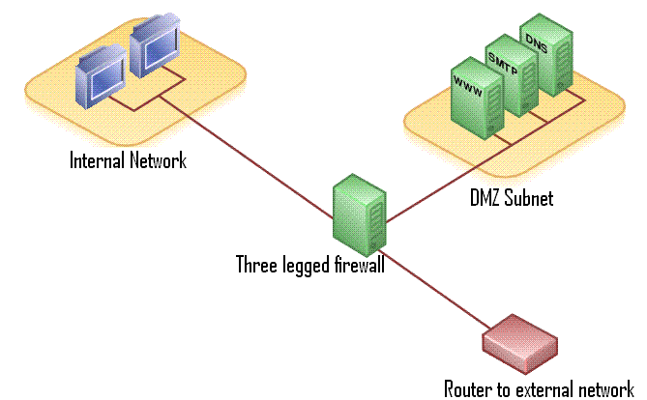
Use special paint to stop radio from escaping your building

Allow only predetermined MAC addresses and IP addresses to have access to the wireless LAN

Use an authentication server instead of relying on a wireless device to authenticate users

Use an EAP authentication protocol

If you use WEP, use 104-bit encryption rather than 40-bit encryption

But just use WPA instead

Assign static IP addresses to wireless clients instead of using DHCP
DMZ

Don’t broadcast the SSID

Place the AP in the demilitarized zone (DMZ) (image from wikipedia)

Last modified 10-27-10

