Downloading and Installing the Microsoft Baseline Security Analyzer (MBSA)
- Start your Windows XP virtual machine and log in as usual.
- Open a browser and go to http://www.microsoft.com/technet/security/tools/mbsahome.mspx
- Click the latest version – at the time I wrote this, it was MBSA 2.1 Beta.
- At the next screen, click Download now. Follow the instructions on your screen to go to the Download Center, validate your Windows copy, and download MBSA. The exact steps vary.
- Install it with all the default selections.
Scanning Your Computer With MBSA
- Click Start, All Programs, Microsoft Baseline Security Analyzer 2.1.
- In the Microsoft Baseline Security Analyzer window, click Scan a computer.
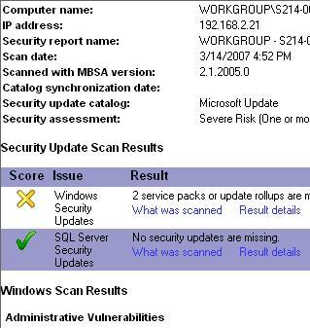
- In the Pick a computer to scan screen, notice that you can scan more than one computer with this tool, and that you can scan for many different problems. We will use the default selection to scan the local computer, and to scan for all the vulnerabilities. The only thing not checked by default is Advanced Update Services Options which is not applicable. Those update services allow large corporate networks to manage updates with a local server, but we are not using them in S214.
- Click Start Scan. Wait until the scan completes.
- When you see the View Security Report header, the scan is complete. Make sure the Windows Security Updates line is visible, as shown to the right on this page. Press Alt+PrtScn to copy this window to the clipboard.
- On the Start menu, click Run. Enter the command mspaint and press the Enter key. Paint opens.
- Press Ctrl+V on the keyboard to paste the image into the Paint window. Save the document in the Shared Documents folder with the filename Your Name Proj X5. Select a Save as type of JPEG. Close Paint.
Reading the Security Report
- Read the Security Report and answer the questions in the box below.
A: What version of the MBSA are you using? ____________________________________

B: In the Administrative Vulnerabilities section, what did it say about your File System?
_________________________________________________________________________
C: What was the result of the Password Expiration test?
_________________________________________________________________________

Turning in your Project
- Email the JPEG images to me as attachments to one e-mail message. Answer the questions in the box in the body of the e-mail message. Send the message to: cnit.235@gmail.com with a subject line of CNIT 235 Proj X1 From Your Name, replacing Your Name with your own first and last name. Send a Cc to yourself.

Last modified 3-14-07

