What You Need for This Project
- A trusted computer running any version of Windows, preferably Windows XP, with Internet access. You need administrator privileges. This can be either a real or virtual machine.

Start Your Host Machine
- If you are working in S214, power on a computer and log on with this name and password:
User name: Your CCSF Student ID, unless it starts with @. If your ID starts with @, replace the @ with X.
Password: changeme

Change Your Password
- Once you get logged in, press Ctrl+Alt+Delete and click the Change Password… button. Change your password to something you can remember.

Making Your VM Folder
- Click Start, My Computer. Double-click the VMs (V:) drive to open it. (If you have a portable hard drive, that’s an even better place to store your VMs.)
- In the VMs (V:) window, right-click the empty space and click New, Folder. Name the folder YOUR NAME VMs replacing YOUR NAME with your own name.

Copying a Windows XP Virtual Machine into Your VM Folder
- In the VMs (V:) window, double-click Hacking folder to open it. Right-click the Win XP Pro for Hacking folder and click Copy.
- In the Hacking window, click the Up button on the toolbar. Right-click the YOUR NAME VMs folder and click Paste. Wait until the copy is finished. This will be your personal Trusted Machine.

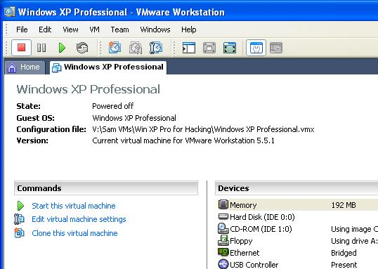
Starting VMware
- Double-click the VMware Workstation icon on the desktop. In the VMware Workstation window, from the menu bar, click View, Go to Home Tab.
- On the Home tab, click the Open Existing VM or Team icon. Navigate to the V: drive, open your folder, open the Win XP Pro for Hacking folder, and double-click the Windows XP Professional.vmx file. You should see a Windows XP Professional VM in the Powered Off state, as shown to the right on this page.

Starting Your Virtual Machine
- In the Windows XP Professional – VMware Workstation window, on the left side, click the Start this virtual machine link.
- If you see a message saying “The location of this virtual machine’s configuration file has changed…,” accept the default selection of Create and click OK.
- When your machine starts up, click the Student account to log in. There is no password, and the Student account has Administrative privileges.

Testing your Internet Connection
- Open Firefox and go to google.com. Make sure you can connect to the Internet. If you cannot connect to the Internet, call your instructor over to help you fix that problem before proceeding.

Configuring Bginfo
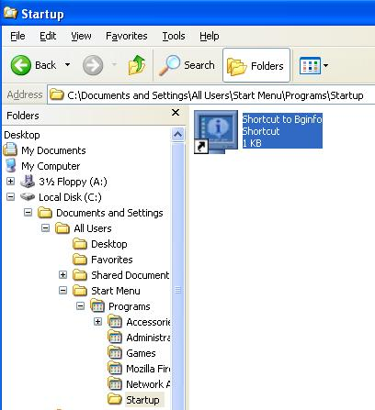
- On the desktop of your virtual machine, there is a file named Bginfo.exe. (If you are working at home, download it from http://www.microsoft.com/technet/sysinternals/Miscellaneous/BgInfo.mspx). This program displays useful system information on the desktop background, including the system’s IP address. But to make it update automatically, you need to place a shortcut to the program into the Startup folder with the following steps.
- Right-click the Start button on your virtual machine’s desktop and click Explore All Users. In the left pane, expand Programs and click the Startup folder. Right-click the Bginfo file on the desktop and drag it into the right pane of the Windows Explorer window. Release the mouse button and select Create Shortcuts Here. A Shortcut to Bginfo icon should appear as shown to the right on this page.

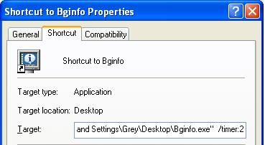
- Right-click the Shortcut to Bginfo icon and select Properties. On the Shortcut tab, in the Target box, add /timer:2 to the end of the target string, as shown to the right on this page. This will make Bginfo run each time you log in, and make the pause only 2 seconds to prevent it from being too annoying.

Changing Your Virtual Machine’s Name
- All the virtual machines now have the same name. This will cause warning messages to appear on the desktops, and it’s confusing. So you should change your machine’s name to contain the station number and your name, with the following steps:
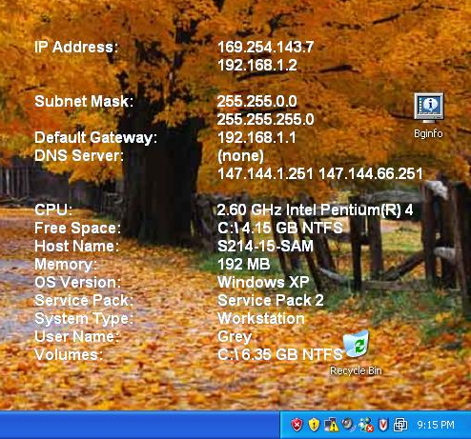
- Click the Start button on your virtual machine’s desktop, right-click My Computer, and click Properties. Click the Computer Name tab. Click the Change button. Enter the name of your station followed by your name, which will be something like this S214-01-YOURNAME. Click OK. When a Computer Name Changes box appears saying “You must restart…”, click OK. In the System Properties box, click OK. In the System Settings Change box, click Yes. Wait while your virtual computer restarts. Log in as you did before.

Saving a Screen Image
- You have now completed Project 1. The only thing that remains is to turn it in. To do that, you need to make a JPEG image of the screen and email it to me, as explained below. Note the hand symbol just below this text: that indicates screen images that you must capture and turn in.
- Click on the virtual machine’s desktop to make sure it is active.
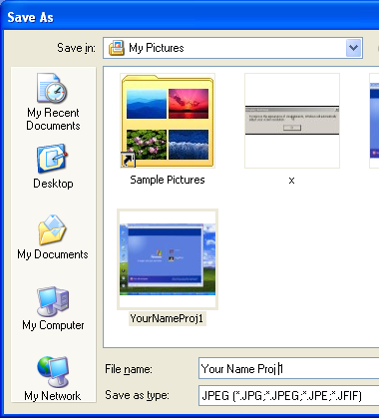
- Press the PrintScrn key in the upper-right portion of the keyboard. That will copy the whole desktop to the clipboard.
- In the virtual machine, click Start, Programs, Accessories, Paint. In the untitled - Paint window, select Edit, Paste from the menu bar. The desktop appears in the Paint window, with only a corner of it visible.
- In the untitled - Paint window, click File, Save. Save the document in the My Pictures folder (or any other place you wish, such as a floppy disk) with the filename Your Name Proj 1. Select a Save as type of JPEG, as shown in the figure to the right on this page.
- Email the JPEG image to me as an attachment. Send it to: cnit.123@gmail.com with a subject line of Proj 1 From Your Name, replacing Your Name with your own first and last name. Send a Cc to yourself.
Last Modified: 1-17-07 6:19 pm

