What You Need for This Project

LEGAL WARNING!
Use only machines you own, or machines you have permission to hack into. Hacking into machines without permission is a crime! Don’t do it! If you do illegal things, you may be arrested and go to jail, and I will be unable to save you. These instructions are intended to train computer security professionals, not to help criminals.
- A trusted computer running any version of Windows, with Internet access. You need administrator privileges. This can be either a real or virtual machine.
- A victim computer running any OS at all (even a Mac or Linux), networked to the trusted computer with either non-switched Ethernet or Wi-Fi. This can be either a real or virtual machine.
Packet Sniffing and Switched Ethernet
- This will only work on a non-switched network – that is, an Ethernet network using hubs. There are ways to do similar things on a switched network, but it’s harder—you have to flood the switch with data so that it stops switching.
- The defect of non-switched Ethernet that we will exploit here is that every frame is sent to every device on the hub, so your computer is able to read what other computers send and receive. Most wired networks are now switched, but wireless networks naturally send signals to every computer nearby, so this sort of attack works well for them.
Installing the Wireshark Packet Sniffer
- Use your trusted virtual machine.
- Open a Web browser and go to WireShark.org
- At the top left of the WireShark main page, click the Download link.
- In the Download a stable release section, click the SourceForge.net link. Find any location in the USA and click the Download link.
- In the Information Bar box, click OK.
- Click in the Information Bar at the top of the Internet Explorer window, and click on Download File.
- In the File Download – Security Warning box, click Run.
- In the Internet Explorer – Security Warning box, click Run.
- In the WireShark Setup Wizard box, click Next. Click through the installer screens accepting all the default selections.
- When a WinPCap Setup box appears, click Next. In the next screen, click I Agree. At the Completing screen, click Finish. (WinPCap is a program that captures packets so WireShark can analyze them, so you need to install it.)
- When the WireShark Setup screen says Installation Complete, click Next. At the Completing screen, click Finish.
Getting Your IP Address
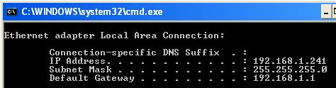
- Click Start, Run. Type in cmd and press the Enter key. In the Command Prompt screen, type in IPCONFIG and press the Enter key. If you have two network adapters, find the one with an IP address that starts with 192.168.1. Write that address in the box below, and make sure it is visible in the screen image you save.
Saving the Screen Image
- Click Start, Run. Enter the command mspaint and press the Enter key. Paint opens.
- Press Ctrl+V on the keyboard to paste the image into the Paint window. Click File, Save. Save the document in the My Pictures folder (or any other place you wish, such as a floppy disk) with the filename Your Name Proj 2a. Select a Save as type of JPEG.

Your IP Address: ____________________
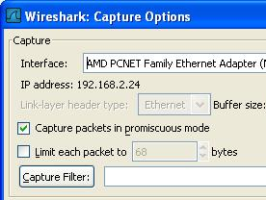
Starting a Capture in Promiscuous Mode
- Click Start, All Programs, Wireshark, Wireshark.
- From the Wireshark menu bar, click Capture, Interfaces. Find the Interface with an IP address starting with 192.168.1. That’s the interface that connects to the room’s LAN. Click the Options button in that interface’s line.
- In the Wireshark Capture Options box, verify that the Capture packets in promiscuous mode box is checked, as shown to the right on this page. This means that your network interface will accept all the frames it receives, even the ones that are addressed to other machines. Click the Start button.
- If you see a message saying Save capture file before starting a new capture?, click Continue Without Saving.
Entering a Password in the CCSF WebMail Client
- In your virtual machine, open a browser and go to hills.ccsf.edu/mail
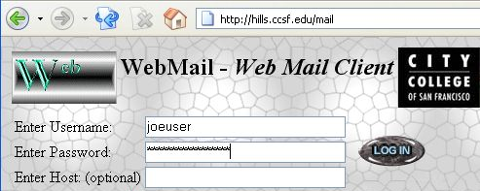
- In the Username box, enter joeuser
- In the Password box, enter topsecretpassword
- Do NOT put in your real user name and password! As you will see, this Web page is not secure. After this lab, you might not want to use it anymore!

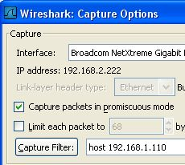
- Click the LOG IN button. After a few seconds, a message appears saying Username/Password Failure.
- In the Wireshark: Capture box, click Stop. When I did it, I only captured 24 packets. If you have a lot more packets, it will make it harder to read the trace – try repeating steps 7 through 15, but be quicker in your actions so that you don’t get as much extra junk from the other machines in the room. Another way to clean up the output is to specify the IP address of the traffic you want to see in the Capture Options box, as shown to the right on this page.
Viewing the Password Captured From Your Own Computer
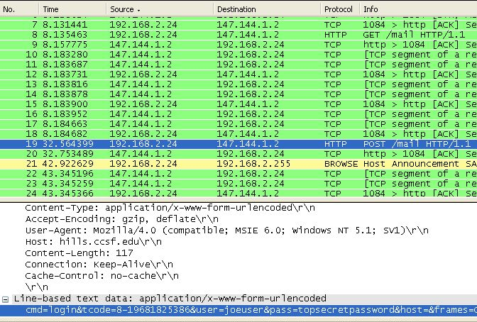
- Wireshark shows the captured packets. Look at the Info column and find a packet that says
POST /mail HTTP/1.1. In the screen below, it is packet 19. This is the packet that sent the user name and password to the hills server. Notice that the Source IP address is your own IP address, the one you wrote in the box on the previous page.
- Click the POST /mail HTTP/1.1 line to select it. The two lower panes now show the details of the packet. Just look at the middle pane, and expand the item called Line-based text data. You should be able to see user=joeuser and pass=topsecretpassword easily readable in the packet, as shown above.
Saving the Screen Image
- On the Start menu, click Run. Enter the command mspaint and press the Enter key. Paint opens.
- Press Ctrl+V on the keyboard to paste the image into the Paint window. Save the document in the Shared Documents folder with the filename Your Name Proj 3b. Select a Save as type of JPEG. Close Paint.
Capturing a Password From a Different Computer
- Go to a different machine in the room (either virtual or real) and get its IP address with IPCONFIG. Write that address in the box to the right on this page.

Other Machine’s IP Address: ____________________
- On your own virtual machine, start another capture in promiscuous mode, as you did in steps 15-18 above.
- On the other machine, go to the hills.ccsf.edu/mail website. Log in with the fake name joeuser2 and password topsecretpassword2.
- On your own virtual machine, stop the capture and examine the captured packets. Find the packet captured from the other machine that shows the username and password, as shown below. I found it helpful to click the gray Info header to sort by Info and look for POST /mail packets. It also took me three tries to get it to work – I think that’s because my virtual machine at home ran so slowly that it did not capture all the packets.
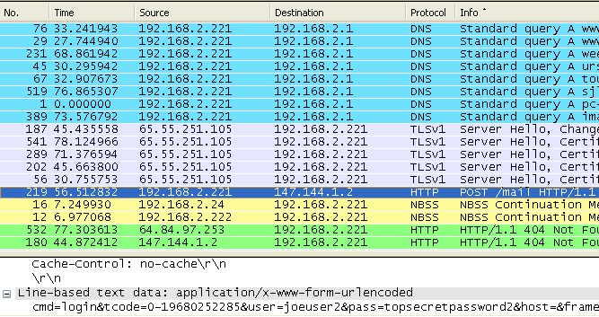

- Make sure these identifying features are visible in your screen image:
  - Info: HTTP POST /mail HTTP/1.1
  - Source: A different IP address than yours, starting with 192.168.1 (not 192.168.2 as shown in the image below)
  - Destination: 147.144.1.2 (CCSF’s Webmail server)
  - Line-based text data showing: user-joeuser2 and pass=topsecretpassword2
Saving the Screen Image
- On the Start menu, click Run. Enter the command mspaint and press the Enter key. Paint opens.
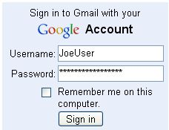
- Press Ctrl+V on the keyboard to paste the image into the Paint window. Save the document in the Shared Documents folder with the filename Your Name Proj 3c. Select a Save as type of JPEG. Close Paint.
Observing a Secure Password Transmission
- On your own virtual machine, start another capture in promiscuous mode, as you did in steps 15-18 above.
- On your own virtual machine, open a browser and go to gmail.com. Log in with the fake name JoeUser and password topsecretpassword, as shown to the right on this page.
- Stop the capture and examine the captured packets. Look in the Info column and find Client Hello, then Server Hello, then Certificate, as shown below. Those exchanges are parts of the SSL Handshake that prepared an encrypted layer to send your username and password.
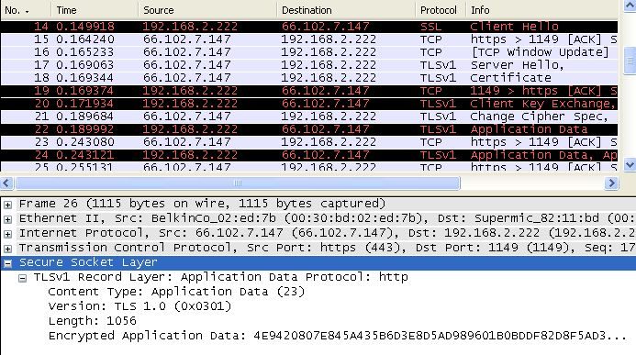

- Find a TLSv1 Application Data packet in the top pane, like packet 26 in the image on the previous page, and click it to select it. In the middle pane, click the + sign to expand Secure Sockets Layer. Expand TLSv1 Record Layer so that the Encrypted Application Data is visible. Your user name and password are concealed in that encrypted data. So even though the packet sniffer can see the data go by, it cannot be read. This is how SSL protects you--all Web logons should use SSL.

- Make sure Encrypted Application Data is visible in your screen image.
Saving the Screen Image
- On the Start menu, click Run. Enter the command mspaint and press the Enter key. Paint opens.
- Press Ctrl+V on the keyboard to paste the image into the Paint window. Save the document in the Shared Documents folder with the filename Your Name Proj 3d. Select a Save as type of JPEG. Close Paint.
Turning in your Project
- Email the JPEG images to me as attachments to one e-mail message to cnit.123@gmail.com with a subject line of Proj 3 From Your Name. Send a Cc to yourself.
Last modified 1-19-07

