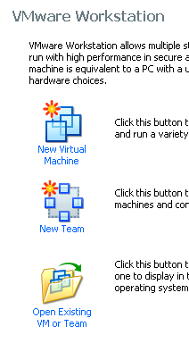
Using VMWare Workstation to Create a New Virtual Machine
- We are using VMware Workstation in the S214 lab, but it’s not a free program. If you are working at home, use VMmanager to create the virtual machine instead.
- Double-click the VMWare Workstation icon on the desktop.
- A VMWare Workstation window opens as shown to the right on this page. Click the New Virtual Machine icon.
- At the Welcome to the New Virtual Machine Wizard screen, click Next.
- At the Select the Appropriate Configuration screen, accept the default selection of Typical and click Next.
- At the Select a Guest Operating System screen, make sure that the Linux radio button is selected and in the Version box, select Ubuntu. Click Next.
- At the Name the Virtual Machine screen, enter a Virtual machine name of Your Name Ubuntu. Click the Browse button to choose the drive and folder to save the VM in. Navigate to V:\YOURNAME_VMs. Click Next.
- At the Network Type screen, accept the default selection of Use Bridged Networking and click Next.
- At the Select the Appropriate Configuration screen, accept the default selection and click Next.
- At the Specify Disk Capacity screen, change the size to 7 GB. Do not check either of the boxes. Click Finish.
- You should now see a window with Your Name Ubuntu in large gray letters near the top.

Adjusting Network Settings
- The Ethernet settings on VMware Workstation are set to match the two physical network interfaces on our lab machines, so you will need to adjust network settings. This only has to be done once for each virtual machine. If you are working at home, this probably won’t be necessary.
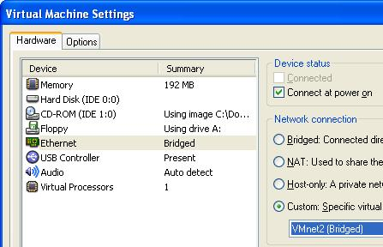
- In the Windows XP Professional – Vmware Workstation window, on the left side, click the Edit virtual machine settings link.
- In the Virtual Machine Settings box, on the Hardware tab, click the Ethernet item to select it. On the right side, click the Custom radio button and select VMnet2 (Bridged) as shown to the right on this page. Click the Add button.
- In the Welcome to the Add Hardware Wizard screen, click Next.

- In the Hardware Type screen, click Ethernet Adapter and click Next.
- In the Network Type screen, on the right side, click the Custom radio button and select VMnet0 (default Bridged). Click Finish.
- In the Virtual Machine Settings screen, click OK.

Booting the Virtual Machine from the Ubuntu CD Image
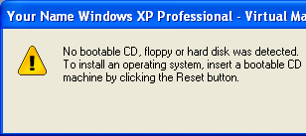
- In the Commands section in the middle of the window, click Start this virtual machine.
- A Your Name Windows XP Professional – Virtual Machine opens saying The keyboard hook timeout value …. Click OK to close the box.
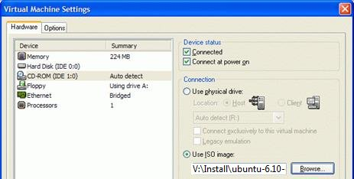
- The virtual machine starts, and attempts to boot up, but there is no operating system installed, so it ends with the message shown on to the right on this page.
- Click OK to close the dialog box.
- From the Menu bar, select VM, Settings.
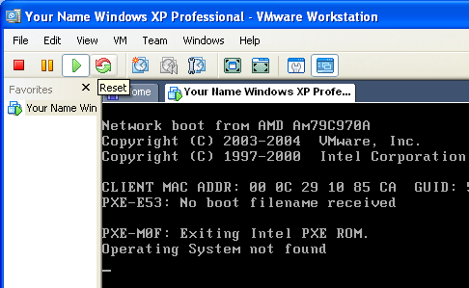
- In the Virtual Machine Settings box, click CD-ROM in the left pane. In the right pane, click Use ISO Image. Click the Browse button and navigate to V:\Install\ubuntu-6.10-desktop-i386.iso
- Click OK to close the Virtual Machine Settings box
- Click the Reset button as shown to the right on this page. If a VMWare Workstation box opens asking Are you sure that you want to restart the guest operating system? click OK. In the next box, click OK.

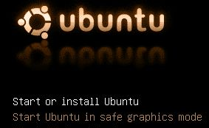
- The virtual machine should boot from the ISO image, and show you the ubuntu starting screen shown to the right on this page. If the virtual machine does not start from the CD, do these steps:
  - Restart the virtual machine again
  - As soon as the startup text appears in the window, click in the window and press the F2 key to edit the BIOS settings.
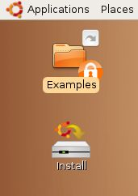
  - Adjust the Boot Order so that CD-ROM is first. Press F10 to Save and Exit, and Enter to confirm.
- Press the Enter key to Start or Install Ubuntu.
- Ubuntu will launch from the ISO file, and show a brown desktop with an Install icon on it, as shown to the right on this page.
- At this point, Ubuntu is running from the virtual CD. This “Live CD” mode is intended to let people try Linux on a Windows machine without changing the hard disk. The problem with it is that you cannot install software, save files, or customize it. Besides, we are using VMware, which protects the Windows XP host system anyway—we don’t need the Live CD feature. So we will install Ubuntu onto the virtual hard disk.

Installing Ubuntu Linux on the Virtual Machine
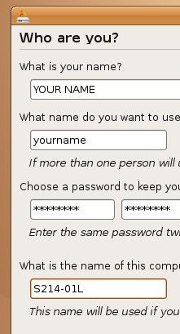
- Double-click the Install icon.
- In the first Linux install screen, accept the default selection of English and click the Forward button.
- In the second Linux install screen, click on the map to select Los Angeles for a time zone, and click the Forward button.
- In the keyboard layout screen, accept the default selection of U.S. English and click the Forward button.
- In the Who are you? screen, type in your name and a logon name. Enter a password you can remember – I recommend P@ssw0rd. Name your computer after the station number on the front panel, adding an L (for Linux) to the end, as shown to the right on this page. click the Forward button.
- In the Prepare disk space screen, accept the default selection of Erase entire disk and click the Forward button. You can do this because it’s a virtual hard disk, dedicated to Linux. It won’t erase the host system’s Windows XP files. This is a lot easier than the old-fashioned technique of partitioning the hard disk and setting up a dual-boot. Virtual machines are a lot easier to set up, and more powerful, because you can use several operating systems at the same time.
- In the Ready to install screen, click the Install button. When you see an Installation Complete box, click Restart now.

Starting Ubuntu Linux from the Virtual Machine
- If you see a message saying “Please remove the disc”, and you are working in S214, do the following steps. (If you are working at home, you can just click the CD button at the top of the VMware Player window to disconnect it.)
  - Click the lower X button in the upper right of the Ubuntu screen to shut down the virtual machine without completely closing VMware Workstation.
  - You should now see a window with Your Name Ubuntu in large gray letters near the top.
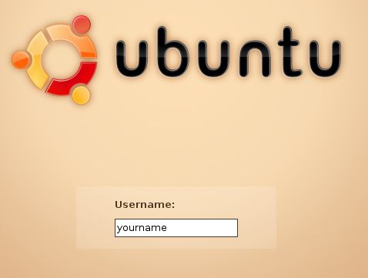
  - From the Menu bar, select VM, Settings.
  - In the Virtual Machine Settings box, click CD-ROM in the left pane. In the right pane, click Use physical drive.
  - Click OK to close the Virtual Machine Settings box
  - Click Start this virtual machine.
- You should see a GRUB LOADING message, and when Ubuntu boots up, you will see the login screen shown to the right on this page. Type in your user name and press the Enter key. Then type in your password and pres the Enter key.

Updating Ubuntu
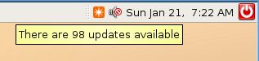
- Just like Windows, Ubuntu has vulnerabilities and a constant stream of updates. And, just like Windows, sometimes the security vulnerabilities are serious, and demonstrate complete stupidity on the part of the designers (see link Ch 1q on my Web page).
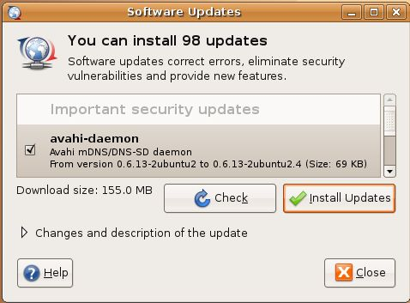
- At the upper right of the screen, you will see a clock with some icons near it. The leftmost icon is an orange square with a white star on it. Point to that icon and you should see that updates are available – 98 updates, when I did it, as shown to the right on this page.
- Click the orange icon. A Software Updates box opens, as shown to the right on this page. Click the Install Updates button.
- A box pops up asking for your password. This is an excellent security feature of Linux that makes it essentially immune from spyware, and Microsoft has incorporated it into Windows Vista. Type in your password and press Enter.
- When you see the Updates Complete message, close all windows.
- Click the red button to the right of the clock and click Restart. Log in as usual.

Installing Nessus and Nmap
- Ubuntu is a Debian Linux distribution, and one of the great things about Debian is that it has a graphical program manager, so you can install applications from a menu right from the Internet without having to compile them. They are just ready to go, like adding Windows components to a Windows machine. And they are all free!
- From the menu bar, click Applications, Add/Remove….
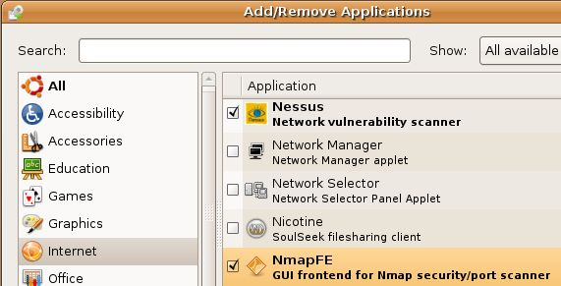
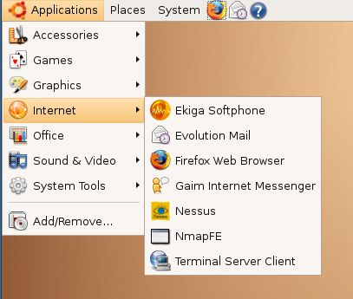
- In the left column of the Add/remove Applications box, click Internet. Scroll down to find Nessus and check it. Also check NmapFE. When a box pops up saying “Install community maintained software?,” click Install. Type in your password when prompted to. Wait while software downloads and progress bars move across the screen.
- Your Add/Remove Programs box should now have two check marks in it, as shown to the right on this page. Click OK.
- In the next box, click Apply. Wait while files download and install. When you see a Changes applied box, click Close.
Saving the Screen Image
- From the Ubuntu menu bar, click Applications, Internet. You should see the Nessus and NmapFE applications on the list, as shown to the right on this page. Ctrl+Alt to release the mouse, and click on the host Windows XP desktop. Press the PrntScn key to copy whole screento the clipboard.
- On the host Windows XP desktop, open Paint and paste in the image. Save it as a JPEG, with the filename Your Name Proj 5.
Turning in your Project
- Email the JPEG image to me as an attachment. Send the message to cnit.123@gmail.com with a subject line of Proj 5 From Your Name. Send a Cc to yourself.
Last modified 1-19-07

