Start Your Ubuntu Virtual Machine
Warning! Unexpected port scans are rude, and possibly even illegal! Port scans can set off intrusion detection systems and get us all into trouble. Don’t scan other people’s servers, just scan machines you have permission to scan. The only machines you should scan in this project are machines in S214, or on your own network at home.
- Double-click the VMware Workstation icon on the desktop. In the VMware Workstation window, from the menu bar, click View, Go to Home Tab.
- On the Home tab, click the Open Existing VM or Team icon. Navigate to the V: drive, open your folder, open the Your Name Ubuntu folder, and double-click the Your Name Ubuntu.vmx file. On the left side, click the Start this virtual machine link.
- If you see a message saying “The location of this virtual machine’s configuration file has changed…,” accept the default selection of Create and click OK.
- When your machine starts up, log in as with the name and password you chose in the previous project.

Port Scanning Your Own Ubuntu Machine
- From the menu bar in the upper left corner of the Ubuntu desktop, click Applications, System Tools, NmapFE.
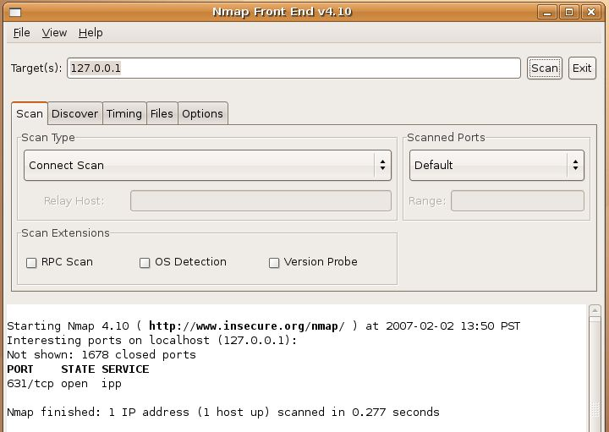
- In the Nmap Front End window, accept the default Target of 127.0.0.1. Accept the default Scan Type of Connect Scan and click the Scan button. The results should show the Interesting ports on localhost as shown to the right on this page. The only port open is 631/tcp ipp. This is the Linux shared printer service. You don’t have a printer installed, but the service is available to share a printer if you want to.

Finding the IP Address of Your Host Machine
- In the Windows XP host machine (not the Ubuntu virtual machine), click Start, Run. In the Run box, enter cmd and press the Enter key. In the Command Prompt window, enter the IPCONFIG command and press the Enter key. Several IP addresses appear. Find the one that starts with 192.168.1 and write it in the box to the right on this page.

Host IP: ____________________

Port Scanning Your Own Host Machine
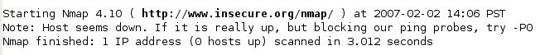
- In the Nmap Front End window, enter the IP address of your host machine. Accept the default Scan Type of Connect Scan and click the Scan button. You should get results as shown below: Host seems down. That’s a strange result, because the host is up. The reason NMAP fails is that we are not running it as root.

Starting NmapFE as root
- Click the X in the upper right corner of the Nmap Front End window to close it.
- From the menu bar in the upper left corner of the Ubuntu desktop, click Applications, Accessories, Terminal.
- In the Terminal window, after the $ prompt, enter this command, then press the Enter key:
sudo nmapfe
This command starts the Nmap Front End. The sudo at the start elevates your privileges to root (administrative) temporarily.
- At the Password: prompt, enter your password and press the Enter key:
Your password is required to elevate your privileges.

Port Scanning Your Own Host Machine as root
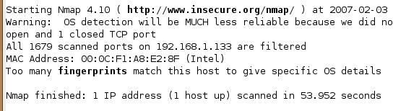
- In the Nmap Front End window, enter the IP address of your host machine. Click in the Scan Type box and look at the options—you have a lot of choices now! Click Connect Scan and click the Scan button. Wait for the scan to finish—it will take about a minute.
- You should get results as shown below on this page, showing all ports filtered. You may see some ports open, depending on how the firewall is set on your host machine.

Starting your Trusted Machine
- Double-click the VMware Workstation icon on the desktop. In the VMware Workstation window, from the menu bar, click View, Go to Home Tab.
- On the Home tab, click the Open Existing VM or Team icon. Navigate to the V: drive, open your folder, open the Win XP Pro for Hacking folder, and double-click the Windows XP Professional.vmx file. You should see a Windows XP Professional VM in the Powered Off state.
- In the Windows XP Professional – VMware Workstation window, on the left side, click the Start this virtual machine link.
- When your machine starts up, click the Student account to log in. There is no password, and the Student account has Administrative privileges.

Finding the IP Address of Your Trusted Machine
- In your trusted Windows XP virtual machine, click Start, Run. In the Run box, enter cmd and press the Enter key. In the Command Prompt window, enter the IPCONFIG command and press the Enter key. Several IP addresses appear. Find the one that starts with 192.168.1 and write it in the box to the right on this page.

Trusted IP: ____________________

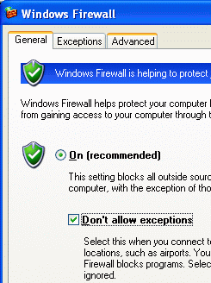
Setting Your Trusted Machine’s Firewall to No Exceptions
- In your trusted Windows XP virtual machine, click Start, Control Panel. If you see a heading of Pick a category in the right pane, click the Switch to Classic View link in the left pane.
- Double-click Windows Firewall. In the Windows Firewall box, on the General tab, check the Don’t allow exceptions box, as shown to the right on this page. Click the OK button.

Port Scanning Your Trusted Machine With the Firewall On – No Exceptions
- In the Nmap Front End window, enter the IP address of your trusted Windows XP virtual machine. Click in the Scan Type box, click Connect Scan, and click the Scan button. Wait for the scan to finish—it will take about a minute.
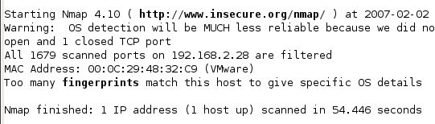
- You should get results as shown to the right on this page, showing All 1679 scanned ports are filtered. That’s what the firewall does—blocks all responses from all ports.

Saving a Screen Image
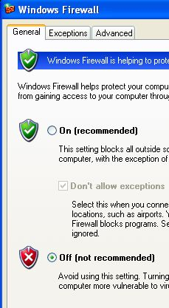
- Click outside the virtual machine to make the host machine’s desktop active.
- Press the PrintScrn key to copy the whole desktop to the clipboard.
- In the host machine, click Start, Programs, Accessories, Paint. In the untitled - Paint window, select Edit, Paste from the menu bar. The desktop appears in the Paint window, with only a corner of it visible.
- In the untitled - Paint window, click File, Save. Save the document in the My Pictures folder (or any other place you wish, such as a floppy disk) with the filename Your Name Proj 6a. Select a Save as type of JPEG.

Setting Your Trusted Machine’s Firewall to Off
- In your trusted Windows XP virtual machine, click Start, Control Panel. If you see a heading of Pick a category in the right pane, click the Switch to Classic View link in the left pane.
- Double-click Windows Firewall. In the Windows Firewall box, on the General tab, check the Off (not recommended) box, as shown to the right on this page. Click the OK button.

Port Scanning Your Trusted Machine With the Firewall Off
- In the Nmap Front End window, verify that the IP address of your trusted Windows XP virtual machine is still in the Target(s) box. Click in the Scan Type box, click Connect Scan, and click the Scan button.
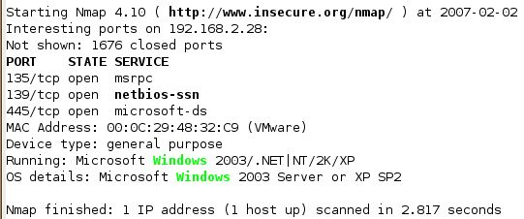
- You should get results as shown below on this page, showing a few open ports: 135, 139, and 445. The scan will finish much sooner, because it’s a lot faster for Nmap to collect responses from open ports than to wait for filtered ports to time out. With the firewall off, several ports respond. The OS detection is more accurate now too, because there are enough ports open to permit more tests.

Saving a Screen Image
- Click outside the virtual machine to make the host machine’s desktop active.
- Press the PrintScrn key to copy the whole desktop to the clipboard.
- In the host machine, click Start, Programs, Accessories, Paint. In the untitled - Paint window, select Edit, Paste from the menu bar. The desktop appears in the Paint window, with only a corner of it visible.
- In the untitled - Paint window, click File, Save. Save the document in the My Pictures folder (or any other place you wish, such as a floppy disk) with the filename Your Name Proj 6b. Select a Save as type of JPEG.

Turning in Your Project
- Email the JPEG images to me as attachments to a single email message. Send it to: cnit.123@gmail.com with a subject line of Proj 6 From Your Name, replacing Your Name with your own first and last name. Send a Cc to yourself.

Last Modified: 2-3-07

