Start Your Ubuntu Virtual Machine
- Double-click the VMware Workstation icon on the desktop. In the VMware Workstation window, from the menu bar, click View, Go to Home Tab.
- On the Home tab, click the Open Existing VM or Team icon. Navigate to the V: drive, open your folder, open the Your Name Ubuntu folder, and double-click the Your Name Ubuntu.vmx file. On the left side, click the Start this virtual machine link.
- If you see a message saying “The location of this virtual machine’s configuration file has changed…,” accept the default selection of Create and click OK.
- When your machine starts up, log in as with the name and password you chose in the previous project.

Installing Ruby on Rails
- Metasploit uses Ruby on Rails, a popular programming environment. Ruby on Rails does not come pre-installed in Ubuntu Linux, so we need to install it. This is a good thing to do, so you see the steps in a typical Linux installation for software that is not included in the official Ubuntu ready-to-go applications.
- From the menu bar in the upper left corner of the Ubuntu desktop, click Applications, Accessories, Terminal.
- In the terminal window, enter this command, then press the Enter key:
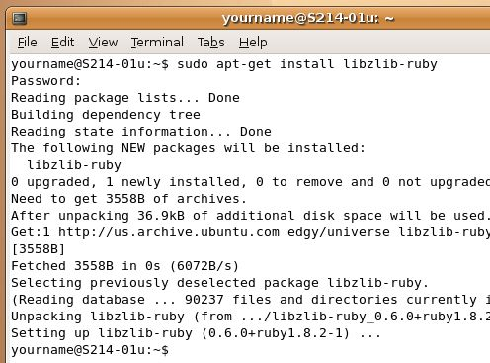
sudo apt-get install libzlib-ruby
sudo raises your privileges to root (administrative). Enter your password when you are prompted to. You won’t see your password on the screen, just type it anyway and press the Enter key. This command downloads and installs the zlib ruby modules. When you see the message Do you want to continue (Y/n)? type Y and press the Enter key. You will see a lot of messages go by as things download and install, as shown to the right on this page. Wait until you see the $ prompt.

- In the terminal window, enter this command, then press the Enter key:
sudo apt-get install libopenssl-ruby
This command downloads and installs the openssl ruby modules. When you see the message Do you want to continue (Y/n)? type Y and press the Enter key. Wait until the messages stop, and you see the $ prompt.
- In the terminal window, enter this command, then press the Enter key:
sudo apt-get install libdl-ruby
This command downloads and installs more ruby modules. Wait until the messages stop, and you see the $ prompt.
- In the terminal window, enter this command, then press the Enter key:
cd /etc/apt
This command changes the working directory to /etc/apt, where a configuration file needs to be edited.
- In the terminal window, enter this command, then press the Enter key:
sudo cp sources.list sources.list.bak
This command copies the sources.list configuration file to a backup copy, which is a good thing to do before making changes, in case you decide you want to return to the original file.
- In the terminal window, enter this command, then press the Enter key:
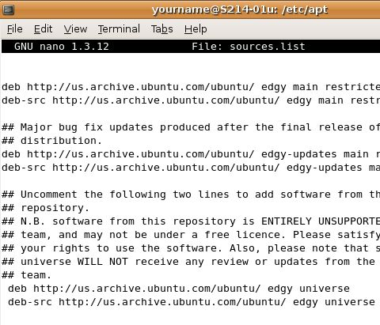
sudo pico sources.list
This command starts the pico text editor so we can change the sources.list configuration file. If you know how to use vi, use it instead. It’s a lot better, but more confusing at first.
- You will now see a file in the terminal window, with the File: sources.list in the center top. The whole window is now a text editor, which works more or less like Notepad. This file specifies where Ubuntu is allowed to look for software. You need to remove four # symbols from this file to allow it to get Ruby on Rails.
- Find these two lines at the bottom of your screen:
# deb http://us.archive.ubuntu.com/ubuntu/ edgy universe
# deb-src http://us.archive.ubuntu.com/ubuntu/ edgy universe
- Delete the # characters from the start of each of those lines, so your screen looks like the image above on this page. That makes the lines effective, instead of leaving them comments.

- Use the down-arrow to scroll down to the bottom of the file, and find these two lines:
deb http://security.ubuntu.com/ubuntu edgy-security universe
deb-src http://security.ubuntu.com/ubuntu edgy-security universe
- Delete the # characters from the start of each of those lines, so your screen looks like the image below on this page. That makes the lines effective, instead of leaving them comments.
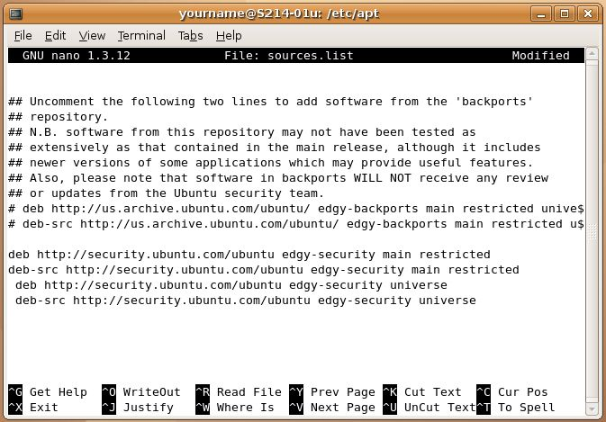

- Hold down the Ctrl key and press the O key to save your file. A message appears saying File name to write: sources.list. Press the Enter key.
- Hold down the Ctrl key and press the X key to exit from pico. You should see a $ prompt again.
- In the terminal window, enter this command, then press the Enter key:
sudo apt-get install ruby ri rdoc mysql-server libmysql-ruby
This command downloads and installs the ruby and mysql base packages. If you are asked for your password, enter it. When you see the message Do you want to continue (Y/n)? type Y and press the Enter key. Wait until the messages stop, and you see the $ prompt.
- In the terminal window, enter this command, then press the Enter key:
sudo wget http://rubyforge.org/frs/download.php/11289/rubygems-0.9.0.tgz
This command downloads and installs the latest ruby gems from rubyforge. Wait until the messages stop, and you see the $ prompt. If you get an error in name resolution, repeat the command.

- In the terminal window, enter this command, then press the Enter key:
sudo tar -xvzf rubygems-0.9.0.tgz
This command extracts the files from the compressed archive file. Wait until the messages stop, and you see the $ prompt.
- In the terminal window, enter this command, then press the Enter key:
cd rubygems-0.9.0
This command changes the working directory to the rubygems-0.9.0 subdirectory, where the extracted files are.
- In the terminal window, enter this command, then press the Enter key:
sudo ruby setup.rb
This command completes adding “gems” to ruby.
- In the terminal window, enter this command, then press the Enter key:
sudo gem install rails --include-dependencies
This command installs “rails”. The process is slow, and there are some error messages such as unrecognized directive: ‘nodoc’ – don’t worry about them. Then there are long pauses while it installs things called actionpack and actionmailer. Wait until the messages stop, and you see the $ prompt.
- In the terminal window, enter this command, then press the Enter key:
sudo gem install –v=1.1.6 rails
This command updates “rails”. Enter your password if you are prompted to. When you see the message Install required dependency … (Y/n)? type Y and press the Enter key. That will happen five times. Wait until the messages stop, and you see the $ prompt.

Downloading Metasploit
- From the menu bar in the upper left corner of the Ubuntu desktop, click Applications, Internet, Firefox Web Browser.
- Go to metasploit.com. In the upper right of the window, next to the Framework 3.0 label, click EVERYONE.
- In the next page, find the 3.0 Beta 3 row, and click the framework-3.0-beta-3-svn.tar.gz link, as shown below on this page.
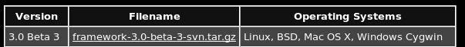

- The next screen shows a long agreement. Scroll to the bottom and click Accept. In the Security Warning box, click Continue.

Opening the Compressed Tarball
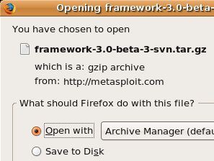
- This file is a compressed tarball—the .tar file extension indicates that it is a Tape Archive—a collection of many files into a single uncompressed file. .That file was then compressed with the compress command to form a compressed archive with the extensions .tar.gz. This type of file is comparable to Windows Zip files.
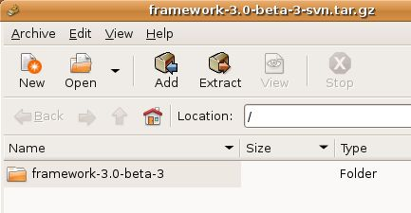
- In the Opening framework-3.0-beta-3-syn.tar.gz box, accept the default selection of Open with Archive Manager, as shown to the right on this page, and click OK. The archive manager is the Linux equivalent of Winzip, and it opens the tarball.

- In the framework-3.0-beta-3-syn.tar.gz box shown to the right on this page, click the Extract button.

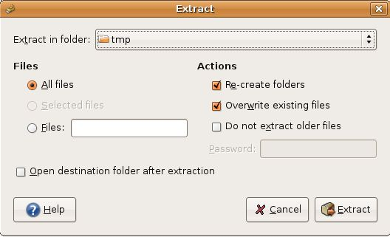
- In the Extract box, accept the default selections as shown to the right on this page and click the Extract button. This extracts the files into the /tmp folder. This is the usual place to put downloaded files, just like the temporary folders Windows uses.

Copying the Metasploit Software to the /usr/local/msf Folder
- Close all the windows, except a Terminal window. If necessary, from the menu bar in the upper left corner of the Ubuntu desktop, click Applications, Accessories, Terminal.
- In the terminal window, enter this command, then press the Enter key:
cd /tmp/framework-3.0-beta-3
This changes the working directory to the directory the Metasploit files are located in.
- In the terminal window, enter this command, then press the Enter key (The first character is the letter l, not the numeral 1.):
ls
This displays the files in the directory, as shown below on this page. Notice that the executable files appear in green, and that they include some files that you may remember from the Windows Metasploit project, such as msfweb.
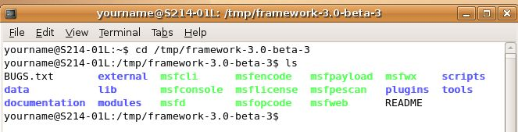

- In the terminal window, enter this command, then press the Enter key:
sudo mkdir /usr/local/bin/msf
This elevates your privileges to administrator with sudo and then creates the folder the files will live in: /usr/local/bin/msf. If you are prompted to, enter your password. Your password is required to elevate your privileges.
- In the terminal window, enter this command, then press the Enter key:
sudo cp * /usr/local/bin/msf -r
This elevates your privileges to administrator with sudo and then copies all the files and folders in the current directory to the /usr/local/bin/msf folder.
- In the terminal window, enter this command, then press the Enter key:
cd /usr/local/bin/msf
This changes the working directory to /usr/local/bin/msf

- In the terminal window, enter this command, then press the Enter key:
ls
This displays the files in the directory, as shown below on this page. All the files and folders are now present in this directory, which is the recommended place to put them according to the Metasploit User Documentation.
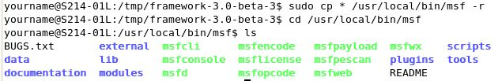

Starting msfweb
- In the terminal window, enter this command, then press the Enter key:
sudo ./msfweb
This command starts the msfweb server, as shown below on this page.
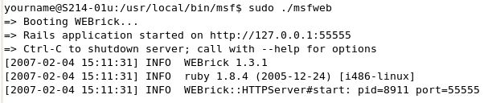

If you see error messages, look for clues in them about the problem. For example, if the messages say that openssl files cannot be found, go repeat step 8 in which you installed them.

Connecting to msfweb with Firefox
- From the menu bar in the upper left corner of the Ubuntu desktop, click Applications, Internet, Firefox Web Browser.
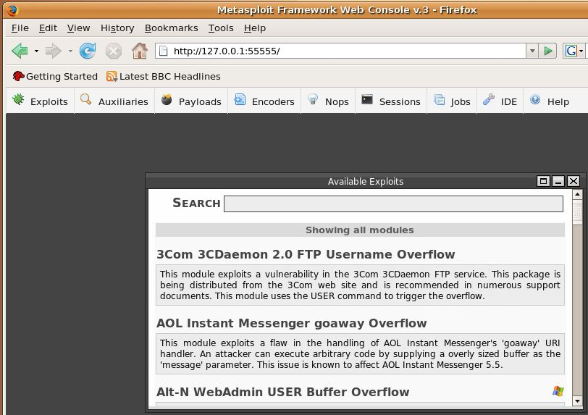
- Type in the address 127.0.0.1:55555 and press the Enter key. In the upper left of the Metasploit page, click Exploits. You should see a list of exploits in the center of the window, as shown below on this page.

Saving the Screen Image
- Press Ctrl+Alt to release the mouse, and click on the host Windows XP desktop. Press the PrntScn key to copy whole screen to the clipboard.
- On the host Windows XP desktop, open Paint and paste in the image. Save it as a JPEG, with the filename Your Name Proj 8.
Turning in your Project
- Email the JPEG image to me as an attachment. Send the message to cnit.123@gmail.com with a subject line of Proj 8 From Your Name. Send a Cc to yourself.

Credits
I got a lot of this from:
http://www.urbanpuddle.com/articles/2006/12/07/install-ruby-rails-on-ubuntu-edgy-eft

Last modified 2-9-07

