What You Need for This Project
- A trusted computer running any version of Windows, with Internet access. You need administrator privileges. This can be either a real or virtual machine.

Introduction to Tor
Tor protects your privacy when you use the Internet by bouncing the packets through randomly-selected "Onion Routers." Tor comes with two related programs—Provixy, a proxy server, and Videlia, a graphical user interface for Tor.
Installing The Onion Router (TOR)
- Use your Windows XP virtual machine.
- Open a Web browser and go to tor.eff.org
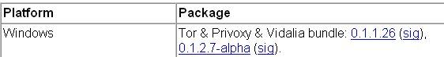
- At the top center of the main page, click Download.
- Click the blue link in the Windows section, which is 0.1.1.26 currently, as shown to the right on this page.
- Save the executable and run it. Click through the Vidalia Bundle Setup Wizard and install the software with the default options.
Configuring Firefox to Use Tor with Torbutton
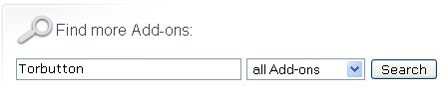
- You need Firefox. If you don't have it, open Internet Explorer and go to getfirefox.com, download it, and install it.
- Open Firefox and go to addons.mozilla.org
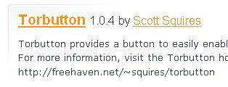
- Scroll down and find the Find more Add-ons box. Enter Torbutton as shown to the right on this page and click the Search button.
- Scroll down and click on Torbutton, as shown to the right on this page. In the next page, click the green Install now link. In the Software Installation box, wait a few seconds, then click the Install Now button.
- Close all windows. Start Firefox again.
Testing Tor: Finding Your Apparent IP Address With Tor Enabled
- Look at the status bar in the lower right corner of your Firefox window. If you see Tor Disabled in red letters, click on the letters to change them to Tor Enabled in green letters, as shown in the figure below on this page.
- Look at the Notification Area in the lower-right corner of your desktop, by the clock. There should be a green leaf, and a blue P with a circle around it, as shown in the figure below on this page. Hover the mouse over the leaf, and look for the message "Tor is running." If Tor is not running, right-click the leaf and click Start. Right-click the blue P and make sure Enable is checked.
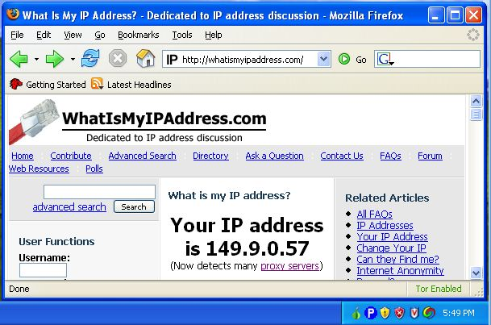

- In the address bar of the Firefox window, enter the address whatismyipaddress.com and press the Enter key. Make sure you can your IP address and the Tor Enabled notation in the lower right corner of the Firefox window.
Saving the Screen Image
- Press the PrtScn button to capture the screen image.
- Click Start, Run. Enter the command mspaint and press the Enter key. Paint opens.
- Press Ctrl+V on the keyboard to paste the image into the Paint window. Click File, Save. Save the document with the filename Your Name Proj 9a. Select a Save as type of JPEG.
Testing Tor: Finding Your Apparent IP Address With Tor Disabled
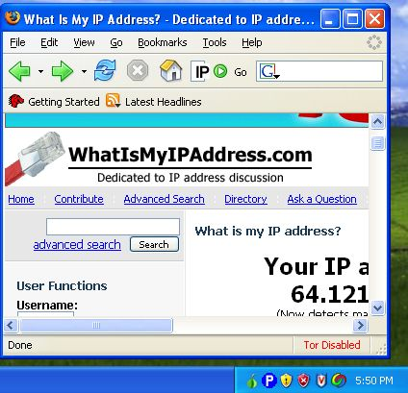
- In the lower right corner of your Firefox window, click on Tor Enabled. The words change to Tor Disabled in red letters.
- Press the F5 key on the keyboard to refresh the page. The IP address should change from the Tor router's address to your real IP address. If you don't want to record a screen image of your complete IP address, scroll the screen so that only part of it is visible, as I did when creating the image below. Just make sure enough of the address is visible to make it clearly different from the IP address in the other image.

Saving the Screen Image
- Press the PrtScn button to capture the screen image.
- Click Start, Run. Enter the command mspaint and press the Enter key. Paint opens.
- Press Ctrl+V on the keyboard to paste the image into the Paint window. Click File, Save. Save the document with the filename Your Name Proj 9b. Select a Save as type of JPEG.
Turning in your Project
- Email the JPEG images to me as attachments to one e-mail message to cnit.123@gmail.com with a subject line of Proj 9 From Your Name. Send a Cc to yourself.
Last modified 2-11-07

