What You Need for This Project

LEGAL WARNING!
Only spy on machines you own, or machines you have permission to soy on. Using keyloggers machines permission is a crime! Don’t do it! If you do illegal things, you may be arrested and go to jail, and I will be unable to save you. These instructions are intended to train computer security professionals, not to help criminals.
- A computer of any sort, as long as it has a keyboard plug that fits into the keylogger (PS/2 or USB).
- An ID card you can give your instructor in exchange for one of the keyloggers.

Plug in the Keylogger
- Unplug the keyboard in the back of your computer and insert the hardware keylogger Plug the keyboard back in.

Enter Text to Capture
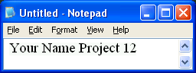
- Open Notepad and type in your name and project 12, as shown below on this page.

- Open a browser and go to Gmail.com. Enter a user name of JoeUser and a password of TopSecretPassword. Don't log in with your real password! Your keystrokes are being recorded!

Viewing the Captured Keystrokes
- Open another Notepad window and type in the password.
  - For the KEYGHOST, the password is vghostlog
  - For the KeyKatch, the password is keykatch
- As soon as you enter the password, a menu appears in Notepad, as shown on the next page. Feel free to experiment with the menu options, but Don't change the password! If you change the password, the device will become useless to everyone else, and there is no practical way to recover it.

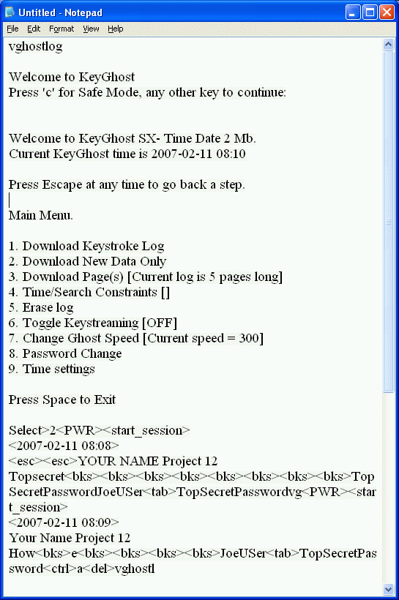

Display the Captured Keystrokes
- Find the option to view the keystrokes. For the example shown to the right on this page, the most convenient option is 2 to see the New Data. Make sure the password TopSecretPassword is visible in the screen, as shown in the last two lines of the image on the right on this page.

Saving a Screen Image
- Press the PrintScrn key in to copy the whole desktop to the clipboard.
- Click Start, Programs, Accessories, Paint. In the untitled - Paint window, select Edit, Paste from the menu bar.
- In the untitled - Paint window, click File, Save. Save the document in the My Pictures folder (or any other place you wish, such as a floppy disk) with the filename Your Name Proj 12. Select a Save as type of JPEG.

Return the Keylogger to Your Instructor
- Give the keylogger back, and reclaim your ID card.

Turning in Your Project
- Email the JPEG image to me as an attachment to an email message. Send it to: cnit.123@gmail.com with a subject line of Proj 12 From Your Name, replacing Your Name with your own first and last name. Send a Cc to yourself.

Last Modified: 2-14-07

