'What You Need for This Project

LEGAL WARNING!
Use only machines you own, or machines you have permission to hack into. Accessing computers without permission from the owners is a crime! Don’t do it! If you do illegal things, you may be arrested and go to jail, and I will be unable to save you. These instructions are intended to train computer security professionals, not to help criminals.
- A computer running Windows XP (any version). This can be either a real or virtual machine.
- You don’t need administrator privileges—you don’t need any login account at all on the Windows XP machine.
- You need physical access to the Windows XP machine, and the ability to boot from a CD.

Getting the Ultimate Boot CD Image
- You need the Ultimate Boot CD image, or a bootable CD of it. If you are working in the S214 lab, the image is already there in the V:\Install folder.
- If you are working at home, you can copy it from there onto a large storage device, or burn a bootable CD in the lab, or download it yourself from ubcd4win.com – you need to download " UBCD4WinV303.exe" and then run it. It performs a long installation process—it takes two hours or more, and requires a Windows installation CD.

Setting the Virtual CD to Use the Ultimate Boot CD Image
- If you are working at home, use VMmanager to direct the virtual CD to the Ultimate Boot CD ISO image. If you are working in S214, do the steps below:
  - Make sure your virtual machine is powered down. You cannot change these settings while it’s on.
  - In the VMware Workstation window, from the menu bar, click View, Go to Home Tab.
  - On the Home tab, click the Open Existing VM or Team icon. Navigate to the V: drive, open your folder, open the Win XP Pro for Hacking folder, and double-click the Windows XP Professional.vmx file. You should see a Windows XP Professional VM in the Powered Off state.
  - From the Menu bar, select VM, Settings.
  - In the Virtual Machine Settings box, click CD-ROM in the left pane. In the right pane, click Use ISO Image. Click the Browse button and navigate to
V:\Install\ UBCD4WinBuilder.iso
  - Click OK to close the Virtual Machine Settings box.
  - Click Start this virtual machine.

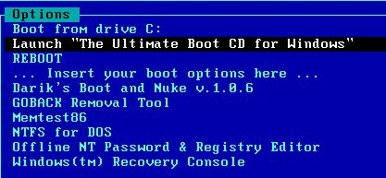
Booting from the Ultimate Boot CD Image
- The virtual machine should boot from the CD. If it doesn’t, you may have to click in the blank window, press F2, and adjust the boot order in the BIOS.
- When you see the screen shown to the right on this page, accept the default selection of Launch "The Ultimate Boot CD for Windows", and press the Enter key.

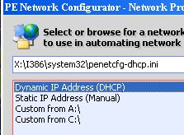
- When you see a box saying "Select shell to start,"don't click anything—just wait for it to close..
- When you see a box say ing "Network support is not started yet. Do you want to start network support now?" click Yes.
- In the "PE Network Configurator" box, accept the default of "Dynamic IP Address (DHCP)" and click OK.
- In the "PE Network Configurator" box, accept the default of "Obtain an IP Address Automatically" and click OK.

Using Password Renew to Create a New Administrator User
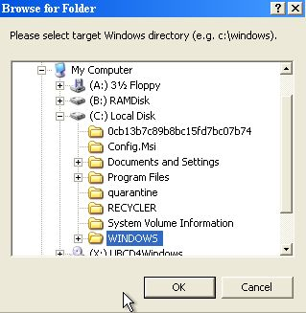
- When you see the desktop, click Start, Programs, Password Tools, Password Renew.
- In the "Password Renew for NT's v. 1.1 BETA" box, in the lower right, click the"Select a target" button. In the "Browse for folders" box, expand"(C:) Local Disk," click the WINDOWS folder, and click OK, as shown to the right on this page.
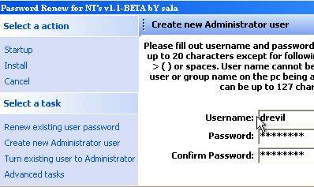
- In the "Password Renew for NT's v. 1.1 BETA" box, in the left pane, click "Create a new Administrator user".
- In the right pane, enter a user name of drevil and a password you can remember, such as password, in both password boxes.
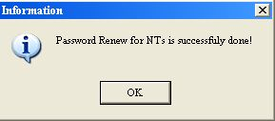
- In the left pane, click "Install". A box should pop up saying "Password Renew for NTs is successfully done!" as shown to the right on this page.

Saving a Screen Image
- Make sure the "Password Renew for NTs is successfully done!" message is visible.
- Press Ctrl+Alt to release the mouse cursor. Click outside the virtual machine to make the host machine’s desktop active.

- Press the PrintScrn key to copy the whole desktop to the clipboard.
- In the host machine, click Start, Programs, Accessories, Paint. In the untitled - Paint window, select Edit, Paste from the menu bar. The desktop appears in the Paint window, with only a corner of it visible.
- In the untitled - Paint window, click File, Save. Save the document in the My Pictures folder (or any other place you wish, such as a floppy disk) with the filename Your Name Proj 15. Select a Save as type of JPEG.

Testing the New Account
- From the desktop, click Start, "Turn off computer." In the "Shut down windows" box, select Restart and click OK.
- Click immediately in the virtual machine's window and press F2 to adjust the BIOS settings. Set the boot order to boot from the hard disk, not the CD. Let Windows start up normally.
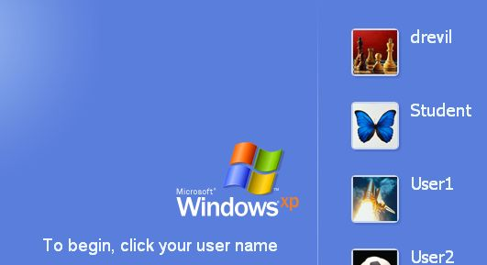
- You should see the drevil account on the Windows Welcome screen, as shown to the right on this page. Click on drevil and enter the password you selected, such as password.
- When the desktop loads, double-click the clock in the lower right corner of the desktop. When the clock opens so you can set the time, that proves you are an Administrator.

Protecting Your Computers From This Attack
- I don't know any defense against this. It is possible that a new Windows version would change the location of the NT password hashes, and cause this particular version of the tool to stop working, but it could just be updated. The only trustworthy way to prevent this would be to lock attackers out of the room with the computer in it. A BIOS password to prevent booting from the CD would slow an attacker down a bit, but all you need to do is open the system unit and remove the motherboard battery to defeat that.

Turning in Your Project
- Email the JPEG image to me as an attachment. Send it to: cnit.123@gmail.com with a subject line of Proj 15 From Your Name, replacing Your Name with your own first and last name. Send a Cc to yourself.

Last Modified: 2-23-07

