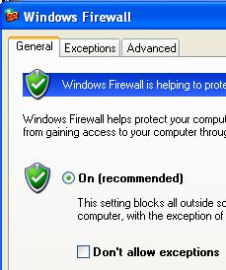
What You Need for This Project
- A trusted computer running Windows XP with Service Pack 2 (or any other version of Windows), with Internet access. You need administrator privileges. This can be either a real or virtual machine.
Turning on the Windows Firewall
- Use your trusted virtual machine.
- Click Start, Control Panel. If necessary, click "Switch to Classic View." Double-click "Windows Firewall." (If you are working at home and you don't have Service Pack 2, you won't have Windows Firewall. Pick a different firewall to test for this first section, anything other than Comodo, and install it.)
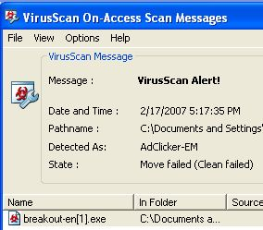
- Set the firewall to "On (recommended)" as shown to the right on this page. Click OK.
Running the Breakout Test
- Open a Internet Explorer (Firefox does not work, despite the presence of a Firefox version) and go to firewallleaktester.com
- In the left column, click on LeakTest16: Breakout. In the Download section, click IE English version. Save the file on your desktop.
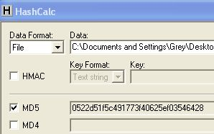
- If your antivirus stops the download, as shown to the right on this page, close the warning, right-click the shield icon in the taskbar tray, and select "Disable On-access scan." Then download it again and save it on your desktop. Breakout is not an adclicker, but the antivirus software is detecting that it does something unusual and stopping it as suspicious. That's a good thing, but we need to bypass it to test the firewall itself.
- Click Start, All Programs, Hashcalc, Hashcalc. Drag the breakout-en file into Date: box and drop it there. You should see the MD5 hash shown to the right on this page—compare it to the hash shown on the firewallleaktester.com website. This should be a habit—don't trust anything you download unless you can check a hash to make sure it is what it claims to be.
- Double-click the breakout-en file. In the Open File - Security Warning box, click Run.
- Internet Explorer should open the page shown below, demonstrating that "Breakout" worked. (If it doesn't work, scroll down a bit on the http://firewallleaktester/leaktest16 .htm page and download the breakout-wp file instead.) The program opened a connection from your machine to a remote website—since the Windows firewall doesn't stop outgoing traffic, this exploit works. This is a simple way to get past the Windows firewall—just trick the victim into initiating the connection.
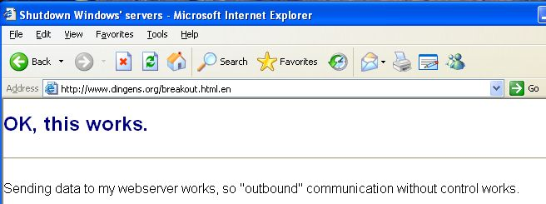

Saving the Screen Image
- Press the PrntScn key to copy the desktop to the clipboard.
- On the Start menu, click Run. Enter the command mspaint and press the Enter key. Paint opens.
- Press Ctrl+V on the keyboard to paste the image into the Paint window. Save the document in the Shared Documents folder with the filename Your Name Proj 16a. Select a Save as type of JPEG. Close Paint.
Running the DNStester Test
- Open a Internet Explorer and go to firewallleaktester.com
- In the left column, click on LeakTest14: DNStester. In the Download section, click dnstester.exe. Save the file on your desktop.
- Click Start, All Programs, Hashcalc, Hashcalc. Drag the dnstester.exe file into Date: box and drop it there. Make sure the MD5 hash matches the hash shown on the firewallleaktester.com website.
- Double-click the dnstester.exe file. In the Open File - Security Warning box, click Run.
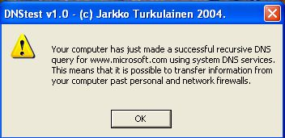
- In the DNStest v 1.0 box, click Yes.
- A box opens as shown to the right on this page with the results—the Windows firewall let the traffic out again.
Saving the Screen Image
- Press the PrntScn key to copy the desktop to the clipboard.

- On the Start menu, click Run. Enter the command mspaint and press the Enter key. Paint opens.
- Press Ctrl+V on the keyboard to paste the image into the Paint window. Save the document in the Shared Documents folder with the filename Your Name Proj 16b. Select a Save as type of JPEG. Close Paint.
Downloading the Free Comodo Firewall
- Open a browser and go to personalfirewall.comodo.com
- In the upper left of the window, click "Download Comodo Firewall Pro for Free Now."
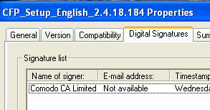
- On the next screen, accept the default selection of English and click Continue.
- Click "Download English Version of Comodo Firewall Pro 2.4." Save the file on your desktop.
Examining the Digital Signature
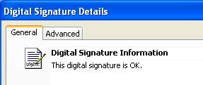
- Unfortunately, there is no MD5 hash on the Comodo website. But Comodo is not stupid—they have provided a digital signature, which is better. To check it, right-click the CFP_Setup_English_2.4.18.184 file on your desktop and click Properties. In the properties sheet, click the "Digital Signatures" tab. You should see a digital signature from Comodo CA Limited, as shown to the right on this page.
- Under the Name of signer: heading, click Comodo, CA Limited to highlight it. Click the Details button. You should see the message "This digital signature is OK," as shown to the right on this page. If the file had been modified, you would see a warning message here. To prove it, let's modify the file and see.
- Right-click the CFP_Setup_English_2.4.18.184 file, hold down the right mouse button, and drage it a small distance on the desktop. Release the mouse button. In the context menu, click Copy here.
- Right-click on the Copy of CFP_Setup_English_2.4.18.184 file and select Rename. Type in the name x and press the Enter key. Now you have a duplicate of the file named x.
- Right-click the x file on your desktop and click Properties. In the properties sheet, click the "Digital Signatures" tab. Click Comodo, CA Limited to highlight it. Click the Details button. You should see the message "This digital signature is OK." Merely changing the file name is not enough to make the digital signature invalid.
Modifying the 'x' File
- Click Start, All Programs, Accessories, Command Prompt. In the Command Prompt window, type in this command and then press the Enter key:
cd desktop
This command changes the working directory to the desktop folder, where the x.exe file is.

- In the Command Prompt window, type in this command and then press the Enter key:
echo "a" >> x.exe
This command adds an ASCII character 'a' to the end of the x.exe file.

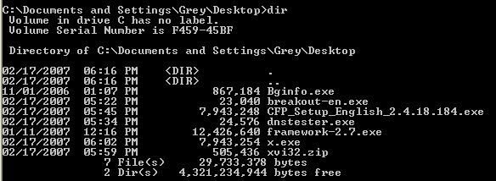
- In the Command Prompt window, type in this command and then press the Enter key:
dir

This command displays a directory of files on the desktop, with their sizes, as shown above on this page. As you can see, the x.exe file is now a few bytes larger than the original CFP_Setup_English_2.4.18.184 file.
- Close the Command Prompt window.
Examining the Digital Signature of the Modified File
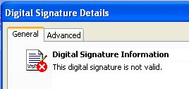
- Right-click the x file on your desktop and click Properties. In the properties sheet, click the "Digital Signatures" tab. Click Comodo, CA Limited to highlight it. Click the Details button. You should see the message "This digital signature not valid," as shown to the right on this page. Any change to the file, even a single character, invalidates the digital signature.
Saving the Screen Image
- Press the PrntScn key to copy the desktop to the clipboard.
- On the Start menu, click Run. Enter the command mspaint and press the Enter key. Paint opens.
- Press Ctrl+V on the keyboard to paste the image into the Paint window. Save the document in the Shared Documents folder with the filename Your Name Proj 16c. Select a Save as type of JPEG. Close Paint.
Installing the Comodo Firewall
- Double-click the CFP_Setup_English_2.4.18.184 file on your desktop.
- In the COMODO Firewall Pro Installer box warning you to install other firewalls, click Yes. (You cannot uninstall Windows Firewall.)
- In the Installation Wizard box, click Next.
- At the License Agreement screen, click Next.
- At the Choose Destination Folder screen, click Next.
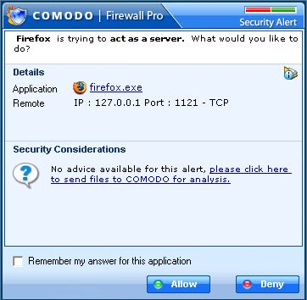
- At the Free License screen, uncheck the Sign me up for news about COMODO products box and click Next.
- In the next screen, accept the default selections of Automatic configuration, Turn off Windows Firewall, and Turn on Windows Data Execution Prevention and click Next.
- Restart your computer when you are prompted to.
- Open Firefox. A pop-up box appears, as shown to the right on this page, asking whether Firefox can act as a server. You must click Allow, or Firefox won't be able to access the Internet. These warning boxes are the cost of filtering outgoing traffic. This more powerful firewall will annoy you more.
Running the Breakout Test
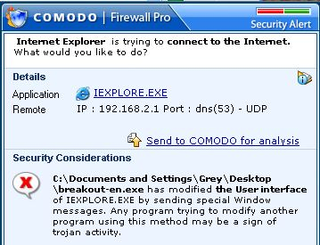
- Right-click the shield icon in the taskbar tray, and select "Disable On-access scan." Then use Internet Explorer to download the breakout test program again from firewallleaktester.com
- On your desktop, Double-click the breakout-en file. In the Open File - Security Warning box, click Run.
- A COMODO alert pops up, warning you that breakout is trying to connect to the Internet using a sneaky method, like a Trojan. COMODO works! It warns you about the breakout attempt.
Saving the Screen Image
- Press the PrntScn key to copy the desktop to the clipboard.
- On the Start menu, click Run. Enter the command mspaint and press the Enter key. Paint opens.
- Press Ctrl+V on the keyboard to paste the image into the Paint window. Save the document in the Shared Documents folder with the filename Your Name Proj 16d. Select a Save as type of JPEG. Close Paint.
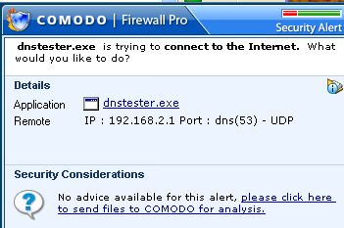
Running the DNStester Test
- Double-click the dnstester.exe file on your desktop. In the Open File - Security Warning box, click Run.
- In the DNStest v 1.0 box, click Yes.
- A COMODO alert pops up again, warning you. Comodo is a very highly-rated firewall because it catches more of these attempts than other firewalls do.
Saving the Screen Image
- Press the PrntScn key to copy the desktop to the clipboard.
- On the Start menu, click Run. Enter the command mspaint and press the Enter key. Paint opens.
- Press Ctrl+V on the keyboard to paste the image into the Paint window. Save the document in the Shared Documents folder with the filename Your Name Proj 16e. Select a Save as type of JPEG. Close Paint.
Turning in your Project
- Email the JPEG images to me as attachments to one e-mail message to cnit.123@gmail.com with a subject line of Proj 16 From Your Name. Send a Cc to yourself.
Last modified 2-25-07

