What You Will Need
Note: this is not a secure Web server. It is just the default IIS configuration. If you want a real Web server to host a Web site, this is only the first step
- A Windows XP machine to use as a Web server
- A Windows XP Installation disk (or ISO file)

Setting the Windows XP Virtual Machine to See the CD Image
- Double-click the VMware Workstation icon on the desktop. In the VMware Workstation window, from the menu bar, click View, Go to Home Tab.
- On the Home tab, click the Open Existing VM or Team icon. Navigate to the V: drive, open your folder, open the Windows XP for Hacking folder, and double-click the Windows XP Professional.vmx file.
- On the left side, click Edit virtual machine settings link.
- In the Virtual Machine Settings box, click CD-ROM in the left pane. In the right pane, click Use ISO Image. Click the Browse button and navigate to V:\Install\en_winxp_pro_with_sp2.iso
- Click OK to close the Virtual Machine Settings box
- On the left side, click Start this virtual machine link.
- As soon as the startup text appears in the window, click in the window and press the F2 key to edit the BIOS settings.
- Adjust the Boot Order so that the hard disk is first. That will prevent your virtual machine from starting from the CD. Press F10 to Save and Exit, and Enter to confirm.
- When your machine starts up, log in as Student, or any other account with Administrative privileges.

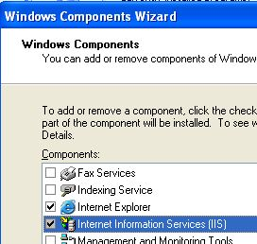
Installing Internet Information Services (IIS)
- On the virtual machine's desktop, click Start, Control Panel. If you see a Pick a category header, click Switch to Classic View. Double-click Add or Remove Programs.
- In the Add or Remove Programs box, click Add/Remove Windows Components.
- In the Windows Components Wizard box, click the box next to Internet Information Services (IIS), as shown to the right on this page.
- If a firewall warning pops up, allow this program access to the Internet.
- In the Windows Components Wizard box, click Next. Wait while files are installed.
- In the Completing the Windows Components Wizard box, click Finish. Close all windows.

Finding Your Web Server's IP Address
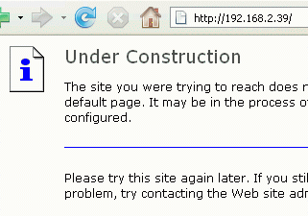
- On the virtual machine's desktop, click Start, Run. Type in CMD and press the Enter key. Type in IPCONFIG and press the Enter key Find the IP address of your machine—in S214, it starts with 192.168.1. Write that address in the box to the right on this page.

Web Server IP: ____________________________

Viewing the "Under Construction"
- On the host system, or another computer in your network, start a Web browser. In the Address bar, type the IP address you wrote in the box above and press the Enter key You should see an Under Construction page, as shown to the right on this page. If you don't, try opening the Web server's firewall.
- The "Under Constuction" page shows that IIS is working correctly, responding to HTTP requests with the default Web page.

Downloading the Big Image
- In the Web server, open a browser and go to samsclass.info
- Click CNIT 123. Click Projects. Find Project 17, as shown below. Right-click the Big Image link and select Save link as…. Save the big01.bmp image in the C:\Inetpub\wwwroot folder.

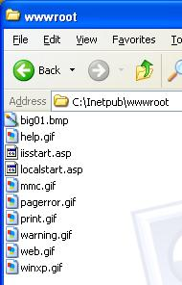
- On the virtual machine's desktop, click Start, My Computer. Double-click the C: drive to open it. If necessary, click Show the contents of this folder. Double-click the Inetpub folder. Double-click the wwwroot folder. This is where IIS stores Web page files by default. For security, it is best not to place your files in this folder, but we'll do it anyway in this project.
- Click Tools, Folder Options. On the View tab, make sure that Hide extensions for known file types is not checked. Click OK.
- In the wwwroot window, click View, List. Find the big01.bmp file, as shown to the right on this page.

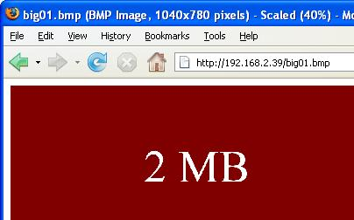
- In the Web browser, enter this address and press the Enter key:
IP-Address/big01.bmp
Don't enter the literal string IP-address; instead, type in the Web Server IP from the box above on this page.
- You should see a big image with the words 2 MB on it, as shown to the right on this page.

Creating the big.html File
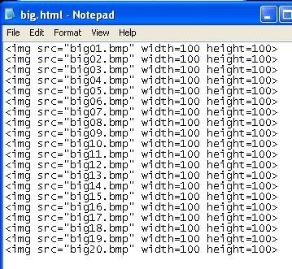
- On the virtual machine's desktop, click Start, All Programs, Accessories, Notepad. Type in the Web page shown to the right on this page. Save it in the C:\Inetpub\wwwroot folder with the filename big.html
- On the virtual machine's desktop, click Start, All Programs, Accessories, Command Prompt. Type in the following commands, ending each one with the Enter key. When entering repetitive commands, use the up-arrow key to repeat a previously typed line, and then use the left-arrow key to edit it.
cd \inetpub\wwwroot
copy big01.bmp big02.bmp
copy big01.bmp big03.bmp
copy big01.bmp big04.bmp
copy big01.bmp big05.bmp
copy big01.bmp big06.bmp
copy big01.bmp big07.bmp
copy big01.bmp big08.bmp
copy big01.bmp big09.bmp
copy big01.bmp big10.bmp
copy big01.bmp big11.bmp
copy big01.bmp big12.bmp
copy big01.bmp big13.bmp
copy big01.bmp big14.bmp
copy big01.bmp big15.bmp
copy big01.bmp big16.bmp
copy big01.bmp big17.bmp
copy big01.bmp big18.bmp
copy big01.bmp big19.bmp
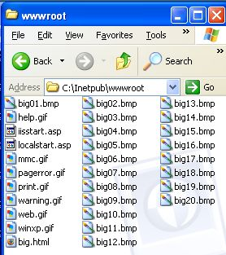
copy big01.bmp big20.bmp

- On the virtual machine's desktop, click Start, My Computer. Double-click the C: drive to open it. If necessary, click Show the contents of this folder. Double-click the Inetpub folder. Double-click the wwwroot folder. You should see 20 images in the folder, as shown to the right on this page.
- In the Web browser, enter this address and press the Enter key:
IP-Address/big.html
Don't enter the literal string IP-address; instead, type in the Web Server'sP address.
- You should see a Web page with 20 images in it, slowly loading, as shown below on this page.
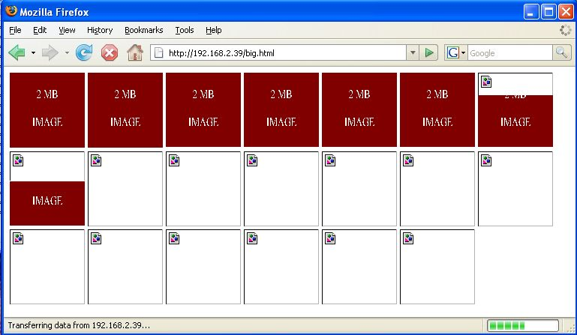

- Go to another machine and open the Web page with the same address: IP-Address/big.html

Saving the Screen Image
- Press the PrntScn key to copy whole screen to the clipboard. Open Paint and paste in the image. Save it as a JPEG, with the filename Your Name Proj 17.
Turning in your Project
- Email the JPEG image to me as an attachment. Send the message to cnit.123@gmail.com with a subject line of Proj 17 From Your Name. Send a Cc to yourself.
Last modified 2-23-07 7 am

