What You Will Need
Warning! Denial of service attacks are illegal! The only machines you should scan in this project are machines in S214, or on your own network at home.
- A Ubuntu machine to perform the Nmap scans
- A Web server with a large page to view, as you set up in the previous project.

Start the Web Server
- Double-click the VMware Workstation icon on the desktop. In the VMware Workstation window, from the menu bar, click View, Go to Home Tab.
- On the Home tab, click the Open Existing VM or Team icon. Navigate to the V: drive, open your folder, open the Windows XP for Hacking folder, and double-click the Windows XP Professional.vmx file.
- On the left side, click Start this virtual machine link.
- When your machine starts up, log in as Student, or any other account with Administrative privileges.

Verifying that Internet Information Services (IIS) is Running
- On the virtual machine's desktop, click Start, All Programs, Accessories, Command Prompt. Type in the following command, then press the Enter key:
netstat –an
- This command lists all the active network connections, as shown below on this page. Look for the line that shows that the Local Address 0.0.0.0:80 is LISTENING–that is the Web server waiting for any connection to port 80. If you don't see the process listening on port 80, something is wrong with your Web server and you need to fix it before proceeding further.
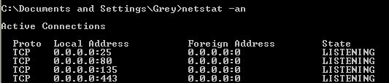

Using Task Manager to Display the Performance of Your Web Server
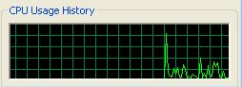
- On the virtual machine's desktop, right-click the taskbar (at the bottom of the screen) and select Task Manager. In Task Manager, click the Performance tab. You should see a graph labeled CPU Usage History, as shown to the right on this page. There's another graph there too, but this is the one of greatest interest now.
- Leave the Task Manager window open on your server, and drag it to the lower right corner of the desktop so it will be easy to keep it visible while other windows are open.

Turn Off the Firewall
- If you have the Comodo firewall, right-click the icon in the taskbar tray and select Adjust Security Level, Allow All. If you have some other firewall, make sure it is off.

Finding Your Web Server's IP Address
- On the virtual machine's desktop, click Start, Run. Type in CMD and press the Enter key. Type in IPCONFIG and press the Enter key Find the IP address of your machine—in S214, it starts with 192.168.1. Write that address in the box to the right on this page.

Web Server IP: ____________________________

Starting Your Ubuntu Virtual Machine
- Double-click the VMware Workstation icon on the desktop. In the VMware Workstation window, from the menu bar, click View, Go to Home Tab.
- On the Home tab, click the Open Existing VM or Team icon. Navigate to the V: drive, open your folder, open the Your Name Ubuntu folder, and double-click the Your Name Ubuntu.vmx file. On the left side, click the Start this virtual machine link.
- If you see a message saying “The location of this virtual machine’s configuration file has changed…,” accept the default selection of Create and click OK.
- When your machine starts up, log in as with the name and password you chose in the previous project.

Running a Normal nmap Scan of the Web Server
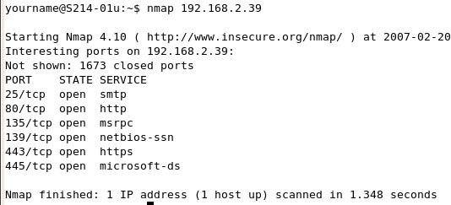
- From the menu bar in the upper left corner of the Ubuntu desktop, click Applications, Accessories, Terminal.
- In the Terminal window, after the $ prompt, enter this command, then press the Enter key:
nmap ip-addr
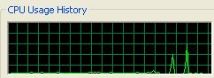
Replacing ip-addr with the server's IP address.
- You should see a scan that takes approximately one second, as shown above on this page.
- Enter the nmap ip-addr command again, and this time watch the CPU Usage History graph on the Web server. You should see a brief spike of activity, as shown to the right on this page.

Running More Intrusive nmap Scan of the Web Server
- In the Terminal window, after the $ prompt, enter this command, then press the Enter key:
nmap ip-addr –sT –p1-65535 –T5
Replacing ip-addr with the server's IP address. This scan uses complete Connect handshakes, scans all 65,535 ports, and does it at the maximum speed. (To see all the nmap options, type nmap –help.)

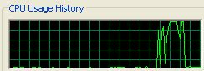
- The CPU Usage History graph on the Web server should show a much larger and longer surge of activity, as shown to the right on this page.

Timing the Web Page Load Without a Port Scan
- Find a watch with a second hand, or double-click the clock in a convenient Windows XP virtual machine, such as the Web server.
- On the host machine (or any other machine in the LAN), open a browser.
- In the Web browser, enter the address below, Then wait until a time you can easily remember, such as the start of a certain minute, and press the Enter key:
IP-Address/big.html
Don't enter the literal string IP-address; instead, type in the Web Server IP from the box on a previous page.

Time to Load Page: ____________________
- Wait until the entire page loads, including all the images, and write the elapsed time in the box to the right on this page. When I did it, it took 50 seconds.

Making a Shell Script to Run Ten Port Scans
- In the Ubuntu machine, in the Terminal window, after the $ prompt, enter this command, then press the Enter key:
echo "nmap ip-addr –sT –p1-65535 –T5" >> tenscans
Replacing ip-addr with the server's IP address. The easiest way to enter this command is to pres the up-arrow to repeat the previous command and then edit it with the left-arrow and right-arrow.
- In the Ubuntu machine, in the Terminal window, after the $ prompt, press the up-arrow key once. You should see the same echo command appear again. Press the Enter key: Repeat this process eight more times, so you have done it a total of ten times. If you lose count, and end up with 8 or 12 repititions, that's OK.
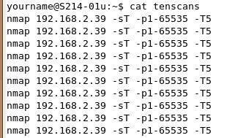
echo "nmap ip-addr –sT –p1-65535 –T5" >> tenscans
- In the Ubuntu machine, in the Terminal window, after the $ prompt, enter this command, then press the Enter key:
cat tenscans
- You should see ten lines as shown to the right on this page. This script will run ten intrusive scans, making the Web server busy for about five minutes.
- In the Ubuntu machine, in the Terminal window, after the $ prompt, enter this command, then press the Enter key:
chmod a+x tenscans
This command makes the tenscans file executable.

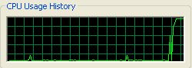
- In the Ubuntu machine, in the Terminal window, after the $ prompt, enter this command, then press the Enter key:
./tenscans
This command executes the tenscans script.
- You should see the CPU Usage History in your Web server increase, and stay high, as shown to the right on this page.

Timing the Web Page Load During a Port Scan
- On the same machine you used to time the previous port load, in the same browser window, hold down the Shift key and click the Reload button. This forces the page to completely reload from the Web server, not just redraw from the local cache. Make a note of the time you started the reload.
- Wait until the entire page loads, including all the images, and note the elapsed time in the box to the right on this page. If it is loading very slowly, just wait for 2 or 3 minutes, and make a note of how many images loaded in that time. When I did it, it only loaded 3 images after 4 minutes.

Time to Load Page During a Port Scan:

_____________________________________

Saving the Screen Image
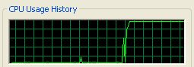
- Go back to the server, and look at the CPU Usage History. You should see a lot of activity, lasting several minutes, as shown to the right on this page. Yours may not peak at 100%, but it should show clear activity.
- Press Ctrl+Alt to release the mouse, and click on the host Windows XP desktop. Press the PrntScn key to copy whole screen to the clipboard.
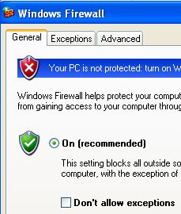
- On the host Windows XP desktop, open Paint and paste in the image. Save it as a JPEG, with the filename Your Name Proj 18a.

Stopping the Port Scans
- In the Ubuntu machine, click in the Terminal window. Hold down the Ctrl key and press C to cancel the scan. Repeat this until you see the $ prompt again.
- Look at the CPU Usage History on the server. Soon it should drop down to 0% or so, as the denial of service attack stops.

Protecting the Server With a Firewall
- There are plenty of good firewalls out there, software and hardware. But for this project, the relatively weak Windows firewall is good enough.
- On the Web server's desktop, click Start, Control Panel. Double-click Windows Firewall.
- In the Windows Firewall box, click On (recommended). Make sure the Don't allow exceptions box is cleared, as shown above on this page.
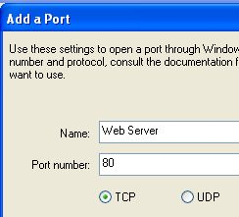
- Click the Exceptions tab. Click the Add Port button.
- In the Add a Port box, enter a Name of Web Server and a Port number of 80. Make sure the TCP radio button is selected, as shown to the right on this page.
- In the Add a Port box, click OK.
- In the Windows Firewall box, click OK.

Testing the Web Server
- On the host machine (or any other machine in the LAN), open a browser. Enter the address below, and press the Enter key:
IP-Address/big.html
Don't enter the literal string IP-address; instead, type in the Web Server IP from the box on a previous page.
- The page should load, as before. If it does not, you need to adjust the firewall settings. Make sure there is only one firewall turned on, and that port 80 TCP is open for incoming traffic.
Starting the Port Scans Again
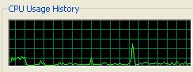
- In the Ubuntu machine, in the Terminal window, after the $ prompt, enter this command, then press the Enter key:
./tenscans
- The scan proceeds as before, but this time the CPU Usage History shows much less burden on the server. The firewall is saving the server from the attack!

Saving the Screen Image
- Make sure the server's CPU Usage History is visible, showing a low level of activity, as shown above on this page.
- Press Ctrl+Alt to release the mouse, and click on the host Windows XP desktop. Press the PrntScn key to copy whole screen to the clipboard.
- On the host Windows XP desktop, open Paint and paste in the image. Save it as a JPEG, with the filename Your Name Proj 18b.
Turning in your Project
- Write the two "Time to Load Page" values you measured in the body of your email!
- Email the JPEG images to me as attachments. Send the message to cnit.123@gmail.com with a subject line of Proj 18 From Your Name. Send a Cc to yourself.

Last modified 2-22-07

