What You Will Need
Warning! Vulnerability scans can be dangerous! The only machines you should scan in this project are machines in S214, or on your own network at home.
- A Ubuntu machine to act as the Nessus server and client
- A Windows 2000, XP, or 2003 machine to act as a Nessus client
- Both machines may be real or virtual
- You need administrative privileges on both machines

Starting Your Ubuntu Virtual Machine
- Start your Ubuntu machine and log in as usual.

Finding Your Ubuntu Machine's IP Address
- From the Ubuntu menu bar, click Applications, Accessories, Terminal.
- In the Terminal window, after the $ prompt, enter this command, then press the Enter key:
ifconfig

Ubuntu IP: ________________________
Find the IP address for your eth0 interface and write it in the box to the right on this page.

Installing the Nessus Server
- In the Terminal window, after the $ prompt, enter this command, then press the Enter key:
sudo apt-get install nessusd nessus nessus-plugins
Enter your password when you are prompted to. This command installs Nessus. If you already installed Nessus in a previous project, you will see messages saying "nessusd is already the latest version" and so on. That's fine.
- In the Terminal window, after the $ prompt, enter this command, then press the Enter key:
sudo update-rc.d nessusd defaults
This command updates Nessus. Once again, you will probably just see messages telling you that you already have the latest version.

Starting the nessusd Daemon
- In the Terminal window, after the $ prompt, enter this command, then press the Enter key:
sudo /etc/init.d/nessusd start
This command starts the Nessus daemon nessusd which listens for connections from the clients.
- In the Terminal window, after the $ prompt, enter this command, then press the Enter key:
ps aux
This command lists the processes running on your Ubuntu machine. Near the end of the list you should see a line like the one shown below, showing nessusd: waiting for incoming connection. Note that the text will be cut off unless you have widened the Terminal window.

Creating the Nessus User
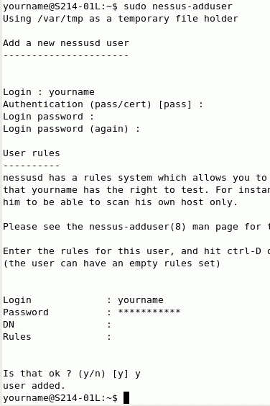
- The Nessus client will need to log in to the Nessus server with an account. Now we need to create that account.
- In the Terminal window, after the $ prompt, enter this command, then press the Enter key:
sudo nessus-adduser
- You should see "Add a new nessusd user" as shown to the right on this page.
- At the Login : prompt, enter your name. I recommend that you use the same login name you used for your Ubuntu login, just so you remember it.
- At the Authentication (pass/cert) : prompt, press Enter to accept the default selection of pass. The other alternative is to authenticate using a certificate, which is more secure, but harder to set up.
- At the Login password : prompt, enter your password. I recommend that you use the same password you used for your Ubuntu password, just so you remember it.
- Below the message "Enter the rules for this user", there is an empty line where you can enter rules. These rules can be used to limit the power of the nessus user, to prevent that person from doing unauthorized scans. But we don't want to limit the scans now, so just hold down the Ctrl key and press D to continue with no rules.
- At the Is that ok ? (y/n) [y] prompt, enter y and press the Enter key. You should see the message user added..

Restarting the nessusd Daemon
- In the Terminal window, after the $ prompt, enter this command, then press the Enter key:
sudo /etc/init.d/nessusd restart
This command restarts the Nessus daemon nessusd, so it will include the new user. This is a common thing in Linux—after making changes, you often need to restart a process. However, you almost never have to restart the whole computer, the way Windows makes you do.

Launching Nessus
- In the Terminal window, after the $ prompt, enter this command, then press the Enter key:
nessus

Launching Nessus
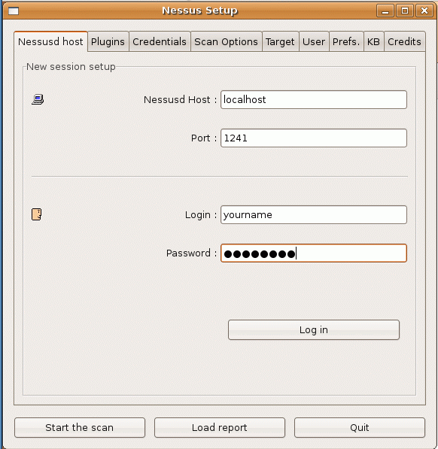
- In the Terminal window, after the $ prompt, enter this command, then press the Enter key:
nessus
- A Nessus Setup window opens, as shown to the right on this page. In the Password: box, enter your password. Click the Log in button.
- A nessus window opens showing you a certificate. Click the Yes button to accept it. This certificate identifies the Nessus server, and if you were concerned about being tricked into connecting to a fake Nessus server, you would do well to examine the certificate more carefully and look for problems with it. But we aren't worried about that right now.
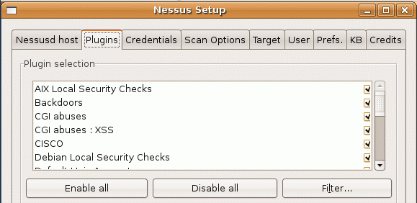
- A Warnings box appears, saying that "The plugins that have the ability to crash remote services…" have been disabled. Click OK.
- A Nessus Setup box appears, listing the plugins that have been enabled.

Scanning the Loopback Address
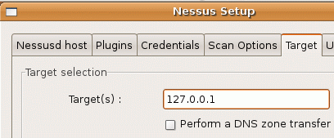
- In the Nessus Setup box, click the Target tab. In the Target(s) : field, enter 127.0.0.1, as shown to the right on this page. That way you will scan your own computer.
- At the lower left of the Nessus Setup box, click the Start the scan button.
- Wait a minute or two for the scan to complete.

Viewing the Vulnerability Report for the Local Host
- In the Nessus "NG" Report window, in the Subnet section, click on 127.0.0.
- In the Host section, click on 127.0.0.1.
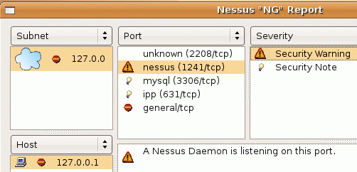
- In the Port section, click on nessus (1241/tcp).
- In the Severity section, click on Security Warning.
- You should see the message A Nessus Daemon is listening on this port as shown to the right on this page.

Saving the Screen Image
- Press Ctrl+Alt to release the mouse, and click on the host Windows XP desktop. Press the PrntScn key to copy whole screen to the clipboard.
- On the host Windows XP desktop, open Paint and paste in the image. Save it as a JPEG, with the filename Your Name Proj 20a. Select a Save as type of JPEG.

Reading the Rest of the Vulnerability Report for the Local Host
- Click through all the ports and severity options, and see what vulnerabilities you have. There aren't likely to be many vulnerabilities, because we haven't got many services running on these Ubuntu machines. It's good for you to be familiar with the typical number of results you can expect to see on a Linux machine, and compare it with the results from a Windows machine below.

Starting Your Windows 2000 Virtual Machine
- Note: If your Windows 2000 Virtual Machine is still using 640x480 resolution with 16 colors, I recommend you stop and do project X3 first to install VMware Tools.
- Double-click the VMware Workstation icon on the desktop. In the VMware Workstation window, from the menu bar, click View, Go to Home Tab.
- On the Home tab, click the Open Existing VM or Team icon. Navigate to the V: drive, open your folder, open the Win 2000 Pro SP2 folder, and double-click the Windows 2000 Professional.vmx file. On the left side, click the Start this virtual machine link.
- If you see a message saying “The location of this virtual machine’s configuration file has changed…,” accept the default selection of Create and click OK.
- When your machine starts up, log in as Administrator with no password.
- The IP addresses for all the network adapters should appear on the desktop of the Windows 2000 machine. Find your IP address and write it in the box to the right on this page. In S214, your IP address should start with 192.168.1.

Win 2000 IP: ________________________

Downloading the NessusWX Client onto the Windows 2000 Machine
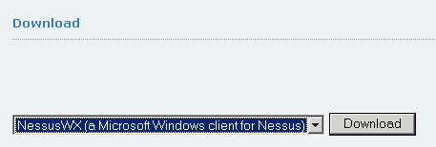
- In the Windows 2000 machine, open a browser and go to nessus.org/download
- In the drop-down list box, select NessusWX, as shown to the right on this page. Click the Download button.
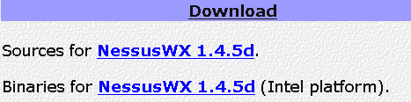
- The next screen instructs you to read the disclaimer. Scroll down a bit and click the blue Download link.
- In the line saying Binaries for NessusWX, click the word Nessus, as shown to the right on this page.
- Save the nessuswx-1.4.5d.zip file on your Windows 2000 machine's desktop and close all windows. This is a Zip file, so we need to add a Zip client to open it.

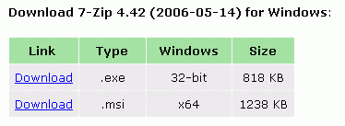
Installing 7-Zip on the Windows 2000 Machine
- In the Windows 2000 machine, open a browser and go to 7-zip.com
- In the 32-bit line, click Download¸ as shown to the right on this page. Save the file on your desktop and install it with the default options.

Installing the NessusWX Client on the Windows 2000 Machine
- In the Windows 2000 machine, open a browser and go to nessus.org/download
- On your Windows 2000 machine's desktop, right-click the nessuswx-1.4.5d.zip file and click 7-Zip, Open archive.
- In the 7-Zip File Manager window, click the Extract button.
- In the Copy box, on the right side, click the … button. In the Browser For Folder box, navigate to C:\Program Files.
- In the Browser For Folder box, click OK.
- In the Copy box, click OK.

Starting the NessusWX Client on the Windows 2000 Machine
- In the Windows 2000 machine, double-click My Computer. Double-click the C: drive to open it. If necessary, click Show files. Double-click Program Files. Double-click the nessuswx-1.4.5d folder.
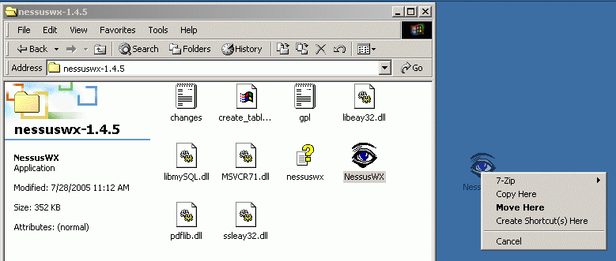
- Right-drag the NessusWX executable file to the desktop and drop it. Select Create Shortcut(s) Here from the context menu, as shown below on this page.

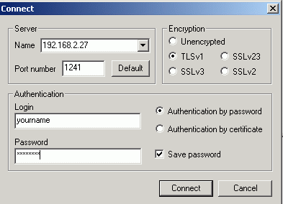
- Double-click the NessusWX shortcut on the Windows 2000 machine's desktop.
- In the Settings box, click OK.
- In the Warning box, a message appears saying "The database directory you specify does not exist. Do you wish to create it?" Click Yes.
- From the Nessus Console menu bar, click Communications, Connect.
- In the Connect box, in the Server Name box, enter your Ubuntu machine's IP address as you wrote it on the first page of this project. Enter your Ubunbu login name in the Login box. Check the Save password box and enter your Ubuntu password into the Password box. Click the Connect button.
- In the New Server Certificate box, click Accept & Save.

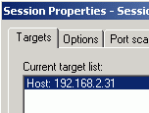
Running a Vulnerability Scan from the Windows 2000 Machine
- In the Windows 2000 machine, in the Nessus Console window, click Session, New.
- In the New Session box, click Create.
- In the Sessions Properties box, on the Targets tab, click the Add button.
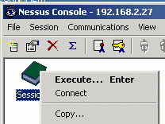
- In the Add Targets box, enter your Windows 2000 machine's IP address and click the OK button.
- You should see your Windows 2000 machine's IP address in the Current target list: as shown to the right on this page.
- At the bottom of the Session Properties box, click OK.
- A book icon labeled Session 1 now appears in the Nessus Console window, as shown to the right on this page. Right-click it and click Execute.
- In the Execute Session box, click Execute.
- When the scan completes, expand the tree in the left pane and examine the vulnerabilities. You should see a netbios-ns vulnerability. Click on it to see the NetBIOS names on your LAN, as shown below on this page.
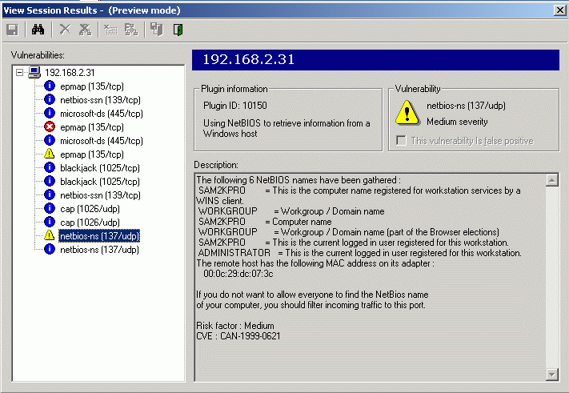

Saving the Screen Image
- Make sure the Windows 2000 machine is showing the NetBIOS vulnerability as shown in the figure on the previous page. If that vulnerability is patched on your machine, find another one to show.
- Press Ctrl+Alt to release the mouse, and click on the host Windows XP desktop. Press the PrntScn key to copy whole screen to the clipboard.
- On the host Windows XP desktop, open Paint and paste in the image. Save it as a JPEG, with the filename Your Name Proj 20b. Select a Save as type of JPEG.
Turning in your Project
- Email the JPEG images to me as attachments to a single email message. Send the message to cnit.123@gmail.com with a subject line of Proj 20 From Your Name. Send a Cc to yourself.

Last modified 3-7-07
Credits
I got a lot of this from http://www.ubuntuforums.org/archive/index.php/t-27674.html (link Ch 5j2)

