What You Will Need
- A Ubuntu machine

Introduction to Perl
- Perl is a lot simpler to use than C. It's usually interpreted, so you don't need to compile it, and it's already included in Ubuntu so you don't have to install it. Perl is designed to handle text data, with useful functions for inputting data from Web forms and other structures, and manipulating it. Because they are simpler, Perl programs are called scripts.

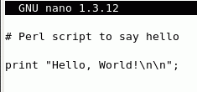
Starting Your Ubuntu Virtual Machine
- Start your Ubuntu machine and log in as usual.

Writing the hello.pl Source Code
- From the Ubuntu menu bar, click Applications, Accessories, Terminal.
- In the Terminal window, after the $ prompt, enter this command, then press the Enter key:
pico hello.pl
The pico editor opens. Type in the program shown above on this page. Hold down the Ctrl key and press O to output your file. Press the Enter key to accept the filename and save your file. Hold down the Ctrl key and press X to exit pico.

Executing the hello.pl Script
- In the Terminal window, after the $ prompt, enter this command, then press the Enter key:
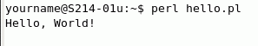
perl hello.pl
This command executes the hello.pl program. You should see Hello World! output, as shown to the right on this page.
- This program works, but it would be nicer if it greeted you by name, and if it put a couple of newline characters after the greeting to make it cleaner-looking. The next version, hello2, will add these features.

Writing the hello2pl Source Code
- In the Terminal window, after the $ prompt, enter this command, then press the Enter key:
pico hello2.pl
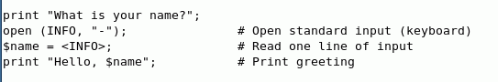
The pico editor opens. Type in the program shown below on this page. Hold down the Ctrl key and press O to output your file. Press the Enter key to accept the filename and save your file. Hold down the Ctrl key and press X to exit pico.

Executing the hello2.pl Script
- In the Terminal window, after the $ prompt, enter this command, then press the Enter key:
perl hello2.pl
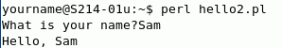
This command executes the hello.pl program. Type in your name and press Enter. You see the greeting, as shown to the right on this page.

Saving the Screen Image
- Make sure the Terminal window is visible, showing your script operating correctly, as shown above on this page.
- Press Ctrl+Alt to release the mouse, and click on the host Windows XP desktop. Press the PrntScn key to copy whole screen to the clipboard.
- On the host Windows XP desktop, open Paint and paste in the image. Save it as a JPEG, with the filename Your Name Proj 22a. Select a Save as type of JPEG.

Using a Long Name
- In the Terminal window, after the $ prompt, enter this command, then press the Enter key:
perl hello2.pl
Give it a long name—a whole line of characters, then press the Enter key. The program just greets you, no matter how long your name is. You can even use several lines of characters, as shown below. There is no apparent limit to how long the input can be—you cannot overflow the buffer. Perl is less powerful than C, but also less dangerous.
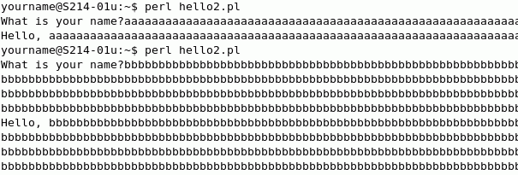

Writing the pingscan.pl Source Code
- We will make a simple ping scanner, like one of the Nmap functions. It will ping each of 100 IP addresses for one second to see if there is any response. This works, although it is a lot slower and clumsier than Nmap.
- In the Terminal window, after the $ prompt, enter this command, then press the Enter key:
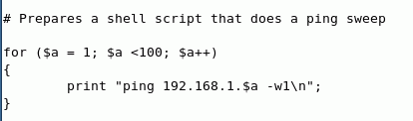
pico pingscan.pl
The pico editor opens. Type in the program shown to the right on this page. (If you are on a different subnet, replace 192.168.1 with the first 3 numbers in your LAN's IP address.) Hold down the Ctrl key and press O to output your file. Press the Enter key to accept the filename and save your file. Hold down the Ctrl key and press X to exit pico.

Running the pingscan.pl Script
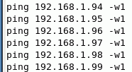
- In the Terminal window, after the $ prompt, enter this command, then press the Enter key:
perl pingscan.pl
- The program prints 100 ping command lines on the terminal, as shown to the right on this page. However, it doesn't execute the PINGs, it just prints out the commands. To make the commands execute, we need to put them into a file and make the file executable.

Using Redirection to Make the ping100a File
- In the Terminal window, after the $ prompt, enter this command, then press the Enter key:
perl pingscan.pl > ping100a
- You see another prompt with no message, which is what Linux does when there is no problem. The > sign is the output redirection operator, and it took the lines of text that were going to the screen and put them into a file named ping100a instead.

Making the ping100a File Executable
- In the Terminal window, after the $ prompt, enter this command, then press the Enter key:
chmod a+x ping100a
This command changes the mode of the ping100 file to make it executable by all users.
- In the Terminal window, after the $ prompt, enter this command, then press the Enter key:
ls
Find the ping100a file in the list and verify that it is now shown in green letters.

Running the ping100a File
- In the Terminal window, after the $ prompt, enter this command, then press the Enter key:
./ping100a
The ping scan should run, with results like those shown below on this page. It will take about 100 seconds to finish.
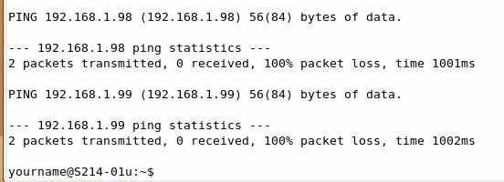

Saving the Screen Image
- Press Ctrl+Alt to release the mouse, and click on the host Windows XP desktop. Press the PrntScn key to copy whole screen to the clipboard.
- On the host Windows XP desktop, open Paint and paste in the image. Save it as a JPEG, with the filename Your Name Proj 22b. Select a Save as type of JPEG.
Turning in your Project
- Email the JPEG images to me as attachments to a single email message. Send the message to cnit.123@gmail.com with a subject line of Proj 21 From Your Name. Send a Cc to yourself.
Last modified 3-26-07

