Copying Your Ubuntu Virtual Machine
- DO NOT DO THIS PROJECT ON YOUR ORIGINAL UBUNTU LINUX MACHINE! Rootkits are very dangerous. I killed two machines developing this project, and I don’t know yet how to fix the damage this project does.
- Make a copy of your Ubuntu virtual machine, and use it just for this project. When it’s over, just delete that wrecked machine.

Start Your Freshly Copied Ubuntu Virtual Machine
- Start your copied Ubuntu machine and log in as usual.

Downloading the Rootkit
- From the Ubuntu menu bar, click Applications, Internet, Firefox Web Browser. Go to http://samsclass.info/123/proj/fk.tkz
- In the Opening fk.tkz box, click the Save to disk radio button. Click the OK button. The file saves on your desktop.

Extracting the Rootkit
- Close all windows. On the desktop, double-click the fk.tgz file.
- In the fk.tkz window, click the Extract button.
- In the Extract box, click the Extract button. A fk-0.4 folder appears on the desktop.

Installing the Rootkit
- From the Ubuntu menu bar, click Applications, Accessories, Terminal.
- In the terminal window, enter this command, then press the Enter key:
cd Desktop
This changes the working directory to the Desktop, where you extracted the installation files.
fk-0.4.
- In the terminal window, enter this command, then press the Enter key:
cd fk-0.4
This changes the working directory to the fk-0.4 folder.
- In the terminal window, enter this command, then press the Enter key:
ls
You should see several files, including install and README.

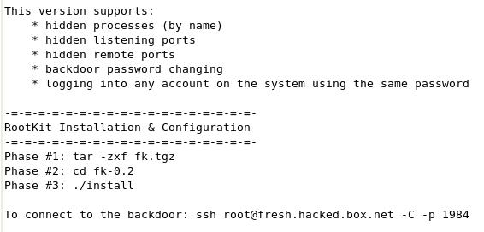
- In the terminal window, enter this command, then press the Enter key:
pico README
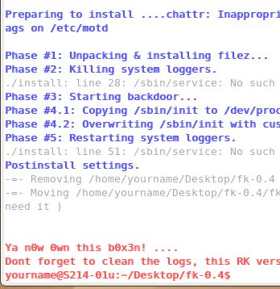
You should see the features and installation instructions, as shown to the right on this page. After reading the installation instructions, press Ctrl+X to exit pico.
- In the terminal window, enter this command, then press the Enter key:
sudo ./install
If you are prompted for your password, enter it. You should see blue messages as the installation proceeds, followed by red messages saying you now own the box., and warning you to go clean the logs to hide your activities from the administrator, as shown to the right on this page.

Using netstat to View Active Connections
- From the Ubuntu menu bar, click Applications, Internet, Firefox Web Browser. Go to www.ccsf.edu
- In the terminal window, enter this command, then press the Enter key:
netstat --protocol=inet
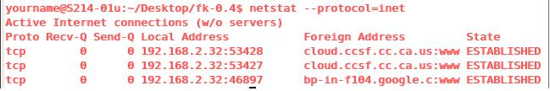
You should see the network connections, as shown below, showing one or more connections to ccsf addresses, with :www added to the end, showing that they are connecting to port 80, the usual World Wide Web port.

- Close Firefox.

Configuring the Rootkit to Hide Connections to Port 80
- In the terminal window, enter this command, then press the Enter key:
cd /dev/proc/fuckit/config
This changes the working directory to the process directory, where the rootkit does its work.
- In the terminal window, enter this command, then press the Enter key:
ls
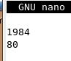
Note these files: lports shows the local ports to hide, progs shows the programs to hide, and rports shows the remote ports to hide.
- In the terminal window, enter this command, then press the Enter key:
sudo pico rports
If you are prompted for your password, enter it. In the pico text editor, add 80 to the end of the file, as shown to the right on this page. Press Ctrl+O and Enter to save the file. Press Ctrl+X to exit pico.

Using netstat to View Active Connections With the Rootkit Hiding Port 80
- From the Ubuntu menu bar, click Applications, Internet, Firefox Web Browser. Go to www.ccsf.edu
- In the terminal window, enter this command, then press the Enter key:
netstat --protocol=inet
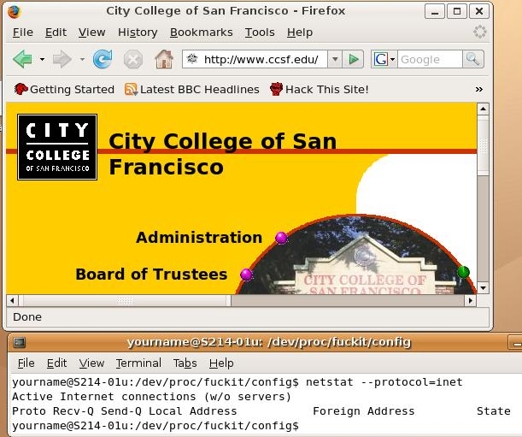
You should see no www connections, even though the browser is clearly visible, as shown to the right on this page. The rootkit is hiding them.

Saving the Screen Image
- Make sure the two windows are both visible, shown the browser and the netstat output.
- Press Ctrl+Alt to release the mouse, and click on the host Windows XP desktop.

- Press the PrntScn key to copy whole screen to the clipboard.
- On the host Windows XP desktop, open Paint and paste in the image. Save it as a JPEG, with the filename Your Name Proj 24a.

Installing the rkhunterRootkit Detector
- In the terminal window, enter this command, then press the Enter key:
sudo apt-get install rkhunter

Running the rkhunterRootkit Detector
- In the terminal window, enter this command, then press the Enter key:
sudo rkhunter -c
If you are prompted for your password, enter it.
- You should see a long list of binaries scroll by, and then the message “[Press <ENTER> to continue]”. Press Enter. rkhunter did not find anything wrong with the binary files on the hard disk.
- Now rkhunter looks for known rootkits one-by-one in alphabetical order. When it gets up to F, it should find the rootkit, as shown below on this page.
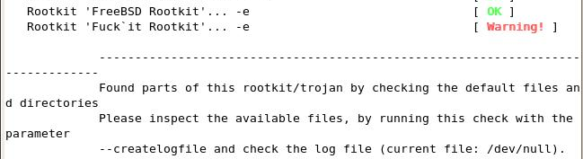

Saving the Screen Image
- Make sure the message saying Found parts of this rootkit/trojan is visible.
- Press Ctrl+Alt to release the mouse, and click on the host Windows XP desktop.
- Press the PrntScn key to copy whole screen to the clipboard.
- On the host Windows XP desktop, open Paint and paste in the image. Save it as a JPEG, with the filename Your Name Proj 24b.

Completing the rkhunter Scan
- When you see the message “[Press <ENTER> to continue]”, press Enter. rkhunter will do a lot of tests, and find a few more problems, all apparently connected with the rootkit you installed.

Removing the Rootkit
- To remove it, see project X7. If you plan to do project X7, do NOT shut down Ubuntu normally. You can suspend the state using VMware. If you shut down Ubuntu with this rootkit in it, it won't start again.
Turning in your Project
- Email the JPEG images to me as attachments to a single message. Send the message to cnit.123@gmail.com with a subject line of Proj 24 From Your Name. Send a Cc to yourself.
Last modified 5-26-07

