Background
The goal of this project is to install the Apache Tomcat Web server on Ubuntu Linux. This is the most common type of Web server, and you should be familiar with it. First we need to install Java, then Tomcat.

Start Your Ubuntu Virtual Machine
- Start your Ubuntu machine and log in as usual.

Editing the sources.list file
- From the Ubuntu menu bar, click Applications, Accessories, Terminal.
- In the terminal window, enter this command, then press the Enter key:
cd /etc/apt
This command changes the working directory to /etc/apt, where a configuration file needs to be edited.
- In the terminal window, enter this command, then press the Enter key:
sudo cp sources.list sources.list.bak2
Enter you password when you are prompted to. This command copies the sources.list configuration file to a backup copy, which is a good thing to do before making changes, in case you decide you want to return to the original file.
- In the terminal window, enter this command, then press the Enter key:
sudo pico sources.list
This command starts the pico text editor so we can change the sources.list configuration file.
- Widen the pico window so you can edit long lines without scrolling.
- Add the words universe and multiverse to the end of the first two lines in the file, so they look like the figure below:

- Hold down the Ctrl key and press the O key to save your file. A message appears saying File name to write: sources.list. Press the Enter key.
- Hold down the Ctrl key and press the X key to exit from pico. You should see a $ prompt again.
- In the terminal window, enter this command, then press the Enter key:
sudo apt-get update
This command gets the new package information.

Installing Sun Java's JDK Package
- In the terminal window, enter this command, then press the Enter key:
sudo apt-get install sun-java5-jdk
This command gets the installer for Sun Java JRE 1.6.0 (Mustang). When you see the question "Do you want to continue?" press Y.

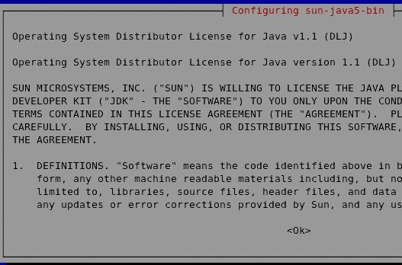
- When you see the "Configuring sun-java5-bin" screen shown to the right on this page, press the Tab key to highlight <Ok>, then press the Enter key.
- The next screen asks "Do you agree with the DLJ licence terms?" Press the Tab key to highlight Yes, then press the Enter key.

Downloading Tomcat
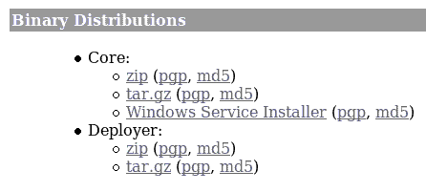
- From the Ubuntu menu bar, click Applications, Internet, Firefox Web Browser. Go to tomcat.apache.org
- On the top left, in the Download section, click “Tomcat 6.x”.
- Scroll to the bottom of the next page. In the Binary Distributions section, as shown to the right on this page, find the Core section. In the tar.gz line, click the md5 link.
- Check the md5 hash value. If you are using the same version I used (Tomcat 6.0.10), you should see the value shown below on this page. If it’s different, write it down so you can make sure your download is good.
- In the Firefox window, click the Back button to return to the previous page.
- In the Core section, click on .tar.gz. In the Opening apache-tomcat-6.0.10.tar.gz box, click the Save to disk radio button. Click the OK button. The file saves on your desktop.

Verifying the MD5 Hash
- In the terminal window, enter this command, then press the Enter key:
cd
This changes the working directory to your home directory.
- In the terminal window, enter this command, then press the Enter key:
cd Desktop
This changes the working directory to the Desktop, where the downloaded file is.
- In the terminal window, enter this command, then press the Enter key:
md5sum apache-tomcat-6.0.10.tar.gz
This calculates the MD5 hash. It should match the value you saw above. If it does not, something is wrong. If necessary, delete the file and download it again.

Uncompressing Tomcat
- In the terminal window, enter this command, then press the Enter key:
tar xvfz apache-tomcat-6.0.10.tar.gz
This extracts the files and creates a folder named apache-tomcat-6.0.10 on your desktop.

Renaming and Moving the Tomcat Directory
- In the terminal window, enter this command, then press the Enter key:
mv apache-tomcat-6.0.10 tomcat
This changes the name of the folder to tomcat which will make future commands shorter. Linux calls this a move.
- In the terminal window, enter this command, then press the Enter key:
sudo mv tomcat /usr/local
This moves the tomcat directory to /usr/local.

Editing .bashrc
- In the terminal window, enter this command, then press the Enter key:
cd
This changes the working directory to your home directory.
- In the terminal window, enter this command, then press the Enter key:
cp .bashrc .bashrc-bak
This makes a backup copy of your .bashrc file in case you make a mistake.
- In the terminal window, enter this command, then press the Enter key:
pico .bashrc
This opens the .bashrc file in the pico editor. This file contains user preferences for the terminal window.
- Scroll to the bottom and enter this line, as shown in the figure below:
export JAVA_HOME= /usr/lib/jvm/java-1.5.0-sun-1.5.0.08

- Hold down the Ctrl key and press the O key to save your file. A message appears saying File name to write: .bashrc. Press the Enter key.
- Hold down the Ctrl key and press the X key to exit from pico. You should see a $ prompt again.

Log Out and Log In Again
- From the Ubuntu menu bar, click System, Quit. Click Log out. Log in as usual.

Starting tomcat
- In the terminal window, enter this command, then press the Enter key:
sudo sh /usr/local/tomcat/bin/startup.sh
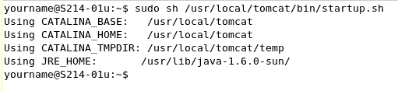
You should see several Using lines, as shown to the right on this page.

Testing tomcat
- From the Ubuntu menu bar, click Applications, Internet, Firefox Web Browser. Type in this Web address:
localhost:8080
You should see a Web page saying "you've setup Tomcat successfully", as shown below on this page. If you see an "Unable to connect" message, tomcat is not running. Something done in the previous steps must be wrong. You may find helpful error messages in the log file at /usr/local/tomcat/logs/catalina.out
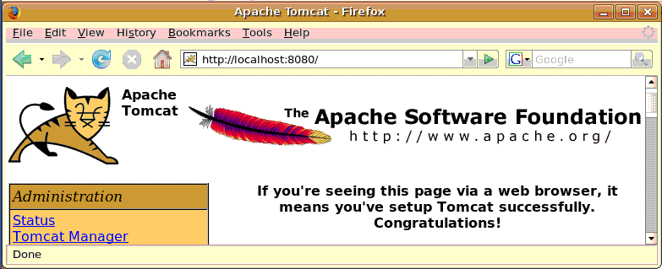

Saving the Screen Image
- Make sure the Apache Window Web page is visible.
- Press Ctrl+Alt to release the mouse, and click on the host Windows XP desktop.
- Press the PrntScn key to copy whole screen to the clipboard.
- On the host Windows XP desktop, open Paint and paste in the image. Save it as a JPEG, with the filename Your Name Proj 25.
Turning in your Project
- Email the JPEG images to me as attachments to a single message. Send the message to cnit.123@gmail.com with a subject line of Proj 25 From Your Name. Send a Cc to yourself.
Credit
Link Ch 10zf -- http://www.spaceprogram.com/knowledge/2006/05/installing-java-5-jdk-and-tomcat-on.html
Last modified 4-8-07

