What You Need for This Project
- An infected virtual machine running Ubuntu Linux with the “Fuckit” rootkit installed. This is what you end up with after project 24.
- A clean virtual machine: A copy of the same virtual machine before the rootkit was installed. It’s best if it matches the infected machine exactly, as far as possible. The repair consists of copying ten files from the clean machine to the infected machine.
Background Information
- The rootkit does not crash the Ubuntu machine while it’s running, but it won’t restart, not even in Recovery mode. You can use the infected machine, and you can close VMware, saving the machine’s running state, and restore that state, but you cannot shut it down normally.
Turn Off the Infected Machine – Suspending its State
- If the infected Ubuntu Linux machine is not running, leave it off for now. If it is running, press Ctrl+Alt to release the mouse pointer, and click the X in the upper right to close VMware. If a box pops up asking whether you want to close VMware and suspend the machine’s state, agree to that. Whatever you do, do NOT shut the Ubuntu machine down normally, because it won’t start up again.
Starting the Clean Machine
- Start your clean Ubuntu virtual machine and log in as usual.
Downloading the backup-fu and fix-fu Scripts
- In your clean Ubuntu machine, open Firefox and go to samsclass.info
- Click the CNIT 123 link. On the next page, click Projects. Scroll down to Project X7, as shown below.

- Right-click the fix-fu link. Click Save link as. Click Save to save the file on your desktop.
- Close Firefox.
- On your Ubuntu desktop, double-click the fix-fu.tar.gz file. Click Extract. Click Extract. A folder named fix-fu should appear on your desktop. Close all windows.

Examining the backup-fu Script in the Clean Machine
- In your clean machine, from the Ubuntu menu bar, click Applications, Accessories, Terminal.
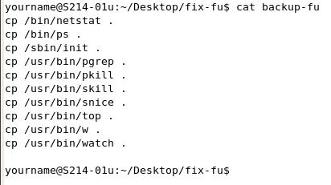
- In the terminal window, enter this command, then press the Enter key:
cd Desktop/fix-fu
This changes the working directory to folder containing the scripts.
- In the terminal window, enter this command, then press the Enter key:
cat backup-fu
You should see the script, as shown to the right on this page. All it does is copy ten files into the fix-fu folder.
Saving the Screen Image
- Make sure the Terminal window is visible, showing the ten cp commands.
- Press Ctrl+Alt to release the mouse, and click on the host Windows XP desktop.
- Press the PrntScn key to copy whole screen to the clipboard.
- On the host Windows XP desktop, open Paint and paste in the image. Save it as a JPEG, with the filename Your Name Proj X7a.

Running the backup-fu Script in the Clean Machine
- In the terminal window, enter this command, then press the Enter key:
sudo ./backup-fu
Enter your password when you are prompted to. This executes the script, copying the files.
- In the terminal window, enter this command, then press the Enter key:
ls
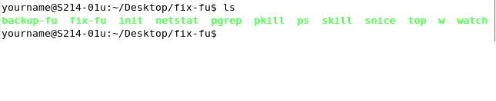
You should see the names of the files appear in green print, as shown below on this page.

Copying the fix-fu Folder to a Shared Folder on the Windows Server
- From the Ubuntu menu bar, click Places, Connect to Server.
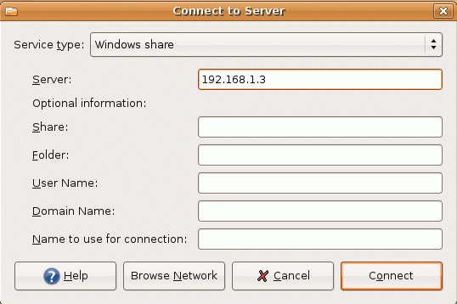
- In the Connect to Server box, select a Service type: of Windows share. In the Server: box, enter 192.168.1.3 as shown to the right on this page. Click the Connect button. (If you are working at home, use some other machine to copy the folder, or a removable storage device such as a floppy disk.)
- On the desktop of the Ubuntu machine, a folder icon appears labeled 192.168.1.3. Double-click that icon to open it.
- In the Windows Network window, double-click the CNIT 123 folder to open it.
- Drag the fix-fu folder from the Ubuntu desktop to the CNIT 123 share on the Windows server. If you see a message saying "A file named fix-fu already exists," click Replace. If the file is already there, it’s from another student, who might have a slightly different version of Ubuntu, so the files might not be the exact files you want.

Shutting Down the Clean Ubuntu Virtual Machine
- In the clean Ubuntu machine, click System, Quit, Shut down.

Turning On the Infected Ubuntu Virtual Machine
- Start VMware and open your infected virtual machine. It should be in a suspended state, so it should open to a desktop without asking you to log in.

Copying the fix-fu Folder to the Infected Ubuntu Machine
- From the infected Ubuntu machine’s menu bar, click Places, Connect to Server.
- In the Connect to Server box, select a Service type: of Windows share. In the Server: box, enter 192.168.1.3 as shown to the right on this page. Click the Connect button.
- On the desktop of the Ubuntu machine, a folder icon appears labeled 192.168.1.3. Double-click that icon to open it.
- In the Windows Network window, double-click the CNIT 123 folder to open it.
- Drag the fix-fu folder from the the CNIT 123 share on the Windows server to your Ubuntu desktop.

Examining the fix-fu Script in the Infected Machine
- In your infected machine, from the Ubuntu menu bar, click Applications, Accessories, Terminal.
- In the terminal window, enter this command, then press the Enter key:
cd Desktop/fix-fu
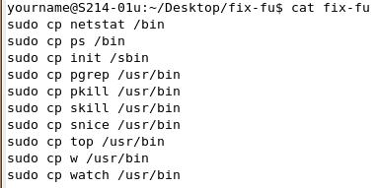
This changes the working directory to folder containing the scripts.
- In the terminal window, enter this command, then press the Enter key:
cat fix-fu
You should see the script, as shown to the right on this page.
Saving the Screen Image
- Make sure the Terminal window is visible, showing the ten cp commands.
- Press Ctrl+Alt to release the mouse, and click on the host Windows XP desktop.
- Press the PrntScn key to copy whole screen to the clipboard.
- On the host Windows XP desktop, open Paint and paste in the image. Save it as a JPEG, with the filename Your Name Proj X7b.

Running the fix-fu Script in the Infected Machine
- In the terminal window, enter this command, then press the Enter key:
sudo ./fix-fu
Enter your password when you are prompted to. This executes the script, copying the files.
- You should now be able to shut down and restart your previously infected machine normally. As far as I know, this completely fixes it.:
Turning in your Project
- Email the JPEG images to me as attachments to a single email message Send the message to cnit.123@gmail.com with a subject line of Proj X3 From Your Name. Send a Cc to yourself.
Notes—How I Created the Fix
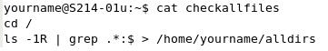
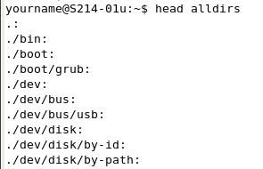
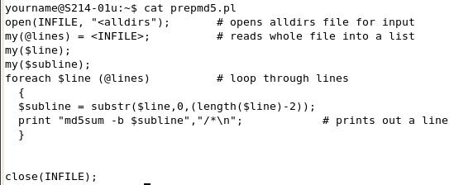
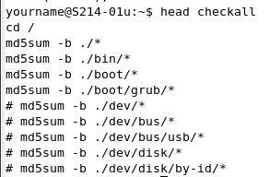
- Here are the steps I used to create this fix. They may be helpful in fixing other rootkit infections.
  - First I used the script shown to the right to create a file listing all the directories in the Ubuntu file system.

  - Here’s what the alldirs file looks like – it’s very long, this is just the first ten records. It lists every directory.

  - Then I used this perl script to create another file with md5sum commands for each directory.

  - This is the result—it’s a long file, but here are the first ten lines. When I ran it, some of the directories made it crash, like the /dev ones, because the things in there are not exactly files. I just commented out the lines that made it crash, which were mostly in /dev or /proc directories, until the script ran without crashing. This means some files were not tested.

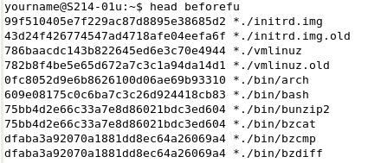
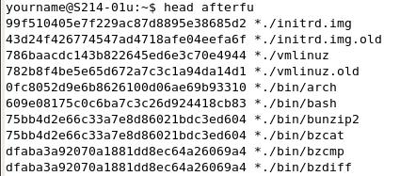
  - This is the result of running the script before installing the rootkit—it’s a long file, but here are the first ten lines. This is a very useful file, showing the MD5 hash for every file on a clean Ubuntu machine, except for the /dev and /proc directories I excluded in the previous step.

  - Then I installed the rootkit and immediately ran the md5 script again. This is the result. The first ten files match, but there are many thousands of files here.

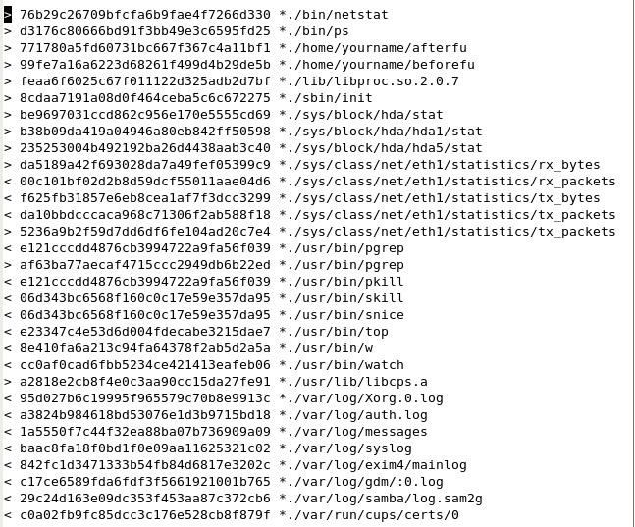
  - To compare them, all I used was this command:
diff beforefu afterfu
  - The results are shown to the right. I cleaned it up a bit, but this is a complete list of all the files that changed. Not a very long list at all!
  - All I did was remove files that did not matter, such as log files, files I created during testing, and network and hard disk statistics files.
  - There were three library files that were not present on my clean system, so I ignored them. It might have been a more complete fix to delete them on the infected system, but the fix seemed to work without worrying about them.
  - That left the ten files to be copied and replaced.

Last modified 3-25-07

