What You Will Need
You need to use an Ubuntu machine with Nessus (Project 20), and Tomcat (Project 25). The machine can be physical or virtual. If you just completed project 25, restart your Ubuntu machine before starting this project, just to make sure Tomcat is not running yet.

Start Your Ubuntu Virtual Machine
- Start your Ubuntu machine and log in as usual.

Downloading WebGoat
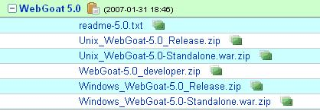
- From the Ubuntu menu bar, click Applications, Internet, Firefox Web Browser. Go to owasp.org
- On the top right, click WebGoat.
- Scroll down to the Download section. Click "OWASP Source Code Center at Sourceforge."
- In the next page, scroll down and find the WebGoat 5.0 section, as shown to the right on this page. Click Unix_WebGoat-5.0_Release.zip.
- In the Opening Unix_WebGoat-5.0_Release.zip box, click the Save to disk radio button. Click the OK button. The file saves on your desktop.

Uncompressing WebGoat
- On the Ubuntu desktop, double-click the Unix_WebGoat-5.0_Release.zip file. Click Extract. Click Extract. A WebGoat-5.0 folder appears on your desktop.

Starting WebGoat
- From the Ubuntu menu bar, click Applications, Accessories, Terminal.
- In the terminal window, enter this command, then press the Enter key:
cd Desktop/WebGoat-5.0
This changes the working directory to the WebGoat directory.
- In the terminal window, enter this command, then press the Enter key:
sudo sh webgoat.sh start8080
This starts the WebGoat server on port 8080. A lot of messages scroll by. Leave the Terminal window open – closing it will stop WebGoat.
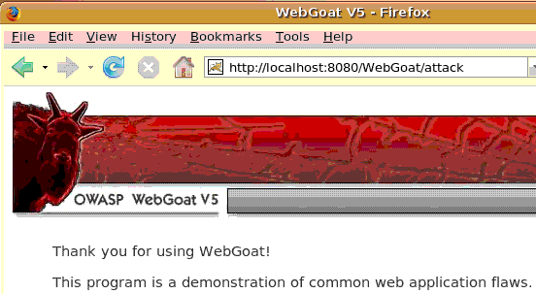
- From the Ubuntu menu bar, click Applications, Internet, Firefox Web Browser. Go to this address:
localhost:8080/WebGoat/attack
Be careful to use capital letters for W and G in "WebGoat". A box pops up asking for a user name and password. Enter guest for the username and guest for the password. The OWASP WebGoat page should open as shown to the right on this page.

Disabling Your Internet Connection
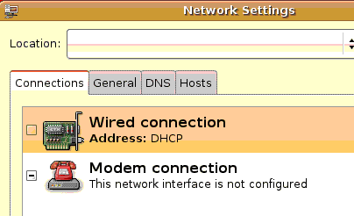
- WebGoat is insecure, so you should not be connected to the Internet while using it.
- To prevent Internet access, from the Ubuntu menu bar, click System, Administration, Networking. Enter your password when you are prompted to.
- In the Network Settings box, uncheck the Wired connection, as shown to the right on this page. Click the Close button.

Testing Your Internet Connection
- Refresh the Firefox window showing localhost:8080/WebGoat/attack
- The page should reload with no error, showing that you can still access your own WebGoat server.
- Leave the WebGoat window alone, and from the Ubuntu menu bar, click Applications, Internet, Firefox Web Browser. Go to yahoo.com
- You should get a "Server not found" message, showing that your machine is no longer connected to the Internet. Close this Firefox window.

Starting the nessusd Daemon
- From the Ubuntu menu bar, click Applications, Accessories, Terminal to open a new Terminal window. Don't use the one that is running WebGoat.
- In the new Terminal window, after the $ prompt, enter this command, then press the Enter key:
sudo /etc/init.d/nessusd start
Enter your password when you are prompted to. This command starts the Nessus daemon nessusd which listens for connections from the clients. It may take a couple of minutes to start.
- In the Terminal window, after the $ prompt, enter this command, then press the Enter key:
ps aux
This command lists the processes running on your Ubuntu machine. Near the end of the list you should see a line like the one shown below, showing nessusd: waiting for incoming connection. Note that the text will be cut off unless you have widened the Terminal window.

Launching Nessus
- In the Terminal window, after the $ prompt, enter this command, then press the Enter key:
nessus

Launching Nessus
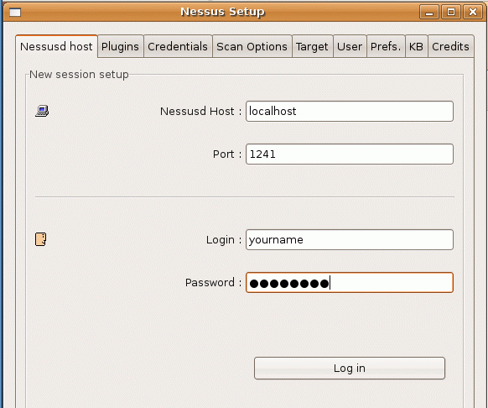
- In the Terminal window, after the $ prompt, enter this command, then press the Enter key:
nessus
- A Nessus Setup window opens, as shown to the right on this page. In the Password: box, enter your password. Click the Log in button. Wait while it logs in and accepts the certificate, which might take a few minutes.
- A Warnings box appears, saying that "The plugins that have the ability to crash remote services…" have been disabled. Click OK.
- A Nessus Setup box appears, listing the plugins that have been enabled.

Scanning the Loopback Address
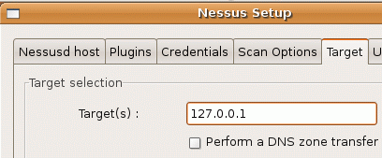
- In the Nessus Setup box, click the Target tab. In the Target(s) : field, enter 127.0.0.1, as shown to the right on this page. That way you will scan your own computer.
- At the lower left of the Nessus Setup box, click the Start the scan button.
- Wait until the scan finishes. You should see progress bars moving. It took quite a while when I did it, five or ten minutes.

Viewing the Vulnerability Report
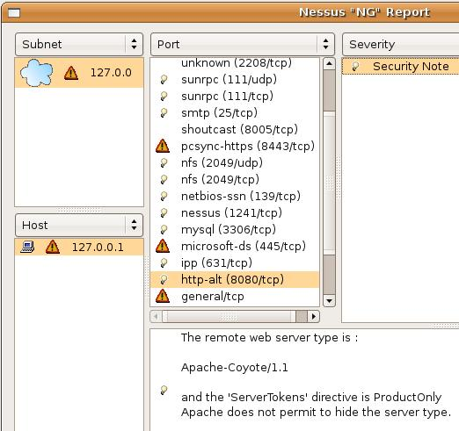
- In the Nessus "NG" Report window, in the Subnet section, click on 127.0.0.
- In the Host section, click on 127.0.0.1.
- In the Port section, click on http-alt (8080/tcp).
- In the Severity section, click on Security Note.
- You should see the message "The remote web server type is: Apache-Coyote/1.1" as shown to the right on this page.

Saving the Screen Image
- Make sure the "Apache-Coyote/1.1" message is visible.
- Press Ctrl+Alt to release the mouse, and click on the host Windows XP desktop. Press the PrntScn key to copy whole screen to the clipboard.
- On the host Windows XP desktop, open Paint and paste in the image. Save it as a JPEG, with the filename Your Name Proj X8. Select a Save as type of JPEG.

Reading the Rest of the Vulnerability Report for the Local Host
- Click through all the ports and severity options, and see what vulnerabilities you have. Notice that there are a lot of services running, some known to be Java and Tomcat services, but not many of them have dangerous vulnerabilities detected by Nessus. In fact, WebGoat has many vulnerabilities, but Nessus can't find them all.
Turning in your Project
- Email the JPEG images to me as attachments to a single message. Send the message to cnit.123@gmail.com with a subject line of Proj X8 From Your Name. Send a Cc to yourself.
Last modified 4-8-07

