Start Your Ubuntu Virtual Machine
- Start your Ubuntu machine and log in as usual.

Set up a GMail Account
- You can do this project with an existing mail account, but I don't recommend it, because you might expose your personal email and your password to other students. So I recommend that you make a temporary email account just for this project, as detailed in the following steps.
- From the menu bar in the upper left corner of the Ubuntu desktop, click Applications, Internet, Firefox Web Browser. Go to Gmail.com
- If you are already signed into Gmail, click sign out.
- Click "Sign up for Gmail".
- Fill in the "Create an Account" page. At the bottom, click the "I accept. Create my account." button.
- In the next page, click "I'm ready – show me my account".
- In the next page, you should see your inbox with a couple of welcome messages. At the top right, click Settings.
- On the Settings page, click "Forwarding and POP".
- In the Forwarding section, click the Forward a copy… radio button and enter your usual email account in the box, as shown below. This will enable you to see your score when your homework is graded.
- In the "POP Download" section, click the Enable POP for all mail" radio button. Click the "Save Changes" button.

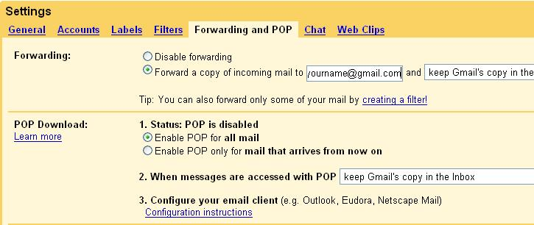

Installing Thunderbird and enigmail
- From the menu bar in the upper left corner of the Ubuntu desktop, click Applications, Accessories, Terminal.
- In the terminal window, enter this command, then press the Enter key:
sudo apt-get install mozilla-thunderbird-enigmail
Enter your password when you are prompted to. At the "Do you want to continue? [Y/n]" prompt, type Y. This command installs the Thunderbird email client with the enigmail OpenPGP Key Manager.

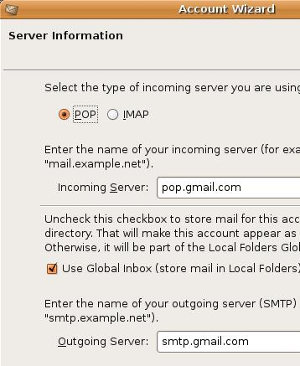
Setting Thunderbird to Receive Normal Gmail
- From the menu bar in the upper left corner of the Ubuntu desktop, click Applications, Internet, Thunderbird Mail.
- In the "Import Wizard" box, accept the default selection of "Don't Import Anything" and click the Next button.
- In the "New Account Setup" box, accept the default selection of "Email account" and click the Next button.
- At the "Identity" screen, enter your name and the new Gmail address you created in the first section of this project. Click the Next button.
- At the "Server information" screen, select POP as the type of incoming server you are using. Enter pop.gmail.com in the Incoming Server field. Set the Outgoing Server to smtp.gmail.com, as shown to the right on this page. Click the Next button.
- At the "User names" screen, enter your Gmail username (including @gmail.com) in the Incoming User Name and Outgoing User Name fields, and click Next.
- At the "Account name" screen, accept the default and click Next.
- At the "Congratulations" screen, verify your account information in the dialog box, and click Finish. Thunderbird will now attempt to get your mail, but it won't work because Gmail uses secure connections, with different ports. Don't wait for it, just proceed with the nest steps. But be warned, Thunderbird will pop up a box in the next minute or so saying it was unable to get your mail. That's OK.

- From the Thunderbird menu bar, click Edit, Account settings.
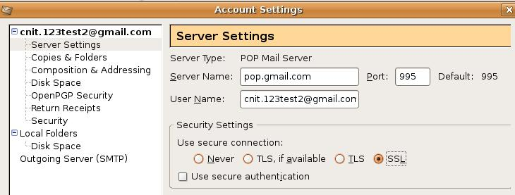
- In the upper left portion of the "Account Settings" box, click "Server Settings". In the right pane, in the "POP Mail Server" section, change the Port to 995, as shown below on this page. In the "Security Settings" section, click the SSL radio button.
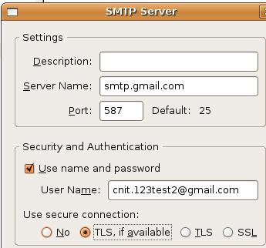
- In the upper left portion of the "Account Settings" box, click "Outgoing Server (SMTP)". In the right pane, click your gmail account and click the Edit button.
- In the "SMTP Server" box, change the Port to 587, as shown to the right on this page. In the "Use secure connection:" section, click "TLS, if available" and click OK.
- In the "Account Settings" box, click OK.
- In the Thunderbird tool bar, click "Get Mail". If Thunderbird is unresponsive, close it and open it again.
- In the "Enter your password" box, type in your password and click OK.
- You should see the two GMail welcome messages in the Thunderbird window, as shown at the top of the next page.

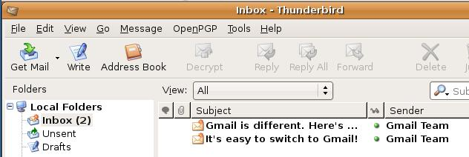

Turning off HTML Message Composition
- OpenPGP signatures don't work with HTML mail, so it's best to shut it off. From the Thunderbird menu bar, click Edit, Account settings.
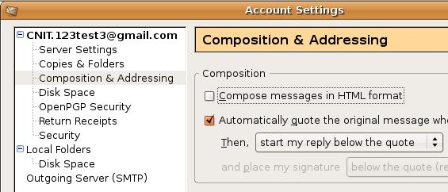
- In the upper left portion of the "Account Settings" box, click "Composition & Addressing". In the right pane, clear the "Compose messages in HTML format" check box, as shown below on this page. Click the OK button.

Generating a Key Pair
- In the Thunderbird menu, click OpenPGP, "Key Management".
- In the "OpenPGP Setup Wizard", accept the default selection of "Yes, I would like to use the wizard…" and click the Next button.
- At the Signing screen, accept the default selection of "Yes, I want to sign all of my email" and click the Next button.
- At the Encryption screen, accept the default selection of "No, I will create per-recipient rules..." and click the Next button.
- At the Preferences screen, click "No, thanks" and click the Next button.
- At the "Create a Key" screen, enter a passphrase of your choice in both boxes and click the Next button. Make sure you remember the passphrase!
- At the Summary screen, notice that you are creating a 2048-bit key. Click Next.
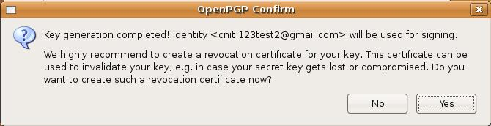
- At the "Key Creation" screen, there is a progress bar, but it doesn't move quickly. To make it move faster, open Firefox and surf through some Web pages. It will collect random bits from your actions. When your key is ready, you will see the "OpenPGP Confirm" box shown below on this page. Click Yes.

- In the "Create and Save Revocation Certificate" box, click Save.
- When you are prompted to, type in your passphrase and click OK.
- In the "OpenPGP Alert" box, click OK.
- At the "Thank you" screen,, click Finish.
- An "OpenPGP Key Management "window appears, with your email address in it. Double-click your email address to see the "Key Properties" as shown below on this page. Click OK to close the "Key Properties" box.
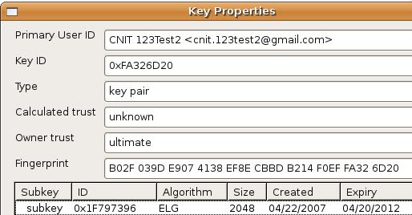
Uploading Your Public Key
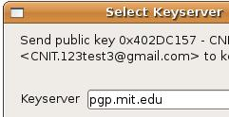
- Now you have created a public key and a private key. But to be useful, you must upload your public key to a keyserver so others can use it to send you email.
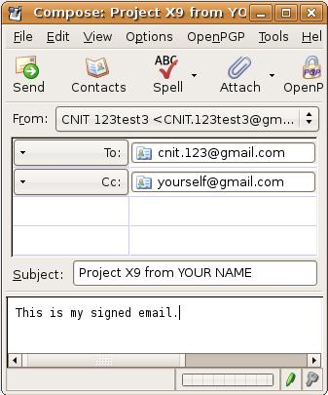
- In the "Key Management" box, click your email address to select your key. From the menu bar, click Keyserver, "Upload Public Keys". In the "Select keyserver" box, select pgp.mit.edu, as shown to the right on this page. Click OK. This will send your public key to a keyserver. Close the "OpenPGP Key Management" box.

Turning in Your Homework
- In the Thunderbird tool bar, click Write.
- Compose a message to cnit.235@gmail.com as shown to the right on this page. Send a Cc: to yourself, at any email account you like. Note the little pen and key symbols in the lower right of the window—they control encryption and signing. Accept the default values (signed but not encrypted) and click the Send button. If it asks for your passphrase and your password, enter them.

Viewing the Signature in a Browser
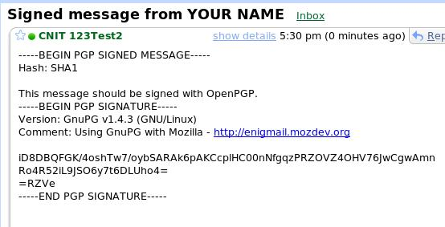
- Open Firefox. Go to gmail.com (or whatever other mail account you sent your Cc: to) and read your email. Look for your signed message. You should see the PGP SIGNATURE section, as shown to the right on this page.

Last modified 4-22-07

