What You Need
- A Windows XP machine with administrator access (real or virtual)

Creating Passwords to Crack
- Click Start, right-click My Computer, and click Manage. In Computer Management, in the left pane, expand the Local Users and Groups container.
- In the left pane of Computer Management, click the Users container. You should see some accounts in the right pane, as shown below on this page.
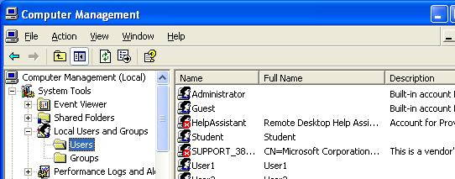

Creating Test Accounts
- In the left pane of Computer Management, right-click Users and click New User.
User name Password
P3 abc
P5 abcde
P7 abcdefg
- In the NewUser box, enter user name of P3 and a password of abc, and click Create. The check boxes in the lower section of the New User box don’t matter, because no one will really be using these accounts.
- Repeat the process to create the three accounts in the box to the right on this page.

Installing Cain
- On the virtual machine's desktop, open a browser and go to oxid.it
- In the upper left, click Projects.
- Scroll down past the disclaimer and click "Cain & Abel".
- Scroll down and click "Download Cain & Abel v4.9 for Windows NT/1000/XP". Save the installer on your desktop.
- Double-click the installer. Install the software with the default options. It will install WinPCap as well as Cain & Abel.

Installing Abel
- Cain is the password cracker, and Abel is the process that harvests the hashed passwords from the Windows machine. You normally install Abel on the target machine, but we'll just install it locally.
- Click Start, Programs, Accessories, Command Prompt.
- Type in the following command and press the Enter key:
copy \"program files"\cain\abel.exe \Windows
This command copies the Abel installer to the C:\Windows folder.
- Type in the following command and press the Enter key:
copy \"program files"\cain\abel.dll \Windows
This command copies the Abel DLL file to the C:\Windows folder. This file is the actual service.
- Type in the following command and press the Enter key:
cd \Windows
This command changes the working directory to C:\Windows.
- Type in the following command and press the Enter key:
abel
This command installs the Abel service. A box pops up saying "Abel service has been installed successfully!" Click OK.
- Type in the following command and press the Enter key:
services.msc
- The Services window appears. At the top of the right pane, right-click Abel and click Start. In the top line of the right pane, you should see the Abel service with a Status of Started, as shown below on this page.
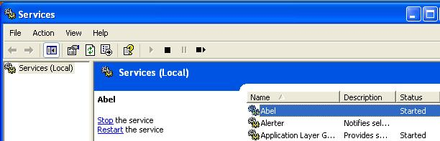

Finding your Computer's Workgroup and Name
- Click Start. Right-click My Computer and click Properties. Click the Computer Name tab. Find the "Full Computer Name" and workgroup and remember it.

Collecting Password Hashes With Cain
- Double-click the Cain icon on the desktop. Click the Network tab.
- In the left pane, double-click Microsoft Windows Network. Then click the + sign next to your workgroup name to expand it. Double-click "All Computers". Double-click your computer name. Expand Abel. Click Hashes.
- A Cain box pops up asking "Include password history hashes?". Click No.
- The password hashes appear, as shown in the figure at the top of the next page. Note that if you have disabled LM hashes in a previous project, the P3, P5, and P7 LanMan Hash values will be identical.
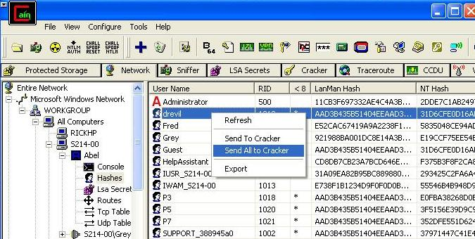
- In the right pane, right-click, and click "Send All to Cracker".

Cracking Passwords
- Click the Cracker tab. In the right pane, right-click P3, point to "Brute-Force Attack", and click "NTLM Hashes", as shown below on this page.
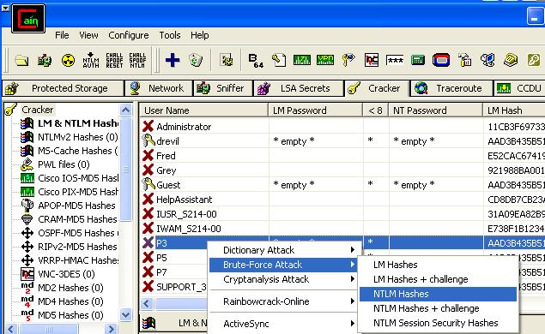

- In the "Brute-Force Attack" box, click the Start button. It should find the three-letter password immediately. Close the "Brute-Force Attack" box.
- In the right pane, right-click P5, point to "Brute-Force Attack", and click "NTLM Hashes".
- In the "Brute-Force Attack" box, click the Start button. It should find the five-letter password within a few seconds. Close the "Brute-Force Attack" box.
- In the right pane, right-click P7, point to "Brute-Force Attack", and click "NTLM Hashes".
- In the "Brute-Force Attack" box, click the Start button. The seven-letter password is hard to crack, however– no answer appears immediately. It might take a long time to crack, so we'll give up. Click the Stop button. Click the Exit button.
- It should find the five-letter password within a few seconds. Close the "Brute-Force Attack" box.
- You should see the two passwords you found, abc and abcde, in the NT Password column of the Cain window, as shown below.

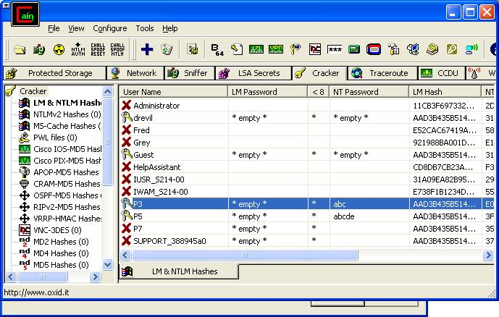

Saving the Screen Image
- Press the PrntScn key to copy whole screen to the clipboard. Open Paint and paste in the image. Save it as a JPEG, with the filename Your Name Proj X10.
Turning in your Project
- Email the JPEG image to me as an attachment. Send the message to cnit.123@gmail.com with a subject line of Proj X10 From Your Name. Send a Cc to yourself.
Last modified 4-23-07

