What You Need
- VMware Player and VMmanager
- At least 8 GB free space on a hard disk
- In S214, you can use VMware Workstation, which replaces both VMware player and VMmanager, but some of the steps will be different.

Getting Your Longhorn Product Key
- Open a browser and go to http://www.microsoft.com/windowsserver/longhorn/audsel.mspx
- Click the blue "I already know about Windows Server "Longhorn" and I'm ready to evaluate." link.
- Click the blue "click here for the TechNet Beta Central site" link.
- In the "Select your Language / Region" box, accept the default of "English (United States)" and click the Go button.
- In the next screen, you have to log in with a Windows Live account. If you don't have one, do these steps:
  - Click the "Sign up now" link on the left and follow the instructions on your screen to createa Windows Live account.
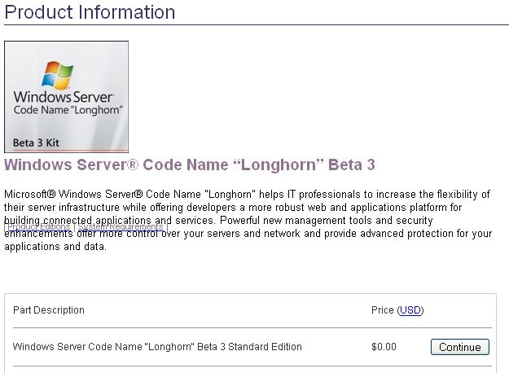
  - You will have to open your email and click on a link to verify your address. When you have verified your address, click the Continue button to proceed with getting your Longhorn product key. If you closed the browser, just open a new one and start at start at step 1 again.
- In the "Product Information" page, on the "Windows Server Code Name "Longhorn" Beta 3 Standard Edition" line, click the Continue button, as shown to the right on this page.
- Scroll to the bottom of the next page. Check the "I Agree" box. Click the "Place Order: button.
- The next page shows your product key. Copy and paste it into an email, or write it down carefully. Don't lose it! You will need it to install Longhorn.

Make Sure There is Enough Room
- Check your hard disk and make sure there is at least 8 GB free space on it for your virtual machine. If there isn't, try a different machine (if you are working in S214).
- Create a folder to put your VM in, such as V:\yourname\Longhorn.

Copy the ISO file to V:\Install
- Check the V: drive to see if there is a V:\Longhorn folder with the sl_6001.16510.070417-1740_x86fre_server-KB3SFRE_EN_DVD.iso file in it. If it's not already there, create a new folder, name it Longhorn, and copy that file from the USB hard drive in the wooden closet into it.
- If you prefer to use a DVD for the installation, you don't need to use the ISO file.

Creating a Virtual Machine
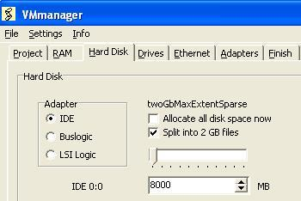
- Click Start, All Programs, VMmanager, VMmanager.
- In the VMmanager window, click the New button.
- On the Project tab, in the "Operating System" section, accept the default selection of Windows. Click the down-arrow and select "Longhorn (experimental)".
- On the RAM tab, select 384 MB.
- On the "Hard Disk" tab, clear the "Allocate all disk space now" check box. Leave the "Split into 2 Gb files" box checked. Enter a size of "8000 MB", as shown to the right on this page.
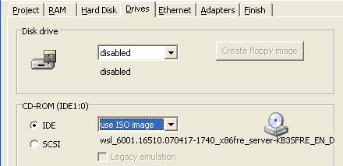
- On the Drives tab, in the "CD-ROM (IDE1:0)" section, on the IDE line, select "use ISO image". Browse to the V:\Longhorn folder and double-click the Longhorn ISO file. Your screen should look like the image to the right on this page.
- On the Ethernet tab, set both Ethernet 0 and Ethernet 1 to Bridged.
- On the Finish tab, click the OK button. Navigate to the V:\yourname\Longhorn folder and click the Save button. In the VMmanager box, click OK.

Creating a Virtual Floppy Disk
- Longhorn Beta does not correctly load the CD-ROM drivers required by VMware, so you will need a virtual floppy disk.
- Click Start, All Programs, VMmanager, VMmanager.
- In the VMmanager window, click the Modify button.

- In the Open box, navigate to the V:\yourname\Longhorn folder and double-click the Longhorn (experimental) file.
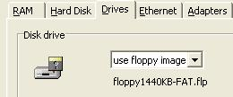
- Click the Drives tab. In the "Disk drive" section, click the "Create floppy image" button. In the VMmanager box, click the "Make file" button. In the "Save As" box, navigate to the V:\yourname\Longhorn folder and click Save.
- A box appears saying "Your disk has been created". Click OK.
- Your VMmanager window should now show "use floppy image"in the "Disk Drive" section, as shown to the right on this page.
- On the Finish tab, click the OK button. In the VMmanager box, click OK.

Starting Your Virtual Machine and Adjusting the BIOS Boot Order
- Click Start, All Programs, VMware, VMware Player.
- In the Open box, navigate to the V:\yourname\Longhorn folder and double-click the Longhorn (experimental) file.
- Press F2 to edit the BIOS settings. Change the boot order to boot from the CDROM first. Press F10 and then Enter to save the BIOS settings.

Booting from the Longhorn ISO file
- The virtual machine should boot from the ISO image.
- In the "Install Windows" box, accept the default selections and click the Next button.
- Click the "Install now" button.
- When you are prompted to, type in your product key and click Next.
- In the "Select the operating system you want to install" screen, accept the default of "Windows Longhorn SERVERSTANDARD" and click Next.
- At the next screen, check the box to accept the license terms and click Next.
- In the "Which type of installation do you want" screen, click Custom.
- In the "Where do you want to install Windows" screen, click on "Disk 0 Unallocated Space" and click Next.

Copying the CD-ROM Drivers to the Floppy Image
- Press Shift+F10. A Command Prompt box opens. Enter this command, then press the Enter key. Note: this is one long line—do not break it into two lines with the Enter key—let it wrap.
xcopy x:\windows\system32\driverstore\filerepository\
cdrom.inf_bba802eb\* a:\
- Three files should be copied, as shown below on this page. Type in EXIT and press the Enter key to close the Command Prompt window.

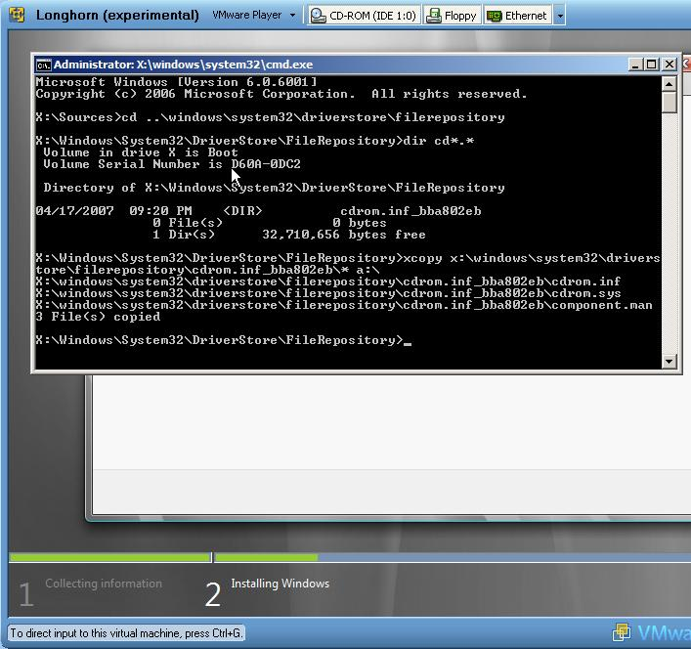

Starting Longhorn for the First Time
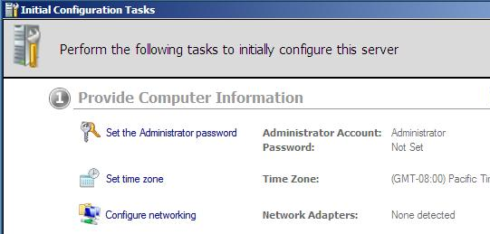
- Longhorn should start up and show the Initial Configuration Tasks screen as shown to the right on this page. Notice that the "Configure networking" line shows that no network adapters were detected. That's the first thing we need to fix.
- In the Longhorn virtual machine, click Start. Click the arrow to the right of the padlock icon. Click Shut Down.
- In the "Shut down windows" box, in the Comment box, enter anything, such as x, and click OK. Longhorn makes you explain why you are shutting it down so it can note the event in the Event Log. That's because it's usually a big deal to shut down a server, and people might ask who did it and why.
- Wait till Longhorn shuts down and VMware Player closes.

Downloading the NIC Drivers
- On the host system (not a virtual machine), open a browser and go to samsclass.info
- Click the"CNIT 123" link. Click Projects. Scroll down to Project X11. Click "NIC Drivers". Save the file in the V:\yourname\Longhorn folder. This file is a virtual floppy image containing the NIC drivers.

Pointing the Longhorn Virtual Machine to the New Virtual Floppy Disk
- Click Start, All Programs, VMmanager, VMmanager.
- In the VMmanager window, click the Modify button.
- In the Open box, navigate to the V:\yourname\Longhorn folder and double-click the Longhorn (experimental) file.
- Click the Drives tab. In the "Disk drive" section, select "use floppy image". In the "Open" box, navigate to the V:\yourname\Longhorn folder and double-click NIC-Vista.
- On the Finish tab, click the OK button. In the VMmanager box, click OK.

Adjusting the BIOS to Boot from the Hard Disk
- Click Start, All Programs, VMware, VMware Player.
- In the Open box, navigate to the V:\yourname\Longhorn folder and double-click the Longhorn (experimental) file.
- Press F2 to edit the BIOS settings. Change the boot order to boot from the hard disk first. Press F10 and then Enter to save the BIOS settings.

Installing the NIC Drivers into the Virtual Longhorn Machine
- Click Start, right-click My Computer, and click Properties.
- In the left pane, click "Device Manager".
- Right-click "Ethernet Controller" and click "Update driver software".
- Click "Browse my computer for driver software".
- Click the Browse button. Scroll down and expand Computer. Click "Floppy Disk Drive A:" and click the OK button.
- In the "Update Driver Software-Ethernet Controller" box, click Next.
- When you see "Windows has successfully updated your driver software", click Close.
- Close all windows.

Starting Internet Explorer
- Click Start, "Internet Explorer".
- In the "Microsoft Phishing Filter" box, click "Turn on automatic Phishing Filter (Recommended)" and click OK.

Downloading Firefox
- Internet Explorer shows a message explaining that the Enhanced Security Configuration is turned on. That makes IE almost useless, so we'll download Firefox.
- In the Internet Explore address bar, enter getfirefox.com and press Enter.
- An "Internet Explorer" box opens saying "Content from the Web site listed below is being blocked…".
- You now have to do these two steps to add the Mozilla site to the Trusted Sites zone:
  - An "Internet Explorer" box opens saying "You are attempting to download…". In the lower section of this box, click Add.
  - In the "Trusted Sites" box, click Add. Click Close.
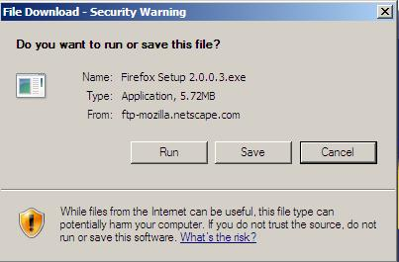
- In the "Firefox 2" screen, click the "Download Firefox" link. If you see an "Internet Explorer" box opens saying "You are attempting to download…", repeat the two steps a and b above.
- You may have to do the whole cycle a third time as well to convince Internet Explorer to let you download Firefox. It has taken me as many as five cycles. It varies depending on how many different mozilla mirrors you are sent to.
- Eventually you should see the "File Download – Security Warning" box shown to the right on this page. Click the Run button.
- When the file downloads, you will seee an "Internet Explorer – Security Warning" box. Click the Run button.
- Click through the Mozilla Firefox Setup Wizard, accepting the default selections. Agree to the license as usual.

Downloading Clamwin
- There are very few antivirus products that work with Longhorn. Avast, AVG, and Mcafee won't even install. One antivirus product that does work is Clamwin, and it's free, so we'll use it.
- Open Firefox and go to clamwin.com
- At the left of the page, click Download. Click "Download Now".
- In the "Opening clamwin…" box, click "Save File". When the file downloads, close Firefox and double-click the clamwin-0.90.1.1-setup file on your desktop.
- Install ClamWin with all the default settings.

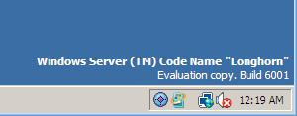

Saving the Screen Image
- You should see a message in the lower right corner of the desktop saying "Windows Server ™ Code Name "Longhorn"", as shown in the figure above on this page. You should also see the blue circular icon indicating that ClamWin is running.
- Press Ctrl+Alt to move the mouse out of the virtual machine.
- Press the PrntScn key to copy whole screen to the clipboard. In the host Windows XP system, open Paint and paste in the image. Save it as a JPEG, with the filename Your Name Proj X11.
Turning in your Project
- Email the JPEG image to me as an attachment. Send the message to cnit.123@gmail.com (send it to cnit.235@gmail.com if you are in the CNIT 235 class) with a subject line of Proj X11 From Your Name. Send a Cc to yourself.
Last modified 4-27-07

