What You Will Need
Warning: Only use this on networks you own. Cracking into networks without permission is a crime—don’t do it!
- A wireless access point
- A computer with any wireless NIC to be the client
- A computer running Win XP Pro with an Orinoco, Cisco, or Prism-type Wi-Fi NIC (In S214, it’s station S214-13)
- In S214, you will need to use a station with a normal Wi-Fi NIC as well, which could be any one of these stations: S214-15, S214-16, S214-17. There are also some USB Wi-Fi NICs available to use on other stations.

Choose Your Access Point/Router
- There are three Access Point/Routers available: Linksys, D-Link, and Belkin. Choose one and use the corresponding instructions below to set up a secure Wireless Local Area Network (WLAN).

Making a Secure WLAN with the Linksys Access Point/Router

Restoring the Access Point to Factory Default Settings
- Get the blue Linksys BEFW11S4 router from the closet. Plug in the power cord. Do not plug in any Ethernet cables yet.
- Press the little red RESET button on the back and hold it in for ten seconds. This resets the router back to its factory default settings.

Connecting a “Wired Client” Computer to the Router
- Choose one computer to be the Wired Client. Disconnect the blue Ethernet cable from the back of the Wired Client. Take another cable and connect the Wired Client to port 1 on the router. Check the front panel of the router: the light under number 1 should light up, but the Internet light should be dark.
- On the Wired Client, click Start, All Programs, Accessories, Command Prompt. Type in this command and press the Enter key.
IPCONFIG
You should see an IP address starting with 192.168.1, as shown below. There are other network adapters present with other IP addresses, but one of them should start with 192.168.1. If you don’t have an IP address like that, restart the Wired Client computer.
Ethernet adapter Local Area Connection 2:

Connection-specific DNS Suffix . :
IP Address. . . . . . . . . . . . : 192.168.1.101
Subnet Mask . . . . . . . . . . . : 255.255.255.0
Default Gateway . . . . . . . . . : 192.168.1.1

- On the Wired Client, in the Command Prompt window, type in this command and press the Enter key.
PING 192.168.1.1
You should see replies, and you should see the front panel lights on the router blink. The Wired Client is now connected to the router as a client.

Changing the Subnet on the Router
- The LAN in S214 uses the 192.168.1.0 subnet, which is the same as the default subnet for the Linksys router. The router won’t be able to connect to the LAN unless it uses a different subnet for its clients, so we need to change the router to a different subnet.
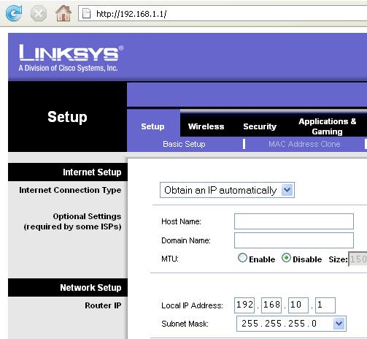
- On the Wired Client. open a browser and go to this address: 192.168.1.1
- A box pops up asking for a user name and password. Leave the User Name blank and enter a password of admin
- In the Linksys page, on the Setup tab, change the Local IP Address to 192.168.10.1, as shown to the right on this page.
- Scroll to the bottom of the page and click the Save Settings button.
- A popup box appears saying “Next time, log in the router with the new IP address”. Click OK.
- Now that the router has a new address, the Wired Client needs a new IP address too to connect to it. To force a DHCP renew, unplug the network cable from port 1 on the router, wait a couple of seconds, and plug it in again.
- On the Wired Client , in the Command Prompt window, type in this command and press the Enter key.
IPCONFIG
You should see an IP address starting with 192.168.10. If you don’t have an IP address like that, restart the Wired Client computer.
- On the Wired Client, in the Command Prompt window, type in this command and press the Enter key.
PING 192.168.10.1
You should see replies, and you should see the front panel lights on the router blink. The Wired Client is now connected to the router again as a client.

Setting the SSID and Channel on the Access Point/Router
- Make up a new SSID to be your network’s name. Write it in the box to the right on this page.

SSID: _______________________

Channel: 1

- On the Wired Client. open a browser and go to this address: 192.168.10.1
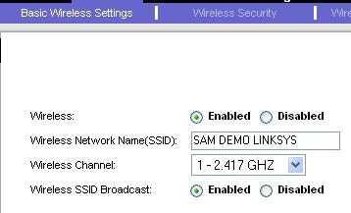
- A box pops up asking for a user name and password. Leave the User Name blank and enter a password of admin
- In the Linksys page, click the Wireless tab. Click the blue “Basic Wireless Settings” tab. In the “Wireless” line, click Enable. Enter your SSID in the “Wireless Network Name(SSID):” box.
- Select a “Wireless Channel” of “1 – 2.417 GHZ”, as shown to the right on this page. At the bottom of the page, click “Save settings”.

Setting WEP Security on the Access Point/Router

WEP Key: ________________________
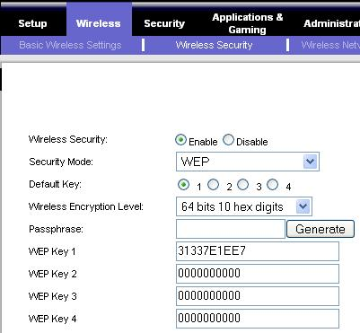
- Make up a ten-digit hexadecimal WEP key and write it in the box to the right on this page. Each digit can be a numeral 0 through 9, or a letter from A through F.
- On the Wired Client, a browser should still be open, showing address 192.168.10.1
  - If the browser window is not still open, open a new one, go to 192.168.10.1, and log in with User Name blank and a password of admin
- In the Linksys page, click the Wireless tab. Click the blue “Wireless Security” tab. In the “Wireless Security” line, click Enable. Select a “Security Mode:” of WEP. Enter the WEP Key you wrote in the box on this page into the “WEP Key 1” field. At the bottom of the page, click “Save settings”.

Connecting the Router to the Room’s LAN
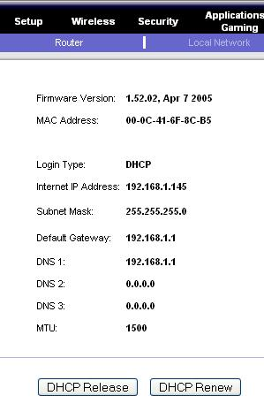
- Find the blue cable attached to the wall that used to be plugged into the Wired Client. Plug it into the WAN port on the router. The Internet front panel light should come on.
- On the Wired Client, a browser should still be open, showing address 192.168.10.1
  - If the browser window is not still open, open a new one, go to 192.168.10.1, and log in with User Name blank and a password of admin
- In the Linksys page, at the upper right, click the Status tab. At the bottom of the screen, click the “DHCP Renew” button. The router should now show an “Internet IP Address” starting with 192.168.1 as shown to the right on this page. If it does not, click the the “DHCP Renew” button again.
- On the Wired Client, in the Command Prompt window, type in this command and press the Enter key.
PING YAHOO.COM
You should see replies, and you should see the front panel lights on the router blink. The Wired Client is now connected to the Internet through the router.

Skip ahead to the “Connecting a “Wireless Client” to the Access Point/Router” section.

Making a Secure WLAN with the Belkin Access Point/Router

Restoring the Access Point to Factory Default Settings
- Get the gray Belkin router from the closet. Plug in the power cord. Do not plug in any Ethernet cables yet.
- Use a pin or paper clip to press the little RESET button on the back and hold it in for ten seconds. This resets the router back to its factory default settings.

Connecting a “Wired Client” Computer to the Router
- Choose one computer to be the Wired Client. Disconnect the blue Ethernet cable from the back of the Wired Client. Take another cable and connect the Wired Client to port 1 on the router. Check the front panel of the router: the light under number 1 should light up, but the WAN light should be dark.
- On the Wired Client, click Start, All Programs, Accessories, Command Prompt. Type in this command and press the Enter key.
IPCONFIG
You should see an IP address starting with 192.168.2, as shown below. There are other network adapters present with other IP addresses, but one of them should start with 192.168.2. If you don’t have an IP address like that, restart the Wired Client computer.
Ethernet adapter Local Area Connection 2:

Connection-specific DNS Suffix . :
IP Address. . . . . . . . . . . . : 192.168.2.2

- On the Wired Client, in the Command Prompt window, type in this command and press the Enter key.
PING 192.168.2.1
You should see replies, and you should see the front panel lights on the router blink. The Wired Client is now connected to the router as a client.

Setting the SSID and Channel on the Access Point/Router
- Make up a new SSID to be your network’s name. Write it in the box to the right on this page.

SSID: _______________________

Channel: 11

- On the Wired Client. open a browser and go to this address: 192.168.2.1
- A Belkin page opens. In the upper right, click the “Log in” button.
- A Login screen appears. Leave the Password box empty and click the Submit button. If the browser displays a “Security Warning” box, click Continue.

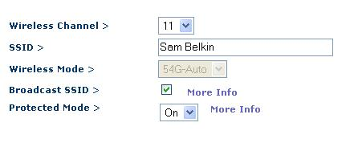
- On the left side of the screen, click “Channel and SSID”.
- In the “Wireless > Channel and SSID” page, enter your SSID in the SSID box.
- Select a “Wireless Channel” of “11”, as shown to the right on this page. At the bottom of the page, click “Apply Changes”.

Setting WEP Security on the Access Point/Router

WEP Key: ________________________
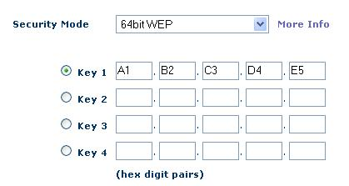
- Make up a ten-digit hexadecimal WEP key and write it in the box to the right on this page. Each digit can be a numeral 0 through 9, or a letter from A through F.
- On the Wired Client, a browser should still be open, showing address 192.168.2.1
- In the left pane, in the Wireless section, click Security. In the “Security Mode” box, select “64-bit WEP”. Enter the WEP Key you wrote in the box on this page into the “Key 1” field, as shown to the right on this page. At the bottom of the page, click “Apply Changes”.

Connecting the Router to the Room’s LAN
- Find the blue cable attached to the wall that used to be plugged into the Wired Client. Plug it into the “Connection to Modem” port on the router. The WAN front panel light should come on.
- On the Wired Client, a browser should still be open, showing address 192.168.2.1
- In the Belkin page, on the left side, in the “Internet WAN” section, click “Connection Type”.
- In the “WAN > Connection Type” screen, accept the default selection of Dynamic and click the Next button.
- In the “WAN > Connection Type > Dynamic IP” screen, leave the “Host Name” box empty and click the “Apply Changes” button.
- On the Wired Client, in the Command Prompt window, type in this command and press the Enter key.
PING YAHOO.COM
You should see replies, and you should see the front panel lights on the router blink. The Wired Client is now connected to the Internet through the router.

Skip ahead to the “Connecting a “Wireless Client” to the Access Point/Router” section.

Making a Secure WLAN with the D-Link Access Point/Router

Restoring the Access Point to Factory Default Settings
- Get the gray D-Link router from the closet. Plug in the power cord. Do not plug in any Ethernet cables yet.
- Use a pin or paper clip to press the little RESET button on the back and hold it in for ten seconds. This resets the router back to its factory default settings.

Connecting a “Wired Client” Computer to the Router
- Choose one computer to be the Wired Client. Disconnect the blue Ethernet cable from the back of the Wired Client. Take another cable and connect the Wired Client to port 1 on the router. Check the front panel of the router: the light under number 1 should light up, but the WAN light should be dark.
- On the Wired Client, click Start, All Programs, Accessories, Command Prompt. Type in this command and press the Enter key.
IPCONFIG
You should see an IP address starting with 192.168.0, as shown below. There are other network adapters present with other IP addresses, but one of them should start with 192.168.0. If you don’t have an IP address like that, restart the Wired Client computer.
Ethernet adapter Local Area Connection 2:

Connection-specific DNS Suffix . :
IP Address. . . . . . . . . . . . : 192.168.0.100

- On the Wired Client, in the Command Prompt window, type in this command and press the Enter key.
PING 192.168.0.1
You should see replies, and you should see the front panel lights on the router blink. The Wired Client is now connected to the router as a client.

Setting the SSID and Channel on the Access Point/Router
- Make up a new SSID to be your network’s name. Write it in the box to the right on this page.

SSID: _______________________

Channel: 6

- On the Wired Client. open a browser and go to this address: 192.168.0.1
- A box pops up asking for a user name and password. Enter a user name of admin and leave the password blank. Click the OK button.
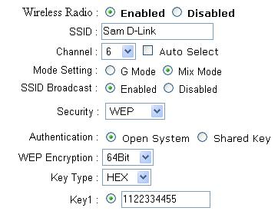
- On the left side of the screen, click “Wireless”.
- Enter your SSID in the SSID box, as shown to the right on this page.
- Select a “Wireless Channel” of “6”, as shown to the right on this page.

Setting WEP Security on the Access Point/Router

WEP Key: ________________________
- Make up a ten-digit hexadecimal WEP key and write it in the box to the right on this page. Each digit can be a numeral 0 through 9, or a letter from A through F.
- In the “Security:” box, select “WEP”. In the “WEP Encryption:” box, select “64-bit”. In the “”Key1:” box, enter the WEP Key you wrote in the box on this page.
- At the bottom of the page, click “Apply”. A message appears saying “The device is restarting”. Click “Continue”.

Connecting the Router to the Room’s LAN
- Find the blue cable attached to the wall that used to be plugged into the Wired Client. Plug it into the “WAN” port on the router. The WAN front panel light should come on.
- On the Wired Client, a browser should still be open, showing the D-Link page.
- On the Wired Client, in the Command Prompt window, type in this command and press the Enter key.
PING YAHOO.COM
You should see replies, and you should see the front panel lights on the router blink. The Wired Client is now connected to the Internet through the router.

Skip ahead to the “Connecting a “Wireless Client” to the Access Point/Router” section.

Connecting a “Wireless Client” to the Access Point/Router
- Find a machine with a wireless NIC to use as the “Wireless Client” computer. Do not use S214-13 for this role. Machines S214-15, 16, and 17 have wireless NICs, and there are also USB wireless NICs available thac can be attached to other stations. However, you need Sam to set them up because it requires administrative privileges to install the drivers.
- In the lower right of the desktop, find the Wireless Network Connection icon, as shown to the right on this page. It shows a computer with radio waves coming from it. Right-click that icon and click “View available wireless networks”.
- Find your SSID in the list and click it, as shown to the right on this page. Click the Connect. button
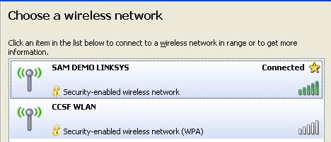
- In the “Wireless network connection” box, enter the WEP Key you wrote in the box on a previous page of these instructions. Put the same key in the second box and click Connect.
- Wait while your Wireless Client connects. When the connection is made, you should see the word “Connected” next to your SSID, as shown to the right on this page.
- On the Wireless Client, click Start, All Programs, Accessories, Command Prompt. Type in this command and press the Enter key.
IPCONFIG
You should see an IP address starting with 192.168.10
- On the Wireless Client, in the Command Prompt window, type in this command and press the Enter key.
PING 192.168.10.1
You should see replies, and you should see the front panel lights on the router blink. The Wireless Client is now connected to the router as a wireless client.

Creating a Lot of Traffic on Your WLAN
- Now you have a wireless client and an Access point working. This is therefore a Wireless Local Area Network (WLAN). In order for the WEP crack to work in a reasonable time, we need a lot of network traffic on the WLAN.
- On the Wireless Client, in the Command Prompt window, type in this command and press the Enter key.

Wireless Default Gateway: ____________________________
IPCONFIG
Find “Ethernet adapter Wireless network connection” on the list, and find the “Default Gateway”. Write that number in the box to the above on this page.
- On the Wireless Client, in the Command Prompt window, type in this command and press the Enter key.
ping Gateway –t –l 655
Note that the second switch is a lowercase L, not the numeral 1. Replace Gateway with the “Wireless Default Gateway” you wrote in the box above. This command will send large PING packets (655 bytes each) to the default gateway. You should see replies. Press Ctrl+C to stop the pinging.
- On the Wireless Client, in the Command Prompt window, type in this command and press the Enter key.
ping Gateway –t –l 65500
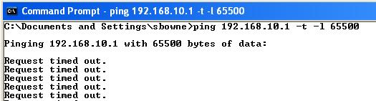
Replace Gateway with the “Wireless Default Gateway” you wrote in the box above. This command will send very large PING packets (65500 bytes each) to the default gateway. You should see “Request timed out” messages, as shown to the right on this page. In fact, the packets are arriving, but it is taking the router too long to respond.
- On the Wireless Client, click Start, All Programs, Accessories, Command Prompt. Type in this command and press the Enter key.
ping Gateway –t –l 65500
Replace Gateway with the “Wireless Default Gateway” you wrote in the box above. This will start a second window sending traffic to the router.
- Repeat the process 28 more times, until you have 30 Command Prompt windows open, all sending very large PINGs to the router. Your taskbar should show 30 command prompt windows open, as shown to the right on this page. This creates a very busy wireless network, suitable for hacking in to.

Cracking the WEP Key with AirCrack
- You must use station S214-13 for this—it’s the only machine in the room with a NIC that can enter Monitor mode. And you must get Sam to log in as an administrator there—Aircrack won’t work as a Limited user.
- On S214-13, click Start, All Programs, Aircrack-ng GUI.
- In the “Aircrack-ng GUI” window, click the Airodump-ng tab. Click the Launch button.
- A list of “Known network adapters” appears. Enter 18 to select the “Atheros Wireless Network Adapter”. Press the Enter key.
- The next choice asks if you are using Orinoco or Atheros. Enter a to select atheros. Press the Enter key.
- At the “Channel(s): 1 to 14, 0 = all ->” prompt, enter the channel number you selected on your access point. It’s written in the same box you wrote your SSID in on a previous page of these instructions. Press the Enter key.
- At the “Output filename prefix ->” prompt, enter the first name of one of your group members and the type of Access Point/Router you are using, such as “SamLinksys” DO NOT USE SPACES IN THE FILENAME PREFIX! Press the Enter key.
- At the “Only write WEP IVs (y/n) ->” prompt, enter “y”. Press the Enter key.
- You should see an airodump-ng window showing the number of packets being captured, as shown below on this page. The important thing us the “# Data” value. You need that to rise quickly—in my tests, it rose at about 15,000 per minute.
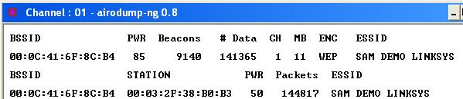

- When the Data rises to 100,000 or so, you can try cracking the key. Leave the airodump-ng data alone. In the “Aircrack-ng GUI” window, on the Aircrack-ng tab, click the Choose button. Navigate to the C:\aircrack-ng-.8-win\bin folder and find the file with your name on it and a .ivs filename extension. Double-click that file and click the Launch button.

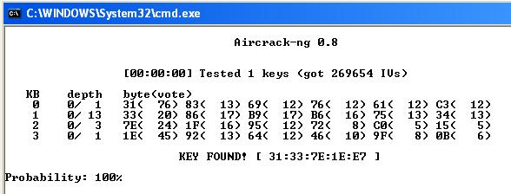
- When you have enough IVs captured (usually at least 100,000), the key will be found, as shown to the right on this page.

Saving the Screen Image
- Press the PrntScn key to copy whole screen to the clipboard. Open Paint and paste in the image. Save it as a JPEG, with the filename Your Name Proj X12.
Turning in your Project
- Email the JPEG image to me as an attachment. Send the message to cnit.123@gmail.com with a subject line of Proj X12 From Your Name. Send a Cc to yourself.
Last modified 5-11-07

