What You Will Need
Warning: Only use this on networks you own. Cracking into networks without permission is a crime—don’t do it!
- Any computer that can boot from CD. This is the "Hacker Computer"
- A BackTrack 2 Bootable CD
- A wireless Access Point/Router
- A "Wireless Client" computer running Windows, Linux, OS X, or any operating system with a wireless NIC (any kind)
- A Linksys WUSB54G ver. 4 NIC, or another one compatible with BackTrack. It is hard to find compatible NICs—I highly recommend this particular one for this purpose.

Setting Up a WEP-Secured Wireless Local Area Network (WLAN)
- Follow the steps in project X12 up to step 72 to configure the router for WEP security, and connect a client.
- Don't bother creating a lot of traffic on your WLAN—we will do this the better way, with packet injection. That is a more realistic attack, because it does not involve starting with any access to the network.

Finding the MAC Addresses of the Wireless Client and the Access Point/Router
- On the "Wireless Client", click Start, "All Programs", Accessories, "Command Prompt".
- On the "Wireless Client", in the Command Prompt window, type in this command and press the Enter key.

Wireless Client MAC Address: ____________________________

Wireless Default Gateway: ____________________________

Access Point MAC Address: ____________________________
IPCONFIG /ALL
- Find the “Ethernet adapter Wireless Network Connection” section. In that section, find the "Physical Address" and write it on the "Wireless Client MAC Address" line in the box above on this page. Use colons to delimit the address, like this: 00:40:f4:dd:af:25
- Find the “Default Gateway” and write it in the box above on this page.
- On the "Wireless Client", in the Command Prompt window, type in this command and press the Enter key.
ping Gateway
Replace Gateway with the “Wireless Default Gateway” you wrote in the box above. You should see replies.
- On the "Wireless Client", in the Command Prompt window, type in this command, and press the Enter key:
arp –a

- The result should show the "Internet Address" and "Physical Address" of the gateway, as shown to the right on this page. Write the "Physical Address" address on the "Access Point MAC Address" line in the box on the previous page. Use colons to delimit the address, like this: 00:0c:41:6f:8c:b4
L:\Documents and Settings\Sam>arp -a

Interface: 192.168.2.14 --- 0x2
Internet Address Physical Address
192.168.1.1 00-30-bd-02-ed-7b

Getting the BackTrack 2 CD
- You need a BackTrack 2 CD. Your instructor handed them out in class. If you are working at home, you can either copy the CD in the lab, or download it yourself from
http://www.remote-exploit.org/backtrack.html

Booting the Hacker Computer from the BackTrack 2 CD
- Insert the bt2 CD and restart your "Hacker Computer". If it won't boot from the CD, press F2 to enter the BIOS settings page and set it to boot from the CD. If it asks for a BIOS Password, press the Enter key.
- You should see a message beginning ISOLONUX. At the boot: prompt, press the Enter key. Several pages of text scroll by as Linux boots.
- When you see a page with a bt login: prompt, type in this username and press the Enter key:
root
- At the Password: prompt, type in this password and press the Enter key:
toor
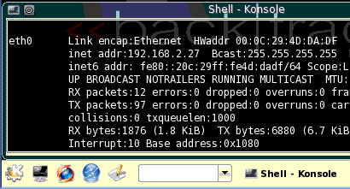
- At the bt ~ # prompt, type in this command and press the Enter key:
Start
button
xconf
- At the bt ~ # prompt, type in this command and press the Enter key:
startx
- A graphical desktop should appear, with a start button showing the letter K on a gear in the lower left, as shown to the right on this page. That K is the Start button.

Plugging in the USB NIC
- Connect the USB cable from the Linksys WUSB54G ver. 4 NIC and verify that the green light on the NIC comes on. There is no pop-up message telling you that the computer has detected it, but it's plug-and-play, just like it would be in Windows! And it has the advanced modes we need, unlike Windows.

Using Airodump to Collect Packets from the WLAN
- On the Hacker Computer, from the Backtrack 2 desktop, click Start, Backtrack, "Radio Network Analysis", 80211, All, Airodump.

- In the airodump window, type in this command and press the Enter key:
airodump-ng --ivs --write projx13 --channel 11 rausb0
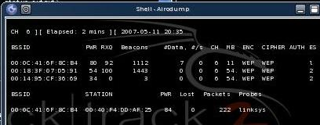
This command starts the packet collection. If your WLAN is not operating on channel 11, change 11 to the correct number. Packets will be collected and the Initialization Vectors (IVs) will be stored in a file named projx13.

- The top section shows all the networks detected by the card. The lower section shows the network chosen for data collection. Verify that the BSSID in the lower section matches the "Access Point MAC Address" you wrote in the box on a previous page.

Using Aireplay to Inject Packets into the WLAN
- You need about 250,000 packets. As you can see, they are being gathered very slowly, because there is very little traffic on the network. We will use aireplay to speed things up.
- On the Hacker Computer, from the Backtrack 2 desktop, click Start, Backtrack, "Radio Network Analysis", 80211, All, "Air Replay".
- In the airreplay window, type in this command and press the Enter key:
aireplay-ng -3 -b 00:0c:41:6f:8c:b4 -h 00:40:f4:dd:af:25 rausb0
This command starts recording ARP packets and replaying them. Replace the first MAC address with the "Access Point MAC Address" you wrote in a box on a previous page. Replace the second MAC address with the "Wireless Client MAC Address" you wrote in a box on a previous page.
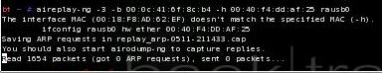

Using Aireplay to Force Disassociation of the Client
- On the Hacker Computer, from the Backtrack 2 desktop, click Start, Backtrack, "Radio Network Analysis", 80211, All, "Air Replay".
- In the airreplay window, type in this command and press the Enter key:
aireplay-ng -0 10 rausb0 -c 00:0c:41:6f:8c:b4 -a 00:40:f4:dd:af:25 rausb0
Replace the first MAC address with the "Access Point MAC Address" you wrote in a box on a previous page. Replace the second MAC address with the "Wireless Client MAC Address" you wrote in a box on a previous page.
This command breaks the connection between the client and the access point ten times, forcing it to re-associate. That creates some ARP packets for the other aireplay window to record and play back.
- After the ten disassociation attacks are over, you should see some ARP requests gotten in the other aireplay window, and the airodump window should show the Data packets coming in rapidly, as shown below.

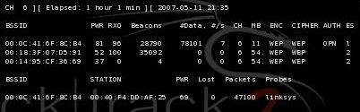

Using Aircrack to Find the WEP Key
- When the #Data rises to 100,000 or so, you can try cracking the key. Leave the airodump-ng window alone, so it continues to collect packets.
- On the Hacker Computer, from the Backtrack 2 desktop, click Start, Backtrack, "Radio Network Analysis", 80211, All, "Air Crack".
- In the “Air Crack” window, type in this command and press the Enter key:
ls -l
This command is lowercase LS –L. There are no numeral 1s in it.

- You should see a list of files, as shown below on this page. Find the file with a name starting with projx13 and a filename extension of .ivs with the largest size. In this case it is projx13-02.ivs with a size of 500571 bytes.
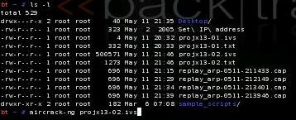

- In the “Air Crack” window, type in this command and press the Enter key:
aircrack-ng projx13-02.ivs
Replace projx13-02.ivs with the exact filename you found in the last step – the largest .ivs file you have.
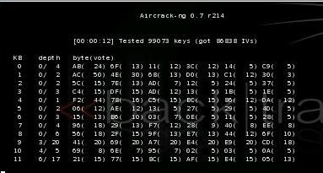
- Aircrack will show a chart of numbers, as shown to the right on this page. Now just wait – it might take as many as 250,000 IVs or even more to crack the key.

- When you have enough IVs captured (usually at least 100,000), the key will be found, as shown below on this page.
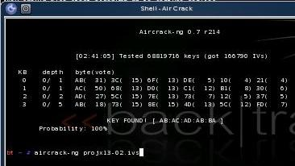

Saving the Screen Image on the Desktop
- On the Hacker Computer, from the Backtrack 2 desktop, click Start, Screenshot.
- In the Screenshot window, click the "Save As…" button.
- In the "Save as – Screenshot" window, in the unlabelled box on the upper right, click the arrow and select /root/desktop.
- In the "Save as – Screenshot" window, in the Location: box, type in a filename of
Yourname-ProjX13.jpg
Firefox
button
- Click the Save button. Your file should appear on the desktop.

Starting Firefox
- On the Hacker Computer, at the lower left of the desktop, click the "Firefox button", as shown to the right on this page.
Turning in your Project
- Firefox opens. Go to a Web-based email service you feel comfortable using in S214 – it should be one with a password you don't use anywhere else.
- Email the JPEG image to me as an attachment. Send the message to cnit.123@gmail.com with a subject line of Proj X13 From Your Name. Send a Cc to yourself.

Last modified 5-12-07

