What You Will Need
Warning: Only do this on networks you own. Cracking into networks without permission is a crime—don’t do it!
- An Ubuntu Linux computer with to use as the "Ubuntu Hacker Computer" (physical or virtual)
- A "Gateway" to the Internet, such as a router
- A "Victim Computer" running Windows, Linux, OS X, or any operating system that can use a Web browser. If the Ubuntu machine is a virtual machine, the host Windows XP system makes a handy victim.

Finding the IP and MAC Addresses of the Victim Computer
- You can use any machine for the victim computer, such as your Windows XP host machine. Click Start, "All Programs", Accessories, "Command Prompt" to a Command Prompt window on the victim computer. Type in this command, and press the Enter key:
IPCONFIG
- Find the "IP Address", as shown below on this page. If you have several network adapters, as we do in S214, there will be several sets of addresses shown. In S214, find the adapter with an IP address starting with 192.168.1. It's usually the Intel adapter, but not always.
Ethernet adapter Local Area Connection:

Connection-specific DNS Suffix . : S214
IP Address. . . . . . . . . . . . : 192.168.1.28
Subnet Mask . . . . . . . . . . . : 255.255.255.0
Default Gateway . . . . . . . . . : 192.168.1.1

- Write the IP Address you just found, and the Default Gateway, in the box to the right on this page.

IP of Victim: ____________________________

IP of Gateway: ____________________________

Starting the Ubuntu Hacker Computer
- Start your Ubuntu Linux virtual machine and log in as usual.

Installing the Required Packages on to the Ubuntu Hacker Computer
- From the Ubuntu desktop, click Applications, Accessories, Terminal. In the terminal window, enter this command, then press the Enter key:
sudo apt-get install dsniff
Enter your password when you are prompted to. Press Y twice when you are prompted to. Wait until the messages stop, and you see the $ prompt.
- In the terminal window, enter this command, then press the Enter key:
sudo apt-get install fragrouter
Press Y when you are prompted to. Wait until the messages stop, and you see the $ prompt.
- In the terminal window, enter this command, then press the Enter key:
sudo apt-get install ssldump
Wait until the messages stop, and you see the $ prompt.

Using arpspoof to Redirect Network Traffic to the Ubuntu Hacker Computer
- On the Ubuntu Hacker Computer, in the Terminal window,type in this command and press the Enter key :
sudo arpspoof -t IP-of-Victim IP-of-Gateway
Replace IP-of-Victim and IP-of-Gateway with the corresponding IP addresses you wrote on the first page of these instructions. Note that the IP addresses in the figure below are from my home network and not correct for S214.
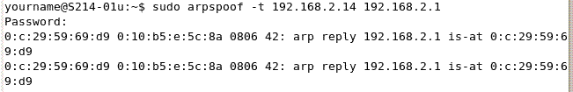

This command sends out ARP replies to the victim saying that the Gateway-IP is at the Hacker-Machine's MAC address. The victim's machine will just believe the ARP replies, so it will send all further Internet traffic to the Hacker Machine instead of the real Gateway. Leave this window open.

Using fragrouter to Perform IP Forwarding on the Ubuntu Hacker Computer
- From the Ubuntu desktop, click Applications, Accessories, Terminal. In the Terminal window, type in this command and press the Enter key :
sudo fragrouter -B1
Enter your password when you are prompted to. The response is "fragrouter: base-1: normal IP forwarding". This command starts IP Forwarding, so the Hacker Computer will forward the packets it intercepts to their correct destination. That way the Victim will not know anything is wrong. Leave this window open.

Using dnsspoof to Redirect all URLs to the Ubuntu Hacker Computer
- From the Ubuntu desktop, click Applications, Accessories, Terminal. In the Terminal window, type in this command and press the Enter key :
sudo dnsspoof
Enter your password when you are prompted to. The response is "dnsspoof: listening on eth0 [udp port 53 and not HackerIP]". This command starts a DNS server on the Hacker Computer which replies to all DNS requests with the hacker computers's IP address. The result is that all Internet traffic to all URLs will be sent to the Hacker Computer. Leave this window open.

Using webmitm to Send and Receive Certificates
- From the Ubuntu desktop, click Applications, Accessories, Terminal. In the Terminal window, type in this command and press the Enter key :
sudo webmitm
Enter your password when you are prompted to. This command sends X.509 Certificates to the Victim, and receives them from the Gateway. The certificates are real certificates, but they won't be verified by a Certificate Authority. This is the only way the Victim can tell they are being deceived.
- You now have to answer a series of questions to determine what information will appear on your digital certificates:
  - At the "Country Name (2 letter code) [AU]:" prompt, type "US" and press the Enter key.
  - At the "State or Province Name (full name) [Some-State]:" prompt, type "CA" and press the Enter key.
  - At the "Locality Name (eg, city) []:" prompt, type "San Francisco" and press the Enter key.
  - At the "Organization Name (eg, company) [Intenet Widgits Pty Ltd]:" prompt, type "CCSF" and press the Enter key.
  - At the "Organizational Unit Name (eg, section) []:" prompt, type "CNIT 123" and press the Enter key.
  - At the "Common Name (eg, YOUR name) []:" prompt, type in "Student" and press the Enter key.
  - At the "Email Address []:" prompt, type in "sbowne@ccsf.edu" and press the Enter key.
  - At the "A challenge password []:" prompt, press the Enter key.
  - At the "An optional company name []:" prompt, press the Enter key.

Checking the Four Windows
- On the Hacker Computer, you should now have four windows open as shown below:
  - A windows with arpspoof redirecting traffic to the "Hacker Computer"
  - A window with fragrouter forwarding traffic
  - A window with dnsspoof redirecting Web traffic to the "Hacker Computer"
  - A window running webmitm to send and receive digital certificates

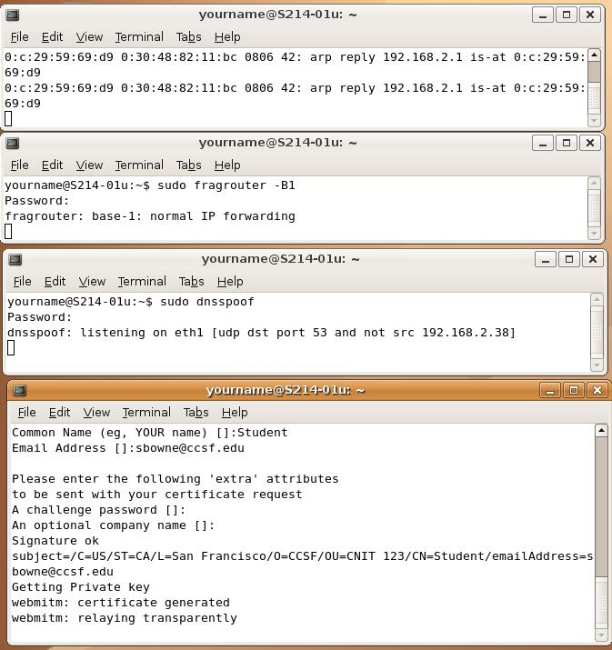
arpspoof
fragrouter
dnsspoof
webmitm

Opening the Gmail Login Page on the Victim Machine
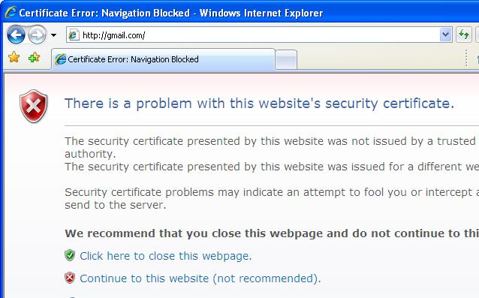
- On the Windows XP Victim Machine, open Internet Explorer and go to gmail.com. You should see the Security Warning shown to the right on this page. (If you have IE version 6, the message looks different.) This is your warning that the security certificate is not genuine.
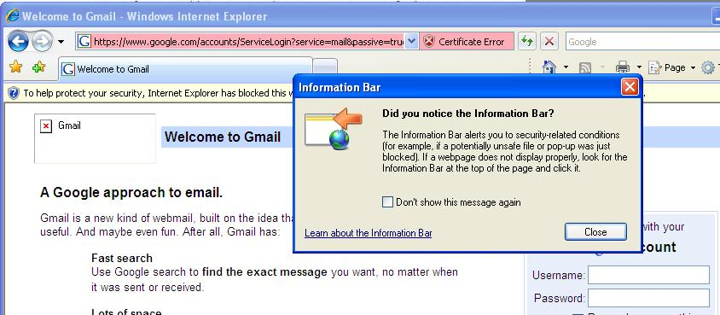
- Click "Continue to this website (not recommended)".
- An "Information Bar" box pops up, as shown to the right on this page. Click the Close button.
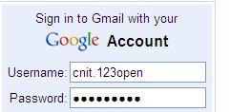
- Find the yellow "Information Bar" at the top of the browser window, which displays the message "To help protect your security, Internet Explorer has blocked this website from displaying content with security certificate errors. Click here for options…". Click the Information Bar and click "Display blocked content".
- When you get to the Gmail login page, don't log in with your real Gmail account! The passwords could be stolen by anyone doing this project. Instead, enter the username and password shown below, but don't click the login button yet!
Username: cnit.123open
Password: 1337h4x0r

Starting Wireshark to Record the Intercepted Traffic
- On the Ubuntu Hacker Computer, from the Ubuntu menu bar, click Applications, Internet, "Wireshark (as root)". Enter your password when you are prompted to.
- From the Wireshark menu bar, click Capture, Interfaces.
- Find the line with your "Hacker Computer's" IP address in it, and click that Capture button. You should see the number of packets captured increasing.

Opening the Gmail Login Page on the Victim Machine
- On the Windows XP Victim Machine, in the Internet Explorer window, click the Log In button. This will send your username and password to Gmail. The man-in-the-middle attack is not perfect, so the login process will not complete—Internet Explorer will just hang. However, it goes far enough to send your password to the hacker.

Decrypting the Captured Traffic on the Hacker Computer
- On the "Hacker Computer", in the "Wireshark Capture" box, click Stop. Click File, Save. Type in a file name of "gmail" and click the Save button.
- From the Ubuntu desktop, click Applications, Accessories, Terminal. In the Terminal window, type in this command and press the Enter key :
sudo ssldump -r /root/gmail -k webmitm.crt -d > gmail-clear
This command uses the digital certificate's key to decrypt the captured traffic, and puts the cleartext in the file gmail-clear in your home directory.
- In the Terminal window, type in this command and press the Enter key :
cat gmail-clear | grep Pass
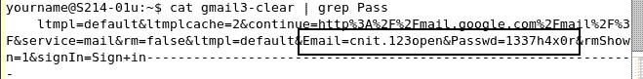
This command displays the lines in the gmail-clear file that contain "Pass". You should see the user name and password in cleartext, as indicated in the figure below.

Saving the Screen Image
- Click outside the virtual machine to make its title bar dim. Press the PrntScn key to copy whole screen to the clipboard in the host Windows XP machine. Open Paint and paste in the image. Save it as a JPEG, with the filename Your Name Proj X14.

Stopping the Attack and Returning to Normal Networking
- On the Ubuntu machine, close all windows and shut down the system.
- On the host Windows XP machine, close all windows and restart the system.
Turning in your Project
- Email the JPEG image to me as an attachment. Send the message to cnit.123@gmail.com with a subject line of Proj X14 From Your Name. Send a Cc to yourself.
Last modified 5-14-07

