What You Need for This Project

LEGAL WARNING!
Use only machines you own, or machines you have permission to hack into. Hacking into machines without permission is a crime! Don’t do it! If you do illegal things, you may be arrested and go to jail, and I will be unable to save you. These instructions are intended to train computer security professionals, not to help criminals.
- A trusted computer running any version of Windows, with Internet access. You need administrator privileges. This can be either a real or virtual machine.
- The "Windows XP Target" virtual machine that was handed out in class, or any other computer running Windows XP with no service packs,

Start Your Vista Host Machine
- Log in as Student.

Starting Your Target Virtual Machine
- Double-click the VMware Workstation icon on the desktop. In the VMware Workstation window, from the menu bar, click View, Go to Home Tab.
- On the Home tab, click the Open Existing VM or Team icon. Navigate to the VMs drive, open your folder, open the WinXP_TARGET folder, and double-click the WinXP_TARGET.vmx file. On the left side, click the Start this virtual machine link.
- If you see a message saying “The location of this virtual machine’s configuration file has changed…,” accept the default selection of Create and click OK.

Changing Your Target Virtual Machine’s Name
- On the Target machine’s desktop, click Start, right-click "My Computer", and click Properties. Click the "Computer Name" tab. Click the Change button. Give your machine an unique name, such as YourNameTarget. Click OK. When a "Computer Name Changes" box appears saying “You must restart…”, click OK. In the System Properties box, click OK. In the System Settings Change box, click Yes. Wait while your virtual computer restarts.
Note: If you get an error message about duplicate names that prevents you changing the name, disable the network adapter before changing the name.

Testing Your Target Virtual Machine’s Internet Connection
- On the Target virtual machine, open Internet Explorer and verify that you can reach the Internet. If you cannot, which happens very often, try the troubleshooting steps listed below.

Troubleshooting a VMware Network Connection
RESTART: Restart the virtual machine
USE DHCP: In the virtual machine, click Start, Control Panel, Network Connections. Right-click "Local Area Connection" and click Properties. Double-click "Internet Protocol (TCP/IP)" and make sure both the "Obtain an IP address automatically" and "Obtain an IP address automatically" buttons are selected. Click OK. Click OK.
REPAIR THE CONNECTION: In the virtual machine, click Start, Control Panel, Network Connections. Right-click "Local Area Connection" and click Repair.
VIRTUAL NETWORKING SETTINGS: In the VMware Workstation window's menu bar, click VM, Settings. In the "Virtual Machine Settings" box, in the left pane, click "Network Adapter" to select it. Make sure the "Connected" box is checked. Then try all three of these options one-by-one to find the one that works best:
      - Bridged
      - NAT
      - Custom: VMnet2
VMWARE BRIDGE PROTOCOL: In the Host machine, click Start and type "NETWORK CONNECTIONS" into the Search box. In the results, click "View network connections". Right-click "Local Area Connection" and click Properties. Make sure the "VMware Bridge Protocol" item is checked. Click OK.

Finding Your Target Virtual Machine’s IP Address
- Click Start, Run. Type in CMD and press the Enter key. In the Command Prompt screen, type in IPCONFIG and press the Enter key. If you have two network adapters, find the one with an IP address that starts with 192. Write that address in the box to the right on this page.

Target IP Address: ________________________

Starting your Trusted Machine
- If you are using VMware Workstation, close the unused tabs in the VMware window that is running your Target virtual machine. This will unlock your trusted machine.
- Double-click the VMware Workstation icon on the desktop. In the VMware Workstation window, from the menu bar, click View, Go to Home Tab.
- On the Home tab, click the Open Existing VM or Team icon. Navigate to the V: drive, open your folder, open the WinXPSP3 folder, and double-click the Windows XP Professional.vmx file. You should see a Windows XP Professional VM in the Powered Off state.
- In the Windows XP Professional – VMware Workstation window, on the left side, click the Start this virtual machine link.

Downloading and Installing Metasploit
- Open a Firefox and go to metasploit.com
- Click Framework. Click Download.
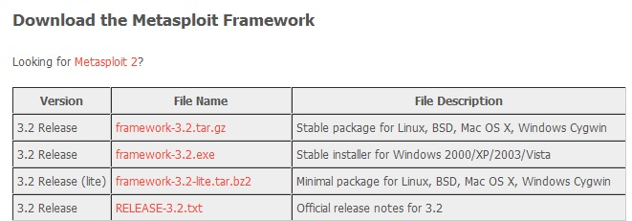
- Scroll down until you see the Windows installer for Metasploit 3,2, as shown below on this page. Click the framework-3.2.exe link. Save the file on your desktop.

Installing Metasploit 3.2
- Double-click the framework-3.2 file on your desktop and click through the installer, accepting all the default selections. A box will pop up, offering to install Nmap. Click Yes. Continue to click on all the default options when prompted. You will also install WinPCap.
- When you see the final box, saying "Completing the Metasploit Frameqork 3.2 Setup Wizard", click Finish. This will launch Metasploit. Even though the installer is done, there is a lot more installation to be completed. A Command Prompt window opens with a lot of file names scrolling by. Wait until it finishes—it will take several minutes.
Launching the MS04-011 LSASS Exploit
- When all the installation is complete, a "Metasploit Framework GUI v3.2-release" window opens, as shown below on this page. Type MS04 into the search box at the top of the window, and click the Find button.
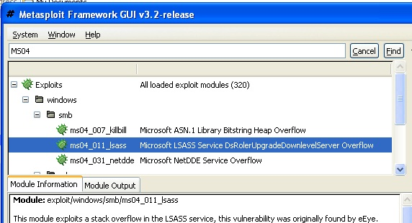

- Double-click ms04_011_lsass. A box opens with a banner reading MSF::ASSISTANT.
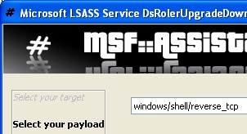
- The first screen asks you to Select your target. Accept the default selection of "Automatic Targetting" and click Forward.
- The next screen asks you to Select your payload. Click the list box down-arrow to see all the payloads, and scroll down to select windows/shell/reverse_tcp as shown to the right on this page. This is a common payload that opens a Command Prompt on the victim machine, so you can type in commands of your choice to do anything you like on that machine. Click Forward.

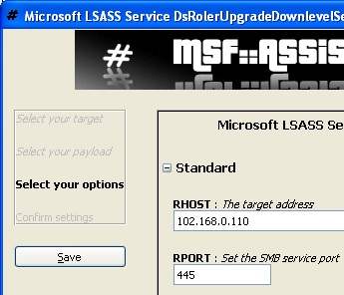
- The next screen asks you to Select your options. Find the Target IP Address you wrote into a box on a previous page of these instructions, and type it into the RHOST box, as shown to the right on this page. Move the window up on the desktop so you can see the buttons at the bottom, and click Forward.
- The next screen asks you to Confirm settings. Click Apply.
- In the "Metasploit Framework GUI v3.2-release" window, in the lower pane, click the "Module Output" tab.
- If the exploit works, you will see a message showing "Session 1 created", and in the lower right Sessions pane an IP address will appear, as shown below on this page. If the exploit fails, just repeat the process to exploit it a second time—sometimes Windows XP requires two attacks to succumb.
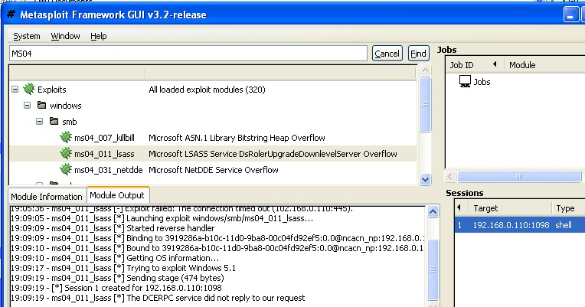

Troubleshooting Tips
- If you cannot get a session, try these tips:
  - Make sure the attacker's firewall is turned off
  - Turn off any security software on the attacker, like Norton or McAfee
  - If there is any firewall or security software on the target, turn it off.
  - Ping from attacker to target and make sure they are connected
  - Check the IP address on target and the attacker and make sure they are on the same subnet. That exploit doesn't work through NAT. If you attack a VM from the host, it must be set to Bridged networking
  - Sometimes the VM has hard disk errors. In a Command Prompt, enter CHKDSK C: /R and then restart the VM.
  - The target VM may just be broken--unzip the .7z file and make a fresh copy
  - If your computer is portable, you could bring it to the S214 lab so your instructor can help you
  - If your computer isn't portable, install TeamViewer on it and leave it on, and you can connect to it remotely from the S214 lab so your instructor can help you

Opening the Session
- In the "Metasploit Framework GUI v3.2-release" window, in the lower right pane, double-click the session line. A command prompt window opens, as shown below on this page. This lets you control the other machine!

Using the Reverse Shell to Tag the Victim’s Desktop
- As shown below on this page, enter two commands to create a file on the victim’s desktop. This is a traditional way childish hackers scare victims, showing that you “own” their box.

cd \documents and settings\student\desktop

echo “ha ha” > YOURNAME_owns_your_computer.txt

(Replace YOURNAME with your own name in the second command.)
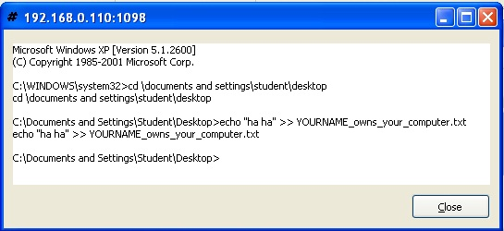

Saving a Screen Image
- Make sure the command prompt window is visible, as shown above on this page, demonstrating that own the Target machine.
- Click outside the virtual machine to make the host machine’s desktop active.
- Press the PrintScrn key to copy the whole desktop to the clipboard.
- In the host machine, click Start, Programs, Accessories, Paint. In the untitled - Paint window, select Edit, Paste from the menu bar. The desktop appears in the Paint window, with only a corner of it visible.
- In the untitled - Paint window, click File, Save. Save the document in the My Pictures folder (or any other place you wish, such as a floppy disk) with the filename Your Name Proj 2a. Select a Save as type of JPEG.

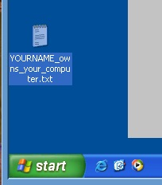
Viewing the Tag
- You should be able to see the new file on the victim’s desktop, as shown to the right on this page. Imagine how you would feel if files started appearing on your computer from nowhere while you were using it!

Patching the Target Machine
- To protect the Target from this attack, we will install a Microsoft security patch. To save time, I already downloaded the patch from microsoft.com/technet/security/bulletin/ms04-011.mspx and saved it in the Target Machine.
- In the Target Machine, click Start, My Documents.
- Double-click the WindowsXP-KB835732-x86-ENU.EXE file. Some files are extracted, and the "Windows XP KB83572 Setup Wizard" opens.
- Restart your Target machine when prompted to.

Launching the MS04-011 Exploit Again
- On the Trusted machine, close the Command Prompt window you used to tag the Target desktop.
- On the Trusted machine, in the "Metasploit Framework GUI v3.2-release" window, double-click ms04_011_lsass. A box opens with a banner reading MSF::ASSISTANT.
- The first screen asks you to Select your target. Accept the default selection of "Automatic Targetting" and click Forward.
- The next screen asks you to Select your payload. Select windows/shell/reverse_tcp and click Forward.
- The next screen asks you to Select your options. Type the Target IP Address into the RHOST box, and click Forward.
- The next screen asks you to Confirm settings. Click Apply.
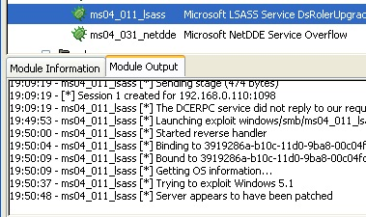
- In the "Metasploit Framework GUI v3.2-release" window, in the lower pane, you should see the message "Server appears to have been patched", as shown to the right on this page.

Saving a Screen Image
- Make sure the "Server appears to have been patched" message is visible, as shown on the previous page.
- Click outside the virtual machine to make the host machine’s desktop active.
- Press the PrintScrn key to copy the whole desktop to the clipboard.
- In the host machine, click Start, Programs, Accessories, Paint. In the untitled - Paint window, select Edit, Paste from the menu bar. The desktop appears in the Paint window, with only a corner of it visible.
- In the untitled - Paint window, click File, Save. Save the document in the My Pictures folder (or any other place you wish, such as a floppy disk) with the filename Your Name Proj 2b. Select a Save as type of JPEG.

Turning in Your Project
- Email the JPEG images to me as attachments to a single email message. Send it to: cnit.123@gmail.com with a subject line of Proj 2 From Your Name, replacing Your Name with your own first and last name. Send a Cc to yourself.

Last Modified: 9-10-10

