What You Need for This Project
- A computer with VMware. You can use any host OS you like, and if you prefer to use some other virtual machine software like VirtualBox or Xen, that’s fine too.
- An Ubuntu 10.04 install CD or ISO file. You can download it from ubuntu.org, and your instructor handed out CDs in class. If you want to use some other version of Ubuntu, or some other Linux distribution, that's OK too.
- The instructions below assume you are using Windows 7 in the S214 lab. If you are working at home, you will have to adapt the steps to match your situation.

Using VMWare Workstation to Create a New Virtual Machine
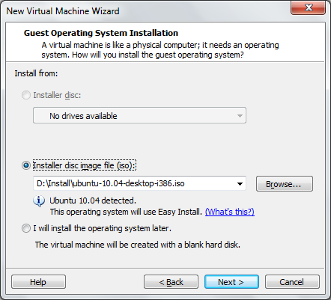
- If you are working at home, install your free copy of VMware Workstation before starting this project.
- Double-click the VMWare Workstation icon on the desktop.
- A VMWare Workstation window opens. Click View, "Go to Home Tab". Click the New Virtual Machine icon.
- A "Welcome to the New Virtual Machine Wizard" screen appears. Select "Typical (recommended)" and click Next.
- The next screen is titled: "Guest Operating System Installation". If you are using an ISO file, click "Installer disc image file (iso)", click the Browse button, and select your Ubuntu installer ISO file, as shown to the right on this page. If you are using a CD, insert the CD and click "Installer disc". Then click Next.
- At the "Easy Install Information" screen, fill in your desired name and password as indicated. Click Next.
- At the Name the Virtual Machine screen, enter a Virtual machine name of Your Name Ubuntu. Click the Browse button to choose the drive and folder to save the VM in. Navigate to V:\YOURNAME_VMs. Create a new subfolder named Ubuntu and click it to select it. Click Next.
- At the Specify Disk Capacity screen, accept the default selections of "20 GB" and "Store virtual disk as a single file". Click Next.
- At the Ready to Create Virtual Machine screen, click Finish. Wait while the OS installs--it will take quite a while. On my netbook, it took about an hour. In the S214 lab it should be faster. You will see various messages go by on the screen, including the screen shown below on this page.
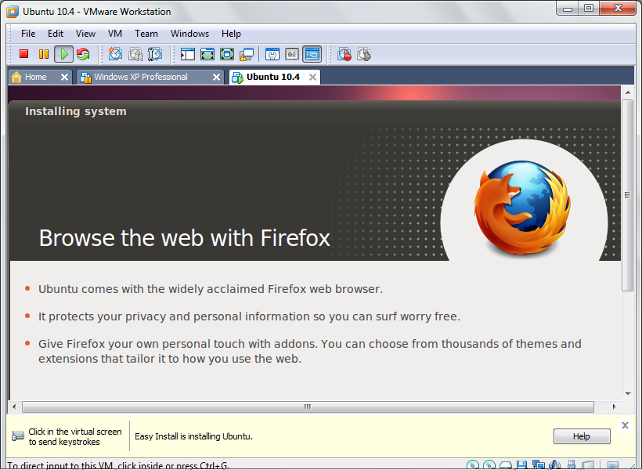

Logging In
- When the installation is complete, you will see a logon screen. Log in with the user name and password you chose.
Note: If your keyboard does not work, that may be a known bug that affects Ubuntu 10.4 on netbooks. I solved that problem with the instructions here: http://www.solo-technology.com/blog/2010/05/01/ubuntu-10-0-4-vmware-and-no-keyboard/
Using VMware in Full-Screen Mode
- Ubuntu doesn't work well with a screen resolution smaller than 1024x768. If you find the screen too small for comfortable work, and menu items are not visible, press Ctrl+Alt+Enter to make the VMware run in full-screen mode. When you want to return to the host Windows 7 desktop, press Ctrl+Alt+Enter again.
Adjusting Screen Saver Behavior
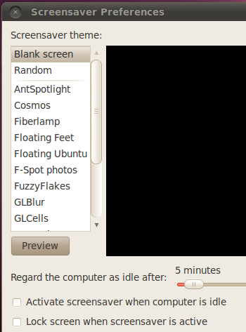
- From the Ubuntu menu bar, click System, Preferences, "Screen Saver". The default option is to turn the screen black after 5 minutes of inactivity, which is disturbing. And every time you try to use it, it will make you re-enter your password. To stop all that annoyance, unchecking the two boxes at the bottom of the "Screensaver Preferences" screen: "Activate screen saver when computer is idle" and "Lock screen when screensaver is active", as shown to the right on this page. Click the Close button.
Adjusting Power Management
- From the Ubuntu menu bar, click System, Preferences, "Power Management". There is no reason to shut down a virtual machine to save power, so set both drop-down list boxes to Never, as shown below on this page. Click the Close button.
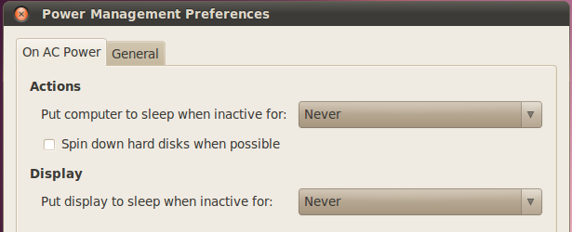

Updates
- Just like Windows, Ubuntu has vulnerabilities and a constant stream of updates. But the updates are not as important, because Linux is a lot more secure in the first place. Also, in my experience, Ubuntu updates are much more likely to break a working machine than Windows updates (see link Ch 1q on my Web page). So my recommendation is to not bother updating during this class unless there is a specific new feature you want.
Saving the Screen Image
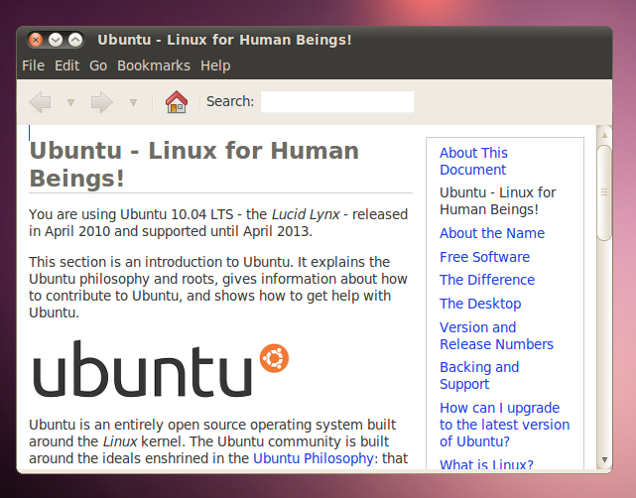
- From the Ubuntu menu bar, click System, "About Ubuntu". You should see a page titled "Ubuntu - Linux for Human Beings", as shown to the right on this page.
- Click on the host Windows 7 desktop taskbar. Press the PrntScn key to copy whole screen to the clipboard.
- On the host Windows 7 desktop, open Paint and paste in the image. Save it as a JPEG, with the filename Your Name Proj 4.

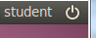
Shutting Down the Ubuntu Machine
- In the upper right of your Ubuntu desktop, to the right of your name, there is a circle with a line through it, as shown to the right on this page. Click that circle. Click "Shut Down…". If a box asks you to confirm you action, click "Shut Down".
Turning in your Project
- Email the JPEG image to me as an attachment. Send the message to cnit.123@gmail.com with a subject line of Proj 4 From Your Name. Send a Cc to yourself.
Last modified 1-9-11

