What You Need for This Project
- A computer with VMware. You can use any host OS you like, and if you prefer to use some other virtual machine software like VirtualBox or Xen, that’s fine too.
- A BackTrack Linux virtual machine, which you made in a previous project. If you want to use some other version of Linux, that's OK too.
- A Windows 7 machine on the same network as your Linux machine. You may not be able to scan your host computer from a VMware Linux machine, however. If you are doing this project with a single machine, for best results I recommend using a second virtual machine to be the target. I recommend using the "Windows XP SP3" virtual machine you used in previous projects in that case.
- The instructions below assume you are using two computers in the S214 lab: one to host the VMware Linux virtual machine, and one to be the target. If you are working at home, you will have to adapt the steps to match your situation.
Warning! Unexpected port scans are rude, and possibly even illegal! Port scans can set off intrusion detection systems and get us all into trouble. Don’t scan other people’s servers, just scan machines you have permission to scan. The only machines you should scan in this project are machines in S214, or on your own network at home.

Start Your Linux Virtual Machine
- Open VMware Player or VMware Workstation. Launch your Linux virtual machine.
- When your machine starts up, log in as root with a password of toor. Launch the desktop with the startx command.

Setting VMware Networking to Bridged
- From the "VMware Workstation" menu bar, click VM, Settings.
- In the "Virtual Machine Settings" box, on the side, click "Network Adapter". On the right side, click Bridged, as shown below on this page. Make sure the Connected box is checked. Click OK.
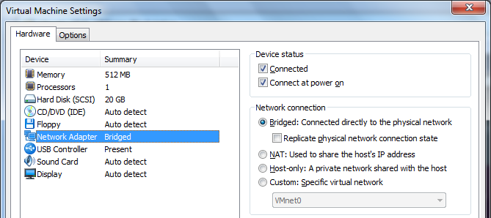

Finding the IP Address of Your Linux Machine
- At the upper left of your Linux desktop, click the little black square icon to open a Terminal window.
- In the Terminal window, after the $ prompt, enter this command, then press the Enter key:
ifconfig
- Find your IP address--it should start with 192.168.1. Write it in the box to the right on this page. (If you are working at home, the IP address may be different.)

Linux IP: _________________________

Ensuring that You Have an Internet Connection
- In the Terminal window, after the # prompt, enter this command, then press the Enter key:
dhclient
Enter your password when you are prompted to. This command runs the DHCP client to get an automatic IP address.
- In the Terminal window, after the $ prompt, enter this command, then press the Enter key:
ping google.com
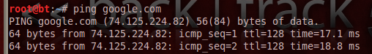
- You should see lines starting "64 bytes from…", as shown to the right on this page. Press Ctrl+C to stop the pinging.
- If you don't see any replies, your virtual machine is not connected to the Internet. You need to be connected to the Internet to proceed with this project. Try troubleshooting it with the instructions titled "Fixing Problems with Linux on VMware", which is in the printed lecture notes and homework, and available on my Web page samsclass.info on the CNIT 123 Page in the Projects section.

Port Scanning Your Own Linux Machine With zenmap
- On the upper left of the BackTrack 5 desktop, click Accessories, Internet, "Zenmap (as root)"
- In the Zenmap window, enter a Target: 127.0.0.1. Accept the default Profile: of Intense Scan, as shown below on thist page. Click the Scan button.
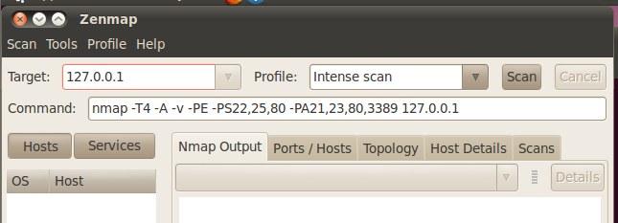

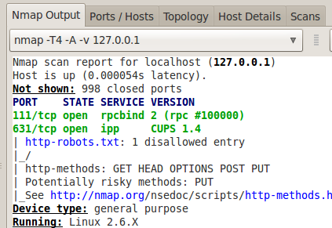
- When the scan completes, scroll back to see a chart showing the open ports in green text. Your Linux machine should have port 631/tcp open, as shown to the right on this page. Port 631 is used for printer sharing, and it's open by default on a freshly installed Linux machine.

Finding the IP Address of Your Windows 7 Target Machine
- You need to use a second computer as the target machine. You cannot use the Windows machine that VMware is running on, because the virtual networking blocks the scan. That machine will be the "Windows 7 Target Machine".
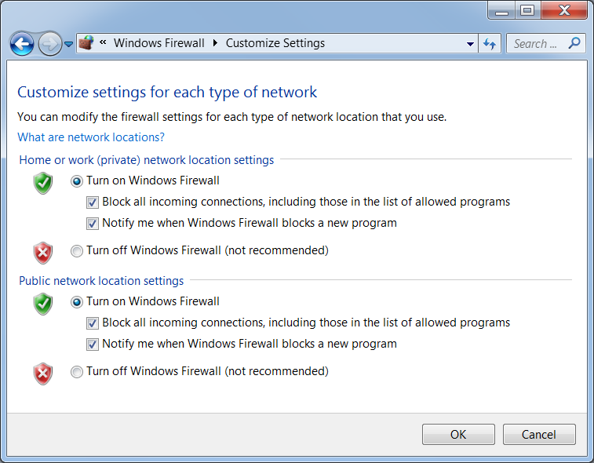
- In your Windows 7 target machine, click Start, Run. In the Run box, enter cmd and press the Enter key. In the Command Prompt window, enter the IPCONFIG command and press the Enter key. Several IP addresses appear. Find the one that starts with 192.168.1 and write it in the box to the right on this page.

Win 7 IP: ____________________

Setting Your Windows 7 Machine's Firewall to Block All Incoming Connections
- In your Windows 7 target machine, click Start. Type in FIRE and click "Windows Firewall" in the results section.
- In the "Windows Firewall" box, on the left side, click "Turn Windows Firewall on or off".
- In the "Customize Settings" box, in the "Home or work (private) network location settings" section, click the "Turn on Windows Firewall" button and check the "Block all incoming connections…" box, as shown below on this page. Make the same adjustments in the "Public network location settings" section. Click the OK button.

Scanning Your Windows 7 Target Machine With Incoming Connections Blocked
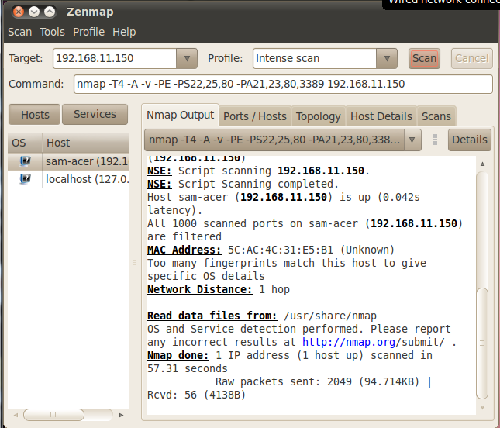
- In the Zenmap window, enter the IP address of your Windows 7 machine. Click the Scan button.
- You should get results as shown to the right on this page, saying "All 1000 scanned ports … are filtered". That’s what the firewall does—blocks all responses to unexpected SYN packets, on all ports.

Saving a Screen Image
- Click outside the virtual machine to make the host machine’s desktop active.
- Press the PrintScrn key to copy the whole desktop to the clipboard.
- In the host machine, launch Paint and paste in the image.
- Save the image with the filename Your Name Proj 5a. Select a Save as type of JPEG.

Setting Your Windows 7 Target Machine's Firewall to Off
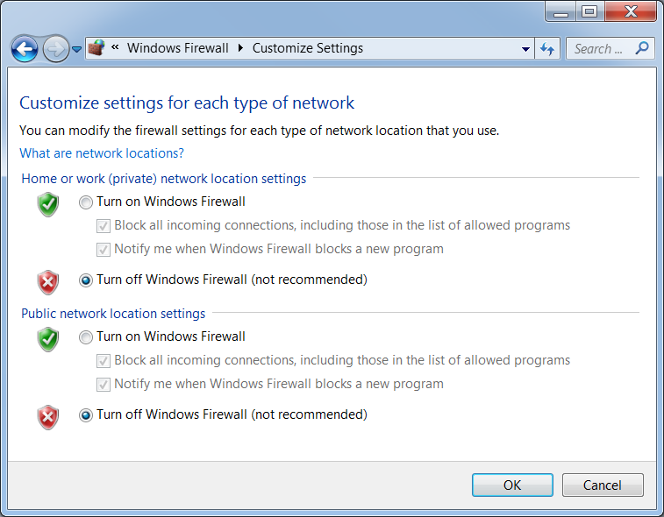
- In your Windows 7 target machine, click Start. Type in FIRE and click "Windows Firewall" in the results section.
- In the "Windows Firewall" box, on the left side, click "Turn Windows Firewall on or off".
- In the "Customize Settings" box, in the "Home or work (private) network location settings" section, click the "Turn off Windows Firewall" button, as shown to the right on this page. Make the same adjustment in the "Public network location settings" section. Click the OK button.

Port Scanning Your Windows 7 Target Machine With the Firewall Off
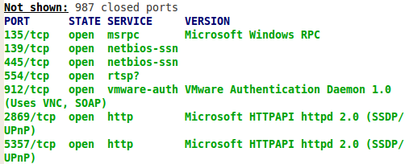
- In the Zenmap window, verify that the IP address of your Windows 7 target machine is still in the Target: box. Click the Scan button. When the scan completes, scroll up to find the green text.
- You should get results as shown to the right on this page, showing open ports: 135, 139, 445, and probably several others.

Saving a Screen Image
- Click outside the virtual machine to make the host machine’s desktop active.
- Press the PrintScrn key to copy the whole desktop to the clipboard.
- In the host machine, launch Paint and paste in the image.
- Save the image with the filename Your Name Proj 5b. Select a Save as type of JPEG.

Turning in Your Project
- Email the JPEG images to me as attachments to a single email message. Send it to: cnit.123@gmail.com with a subject line of Proj 5 From Your Name, replacing Your Name with your own first and last name. Send a Cc to yourself.
Last Modified: 1-29-12

