What You Will Need
- A BackTrack 5 Linux machine (you can use other Linux versions if you like)

Starting Your Linux Virtual Machine
- Start your Linux machine and log in as usual.

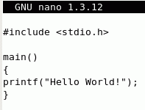
Writing the hello.c Source Code
- In the Terminal window, after the $ prompt, enter this command, then press the Enter key:
pico hello.c
The pico editor opens. Type in the program shown to the right on this page. Hold down the Ctrl key and press O to output your file. Press the Enter key to accept the filename and save your file. Hold down the Ctrl key and press X to exit pico.

Compiling hello.c to Create the hello File
- In the Terminal window, after the $ prompt, enter this command, then press the Enter key:
gcc hello.c –o hello
This command compiles the hello.c program, creating an executable machine language file named hello. If you made any errors typing in the hello.c file, you will get error messages here. Use pico to fix the errors and recompile the file until it compiles without any errors.

Executing the hello File
- In the Terminal window, after the $ prompt, enter this command, then press the Enter key:
./hello
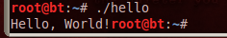
This command executes the hello program. You should see "Hello World!" at the start of the next line, as shown to the right on this page.

- This program works, but it would be nicer if it greeted you by name, and if it put a couple of newline characters after the greeting to make it cleaner-looking. The next version, hello2, will add these features.

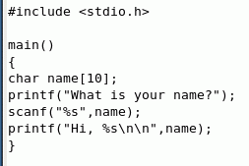
Writing the hello2.c Source Code
- In the Terminal window, after the $ prompt, enter this command, then press the Enter key:
pico hello2.c
The pico editor opens. Type in the program shown to the right on this page. Hold down the Ctrl key and press O to output your file. Press the Enter key to accept the filename and save your file. Hold down the Ctrl key and press X to exit pico.

Compiling hello2.c to Create the hello2File
- In the Terminal window, after the $ prompt, enter this command, then press the Enter key:
gcc hello2.c –o hello2
This command compiles the hello2.c program, creating an executable machine language file named hello2. If you made any errors typing in the hello2.c file, you will get error messages here. Use pico to fix the errors and recompile the file until it compiles without any errors.

Executing the hello2 File With Your Name
- In the Terminal window, after the $ prompt, enter this command, then press the Enter key:
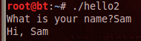
./hello2
This command executes the hello2 program. It should ask you for your name. When you type in your name, you should be greeted by name, as shown to the right on this page.

Crashing the hello2 Program With a Long Name—Buffer Overflow
- The hello2 program is poorly written, and exposes your machine to being exploited by hackers. That's because it takes the name from typed input and puts it in the name string, but the name string has a size limit—it only has enough room for 10 characters. Names longer than 10 characters will cause user-input data to overwrite parts of memory that were not intended to store data, making the program crash. This is a Buffer Overflow.
- In the Terminal window, after the $ prompt, enter this command, then press the Enter key:
./hello2
This command executes the hello2 program.

- When you see the What is your name? prompt, type in this name:
12345678901234567890
Scroll up bit and you should see a *** stack smashing detected *** message, as shown below on this page. Although this just crashes the machine, which could result in a denial of service, with carefully crafted false data it is often possible to use such errors to open a shell on the host, giving you complete control over it. That's how many of the Metasploit exploits work.

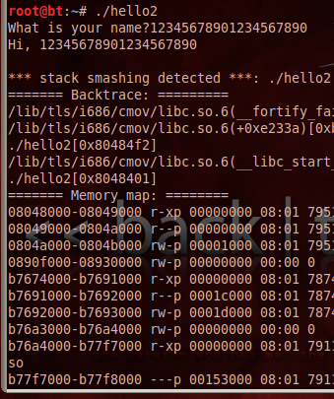
Saving the Screen Image
- Press Ctrl+Alt to release the mouse, and click on the host Windows desktop. Press the PrntScn key to copy whole screen to the clipboard.
- On the host Windows desktop, open Paint and paste in the image. Save it as a JPEG, with the filename Your Name Proj 8a.

Writing the hello3.c Source Code
- We need to patch this code. So we'll make another version. In the Terminal window, after the $ prompt, enter this command, then press the Enter key:
cp hello2.c hello3.c
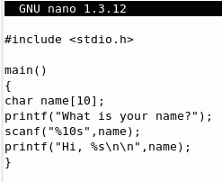
This makes a copy of hello2.c named hello3.c.
- In the Terminal window, after the $ prompt, enter this command, then press the Enter key:
pico hello3.c
The pico editor opens. Modify the scanf call to match the program shown to the right on this page. Hold down the Ctrl key and press O to output your file. Press the Enter key to accept the filename and save your file. Hold down the Ctrl key and press X to exit pico.

Compiling hello3.c to Create the hello3 File
- In the Terminal window, after the $ prompt, enter this command, then press the Enter key:
gcc hello3.c –o hello3
This command compiles the hello3.c program, creating an executable machine language file named hello3. If you made any errors typing in the hello3.c file, you will get error messages here. Use pico to fix the errors and recompile the file until it compiles without any errors.

Running the hello3 File With a Long Name
- In the Terminal window, after the $ prompt, enter this command, then press the Enter key:
./hello3
This command executes the hello program.
- When you see the What is your name? prompt, type in this name:
12345678901234567890
The program now just ignores any characters after the first ten. There is no error message, and no stack overflow. The program is patched. This is what many of those Microsoft security patches do—correct code to remove buffer overflow vulnerabilities. By the way, this is not a very complete fix, because it leaves some keyboard characters in an input buffer which could lead to unexpected results later in the program. For a more thorough way of patching scanf, see link Ch 7i.
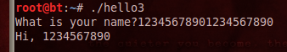

Saving the Screen Image
- Press Ctrl+Alt to release the mouse, and click on the host Windows desktop. Press the PrntScn key to copy whole screen to the clipboard.
- On the host Windows desktop, open Paint and paste in the image. Save it as a JPEG, with the filename Your Name Proj 8b. Select a Save as type of JPEG.

Using ping
- In the Terminal window, after the $ prompt, enter this command, then press the Enter key:
ping 192.168.1.1
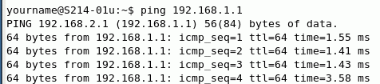
That number is the default gateway in S214. If you are not in S214, use your default gateway instead of that address. You should see a series of lines starting "64 bytes from" as shown below on this page. Ping will just continue sending packets until you terminate it by holding down the Ctrl key and pressing C.

- In the Terminal window, after the $ prompt, enter this command, then press the Enter key:
ping 192.168.1.1 –w1
Note that the last two characters are the letter w and the numeral 1. This makes ping end faster—it stops after one second.

Writing the pingscan.c Source Code
- We will make a simple ping scanner, like one of the Nmap functions. It will ping each of 100 IP addresses for one second to see if there is any response. This works, although it is a lot slower and clumsier than Nmap.
- In the Terminal window, after the $ prompt, enter this command, then press the Enter key:
pico pingscan.c
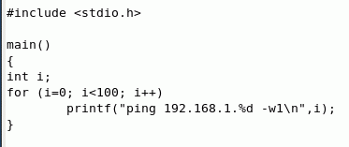
- The pico editor opens. Type in the program shown to the right on this page. Note that the last two characters in the printf format string are the letter w and the numeral 1. (If you are on a different subnet, replace 192.168.1 with the first 3 numbers in your LAN's IP address.) Hold down the Ctrl key and press O to output your file. Press the Enter key to accept the filename and save your file. Hold down the Ctrl key and press X to exit pico.

Compiling pingscan.c to Create the pingscan File
- In the Terminal window, after the $ prompt, enter this command, then press the Enter key:
gcc pingscan.c –o pingscan
This command compiles the pingscan.c program, creating an executable machine language file named pingscan. If you see error messages, use pico to fix the errors and recompile the file until it compiles without any errors.

Executing the pingscan File
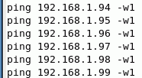
- In the Terminal window, after the $ prompt, enter this command, then press the Enter key:
./pingscan
- The program prints 100 ping command lines on the terminal, as shown to the right on this page. However, it doesn't execute the PINGs, it just prints out the commands. To make the commands execute, we need to put them into a file and make the file executable.

- In the Terminal window, after the $ prompt, enter this command, then press the Enter key:
./pingscan > ping100
- You see another prompt with no message, which is what Linux does when there is no problem. The > sign is the output redirection operator, and it took the lines of text that were going to the screen and put them into a file named ping100 instead.
- In the Terminal window, after the $ prompt, enter this command, then press the Enter key:
ls
Note that this command starts with a lowercase L, not the numeral 1. This shows a list of the files and directories in the working directory, as shown below. Your filenames will be different, but you should be able to see the ping100 file. Data files are in gray letters, executable files are green, and directories are aqua. Note that the ping100 file is present, but in gray letters—this file is not executable.

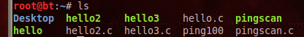

- In the Terminal window, after the $ prompt, enter this command, then press the Enter key:
chmod a+x ping100
This command changes the mode of the ping100 file to make it executable by all users.
- In the Terminal window, after the $ prompt, enter this command, then press the Enter key:
ls
Find the ping100 file in the list and verify that it is now shown in green letters.
- In the Terminal window, after the $ prompt, enter this command, then press the Enter key:
./ping100
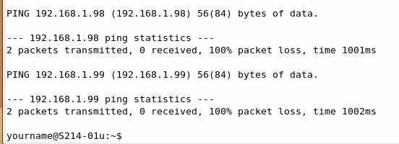
The ping scan should run, with results like those shown below on this page. It will take about 100 seconds to finish.

Saving the Screen Image
- Press Ctrl+Alt to release the mouse, and click on the host Windows desktop. Press the PrntScn key to copy whole screen to the clipboard.
- On the host Windows desktop, open Paint and paste in the image. Save it as a JPEG, with the filename Your Name Proj 8c. Select a Save as type of JPEG.
Turning in your Project
- Email the JPEG images to me as attachments to a single email message. Send the message to cnit.123@gmail.com with a subject line of Proj 8 From Your Name. Send a Cc to yourself.
Credit:
I got some of this from crasseux.com/books/ctutorial/String-overflows-with-scanf.html (Link Ch 7i)

Last modified 9-29-11

