What You Need for This Project
- A computer running Windows (any version) with Internet access. You need administrator privileges. This can be either a real or virtual machine. The instructions below assume you are using Windows 7.
- A computer running Linux (any version). The instructions below assume you are using Ubuntu.
Downloading and Installing ActivePython
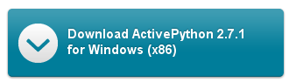
- Start a browser and go to http://www.activestate.com/activepython/downloads
- Click the blue "Download ActivePython 2.7.1 for Windows (x86)" button, as shown to the right on this page.
- Save the file on your desktop and run it. Install the software with all the default selections.
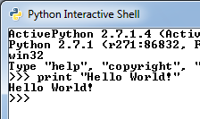
Starting ActivePython
- Click Start, "Python Interactive Shell".
“Hello World” in Python
- A "Python Interactive Shell". window opens. At the >>> prompt, type in this command, then press the Enter key:
print "Hello World!"
The result is to print “Hello World!” on the next line, as shown to the right on this page.
Making a Customized Greeting in Interactive Python
- At the >>> prompt, type in this command, then press the Enter key:
name = raw_input("What is your name: ")
- The next line asks what your name is. Type in your name and press Enter.
- The next line shows a >>> prompt. Your name has now been stored in the variable name. To see that, at the >>> prompt, type in this command, then press the Enter key:
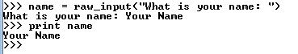
print name
You should see your name on the next line, as shown to the right on this page.
- The variable name persists until you change it, or close Python. You can use it again. To see that, at the >>> prompt, type in this command, then press the Enter key:
print “Hello”, name
You should see your customized greeting.
- Close the "Python Interactive Shell" window.
Making hello.py: a Customized Greeting Python Script
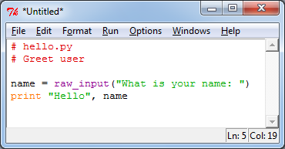
- The interactive shell is good for simple, short actions, but it’s not a good way to make a long script. To create a script, click Start and type PYTHON into the Search box. Then click "IDLE (Python GUI)". A "Python Shell" window opens.
- From the menu bar, click File, "New Window".
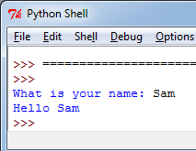
- In the *Untitled* box, accept type in the script shown to the right on this page. The first two lines are comments, indicated by the # sign.
- After typing in your script, from the *Untitled* menu bar, click File, Save. Save it in the Documents library with the name hello. PythonWin will add the file extension .py to the file name.
- To run the script, from the hello menu bar, click Run, "Run Module".
- Blue text appears in the "Python Shell" window asking for your name. Type in your name and press Enter.
- The message "Hello" followed by your name appears on the next line, as shown to the right on this page.
Saving the Screen Image
- Press the PrntScn key to copy the desktop to the clipboard. Start Paint and paste the image into it. Save the image with the filename Your Name Proj 10a.
Starting a Netcat Listener in Ubuntu Linux
- Now we’ll open a socket from Python on Windows to Netcat on Linux, and transfer data both ways.
- Start your Ubuntu Linux machine and log in as usual.
- From the Ubuntu menu bar, click Applications, Accessories, Terminal.
- In the Terminal window, after the $ prompt, enter this command, then press the Enter key:
ifconfig

Ubuntu IP: ________________________
Find the IP address for your eth0 interface and write it in the box to the right on this page.
- We will use netcat to listen for inbound data. After the $ prompt, type in this command, then press the Enter key:
nc –l 4242
Note that the first switch is a lowercase L, not the numeral 1. This will start a process listening on port 4242 on the Linux machine.
Displaying the Listening Sockets on the Ubuntu Machine
- Leave the terminal window showing the nc command alone, and from the Ubuntu menu bar, click Applications, Accessories, Terminal to open a second Terminal window.
- In the new Terminal window, after the $ prompt, enter this command, then press the Enter key:
netstat –l --protocol=inet
You should see a list of network connections that are listening, as shown below on this page. Look for the line that shows *:4242 – that’s the netcat listener, waiting for any incoming connections on port 4242.
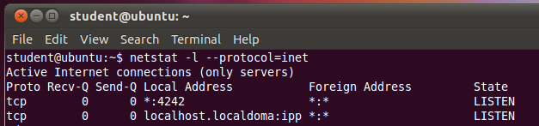

Establishing a TCP Socket in Python on Windows
- From the menu bar, click File, "New Window".
- In the *Untitled* box, type in the script shown below on this page. Put your Ubuntu machine’s IP address in the second line—that’s the number you wrote in the box on a previous page of these instructions.

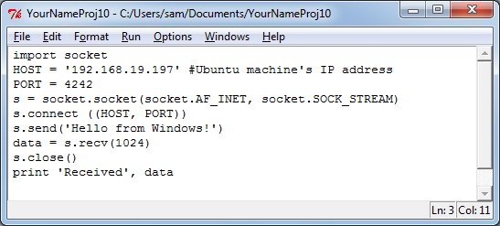

- After typing in your script, from the *Untitled* menu bar, click File, Save. Save it in the Documents library with the name YourNameProj10. PythonWin will add the file extension .py to the file name.
- To run the script, from the hello menu bar, click Run, "Run Module".
- Nothing happens on the Windows machine, unless you have made a typographical error in the script.
Observing the Session Established on the Windows Machine
- Leave the PythonWin windows alone for now.
- From the Windows desktop, click Start, Run. Type in CMD and press the Enter key.
- In the Command Prompt window, enter this command and press the Enter key:
netstat -n
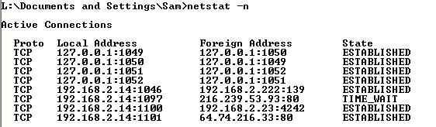
You should see a list of network connections. Look for the line that shows a Foreign Address ending with :4242 (second from the bottom in the figure below). The connection should show a State of ESTABLISHED.

Saving the Screen Image
- Press the PrntScn key to copy the desktop to the clipboard. Open paint and paste in the image. Save the image with the filename Your Name Proj 10b.
Receiving and Sending Data With the Ubuntu Linux Machine
- Leave the PythonWin windows alone on the Windows XP machine.
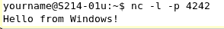
- Return to the Ubuntu machine. Look at the Terminal window that is running the netcat listener. You should see the text sent from the Windows machine on it: “Hello from Windows!” as shown to the right on this page.
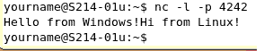
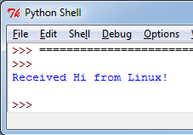
- Click in the Terminal window, and type in the message “Hi from Linux!” Then press the Enter key. Your Terminal window should now look like the figure to the right on this page.
Observing the Received Data on the Windows Machine
- Go back to the Windows machine. In the "Python Shell" window, you should see the message “received Hi from Linux!” as shown to the right on this page.
Saving the Screen Image
- Press the PrntScn key to copy the desktop to the clipboard. Open paint and paste in the image. Save the image with the filename Your Name Proj 10c.
Turning in your Project
- Email the JPEG images to me as attachments to one e-mail message to cnit.123@gmail.com with a subject line of Proj 10 From Your Name. Send a Cc to yourself. Last mod. 3-5-11

