What You Need for This Project
- A virtual machine running Windows XP (any version)

Copying the Virtual Machine
- Make a copy of your VM for this project. Don't work with the original, because you will want to discard this VM after rootkitting it. This rootkit is not good for the machine. You can see one of the errors it caused on my virtual machine below—I don't think you will be able to trust your machine after doing this to it.
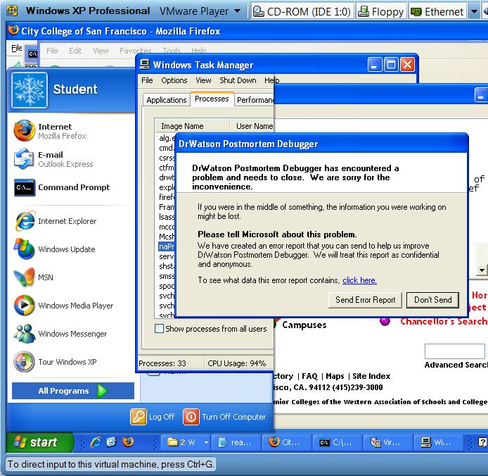

Starting the Windows XP Virtual Machine
- Use VMware and start your copied virtual machine.

Downloading the Hacker Defender Rootkit
- Open a browser on your Windows XP virtual machine go to samsclass.info and click the "CNIT 123" link. Scroll down to "Project 11" and click the hxdef100r link, as shown to the right on this page.
- Save the hxdef100r.7z file on your desktop.
- On your desktop, right-click the hxdef100r.7z file. If 7-Zip appears in the context menu, click 7-Zip, "Extract Here" as shown below on this page. If no 7-Zip item is visible, you need to open a browser, go to 7-zip.com, download 7-zip, and install it.
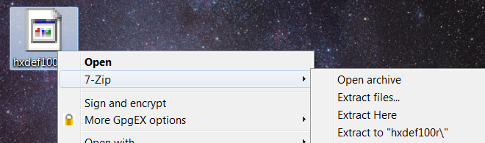

- When you extract the file, 7-Zip will ask for a password. You may have to move the "Extracting" window to the side to see the "Enter password" window. The password is sam
- When the file is extracted, a hxdef100r folder will appear on your desktop.
- Close all windows.

Installing the Hacker Defender Rootkit
- On your desktop, double-click the hxdef100r.zip file.
- In the hxdef100r.zip window, double-click the readmeen file. Scan this file, it’s interesting. This rootkit was in actual use on many infected systems according to your textbook author, and the readme file claims that there are commercial versions with more features. This is an example of illegal commercial software—malware authors sell their programs, and sometimes even try to fight piracy of them.
- Click Start, "My Computer". Double-click the C: drive to open it. If necessary, click "Show the contents of this folder".
- Drag the hxdef100.ini file to the C: window and drop it there. If your antivirus software stops it, turn off your antivirus software. For McAfee antivirus, the steps are:
  - Right-click the shield icon in the taskbar tray, on the lower right of the desktop
  - Click "Disable On-Access Scan"
- Drag the hxdef100.exe file to the C: window and drop it there.

Customizing the Configuration File
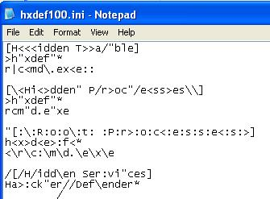
- In the C: window, double-click the hxdef100.ini file. It's messy, with a lot of added <, >, /, and \ characters, as shown to the right on this page.
- From the Notepad menu bar, click Edit, Replace.
- In the "Find what:" box, type <
- Click the "Replace All" button.
- Empty the "Find what:" box, and type > into it. Click the "Replace All" button.
- Empty the "Find what:" box, and type / into it. Click the "Replace All" button.
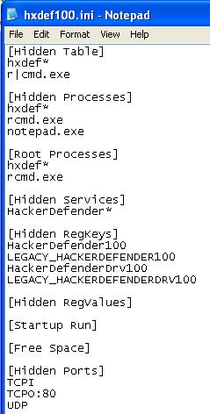
- Empty the "Find what:" box, and type \ into it. Click the "Replace All" button.
- Empty the "Find what:" box, and type " into it. Click the "Replace All" button.
- Empty the "Find what:" box, and type : into it. Click the "Replace All" button.
- The file should be much cleaner now, as shown to the right on this page. From the Notepad menu bar, click File, Save.
- In the [Hidden Processes] section, add this line, as shown to the right on this page:
notepad.exe
- In the [Hidden Ports] section, modify the TCPO line to look like this, as shown to the right on this page:
TCPO:80
- From the Notepad menu bar, click File, Save.
- The rootkit is now configured to hide the Notepad process, and also outgoing HTTP connections (port 80).

Viewing the Notepad Process with Task Manager
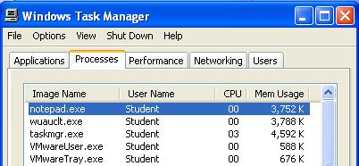
- Right click the taskbar and click "Task Manager". In "Windows Task Manager", click the Processes tab. The notepad.exe process should be visible, as shown to the right on this page.

Viewing Network Connections with NETSTAT
- Open a Web browser and go to www.ccsf.edu
- Click Start, Run. Type in CMD and press the Enter key.
- In the Command Prompt window, type this command, and then press the Enter key:
NETSTAT
- You should see some connections to cloud.ccsf.cc.cca.us:http, as shown below on this page.

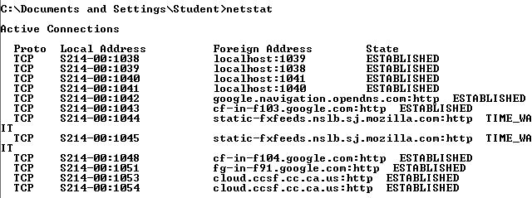

Running the Rootkit
- In the Command Prompt window, type this command, and then press the Enter key:
cd \
This changes the working directory to C:\, where the rootkit is.
- In the Command Prompt window, type this command, and then press the Enter key:
hxdef100.exe -:noservice
This starts the rootkit normally.

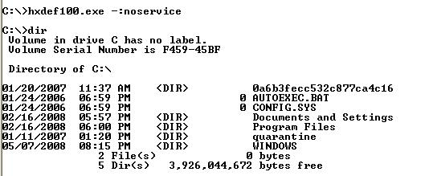
- In the Command Prompt window, type this command, and then press the Enter key:
dir
- The rootkit files are no longer present in the directory, as shown to the right on this page. The rootkit is working!

Examining the C: drive with Windows Explorer
- Click Start, "My Computer". Double-click the C: drive to open it. If you already have a C: window open, click View, Refresh.
- You should see folders, but no files starting hxdef, as shown below on this page.

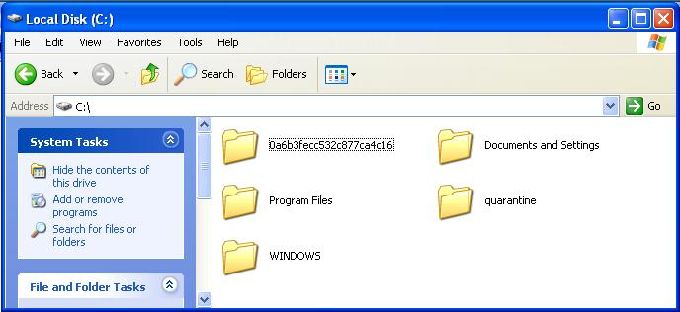
Capturing a Screen Image

- Click outside the virtual machine to make the host operating system active.
- Press the PrintScrn key in the upper-right portion of the keyboard.
- Click Start, Programs, Accessories, Paint. In the untitled - Paint window, select Edit, Paste from the menu bar.
- In the untitled - Paint window, click File, Save. Select a Save as type of JPEG. Save the document with the filename Your Name Proj 11a.

Examining Processes with Task Manager
- Click Start, Programs, Accessories, Notepad.
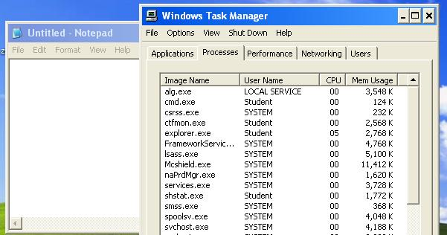
- Right click the taskbar and click "Task Manager". In "Windows Task Manager", click the Processes tab. Click the "Image Name" header to sort the processes alphabetically. The notepad.exe process should be invisible, as shown to the right on this page.

Capturing a Screen Image
- Make sure the Notepad window is visible, and that the Task Manager window shows an alphabetical list that clearly shows that notepad.exe is absent.
- Click outside the virtual machine to make the host operating system active.
- Press the PrintScrn key in the upper-right portion of the keyboard.
- Click Start, Programs, Accessories, Paint. In the untitled - Paint window, select Edit, Paste from the menu bar.
- In the untitled - Paint window, click File, Save. Select a Save as type of JPEG. Save the document with the filename Your Name Proj 11b.

Viewing Network Connections with NETSTAT
- Open a Web browser and go to www.ccsf.edu
- Click Start, Run. Type in CMD and press the Enter key.
- In the Command Prompt window, type this command, and then press the Enter key:
NETSTAT

- The list of connections should not show any connections to :http addresses, as shown below on this page.
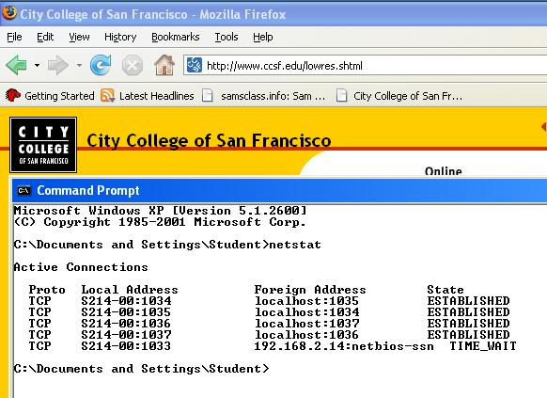

Capturing a Screen Image
- Make sure the browser is visible, showing a Web page, and the NETSTAT output is also visible, showing that there are no HTTP connections. The contradiction between these two items demonstrates that the rootkit is working.
- Click outside the virtual machine to make the host operating system active.
- Press the PrintScrn key in the upper-right portion of the keyboard.
- Click Start, Programs, Accessories, Paint. In the untitled - Paint window, select Edit, Paste from the menu bar.
- In the untitled - Paint window, click File, Save. Select a Save as type of JPEG. Save the document with the filename Your Name Proj 11c.

Turning in Your Project
- Email the JPEG image to me as attachments to one e-mail message. Send it to: cnit.123@gmail.com with a subject line of Proj 11 From Your Name, replacing Your Name with your own first and last name. Send a Cc to yourself.

Returning Your Machine to Normal Function
- Simply restarting the machine should stop the rootkit. And the antivirus should remove it. But I don't recommend trusting any of that—just delete the virtual machine. That's what virtual machines are for.
Last Modified: 1-9-11

