What You Need for This Project

LEGAL WARNING!
Only spy on machines you own, or machines you have permission to soy on. Using keyloggers machines permission is a crime! Don’t do it! If you do illegal things, you may be arrested and go to jail, and I will be unable to save you. These instructions are intended to train computer security professionals, not to help criminals.
- A computer of any sort, as long as it has a keyboard plug that fits into the keylogger (PS/2 or USB).
- An ID card you can give your instructor in exchange for one of the keyloggers.

Plug in the Keylogger
- Unplug the keyboard in the back of your computer and insert the hardware keylogger Plug the keyboard back in. I wrote these instructions for the KeySpyer keyloggers I bought in April 2009.

Enter Text to Capture
- Open Notepad and type in your name and project 15, as shown below on this page.
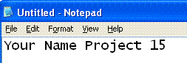

- Open a browser and go to Gmail.com. Enter a user name of JoeUser and a password of TopSecretPassword. Don't log in with your real password! Your keystrokes are being recorded!

Entering the Password to View the Menu
- Open another Notepad window and type in this password, followed by the Enter key:
menu
- A menu appears, as shown on the next page. While the keylogger is in this mode, you won't be able to type into any other window—it grabs the keyboard and won't let go until you exit. All you need to do for this project is dump the captured keystrokes, as shown on the next page, but feel free to experiment with the menu options. However, Don't change the password! If you change the password, the device will become useless to everyone else, and there is no practical way to recover it.

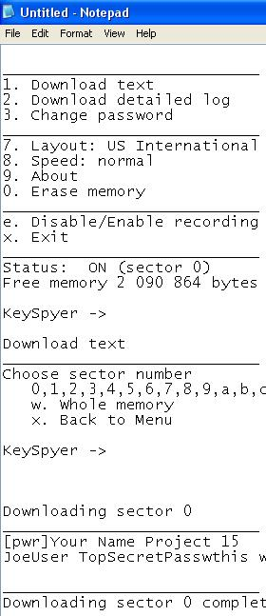
Display the Captured Keystrokes
- Type in the number 1
- At the next prompt, type the letter w
- The captured text appears, as shown to the right on this page. Make sure the password TopSecretPassword is visible in the screen, as shown in near the bottom of the image on the right on this page.

Saving a Screen Image
- Press the PrintScrn key in to copy the whole desktop to the clipboard.
- Click Start, Programs, Accessories, Paint. In the untitled - Paint window, select Edit, Paste from the menu bar.
- In the untitled - Paint window, click File, Save. Save the document in the My Pictures folder (or any other place you wish, such as a floppy disk) with the filename Your Name Proj 15. Select a Save as type of JPEG.
Note: If you cannot type in the file name, that means the keylogger is locking the keyboard. Go back to Notepad and type in x to exit the keylogger, or menu to see the menu again, and then x.. If all else fails, physically disconnect the keylogger and plug the keyboard back in without it to make your keyboard respond.

Erasing the Memory
- In the Notepad window,, type in this password, followed by the Enter key:
menu
- Type in the number 0
- At the next prompt, type Y
- Wait until the process completes, and you see another KeySpyer -> prompt. Then type x to exit the keylogger menu mode.

Return the Keylogger to Your Instructor
- Give the keylogger back, and reclaim your ID card.

Turning in Your Project
- Email the JPEG image to me as an attachment to an email message. Send it to: cnit.123@gmail.com with a subject line of Proj 15 From Your Name, replacing Your Name with your own first and last name. Send a Cc to yourself.
Last Modified 4-16-09

