What You Will Need
- A Windows 7 machine to use as a Web server

Installing Internet Information Services (IIS)
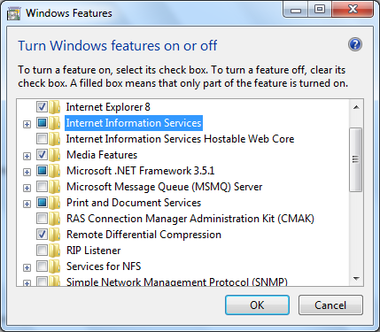
- On your Windows 7 desktop, click Start, type in Prog, and click "Programs and Features".
- Click "Turn Windows features on or off". Click the "Internet Information Services" box, as shown to the right on this page. Click OK. Wait until IIS is installed.

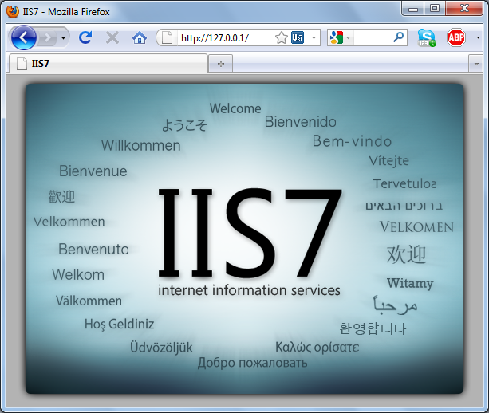
Testing your Web Server
- Open a Web browser and go to this URL: 127.0.0.1
- You should see an IIS Welcome page, as shown to the right on this page. This shows that IIS is working.

Finding Your Web Server's IP Address
- Click Start. Type in CMD and press the Enter key. Type in IPCONFIG and press the Enter key Find the IP address of your machine—in S214, it starts with 192.168.1. Write that address in the box to the right on this page.

Web Server IP: ____________________________

Adjusting Folder Permissions
- By default, IIS doesn't let you add a Web page to your folder, which is irritating.
- Click Start, Computer. Open drive C:. Open the Inetpub folder. Right-click the wwwroot folder and click Properties. On the Security tab, click Edit. Click the Add button and add your account. Give yourself Full Control permission. Click OK. Click OK.

Creating a Web Page
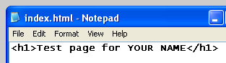
- Click Start, type in NOTE, and click Notepad. Type in the HTML shown to the right on this page, or make any other page you like. Save it in the C:\Inetpub\wwwroot folder with the filename index.html (be sure to select a type of "All Files" to prevent Notepad from adding a .txt to the filename).
- Open a Web browser, enter this address, and press the Enter key:
IP-Address/index.html
Don't enter the literal string IP-address; instead, type in the Web Server's IP address.
- You should see your Web page, as shown below on this page.
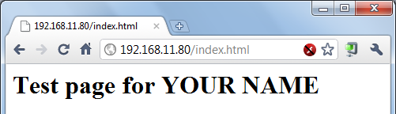

Saving the Screen Image
- Press the PrntScn key to copy whole screen to the clipboard. Open Paint and paste in the image. Save it as a JPEG, with the filename Your Name Proj 16.
Turning in your Project
- Email the JPEG image to me as an attachment. Send the message to cnit.123@gmail.com with a subject line of Proj 16 From Your Name. Send a Cc to yourself.
Last modified 1-9-11

