What You Will Need
Warning! Denial of service attacks are illegal! The only machines you should scan in this project are machines in S214, or on your own network at home. The people who used this tool to bring down Mastercard and Visa in late 2010 and early 2010 are headed to prison.
- A Windows machine to perform the attack
- A Web server with a large page to view, as you set up in the previous project.
- In these instructions, I both machines are using Windows 7. Either or both machines can be virtual machines.

Verifying that Internet Information Services (IIS) is Running
- On the Web server, click Start, All Programs, Accessories, Command Prompt. Type in the following command, then press the Enter key:
netstat –an
- This command lists all the active network connections, as shown below on this page. Look for the line that shows that for protocol TCP, the Local Address 0.0.0.0:80 is LISTENING–that is the Web server waiting for any connection to port 80. If you don't see the process listening on port 80, something is wrong with your Web server and you need to fix it before proceeding further.
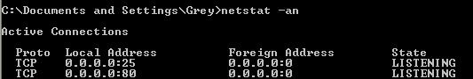

Using Task Manager to Display the Performance of Your Web Server
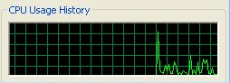
- On the Web server, press Shft+Ctrl +Esc. In Task Manager, click the Performance tab. You should see a graph labeled CPU Usage History, as shown to the right on this page. There's another graph there too, but this is the one of greatest interest now.
- Leave the Task Manager window open on your server, and drag it to the lower right corner of the desktop so it will be easy to keep it visible while other windows are open.

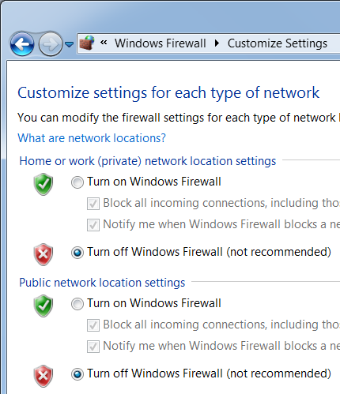
Turn Off the Firewall
- On your Web server, click Start. Type in FIRE and click "Windows Firewall" in the results section.
- In the "Windows Firewall" box, on the left side, click "Turn Windows Firewall on or off".
- In the "Customize Settings" box, in the "Home or work (private) network location settings" section, click the "Turn off Windows Firewall" button, as shown to the right on this page. Make the same adjustment in the "Public network location settings" section. Click the OK button.

Finding Your Web Server's IP Address
- On the virtual machine's desktop, click Start, Run. Type in CMD and press the Enter key. Type in IPCONFIG and press the Enter key Find the IP address of your machine—in S214, it starts with 192.168.1. Write that address in the box to the right on this page.

Web Server IP: ____________________________

Viewing your Web Page
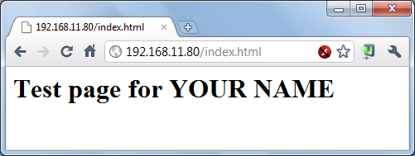
- On your attacker machine, open a Web browser, enter this address, and press the Enter key:
IP-Address/index.html
Don't enter the literal string IP-address; instead, type in the Web Server's IP address.
- You should see your Web page, as shown to the right on this page.

Downloading LOIC on your Attacker Machine
- The Low Orbit Ion Cannon (LOIC) is a famous DoS attack tool, used by the 4chan online community to illegally take down Scientology websites. It is considered a fairly low-tech DoS attack tool, easily blocked by the target.
- On your Windows 7 host system, open a Web browser and go to sourceforge.net/projects/loic
- Download the latest version of LOIC--when I did it, it was loic-1.0.4-binary.zip.
- Right-click the loic-1.0.4-binary.zip file and click "Extract All…", Extract.
- Double-click the LOIC.exe file.
Attacking your Web Server with LOIC
- In the "Low Orbit Ion Cannon" window, in the IP field, enter your Web server's IP address. Click the "Lock On" button. In the lower left, select a Method of TCP. Click the "IMMA CHARGIN MA LASER" button. The attack starts, showing a large number of Requests in the lower right corner, as shown below on this page..
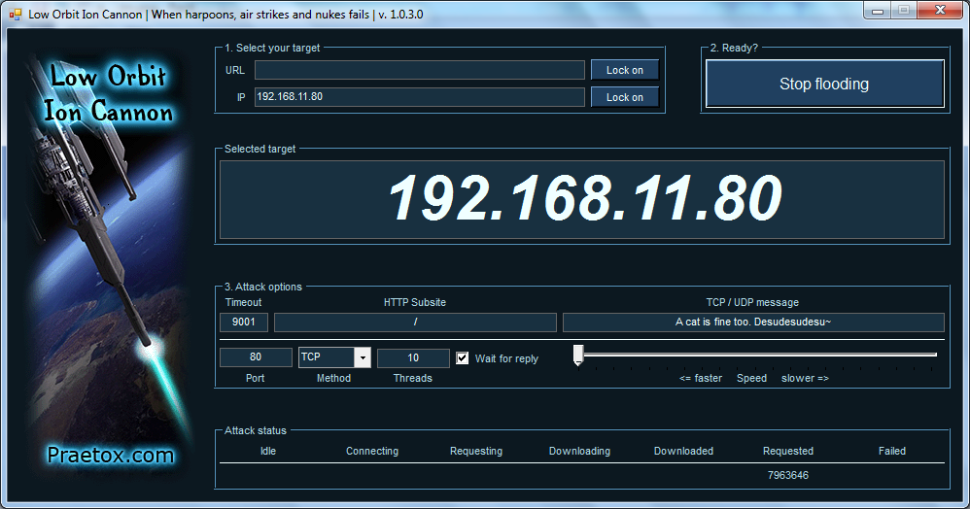

Saving the Screen Image
- Make sure the "Low Orbit Ion Cannon" window is visible, showing a number "Requested" in the lower right corner.
- Press the PrntScn key to copy whole screen to the clipboard. Save the image with the filename Your Name Proj 17.
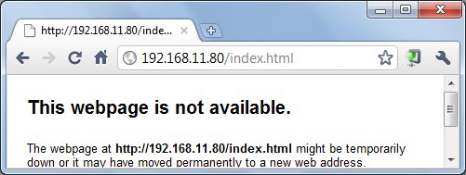
- Click in the Web browser showing your test page and press the F5 key to refresh the page. You should see an error message, as shown below on this page. (The exact appearance of the error message varies).

Viewing the CPU Usage
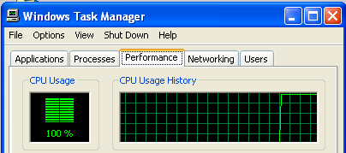
- On your Web server, look at the Task Manager window. You should see constant 100% CPU Usage, as shown to the right on this page. Sometimes the attack can be so strong that the virtual machine loses its network connection, which may briefly lower the CPU Usage.

Stopping the Attack
- In the "Low Orbit Ion Cannon" window, click "Stop Flooding".
- Look at the CPU Usage History on the server. Soon it should drop down to a low number, like 0% or 10%, as the denial of service attack stops.
- In your Web browser showing your test page, press F5. The page should reload.
Turning in your Project
- Email the JPEG image to me as an attachment. Send the message to cnit.123@gmail.com with a subject line of Proj 17 From Your Name. Send a Cc to yourself.

Last modified 1-9-11

