What You Need
- A Windows machine with administrator access (real or virtual). It can run any version of Windows, XP or later. These instructions were written for Windows 7. If you want to use Windows Server 2008, you need to disable the "Password must meet complexity requirements" policy as explained here:
http://windows.microsoft.com/en-us/windows/change-password-policy-settings#1TC=windows-7
- Cain & Abel will be detected as malware by your virus scanner. You will need to allow it to install, which is pretty easy if you use Microsoft Security Essentials. If you don't want to install it on your real machine, use a VM.

Creating Passwords to Crack
- Click Start, type in CMD and press Shift+Ctrl+Enter. If a "User Account Control" box appears, click Yes.
- In the Administrator Command Prompt window, enter these commands:
net user p3 abc /add
net user p5 abcde /add
User name Password
P3 abc
P5 abcde
P7 abcdefg
net user p7 abcdefg /add
Those commands create three new users on the systems, as shown in the chart shown to the right on this page.

Installing Cain & Abel
- Open a browser and go to www.oxid.it
- In the upper left, click Projects.
- Scroll down past the disclaimer and click "Cain & Abel".
- Scroll down and click "Download Cain & Abel v4.9.36 for Windows NT/2000/XP". (The version number may be higher now.) Save the installer on your desktop.
- Double-click the installer. Install the software with the default options. It will install WinPCap as well as Cain & Abel.

Displaying the Password Hashes
- Click Start, type in CAIN. Right-click Cain in the results and click "Run as Administrator" If a "User Account Control" box appears, click Yes.
- In the Cain window, at the top, click the Cracker tab. Move the mouse to the center right, where a blank white pane appears with a gray grid. Right-click and click "Add to list". In the "Add NT Hashes from" box, click Next.
- The password hashes appear, as shown in the figure on the next page. The LM hashes will all be the same if you are using Windows Vista or later, but the NT hash contains the password information.
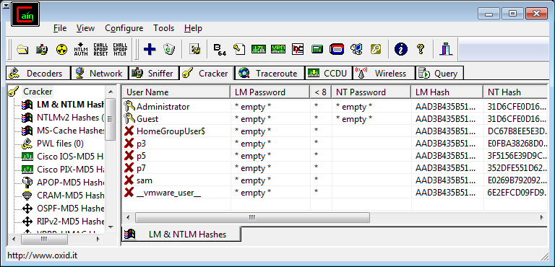

Cracking Passwords
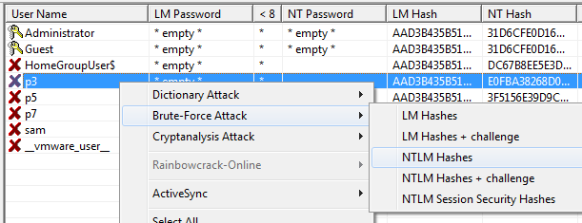
- In the right pane, right-click p3, point to "Brute-Force Attack", and click "NTLM Hashes", as shown below on this page. Note: we are cracking the NTLM hashes, not the old, weak LM hashes. The NTLM hashes are much more difficult to crack, so it will only work for short passwords.

- In the "Brute-Force Attack" box, click the Start button. It should find the three-letter password immediately. Close the "Brute-Force Attack" box.
- In the right pane, right-click p5, point to "Brute-Force Attack", and click "NTLM Hashes".
- In the "Brute-Force Attack" box, click the Start button. It should find the five-letter password within a few seconds. Close the "Brute-Force Attack" box.
- In the right pane, right-click p7, point to "Brute-Force Attack", and click "NTLM Hashes".
- In the "Brute-Force Attack" box, click the Start button. The seven-letter password is hard to crack, however– no answer appears immediately. It might take a long time to crack, so we'll give up. Click the Stop button. Click the Exit button.

- You should see the two passwords you found, abc and abcde, in the NT Password column of the Cain window, as shown below.
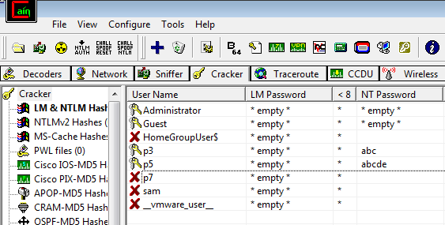

Saving the Screen Image
- Press the PrntScn key to copy whole screen to the clipboard. Open Paint and paste in the image. Save it as a JPEG, with the filename Your Name Proj 18.
Turning in your Project
- Email the JPEG image to me as an attachment. Send the message to cnit.123@gmail.com with a subject line of Proj 18 From Your Name. Send a Cc to yourself.
Last modified 4-19-14

