What You Will Need
- A computer Windows 7 (or Windows XP, or Vista)
- Administrator privileges
- The instructions assume you are using Windows 7

Downloading and Installing HashCalc
- Open Firefox and go to slavasoft.com/hashcalc
- On the upper left, click the blue "Hashcalc 2.02´link. Save the Zip file on your desktop.
- On your desktop, right-click the hashcalc.zip file and click "Extract All" Click Extract.
- A hashcalc window opens containing a setup.exe file. Double-click the setup.exe file and install the software with the default options.

Downloading and Installing the Hello.exe and Erase.exe Files
- Open Firefox and go to www.mscs.dal.ca/~selinger/md5collision
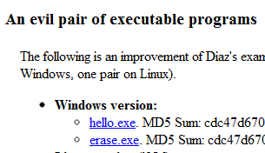
- Scroll down to the section titled "An evil pair of executable programs", as shown to the right on this page.
- Click the hello.exe file. Save it on your desktop.
- Click the erase.exe file. Save it on your desktop.

Running the Files
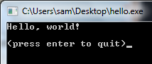
- Normally a MD5 hash is used to verify that a file has not been altered. If two files have the same hash value, they are expected to be identical.
- On your desktop, double-click the hello.exe file. In the "Open File - Security Warning" box, click Run. A box opens saying "Hello World", as shown to the right on this page.
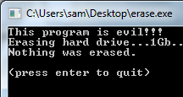
- On your desktop, double-click the erase.exe file. In the "Open File - Security Warning" box, click Run. A box opens saying "This program is evil!!!", as shown to the right on this page.

Capturing the Screen Image
- Make sure the "This program is evil!!!" message is visible.
- Press the PrntScn key to copy whole screen to the clipboard. Open Paint and paste in the image. Save it as a JPEG, with the filename Your Name Proj 19a.

Calculating the Hash Values
- Click Start and type in HASH
- In the search results, click HashCalc.
- A gray HashCalc box opens.
- Drag the hello.exe file from your desktop and drop it in the HashCalc window.
- The MD5 hash appears, ending in 007, as shown below on this page.

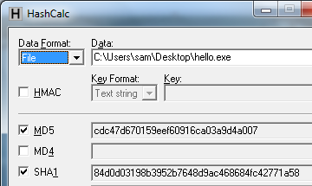

- Drag the erase.exe file from your desktop and drop it in the HashCalc window.
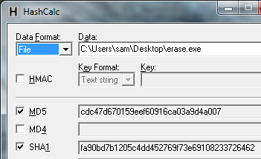
- The MD5 hash appears, ending in 007, as shown below on this page.

Capturing the Screen Image
- Make sure the MD5 hash ending in 007 is visible.
- Press the PrntScn key to copy whole screen to the clipboard. Open Paint and paste in the image. Save it as a JPEG, with the filename Your Name Proj 19b.
Turning in your Project
- Email the JPEG image to me as an attachment. Send the message to cnit.123@gmail.com with a subject line of Proj 19 From Your Name. Send a Cc to yourself.
Last modified 1-9-11

